

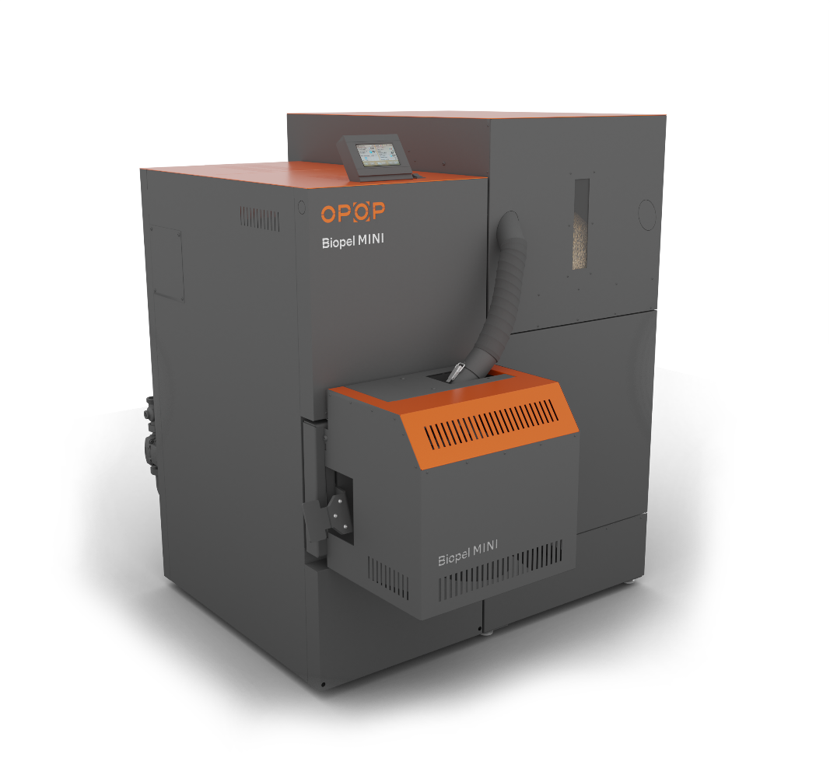

Operating Instructions
Biopel MINI

TABLE OF CONTENTS
1. INTRODUCTION 4
2. BASIC CHARACTERISTICS OF BIOPEL MINI SERIES BOILERS 4
3. MAIN PARAMETERS AND DIMENSIONS 5
3.1. Biopel MINI 11 / 15 kW; 21 / 30 / 40 kW 5
3.2. Hydraulic losses of boilers 8
3.3. Burner 8
3.4. Hopper 9
3.5. External feeder 10
4. PRESCRIBED FUEL 10
5. BASIC COMPONENTS OF THE INSTALLATION CONFIGURATION AND PACKAGE CONTENT 10
5.1. Biopel MINI 11 / 15kW; 21 / 30 / 40kW 10
5.2. Burner 11
Package content: 11
5.3. Hopper 12
5.4. External feeder 12
6. INSTALLATION PROCESS 13
6.1. Hopper 14
6.1.1. External Hopper 14
6.1.2. Tower hopper 16
6.2. Burner 19
6.3. External feeder 19
6.4. Control unit 20
6.5. Electrical Connection of the Unit and Accessories 21
7. BOILER CONTROL UNIT 24
7.1. Basic navigation 24
7.2. Basic operating modes 26
8. CONTROL UNIT FUNCTIONS DESCRIPTION 27
8.1. On / Off 27
8.2. Temperature Settings 27
8.3. Coefficients 27
8.4. Manual operation 28
8.5. CH and DHW Mode for Pumps 28
8.6. Weekly Programme 28
8.7. Disinfection 28
8.8. Installation menu 29
8.9. Service Menu 31
8.10. Language Selection 31
9. FIRST BOILER START-UP 31
10. COMBUSTION CORRECTION 32
10.1. Flame quality 32
10.2. Change fan speed 33
10.3. Change external feeder operating time 33
10.4. Non-standard installations 33
11. HEATING SYSTEM CONTROL 35
11.1. One CH circuit + DHW 35
11.2. Two CH circuit + DHW 36
11.3. One CH Circuit with 4-Way Valve + DHW 39
11.4. One CH Circuit with 4-Way Valve and Buffer Tank + DHW 40
12. Storage tank size determination 43
13. REGULAR MAINTENANCE 44
14. BIOPEL ONLINE 44
15. FIRMWARE UPDATES 45
16. OPERATING AND ALARM MESSAGES 45
17. TROUBLESHOOTING OF SPECIFIC SITUATIONS 46
18. ELECTRICAL SAFETY 49
19. FACTORY SETTINGS 49
20. ENERGY EFFICIENCY 51
21. IDENTIFICATION MARKS 52
22. WARRANTY CONDITIONS, GENERAL INSTRUCTIONS 57
23. APPLICABLE STANDARDS AND REGULATIONS 58
24. WARRANTY CARD 59

INTRODUCTION
To correctly install, start and operate this boiler from the Biopel series, read this manual step by step, from chapter 1 onwards and proceed chronologically so that none of the steps necessary for the correct boiler operation are omitted during installation and commissioning. Chapters describe first boiler installation, then chronologically accessories connection and activation and boiler maintenance. Chapters describe first boiler installation, then chronologically accessories connection and activation and boiler maintenance.
The latter half of the manual provides examples of heating system wiring and accessories, including a description of the settings in the control unit. If one or more accessories are connected to the boiler, use this information to properly set-up the accessories properly so boiler operation will be in in accordance with user manual.
If you require additional information regarding the boiler function or boiler-controlled components, please do not hesitate to contact a certified installer or an OPOP representative directly.

BASIC CHARACTERISTICS OF BIOPEL MINI SERIES BOILERS
Biopel MINI boilers are produced in several sizes according to their maximum power, from 11 to 40 kW. The control system of these boilers allows to regulate all control elements of heating systems. The control unit is equipped with many advanced features, ensuring its adaptation to the customer's needs. In addition, it allows the connection of many additional devices that simplify the boiler operation and add additional superior features.
The Biopel MINI boiler control unit enables:
- Control of 2 mixing valves.
- Connection of 2 room thermostats to control 2 separate heating circuits.
- Connection of 5 pumps - central heating pump (CH pump), hot water pump (DHW), valve pump 1, valve pump 2, pump with independently configurable settings.
- Equithermal control based on outdoor temperature.
- Time control of boiler outlet temperature - programmable weekly operation mode.
- Heating of storage tank by 2 temperature sensors.
- Online control of all boiler and heating circuit functions via OPOP web interface.
- Mobile application for iOS and Android phones, allowing remote boiler management and the entire heating system.
- Control unit firmware update via USB interface to get new functions.
- DPCh - operation error detection. The unit displays error and operation messages on the main panel, which are also stored in the Main Settings, Activity History. By clicking on an operating error, you can view a detailed description of the problem and how to solve it.

In addition, the Biopel boiler's v12 MINI control unit allows connection of a wide range of additional devices, which make boiler maintenance more automatic or add new control options:
- RT10 room thermostat, displaying information of the entire heating system.
- Compressor cleaning of boiler burner and exchanger, extending significantly the need for manual boiler and burner maintenance.
- Automatic ash removal, extracting ash from the boiler into an external container, extending the intervals between boiler ashtray cleaning.
- Lambda sensor, allowing automatic correction of the combustion process by measuring the remaining oxygen inside the boiler.
- GSM module, with which you can receive boiler status reports via SMS. Use in case your boiler cannot be connected to the internet and regulated online.
- S8-Wifi module, allowing control of thermostatic radiator heads. Each room is thus heated as a separate zone with its own room temperature. Therefore, this device ensures optimum heat consumption and keeps heating costs to a minimum.
- Vacuum feeder, transporting pellets from silo to the boiler hopper over long distances.
- Cascade controller, allowing you to operate up to 4 boilers connected together in one boiler room and use their power according to the current requirement of the heating system.

MAIN PARAMETERS AND DIMENSIONS
The main components of the basic configuration are the boiler, burner, feeder and pellet hopper. You can find the main parameters and dimensions of each of these components below.

Biopel MINI 11 / 15 kW; 21 / 30 / 40 kW
The boiler body is always different according to its maximum power. Main differences are external dimensions, size of connection outlets and inlets, flue diameter, heat exchanger shape, its type and number of doors.
Technical parameters: |  | Biopel Mini 11 | Biopel Mini 15 | Biopel Mini 21 | Biopel Mini 30 | Biopel Mini 40
Nominal output | kW | 11 | 15 | 21 | 30 | 40
Minimal output | kW | 3.3 | 4.4 | 6.1 | 7.6 | 9.8
Guaranteed fuel | wood pellets 6-8mm
Fuel consumption (at boiler nominal output) | kg/h | 2.36 | 3.36 | 4.68 | 6.52 | 8.42
Fuel consumption (at boiler minimal output) | kg/h | 0.741 | 1.01 | 1.373 | 1.96 | 2.212
Emission class *¹ | 5 / Ecodesign
Efficiency *¹ | % | 93.6 | 93.3 | 92.9 | 92.7 | 93.6
Water volume | L | 32 |  | 54
Operational chimney draught | [Pa] | 5.5 | 7.5 | 8 | 11 | 11
Maximum operating pressure of water | bar | 2
Maximum temperature of heating water | °C | 80
Minimum temperature of return water | °C | 55
Referential flue gas temperature (at boiler nominal output) | °C | 85 - 105 | 101 - 121 | 102 - 122 | 107 -127 | 117 -137
Acoustic power level | Lwa [dB] | 62 | 62 | 64 | 65 | 66
Max. input power | W | 430 | 430 | 430 | 430 | 420
Nominal/minimum input power | W | 35/15 | 40/26 | 48/30 | 55/32 | 84/34
Power consumption in standby mode | W | 5 | 5 | 5 | 5 | 5
Weight | kg | 160 |  | 240
Connecting voltage | V/Hz | 230V/50Hz ±10%
Cover IP protection rating | IP | IP 20
Dimensions:
Boiler height [A] | mm | 1088 |  | 1257
Boiler width [B] | mm | 352 |  | 482
Boiler depth [C] | mm | 814 |  | 914
Flue diameter | mm | 130 |  | 150
Flue centre position from the ground [D] | mm | 739 |  | 898
Inlet water funnel position from the ground [E] | mm | 156
Outlet water funnel position from the ground [F] | mm | 822 |  | 992
Inlet and outlet water connection [G] | inches | G 1 ¼ (female thread)

Technical parameters: |  | Biopel Mini 11 | Biopel Mini 15 | Biopel Mini 21 | Biopel Mini 30 | Biopel Mini 40
Boiler depth including burner cover [H] | mm | 1043 |  | 1170
Height of burner cover [I] | mm | 349 |  | 413
Burner cover depth [J] | mm | 281 |  | 308
*¹ Emission values and classes are determined by tests in test institutes, measured according to EN 303-5 Standards.
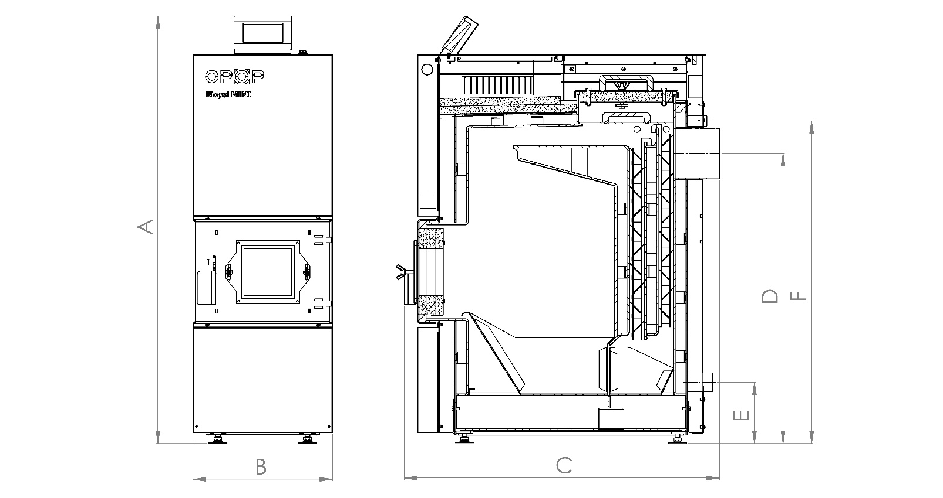

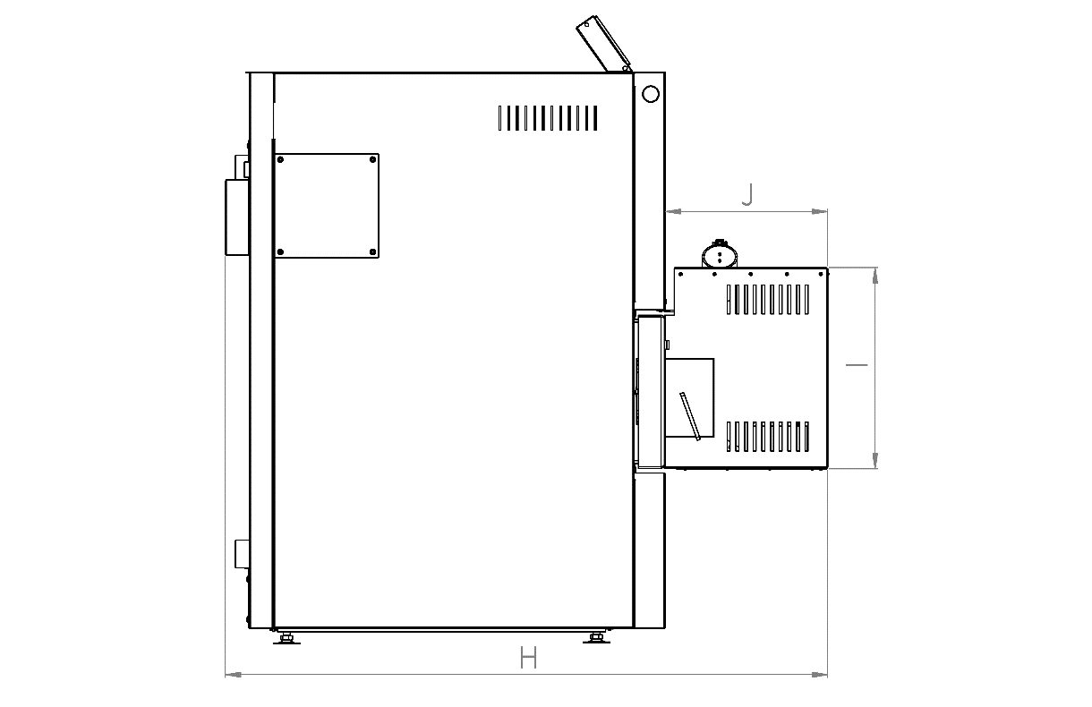

Hydraulic losses of boilers

Biopel MINI 11 |  |  | Value | Uncertainty
Δt = 10 °C | Water flow through the boiler | [m³/h] | 0.950 | 0.005
Δt = 10 °C | Boiler's hydraulic loss | [Pa] | 114 | 28
Δt = 10 °C | Boiler's hydraulic loss | [mbar] | 1.14 | 0.28
Δt = 10 °C | Flow resistance coefficient | [-] | 2.12 | 0.59
Δt = 20 °C | Water flow through the boiler | [m³/h] | 0.475 | 0.002
Δt = 20 °C | Boiler's hydraulic loss | [Pa] | < 23 | -
Δt = 20 °C | Boiler's hydraulic loss | [mbar] | < 0.23 | -
Δt = 20 °C | Flow resistance coefficient | [-] | < 1.75 | -

Biopel MINI 21 |  |  | Value | Uncertainty
Δt = 10 °C | Water flow through the boiler | [m³/h] | 1.806 | 0.016
Δt = 10 °C | Boiler's hydraulic loss | [Pa] | 235 | 36
Δt = 10 °C | Boiler's hydraulic loss | [mbar] | 2.35 | 0.36
Δt = 10 °C | Flow resistance coefficient | [-] | 1.21 | 0.46
Δt = 20 °C | Water flow through the boiler | [m³/h] | 0.907 | 0.004
Δt = 20 °C | Boiler's hydraulic loss | [Pa] | 62 | 24
Δt = 20 °C | Boiler's hydraulic loss | [mbar] | 0.62 | 0.24
Δt = 20 °C | Flow resistance coefficient | [-] | 1.27 | 0.58

Biopel MINI 40 |  |  | Value | Uncertainty
Δt = 10 °C | Water flow through the boiler | [m³/h] | 3.441 | 0.070
Δt = 10 °C | Boiler's hydraulic loss | [Pa] | 775 | 36
Δt = 10 °C | Boiler's hydraulic loss | [mbar] | 7.75 | 0.36
Δt = 10 °C | Flow resistance coefficient | [-] | 1.10 | 0.28
Δt = 20 °C | Water flow through the boiler | [m³/h] | 1.725 | 0.008
Δt = 20 °C | Boiler's hydraulic loss | [Pa] | 199 | 24
Δt = 20 °C | Boiler's hydraulic loss | [mbar] | 1.99 | 0.24
Δt = 20 °C | Flow resistance coefficient | [-] | 1.12 | 0.36

Burner
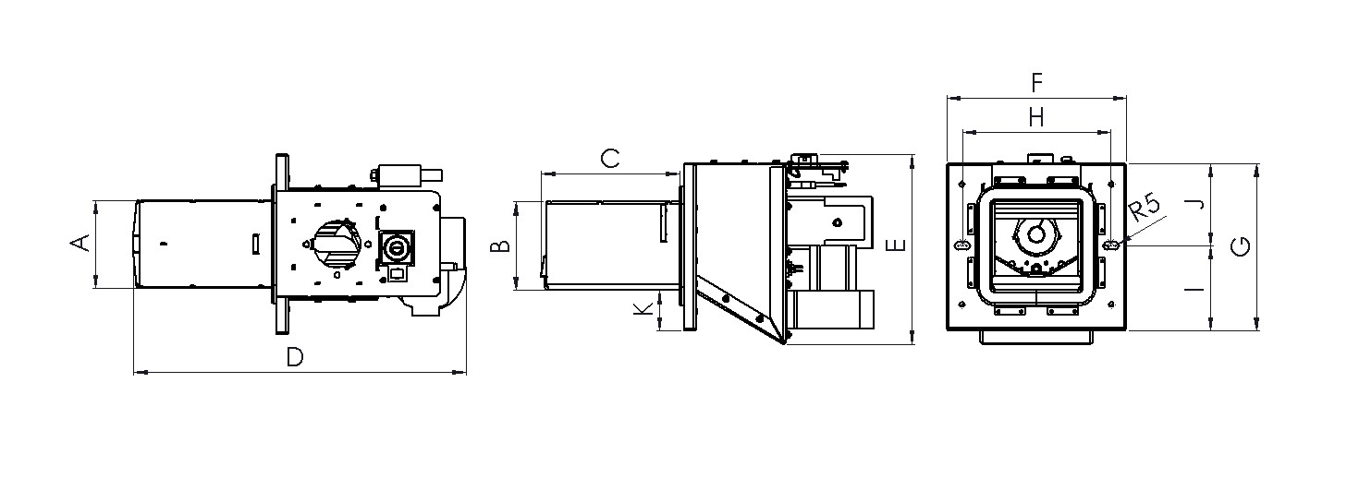
The pellet burner, like the boiler, differs according to its maximum power. The differences are in burner dimensions, types of electrical components, shape and size of grates, thickness of the material used.

Dimensions mm | Biopel burner 10 | Biopel burner 15 | Biopel burner 20 | Biopel burner 30 | Biopel burner 40 | Biopel burner 60 | Biopel burner 80-100 | Biopel burner 150-200
A | 116 | 116 | 145 | 177 | 183 | 183 | 213 | 324
B | 116.6 | 116.6 | 116.6 | 171 | 173.8 | 173.8 | 198.8 | 224
C | 132 | 177 | 221 | 250,7 | 322.6 | 322.6 | 360.9 | 523.6
D | 354 | 399 | 446.1 | 500 | 573 | 602 | 637 | 842.4
E | 316.5 | 316.5 | 319.1 | 380.3 | 390.8 | 457.8 | 476.8 | 477.4
F | 236 | 236 | 240 | 278 | 333 | 333 | 340 | 453
G | 220 | 220 | 240 | 278 | 273 | 273 | 299 | 298
H | 195 | 195 | 204 | 248 | 306 | 306 | 306 | 412
I | 111,5 | 111,5 | 120 | 139 | 144 | 144 | 150 | 147.5
J | 108.5 | 108.5 | 120 | 139 | 129 | 129 | 149 | 150.5
K | 53 | 53 | 70.4 | 58.5 | 43 | 43 | 50 | 37

Hopper
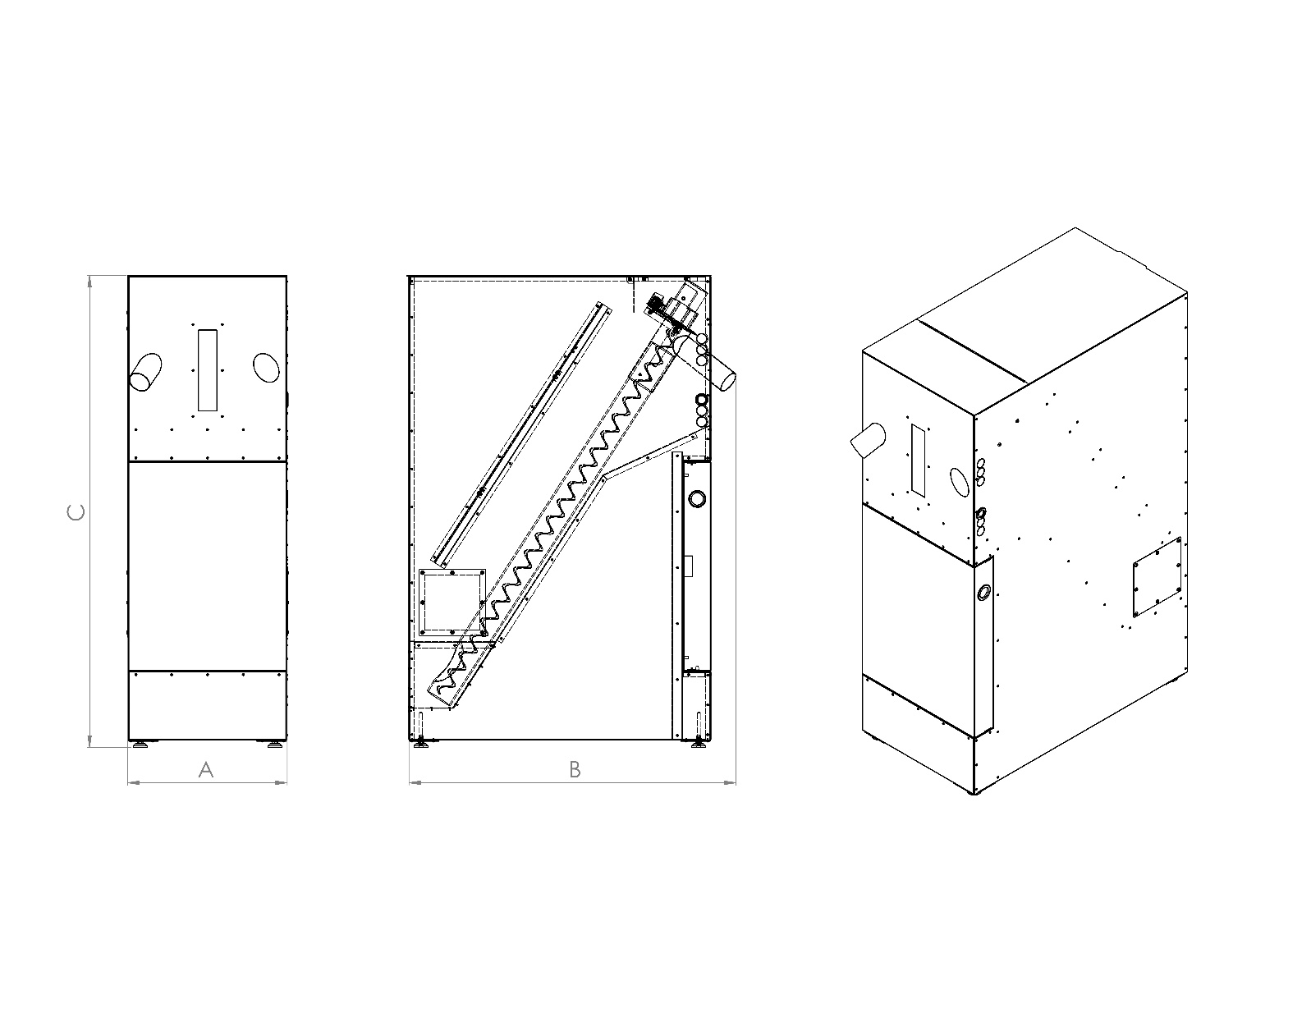
Hoppers are divided into 2 main types. Compact version and external version applicable for all boiler sizes. In the boiler manual and control unit you may come across two names, namely Hopper or Pellet Tank.
Hopper type | cm | External 60x60 | External 80x80 | External 100x100 | External 1420x80 | Compact 150 | Compact 225
Pellet volume | kg | 110 | 220 | 300 | 350 | 150 | 225
Weight | kg | 25 | 29 | 35 | 38 | 42 | 52
Height [C] | mm | 1300 | 1300 | 1300 | 1300 | 1283 | 1283
Width [A] | mm | 600 | 815 | 1000 | 1420 | 434 | 594
Depth [B] | mm | 600 | 815 | 1000 | 815 | 889 | 960

External feeder
The external pellet feeder is only used with external hopper version configuration. The compact pellet hopper is already equipped with a feeder from the factory. You can choose between two sizes of the external feeder - 2 or 3m length.
External feeder type | m | 2 | 2,5 | 3

PRESCRIBED FUEL

Fuel | Fuel type | Grain size [mm] | Calorific value [kJ/kg-1]
Wood pellets | ENplus A1 | 6 | 16.5-19.5
  - Water content in fuel: max. 10%
  - Low caking property
  - Low swelling

For heating with the Biopel MINI boiler use only pellets that comply with ENplus1. The pellets must be made from wood only. The lower the bark component in the pellet, the higher you can expect quality combustion with minimal ash.

BASIC COMPONENTS OF THE INSTALLATION CONFIGURATION AND PACKAGE CONTENT
Biopel MINI is available in several sizes according to the maximum boiler power, from 11 to 40kW. Each size has its differences, not only in terms of dimensions, but also design of heat exchanger, doors, connection dimensions of inlets, outlets, flue gas outlets. Boiler size is also influenced by pellet hopper, feeder, burner dimensions, etc. You can read the basic parameters of all the complete Biopel MINI elements set below.

Biopel MINI 11 / 15kW; 21 / 30 / 40kW
The boiler is equipped with two doors, one for cleaning and one for ash. A control unit on the top of the boiler and a cover for the cleaning door. The cleaning door is secured with thumb nuts and is completely removable for better access and boiler exchanger cleaning.
On the front sides, you will find the ash door and the burner hole. In addition, at the top of the side covers, you will find a hole for attaching the automatic exchanger cleaner (an additional device), and ducts leading the wiring from the unit to the rear of the boiler.
There are 2 inlets and outlets in the rear part of the boiler - top for the boiler outlet water, bottom for the boiler inlet water. Next to the water outlet, there are sinks for temperature sensors (CH sensor and Termik sensor). The water inlet is at the bottom of the boiler together with the pipe for the filling valve. There are two covers on the boiler's rear casing. The first is located next to the flue outlet and covers the Lambda Probe and Flue Gas Temperature Sensor connection. The second cover is located at the bottom of the boiler and covers the hole for mounting the automatic ash removal (additional device). The flue outlet connection is located in the rear, central part of the boiler.

Temperature sensors (CH, Termic, and flue gas sensor) are led to the rear of the boiler through the side shaft for cabling and connected to the respective pits.
There are adjustable legs on threads at the bottom of the boiler, which can be used to adjust the boiler height and level the unevenness of the base in the boiler room. The ash door hinges can be mounted on the opposite side of the boiler in the event of installing the so-called compact version of the hopper on the opposite side. Refitting of the ash door hinges is necessary to ensure the ash door's smooth opening.
The ash door hinges can be attached to the boiler on the left or right, according to the customer's needs. Therefore, the ash door can be installed from the left or right.
There are 2 ashtrays inside the boiler and above the ashtray, in the exchanger part of the boiler, you will find the so-called flue turbulators, which reduce the flue gas temperature in the chimney and increase the boiler efficiency.

Burner
The pellet burner is different according to power, type of grate and type of electrical components used in the burner. The maximum burner power is also indicated by its external dimensions. The burner is equipped with the following components:
- internal pellet feeder (motor and worm),
- fan,
- ignition cartridge,
- photosensor,
- safety temperature sensor,
- burner circuit board,
- removable grate,
- asbestos sealing cord,
- holes for adjusting screws for attachment to the boiler.
At the top, there is a hole for the burner tube connection with three holes for fixing the tube with screws. Next to this hole, you can find 2 connectors for connecting the burner to the control unit. The smaller connector transmits the signal from the photosensor and the safety temperature sensor. The large connector transmits 230V voltage to control the burner's electrical components (fan, internal feeder motor, ignition cartridge). The fan and the internal feeder motor are each connected to a separate start-up capacitor, which are also located on the burner body.
The burner body and grate are made from stainless steel to withstand the high combustion temperatures of up to 1100 °C. The burner grate is removable and requires regular cleaning. The holes in the burner must be permeable for maximum combustion efficiency.

The ignition cartridge and the asbestos sealing cord are subject to wear. They must be replaced at regular intervals.
The ignition cartridge ensures automatic ignition of pellets, which normally takes 3 to 5 minutes. The resulting flame is detected by a photosensor, which ensures the transition from the automatic ignition phase to normal operation. The photosensor together with the flame safety sensor also serve to ensure the safety of operation and are responsible for shutting down the burner in case of the flame suddenly going out (photosensor) or burner overheating (safety temperature sensor).
The asbestos sealing cord must always lay tight on the boiler or the burner flange on the boiler to prevent smoke and heat escaping from the joint into the room. Otherwise, combustion fumes would escape into the room and there would be a risk of damage to the boiler components and a risk of fire.
The burner is the heart of the boiler and requires regular maintenance of its components, especially the grate. The burner grate is removable for more convenient cleaning. Ensure that the grate is correctly fitted back into the burner, so that it cannot move or fall out. For more information on burner cleaning and handling, see the Regular Maintenance section.

Package content:
- Burner 11 - 40kW
- Control unit v12 display
- Burner cover
- Burner tube - for connection to the burner
- Three 4M bolts for fixing the burner pipe to the burner hole
- Sealing ring - for sealing the connection between the burner hole and the burner pipe
- PVC hose - to connect the burner to the external feeder
- 2 bolts for fixing the burner to the ash door
- 2 wing nuts - for fixing the burner to the boiler
- 2 washers under the wing nuts
- Burner flange (30 and 40kW)
- Burner gasket cover plate (30 and 40kW)

Hopper
The basic diagram of both types of hoppers, i.e., Compact and External versions are shown below. The External hopper can be combined with all boiler sizes. It is assembled on site, i.e., it comes from the factory disassembled. For a description and assembly diagram, please refer to the Installation Procedure section of this manual.
The Compact version of the hopper is shown on the right-hand side of the picture. It is already factory-assembled, and can be easily fixed to the boiler, on both sides according to the position of the pellet burner.
e
a
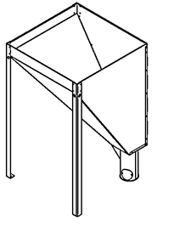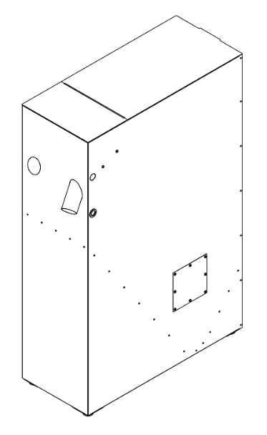
e
h
g
f
c
b

- External hopper
- 3 main hopper legs - fixed to the top of the hopper
- Leg for inserting the External Feeder. There is a hole in the leg into which the feeder is inserted
- Cleaning hole for removing dust out of the hopper
- Filling opening - can be fitted with a cover
- Compact hopper
- Hole for changing the feeder to the other side
- Cleaning hole for removing dust out of the hopper

External feeder
The external pellet feeder is used to transport pellets from the External hopper to the burner. It is only installed when combined with the External hopper, as the Compact hopper version already has this feeder integrated inside. The feeder is equipped with a motor whose speed varies according to the boiler size. Check the label on the External Feeder to see which boiler power this feeder is designed for. Only use the type of External Feeder that is designed for your boiler size.
c
b
a
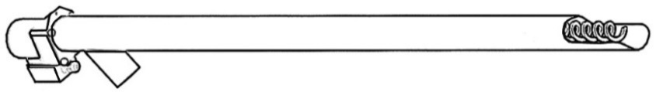
d
e
f

- Feeder motor with capacitor - the bigger the boiler, the faster the motor
- PVC feeder pipe
- Feeder spiral
- Pellet inlet into feeder
- Pellet outlet from feeder to burner
- 230V socket - for connecting the external feeder to external socket on the boiler

INSTALLATION PROCESS
The whole installation process can be divided into the following points:
- Installation of the boiler, hopper, burner or external feeder
- Installation of additional devices
- Boiler's first start-up
- Calculating the external feeder power in case of non-standard installation
- Combustion correction
- Adjustment of other functions and correction of additional device operation
The display is located in the boiler ashtray and must be installed on top of the boiler using 2 screws. Then plug the cable into the black connector in the middle of the main control unit PCB.
The Compact hopper is not permanently attached to the boiler. It is only attached to the boiler after it has been installed in its final position. The pellet feeder must be placed in the left or right hole in the front of the hopper by gouging out the oval metal cover and inserting the feeder outlet into it. The feeder outlet should be on the side closer to the boiler. Then be sure to secure the feeder with the two screws on the inside of the hopper. Pull the feeder power cable from the control unit on the boiler into the hopper through the small gouge hole on the top of the hopper.
After placing the hopper, install the pellet burner into the boiler, from the front of the boiler. Before installing the burner, it is necessary to first select the side to open the door. If you want the door to open on the opposite side, then the door must be removed and fitted on the opposite side of the boiler. Depending on the size, the burner is placed in the ash door either with or without the burner flange, which serves as a spacer between the burner and the ash door.
The cable going to and from the external socket is routed through side shaft on the top of the boiler.
The external feeder is inside the hopper. Its outlet is at the front of the hopper and must be connected to the burner using PVC hose and burner tube (burner accessory). The feeder connector must be connected to the external boiler socket using a 230V cable.

Caution: Make sure that the PVC hose is not slack, otherwise pellets falling from the external feeder outlet into the burner can become stuck inside the PVC hose.
The second version of the pellet hopper is called External Hopper. External hopper can be used with all sizes of Biopel MINI boilers. The External hopper is assembled during the boiler installation and is usually sold in disassembled form. The end of the 2 or 3m external feeder is inserted into the bottom leg of the hopper. The external feeder angle should be 45° from the ground. The feeder is connected to the burner by a PVC hose and burner pipe. The external feeder power supply is led into the external feeder socket using a 230 V cable.
The External hopper can be placed anywhere inside the boiler room, but only in such a way as to ensure that the pellets fall smoothly from the feeder outlet into the burner. Make sure that the PVC hose is not slack, otherwise the pellets falling into the burner may become stuck.
The speed of the motor inside the external feeder varies according to boiler size. The external feeder label always indicates which boiler power range the external feeder is designed. Only use the type of external feeder that is designed for your boiler size. Otherwise, the external feeder will be too fast or slow, causing poor pellet feeding to the burner.

Hopper
The Compact pellet hopper installation is easy, as it is already pre-assembled from the factory. Unpack the hopper from the slatting, remove the protective film and place the hopper next to the boiler. Check the ash door opening. If the hopper is on the side of the boiler with the ash door hinges, you must move the hinges to the opposite side of the boiler so that the hinges do not cause the doors to get stuck.

External Hopper
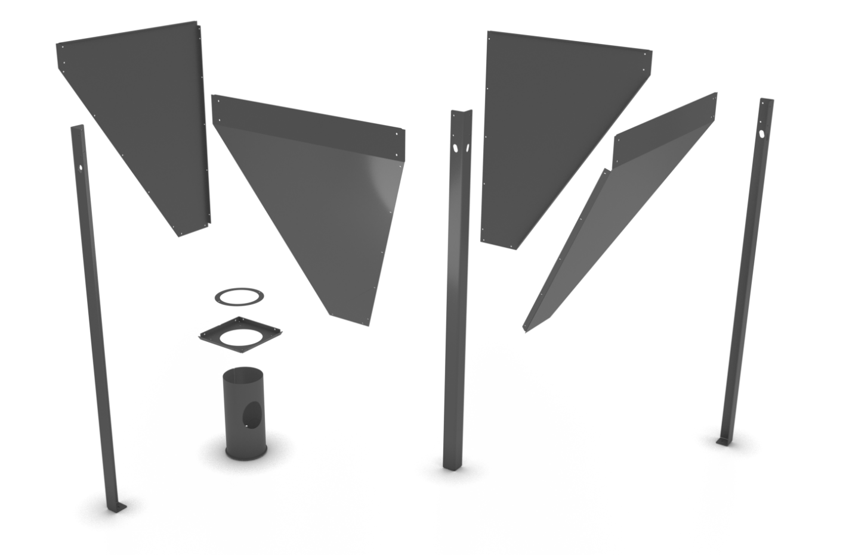

A
B
C
D
E
F
F
F

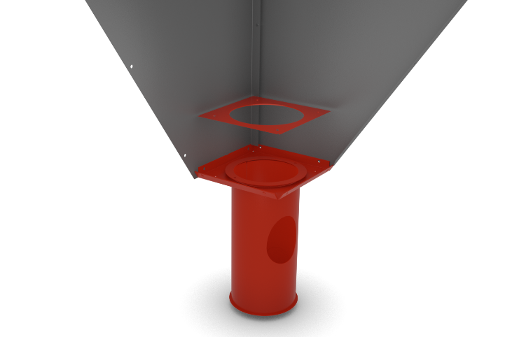

1
2
3
4

A
B
E




C
D

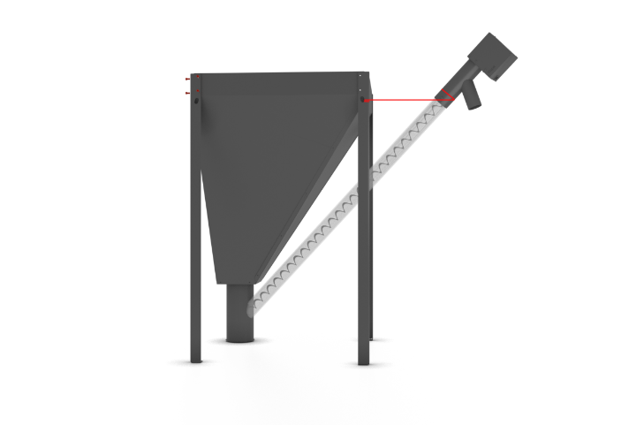
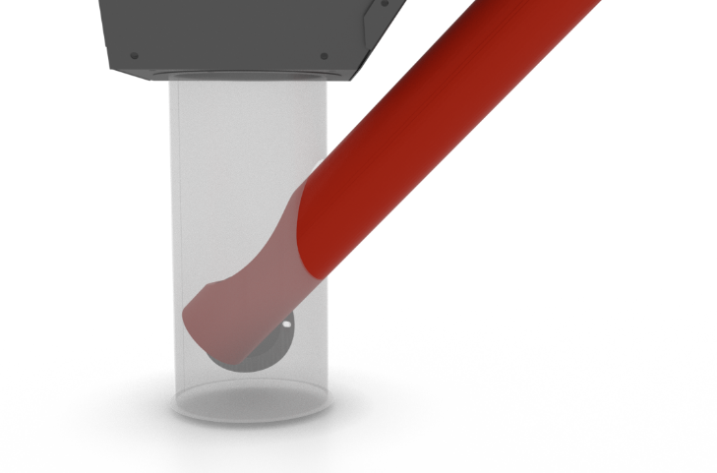
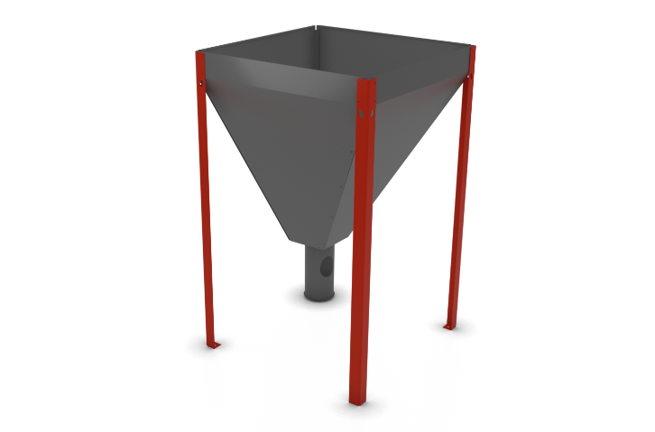
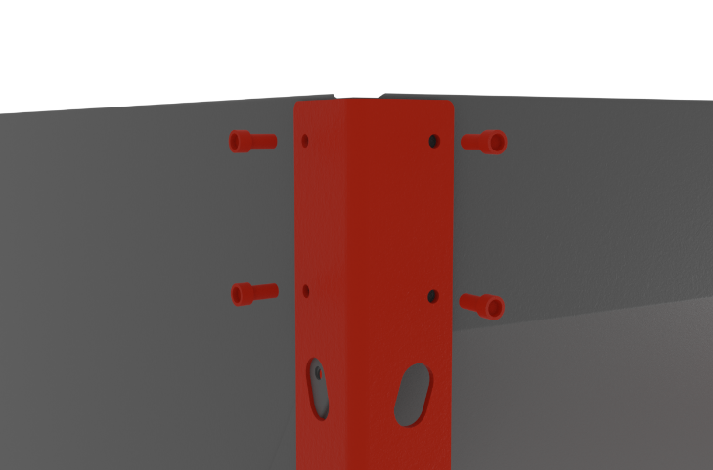
5
6
8
7
F
F

45-55°

The external hopper consists of 4 main plates A, B, C, D, which you connect together one by one. Start by connecting plates A and B, see figure 1.
Then fix the chimney square frame E to plates A, B. Slide chimney E through square E and attach using the four screws and the last square frame with a round hole, see figure 2.
Continue by joining side plates C and D. Simultaneously, or after the main plates A, B, C, D have been assembled, attach the legs F to the assembly using 4 screws for each leg.
Once the hopper is folded, put it on the legs and slide it to the boiler. Then insert a 2 or 3m long external feeder into the hopper chimney, see figure 7. The external hopper chimney can be rotated. Therefore, turn it so that the feeder opening faces the burner. After inserting the feeder into the chimney, then re-adjust the hopper and feeder position so that the feeder outlet is above the burner.
Attach the feeder to the hopper with the chain and hook so that the angle of the feeder from the ground is between 45-55°. This ensures the expected fuel feeding.
If the boiler room space does not allow the feeder installation at this angle, it is then imperative to calibrate the feeder in the installation set-up. After calibrating the feeder, check the pellet burning and adjust the fan speed in the Coefficients menu in the Installation Set-up so that the flame does not create smoke.
Make sure that the feeder outlet is as far above the burner as possible so that when the burner and feeder are connected with PVC hose, the hose will not become slack so that pellets could become stuck in the hose.

Tower hopper
Always operate the Tower version of the hopper with the orange lid in place to prevent backfiring and damage to the PVC hose.

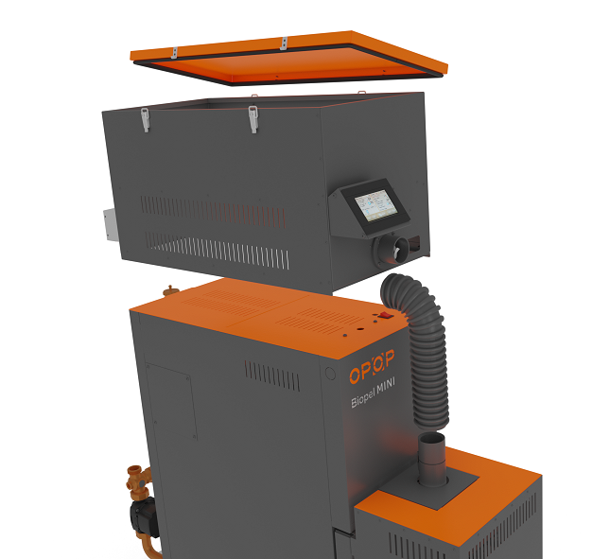

Hopper lid with seal
Feeder motor with socket

Display holder
Feeder outlet

Rear orange cover can be removed

Straight burner pipe

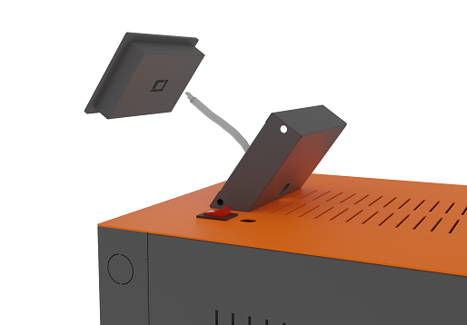
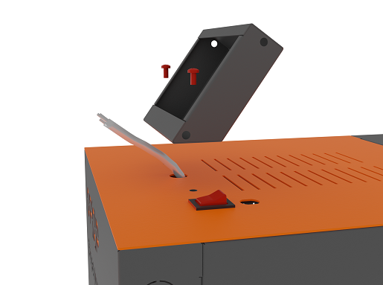

Disconnect the connector on the back of the display

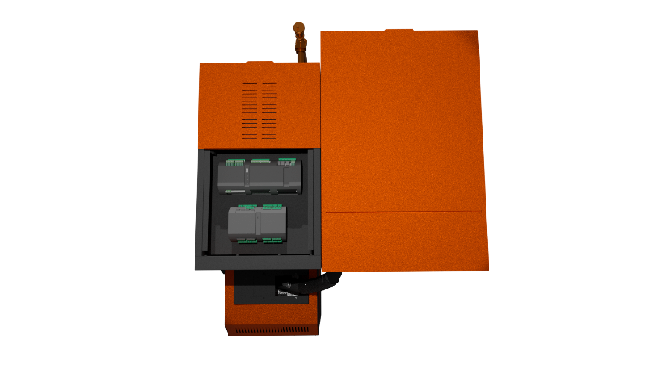
Unplug the display cable by the connector.
The feeder cable is factory coiled and laid on the boiler control unit. Access the control unit by removing the top orange cover, which is fixed to the boiler by 2 screws.
After loosening the screws, then pulling backwards and then upwards, carefully remove the orange cover and pull the feeder cable through to the rear of the boiler, as shown in the picture.
Caution! There is a switch and fuse attached to the orange boiler cover; so proceed carefully when removing the cover to avoid damaging the cable.

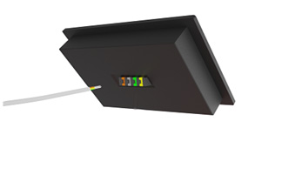
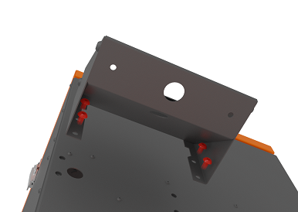

Plug in the connector on the back of the display

Fix the side walls to the display holder. Then use the 4 screws to fix the display to the Tower hopper as shown in the picture above. Pull the cable through the Tower hopper and display holder to the display itself. Screw the display cable back in using a small screwdriver according to the colours.

Caution! The orange Tower hopper lid must always be closed and secured with the 4 pull-down clips to seal during operation. Otherwise, there is a risk of flame backfiring into the hopper and damaging the PVC burner hose.
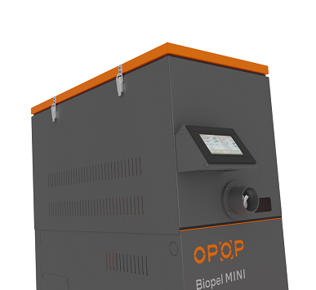
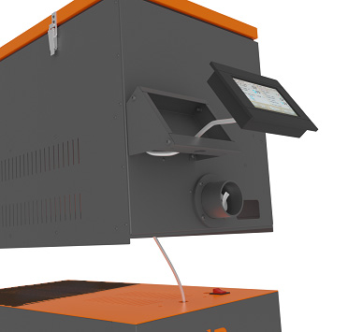
The orange lid must always be closed and secured with metal pull-down clips!
Place the display in the display holder according to the pictures above. Adjust the display cable so that the excess length is inserted under the orange boiler cover to prevent it from squeezing when positioning the Tower hopper. Place the tower hopper on the boiler so that it is aligned with the boiler, both at the front and back. Attach the PVC hose to the Tower hopper feeder outlet and secure with a quick coupling. Next, connect the feeder power cable to the back of the boiler as shown in the picture above.
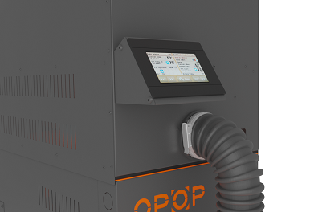
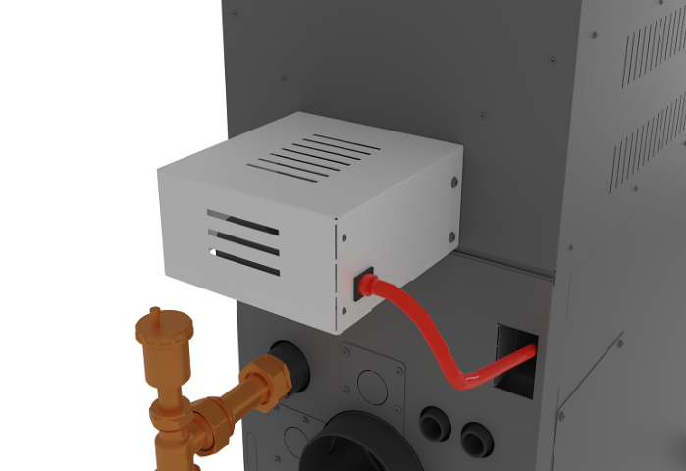
Caution! The rear orange cover on top of the boiler is removed when installing the Tower container.
The Tower hopper cleaning hole is located on both the left and right side of the hopper. Loosen the 4 screws to remove the cleaning hole cover. You can reach over the boiler cleaning door through it.
The cleaning door can be removed and the boiler exchanger can then be easily cleaned with either a vacuum cleaner or a cleaning tool. By lifting the flue gas turbulators and shaking them off, you achieve a near-perfect cleaning of all boiler exchanger components.
For complete boiler exchanger cleaning, remove the Tower container, empty pellets, and clean the boiler exchanger properly and completely every now and then.
The intervals for cleaning vary and are influenced by many factors. It is recommended to regularly clean and monitor boiler exchanger clogging through the cleaning hole. See Chapter 13, Periodic Maintenance, for more information on recommended cleaning intervals.
1
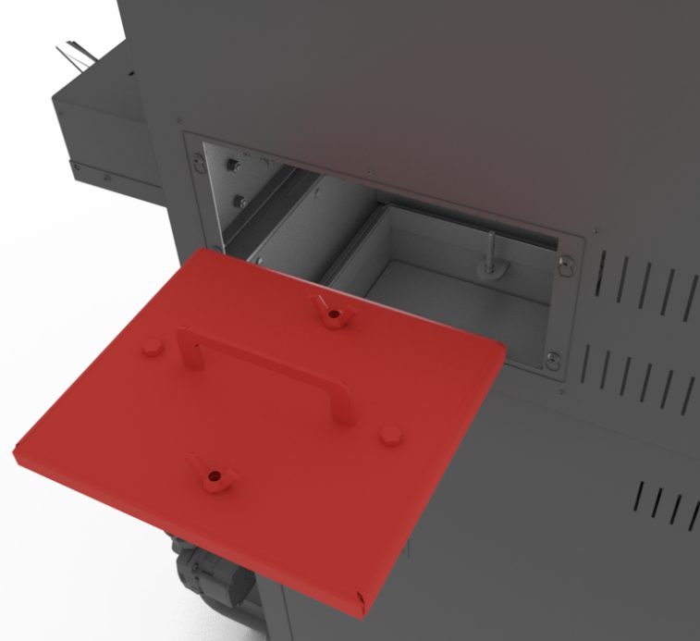
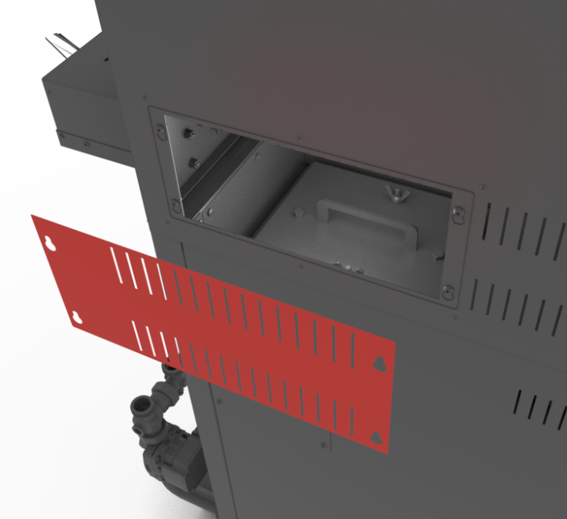
The boiler cleaning door can be removed through the cleaning opening of the Tower container
Cleaning hole cover on the sides of the Tower container

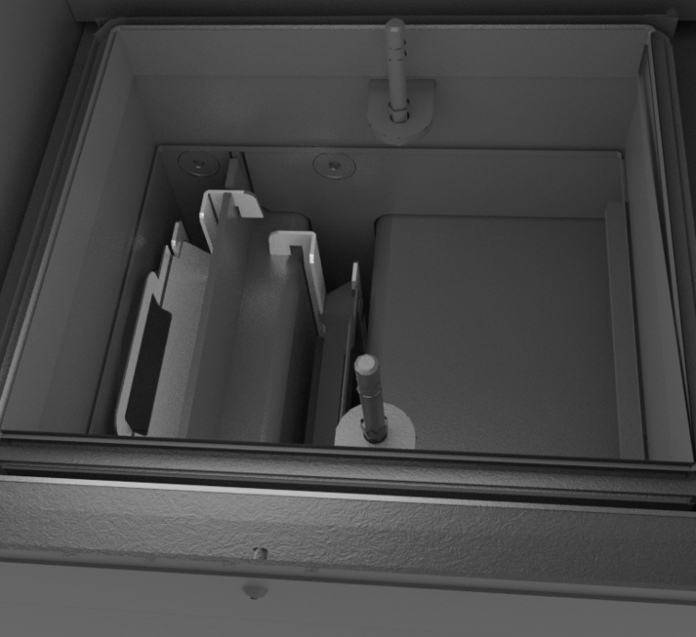
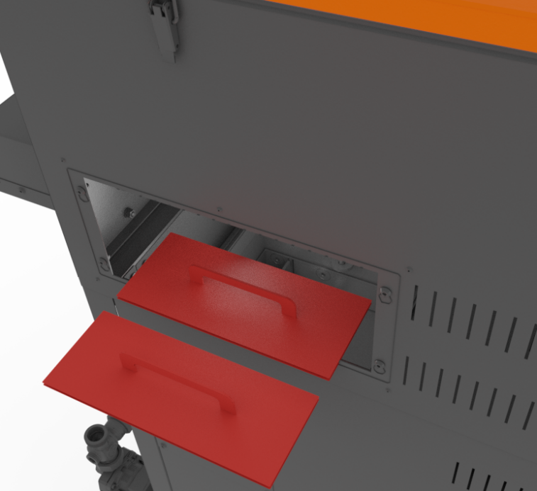
Shake off the turbulators and clean the boiler exchanger's horizontal surface
Remove the cover plates and clean the exchanger

Burner
The burner type and size always depends on the size of the Biopel MINI boiler. Therefore, installing the burner varies according to burner and boiler size. The entire installation can be summarised in the main points below:
- Unpack all the burner parts in the box.
- Install the burner flange on the burner opening on the boiler, if included. Flange type varies according to the burner size, therefore the flange installation method on the boiler varies.
- Attach the burner on the 2 burner bolts (installed on the flange or on the burner opening on the boiler) and tighten with 2 wing nuts and 2 washers. The joint must be as tight as possible. Push on the burner several times during tightening to ensure that the burner is firmly attached and that it does not move in any direction.
- Done. The burner is installed in position. If you have moved the Compact or External hopper during the burner installation, place the hopper back in its final position.
The next step is to install the external pellet feeder, if you used the External pellet hopper, then connect the feeder to the burner. Follow the steps below.

External feeder
The external feeder installation is only done in combination with the External pellet hopper. If this is your case, please follow the points below. If you have used the Compact version of the hopper, skip to the next paragraph regarding the connection of the external feeder to the burner.
- Remove the paper cover from the top of the external feeder.
- Make sure that no parts of the feeder have been damaged during handling. Check the bottom of the feeder where the worm shaft exits the PVC tube to the outside. The hole at the end of the PVC tube must not be deformed in any way. The edges of the tube opening must be horizontally aligned with the tube body, not curved inwards (towards the worm shaft). If this were the case, there would be a risk of the worm shaft getting stuck on the opening of the PVC tube and possibly jamming the feeder.
- Rotate the External hopper's bottom leg so that the opening in the leg faces towards the boiler.
- Slide the bottom end of the external feeder into the hole in the hopper leg. The hole in the bottom of the external feeder must be entirely inside the bottom leg of the external hopper's bottom leg.
- Using the chain and hook (included with the External hopper), hang the top of the external feeder by the top edge of the External hopper or by the holes in the top of the External hopper legs.
- Adjust the chain so that the external feeder is at an angle of approximately 45° from the ground. If the angle is smaller, the feeder gives more pellets than the standard, if the angle is larger, the feeder gives less pellets than the standard. If the angle is different, a combustion correction will be necessary, see chapter Combustion Correction.
The feeder must be at a 45° angle to the ground for proper fuel feeding. If not, make adequate combustion correction, see the Combustion Correction chapter.
The external feeder is placed. Connect it to the burner. This connection is made for both the external and compact versions of the hopper. Please follow the steps below:
- Place the burner pipe inside the hole in the top of the burner. DO not forget to use the sealing ring.
- Secure the burner pipe with 3 black screws.
- Connect external feeder outlet and burner pipe with PVC hose. Please note: The PVC hose must not be slack to avoid pellets becoming stuck. The pellets must fall inside the PVC hose without jamming on the way to the burner. Check the correct installation of the PVC hose during boiler operation!

Control unit
The external feeder is connected to the burner. Now we need to connect all main cables with the v12 MINI control unit. Follow the steps below:
- Remove the top cover of the boiler. It is secured with 2 screws.
- Connect 230V power cable to the socket that will supply the boiler electrically.
- Connect 230V cable from the control unit to the socket at the top of the external feeder.
- Connect burner cable with the two connectors to the sockets at the top of the burner.
The basic electrical wiring is complete. If you are connecting other devices to the control unit, use the wiring shaft on top of the boiler.
The boiler must never be operated with an open or leaking ash door. Otherwise, there is a risk of damage to the boiler's electrical components due to warm air escaping from the ash door.
A diagram of the electrical outputs in the control unit is shown on the next page. Use this diagram to connect other additional devices of your choice. Once all electrical components are connected, place the top cover back on the boiler and you can start the boiler for the first time using the main switch (red button on top of the boiler).
The installation is practically complete at this point. This is followed by the so-called First Boiler Start-up and Combustion Correction, described in the chapters First Boiler Start-up and Combustion Correction. Before proceeding to these steps, we recommend that you study the basic boiler control method and the description of the menu items in the Boiler Control Unit and Description of Control Unit Functions chapters.
Before starting the boiler for the first time, read the chapters Electrical Connection of Accessories, Control Unit and Description of Control Unit Functions.
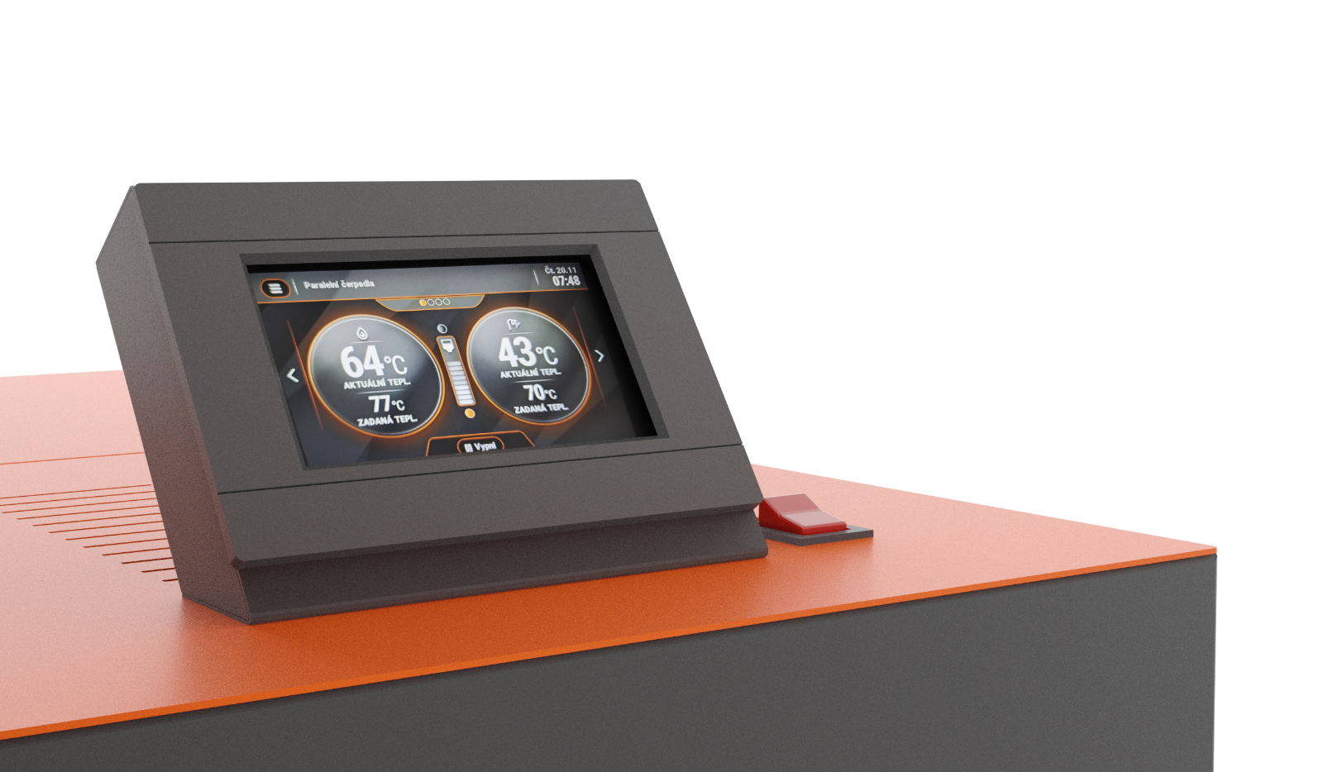
These chapters will help you to understand how to operate the boiler and the v12 MINI boiler unit. Also use these chapters for the installing accessories, which you will then activate during the boiler's first start-up and, if necessary, set-up in the Installation menu. Bear in mind that the operation of the accessories is pre-set in the Factory Setup, so just activate it and it should operate under standard conditions without problems. Settings the operation of additional devices can be changed at any time in the Installation menu.

Electrical Connection of the Unit and Accessories

SENSORS AND ROOM THERMOSTATS
1

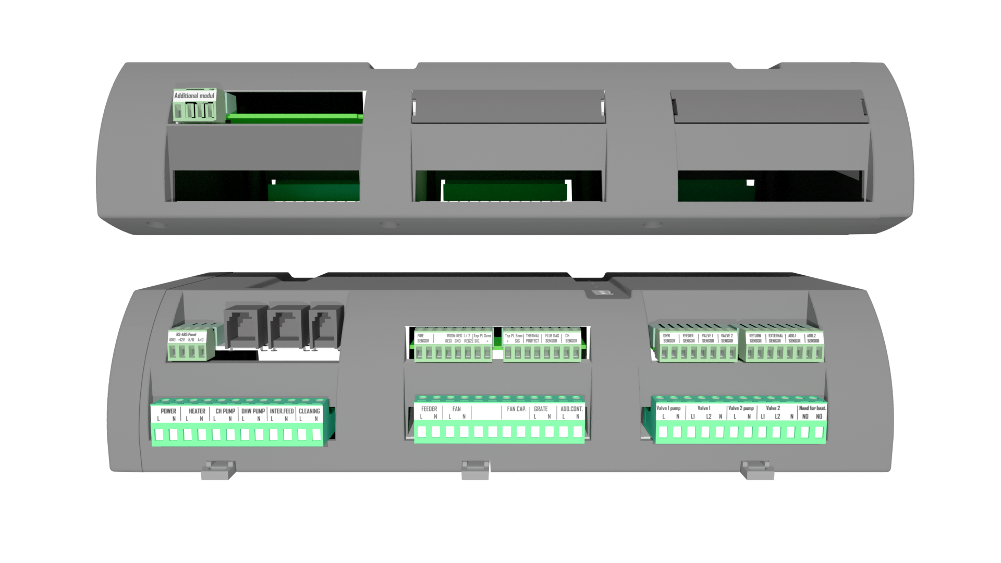

VOLTAGE OUTPUTS
2

RS INPUTS AND DISPLAY
4
ADDITIONAL MODULE
3

A detailed description of the control unit terminals can be found in the text below.
- Sensors and room thermostats
  - Fire sensor - flame sensor, detecting whether there is a fire in the boiler
  - Room reg. 1 and 2 - room thermostats ON/OFF, potential-free
  - PL Sens. - 2 pellet level sensors, lower and upper
  - Thermal protection - safety sensor against boiler overheating. Shuts down the boiler when the CH temperature exceeds 97 °C
  - Flue gas sensor - flue gas temperature sensor
  - CH sensor - central heating sensor, boiler outlet water temperature
  - DHW sensor - boiler temperature sensor for domestic hot water
  - Feeder sensor - temperature sensor on the burner. In the back of it. The temperature should not exceed 48 °C
  - Valve 1 and Valve 2 sensor - mixing valve temperature sensor
  - Return sensor - return water sensor in case the valve is activated including the reverse protection function inside it
  - External sensor - outdoor temperature sensor for equithermal control and blocking of boiler heating at set temperature
  - Add 1 and Add 2 sensor - buffer tank sensor. Add 1 upper temperature, Add 2 lower temperature

- Voltage outputs
  - Power - 230 V power supply
  - Heater - ignition cartridge for igniting pellets
  - CH pump - central heating pump on the primary circuit after the boiler
  - DHW pump - domestic hot water pump
  - Internal feeder - feeder in the burner, moving the pellets to the burner grate
  - Cleaning - outlet for cleaning the heat exchanger - for future use
  - Feeder - main pellet feeder in the pellet hopper
  - Fan - fan on the burner
  - Fan cap. - for some fans an additional capacitor is required
  - Grate - grate cleaning - for future use
  - Add. Contact - for future use
  - Valve 1 pump - mixing valve 1 pump
  - Valve 1 - electromotive mixing valve 230 V
  - Valve 2 pump - mixing valve 2 pump
  - Valve 2 - electromotive mixing valve 230 V
  - Need for heat - additional contact for switching off and starting the boiler using another heating source

- RS inputs and display
  - RS connectors - for connection of RT10 thermostat, lambda sensor, exhaust fan
  - RS 485 panel - boiler control unit display

- Additional module
  - Additional module - for connecting additional accessories, see next page.

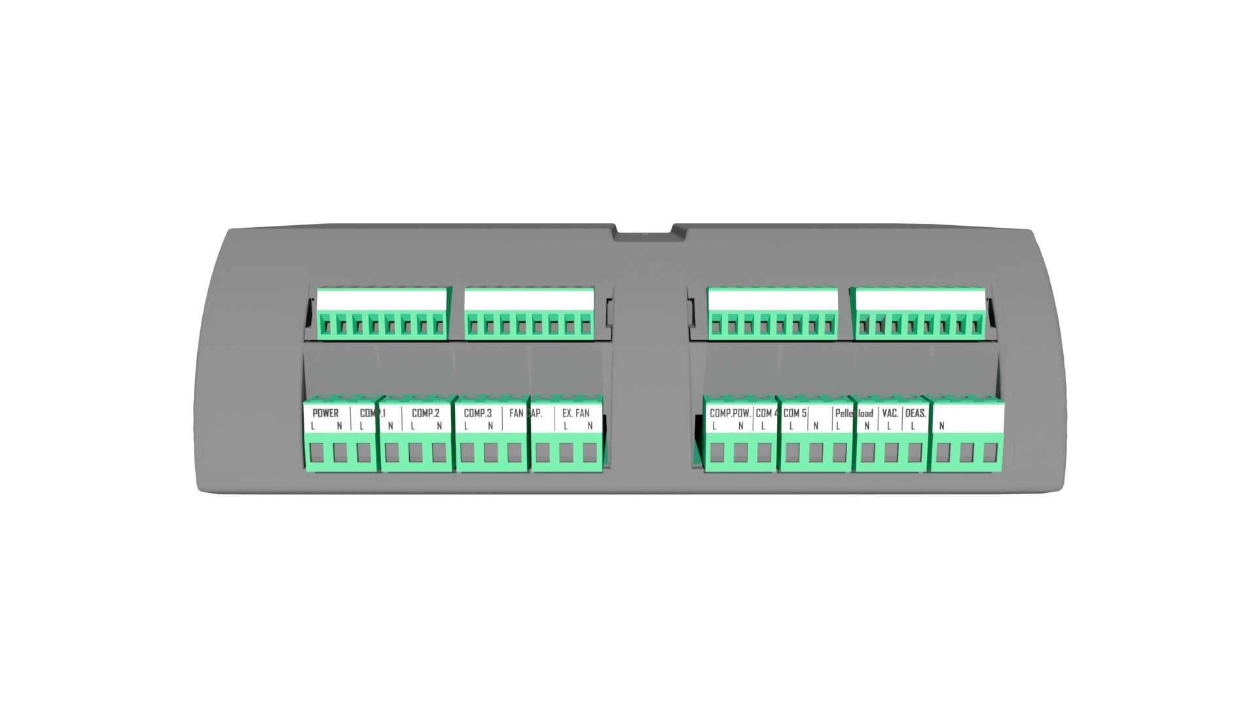

For wiring and terminals of the additional module see below in the text.
- POWER - power for 230 V additional module.
- COMP.1 / COMP.2 / COMP.3 - COMPRESSOR CLEANING - power supply for solenoid valves for compressor cleaning of burner (COMP.1) and boiler exchanger (COMP.2 / COMP.3).
- FAN CAP. - FAN CAPACITOR - additional capacitor for some types of fans
- EX. FAN - EXHAUST FAN - additional exhaust fan, which is mounted on the flue pipe after the boiler in case of very low chimney draught.
- PELLET LOAD / VAC. - PELLET VACUUM LOADER - additional device for transporting pellets from longer distances.
- COM 4 / COM 5 - COMPRESSOR CLEANING - used for cleaning the heat exchanger of 100 to 200 kW high-output boilers.
- COM. POW. - COMPRESSOR POWER - compressor power supply for compressor cleaning of burner and boiler exchanger.
- DEAS. - automatic de-ashing, extracting ash from the boiler into an external box.

You activate the additional module in the Installation menu. The main screen will then display the additional module panel, see below. Here you can see which of the additional module components are activated.

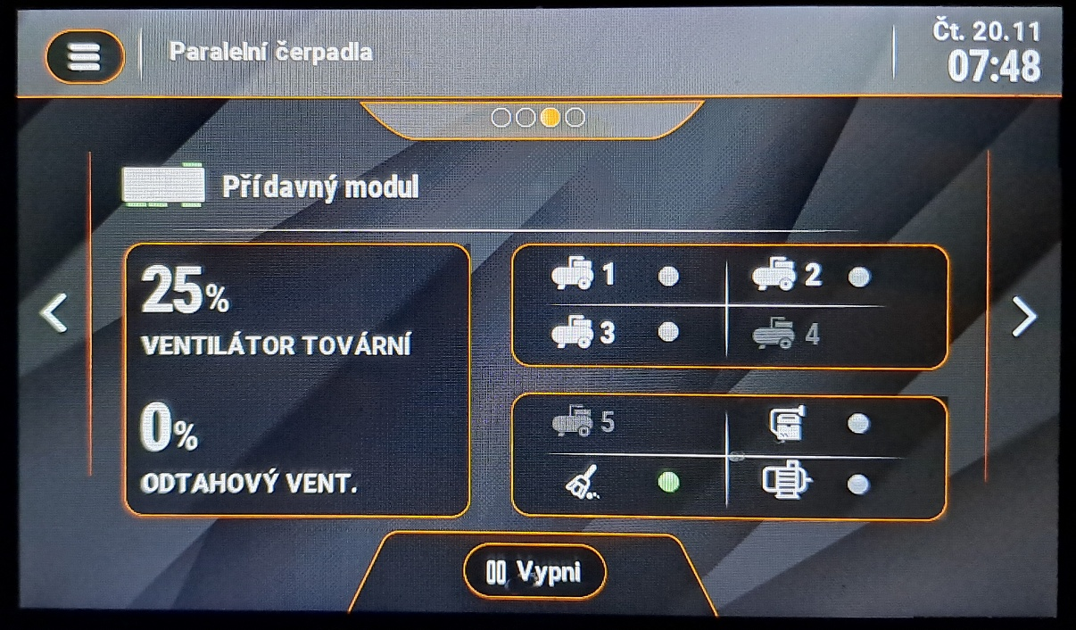

Compressor cleaning solenoid valves
Burner fan speed

Vacuum feeder
Additional exhaust fan speed
Exhaust fan

De-ashing

BOILER CONTROL UNIT
The v12 MINI boiler control unit is equipped with a high-resolution touch screen device. The display is set to high press sensitivity to ensure easy operation in boiler room environment. It is additionally protected by Plexiglass, which shields the display against damage. The display is connected by a data cable into a connector on the top of the boiler where the control unit is located. On boiler activation, i.e., when it is switched on using the main switch on the top of the boiler, the display is activated and the current software version in the display and control unit is checked. The software version numbers are displayed on the unit display together with the OPOP s.r.o. logo when the unit is started. These numbers must be identical for proper boiler operation. If they are not, the unit remains idle in the synchronisation part and it is necessary to update the SW using the USB connector on the display.
The next step is language selection which is displayed after the unit is activated for the first time. You can also change the language at any time in the unit's menu by clicking the "Language selection" button with a picture of flags. Once language is selected, we recommend to read the following chapters to familiarise yourself with the v12 MINI control unit functions.

Basic navigation
The basic navigation is intuitive thanks to the touch screen, which simplifies the whole control. Read the basic description of the boiler control unit main panel below, i.e., what you can read and control from it.
h
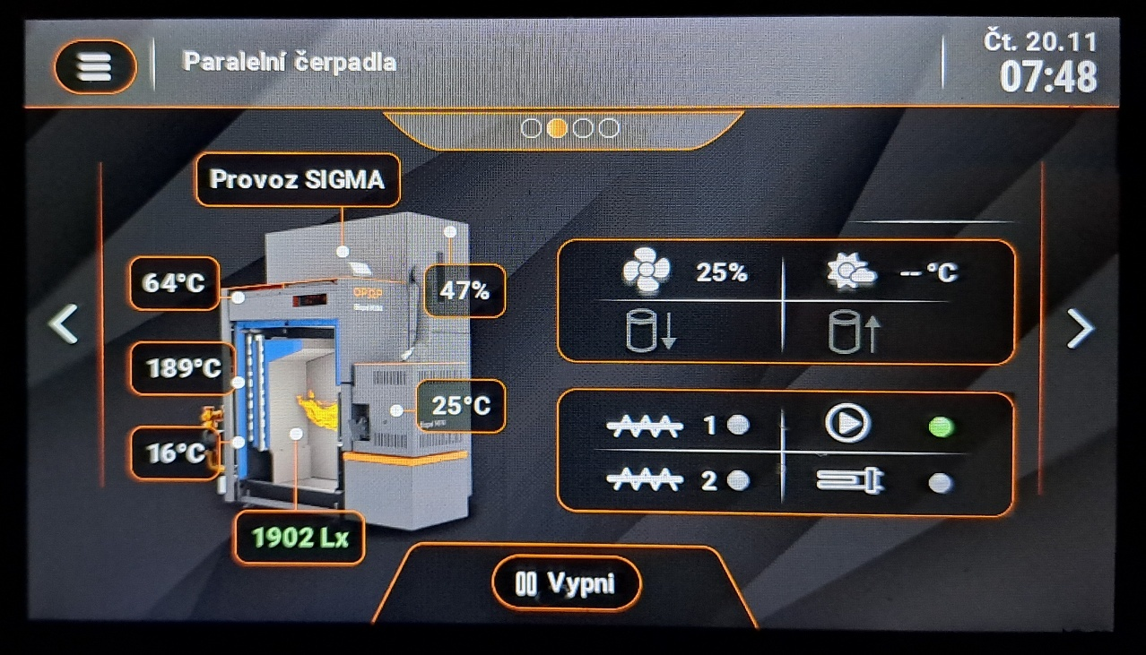
q
r
j
i
m
p
o
f
n
k
i
e
b
g
c
d
a
v12 MINI control unit main panel
- CH temperature measured by the CH sensor connected to the sink on the outlet at the back of the boiler.
- The boiler's current operating mode - Ignition, SIGMA operation or Extinction.
- Temperature of the internal feeder in the burner, normally in the range 15-55 °C.
- Flue gas temperature in the chimney
- Operating modes. Display of pump operating mode, according to the Operating Modes setting in the Main Settings.
- Outdoor temperature, measured by an outdoor sensor connected to the "Weather sens." output in the boiler external socket.
- Flame detection by photosensor.
- Current date and time entered in the Main Settings.
- Menu button, to enter the boiler unit menu.
- Change the display of the main panel to show various information about boiler operation and its accessories.
- The temperature at the burner in the back of it. It should be below 48 °C.
- The amount of fuel in the container if the pellet level sensors are connected.
- Switching the boiler off and on.
- Burner fan speed
- CH pump, i.e., the pump on the primary circuit just after the boiler.
- Ignition cartridge, igniting the pellets during Ignition.
- Main and secondary pellet feeder - in the hopper and burner.
- Buffer tank sensors - upper and lower sensor.

Basic operating modes
Biopel goes through several operating modes during its operation, which are displayed on the Main Panel. You can find more information regarding each operation mode down below, included associated messages.
Ignition: automatic ignition of pellets on the grate. Maximum time set at 12min. During this time, the boiler will go through several operating stages:
- Pre-ventilation – grate cleaning by fan, factory setting (FS) = 30s.
- Sub-base time - pellet dosing by feeders; the internal feeder in the burner works twice as long to move all the pellets to the burner grate. FS = 12 - 15s
- Fan delay - preheating igniter before starting the fan. FS = 30s
- Fan speed 1 - fan speed during the first 6 min of ignition. Fan operates at low speed to produce a flame without cooling the ignitor. FS: 3-8%
- Fan speed 2 - fan speed during the second 6 min of ignition. Maximum ignition cycle is 12min. If the pellets do not ignite during the first 6 min, the fan will increase its speed to create a flame. The standard ignition time is 3-6min. FS: 5-16%
- Ignition delay - flame has been created, photosensor detects light, followed by flame stabilisation. If the flame detection by the photosensor is stable, the boiler goes into SIGMA mode (normal operation). If the flame detection by the photosensor is not stable, the boiler remains in the Ignition phase until the flame is large enough. If the flame goes out, a second Ignition follows (for a maximum of another 12 min).
- The output of the Ignition phase can be:
  - Transition to SIGMA mode - normal boiler operation, or
  - Alarm message - Ignition error, pellets failed to ignite for some reason. The boiler tries Ignition twice before the announcement of this error condition appears. For more information, see the Operating and Error Messages chapter.
SIGMA mode: normal boiler operation, indicated by the current boiler power and fan speed in %, which correspond to the percentage of the current power. The following operational states occur in SIGMA mode:
- Min. output – the boiler starts its operation in the lower half of the power spectrum, i.e., 0-50% of the maximum power. The reason for this is to ensure that the small flame is not smothered by a large amount of pellets after ignition. FS = 1-50% of maximum output, depending on boiler type.
- Max. output – the boiler gradually increases its output up to the maximum, i.e., 100%. This can take 5 to 15 minutes, depending on boiler type. The modulation is then influenced by the set and measured CH temperature.
- SIGMA modulation - As the boiler approaches the set CH temperature, it begins to modulate output to keep the set temperature within the limit given by the factory setting in the Service menu. Boiler set temperature can be exceeded by 5°C. This is also the modulation range within which the boiler attempts to maintain the CH temperature so that it does not have to enter the Extinction phase if the set temperature is exceeded by 5 °C or more.
- The output of the ignition phase can be:
  - Transition to Extinction - Set temperature exceeded by 5°C.
  - Continuous SIGMA mode - the set CH temperature is not exceeded by 5 °C credit to downward power modulation. The boiler remains in SIGMA mode and maintains the CH temperature at the set value by up and down power modulation.
  - Switched off by thermostat - the room thermostat forces the transition from SIGMA mode to Extinction as the room temperature has been reached.
Extinction: phase that the boiler enters when warmed to the set CH temperature + 5 °C, as the room thermostat does not instruct on heating. Boiler goes through the following operating stages in the Extinction phase:
- Cleaning - first phase of extinction. Photosensor still detects flame in the boiler, so the boiler tries to burn it out by deactivating the external feeder and increasing the fan speed to 70%. This continues for a set time or until there is no more flame in the boiler.
- Cooling - After all the remaining pellets on the grate have burned out, the photosensor no longer detects the light, so the boiler goes into the second phase of extinction, which is cooling. Fan speed is 100%. The grate is cooled by the fan to prevent its deformation. The grate can only deform without fresh air supply, so the fan cools it. FS = 5-15min depending on the boiler type.
When the Extinction is finished, the unit shows "Stand by” message. This is a standby mode where the boiler waits for conditions to reactivate the Ignition phase. This situation occurs when the measured CH temperature drops by 15 °C or when the room thermostat instructs the heating.

CONTROL UNIT FUNCTIONS DESCRIPTION
This chapter presents a complete description of all functions in the v12 MINI control unit menu. This list can be used as a general introduction to the individual functions. In all functions, you will find recommended settings and a description of what each item controls and information on how the functions are interrelated.

On / Off
This function is used to activate and deactivate the boiler. If the boiler is deactivated, you will see the Ignition sign. After pressing it and confirming it, the boiler will enter the automatic pellet ignition mode. After about 5 minutes, the boiler will ignite and switch to the so-called SIGMA mode. If the boiler is activated, i.e., in SIGMA mode or Ignition mode, you will see the Extinction sign. After pressing it and confirming it, the boiler will enter the Extinction mode. The feeders stops feeding fuel and the fan increases fan speed to clean and cool the grate. This takes 5-15min, depending on burner. The boiler will then shutdown and remain deactivated until the Ignition button is pressed.

Temperature Settings
These settings contain user functions that modify the boiler operation, but do not affect its operation and the operation of accessories important for its proper function.
1. Set CH temperature | Select the central heating temperature (maximum boiler temperature). It is recommended to set it between 60-80°C. higher temperature is better for proper boiler operation and long boiler service life. | 60–80°C
2. Boiler Hysteresis | Select the boiler hysteresis, which defines when the boiler restarts after extinguishing. This means a drop in the CH temperature by a set limit at which the boiler switches on again.
3. Set DHW temperature | Select the desired domestic hot water temperature. DHW is only activated if the DHW sensor is connected to the "DHW sensor" output in the external socket and if the operating mode in the Main settings is correctly selected. | 45-70°C
4. DHW Hysteresis | Select the DHW hysteresis, i.e. at what drop in the DHW temperature against the set value the DHW pump will start heating the DHW again.
5. Set room temperature | If the RT10 thermostat is connected, you can change the desired room temperature here.
6. Outdoor temperature correction | Correction of the outdoor temperature sensor if it does not show the correct value.

Coefficients
Items to correct the flame by the fan and pellet feeder for the boiler's min. and max. output.

1. Coefficients | All corrections are factory-set to 0. The user can decrease this number (-) ; (lower fan speed or lower pellet feed) or increase this number (+) ; (higher fan speed or higher pellet feed).  The adjusted coefficients are displayed on the main panel at the power indicator (feeder coefficient) and at the fan speed indicator (fan coefficient).
1.1 Max. fan coefficient | This function is responsible for changing the fan speed during normal boiler operation. Only the maximum speed value is changed.
1.2 Min. fan coefficient | This function is responsible for changing the fan speed during normal boiler operation. Only the minimum speed value is changed.
1.3 Min. feeder coefficient | This function adjusts pellet feeding or the running time of the feeders, which is saved in the service menu. Change the feeder operating times and feeder breaks for the minimum boiler power.
1.4 Max. feeder coefficient | This function adjusts pellet feeding or the running time of the feeders, which is saved in the service menu. Change the feeder operating times and feeder breaks for maximum boiler power.

Manual operation
Here, it is possible to forcibly start all electrical components connected to the boiler, including all additional devices.

CH and DHW Mode for Pumps
Setting the activation method of the CH and DHW pumps for the needs of heating the house and hot water heating.

1. Pump operating modes | Operating mode of CH and DHW pumps connected to external socket. Select the time that pumps are to be switched on and off. Caution: CH and DHW pumps only operate in this mode if the current CH temperature is above 40 °C. This is set in the Service menu, Pump Switch-On Temperature. The activated pump is indicated on the Main Panel by an icon
1.1 House heating *¹ | Only the central heating pump is working. The pump switch-on temperature is set to 40°C. The DHW pump is deactivated.
1.2 DHW priority *² | The DHW pump is overridden by the CH pump. The moment the DHW temperature is reached - the DHW pump is deactivated and the CH pump is switched on for heating the house. The moment the DHW drops below the DHW Hysteresis - the CH pump is deactivated and the DHW pump is re-started until the DHW temperature reaches the desired value.
1.3 Parallel pumps *² | Both CH and DHW pumps operate simultaneously to heat both the house and the boiler.
1.4 Summer mode *² | Only the DHW pump is activated to heat the boiler.
1.5 CH pump summer | In case a pump is not used for DHW heating but a zone valve instead, it is necessary to ensure water circulation by means of the CH pump also for DHW heating.
*¹ Connect the CH pump into the "CH pump" output in the control unit.
*² Connect the DHW pump into the "DHW pump" output in the control unit.

Weekly Programme
Here you can run the boiler as well as DHW heating in set periods of time.

1. Boiler's weekly programme | Allows running the boiler during each hour, every day of the week.
1.1 Mode 1 (Mon-Sun) | Activates Mode 1.
1.2 Mode 2 (Mon-Fri)  (Sat-Sun) | Activates Mode 2.
1.3 Mode 1 settings | Select the desired adjustments to CH temperatures for Mode 1.
1.4 Mode 2 settings | Select the desired adjustments to CH temperatures for Mode 2.

2. Weekly DHW programme | Allows weekly adjustment of DHW temperature during each hour, every day of the week. BY + - 20°C. If one of the modes is activated, the current temperature lowering is then displayed on the Main Panel under Set CH Temperature.
2.1 Mode 1 (Mon-Sun) | Activates Mode 1.
2.2 Mode 2 (Mon-Fri)  (Sat-Sun) | Activates Mode 2.
2.3 Mode 1 settings | Select the desired adjustments to DHW temperatures for Mode 1.
2.4 Mode 2 settings | Select the desired adjustments to DHW temperatures for Mode 2.

Disinfection
If one of the DHW heating modes is activated, you can activate the so-called disinfection, which increases the boiler temperature temporarily above 70 °C to disinfect the boiler and extinguish all dangerous bacteria. Once the disinfection cycle is complete, the DHW temperature returns to its user-selected set point.

Installation menu
In the installation menu, both the installer and the user can activate and modify the operation of additional devices and also adjust the combustion process.
1. First start | Here, it is possible to forcibly start all electrical components connected to the boiler, including all additional devices.
2. Additional module | The additional module is connected to the main module and allows controlling additional devices such as compressor cleaning, de-ashing, exhaust fan and vacuum feeder.
3. Choice of operating algorithm | Select the PID or Sigma operating algorithm. The Sigma operating algorithm is standard, allowing adjustments of power modulation in the service menu.

4. Feeder calibration | Allows measuring the performance of the external feeder to automatically calculate pellet feeding relative to boiler power.  This automatically ensures that the desired amount of pellets is fed into the burner, corresponding to the actual boiler power as displayed on the unit's main panel.  This ensures easier boiler set-up. The installer then only adjusts the fan speed for ideal combustion, not the amount of fuel, which is adjusted automatically.
4.1 Fuel calorific value | It is given in MJ/kg of pellets. It has a major influence on the amount of pellets burned. Please refer to the pellet packaging or ask the pellet manufacturer for this information.
4.2 Container content | Enter the size of the pellet container. The main panel then displays how much fuel is left in the container.
4.3 Fuel weight | Enter the amount of pellets in grams, weighed using the "Start weighing" function. From this value, the boiler control unit automatically calculates the pellet dosage. Therefore, the boiler will have adequate output according to the requirement of the heating circuits.
4.4 Start weighing | Activate the external feeder for 5 min. Before activating the function, tie the bag at the external feeder outlet so that the pellets can fall into the bag. Then activate this function. The feeder will deactivate itself after 5min. Then weigh the contents of the bag on a table scale and enter the number in grams into the "Fuel weight" function and you're done.

5. Buffer tank * | Set the buffer tank heating method.
5.1 Buffer tank | In this sub-menu, activate or deactivate heating the buffer tank.
5.1.1 Off | Deactivates heating the buffer tank.
5.1.2 On | Activates heating the buffer tank.
5.2 DHW function | Activates DHW heating by means of the buffer tank.
5.2.1 From buffer tank | DHW heating is done through the buffer tank.
5.2.2 From boiler | DHW heating is done through the DHW pump.
5.3 Set temperature top | Enter the maximum temperature at the top of the buffer tank.
5.4 Set temperature bottom | Enter the maximum temperature at the bottom of the buffer tank.
* Connect the sensors for heating the buffer tank to outputs "C1" and "C2" in the control unit.

6. Valve 1, 2 | Controls the mixing valve for one heating circuit.

7. Room thermostat | Activate the selected type of room thermostat. Select the Standard Thermostat, which operates on an open/closed circuit basis, or the RT10 OPOP room thermostat. The fact that the room thermostat has been activated is indicated by the icons  An orange icon indicates that the thermostat is instructing the boiler to heat. A red icon indicates that the thermostat is not instructing the boiler to heat.
7.1 Standard Thermostat 1 *¹ | A voltage-free thermostat operating on a closed/open circuit basis. Open circuit instructs the boiler to enter the Extinction phase, i.e., commands it to stop heating. Closed circuit instructs the boiler to go into the Ignition and SIGMA operation phase, i.e., commands it to heat. The House icon on the Main Panel flashes if the circuit has been closed and the thermostat therefore instructs the heating.
7.2 Standard Thermostat 2 | A voltage-free thermostat operating on a closed/open circuit basis. Open circuit instructs the boiler to enter the Extinction phase, i.e., commands it to stop heating. Closed circuit instructs the boiler to go into the Ignition and SIGMA operation phase, i.e., commands it to heat. The House icon on the Main Panel flashes if the circuit has been closed, so the thermostat instructs the heating.
7.3 RT10 controller | RT10 room thermostat, connected to the RS output inside the external socket in the front of the boiler.

8. Internet module | Internet module allowing connection of the boiler to the OPOP online server that provides online remote management of your boiler.
8.1 Switch the module off/on | Deactivation and activation of the module.
8.2 Choosing a Wi-Fi network | Wi-fi network connection.
8.3 Registration | Get the registration number to register your boiler on the OPOP online server.

9. Burner cleaning | Activating the fan for cleaning the burner grate. The fan regularly increases its speed to clean the burner grate.
9.1 Cleaning intervals | Time between cleaning. Bigger burner / more frequent cleaning required. | 6-15min
9.2 Fan operation time | Cleaning time. Bigger burner / longer cleaning required. | 10-20s
9.3 Fan intensity | Fan speed during cleaning. Larger burner / faster speed required. Caution for high rotational speed during cleaning. High speed (especially during low boiler output) may cause extinction (no flame after cleaning). High speed may also cause unburned pellets to fall into the ashtray. If any of these situations occur, reduce the fan speed. | 50-100%.

10. Additional pump * | Activate and set the additional pump.
10.1 Device type | Select the pump type. For the purpose you will use it.

11. Potential-free contact | The potential-free contact is used to switch the boiler using an external heating source.

12. Cascade | The cascade controller is an additional module that allows control of up to 4 boilers simultaneously as though it were one. The power of each boiler is then used only when necessary. Boilers are connected to the cascade controller using RS data cable.

13. Lambda | Regulates the residual oxygen in the boiler using a lambda probe.

14. Temperature graphs | Displaying the temperature history graph for CH, DHW, flue gas and feeder temperature on the burner.

14.1 Ignition blocking | Blocks boiler start-up (defrost) if the outdoor temperature measured by the outdoor sensor is higher than the temperature set in the Set Temperature function. Please note: the outdoor sensor must be plugged in, otherwise an error message will occur.

14.1 Clock setting * | Setting the current time.
14.2 Date setting * | Setting the current date.
* Important for online functions, Boiler Weekly Programme, and for Alarm History.

15. Factory settings | Do you want to reset all settings made by the user in the installation menu to the factory values?

Service Menu
Service menu is used to set the feeder operation and fan speed in all operating states of the boiler. This menu is secured with an access code, as changes to these parameters can have a major impact on the correct boiler operation. Therefore, changes in this menu should only be made by a certified installer with a valid authorisation from OPOP s.r.o.

Language Selection
Selecting the language is easy via the custom menu in the main display menu of the v12 MINI. The first time the control unit is switched on, the display asks you to select the language. If you miss this selection (the time interval is 30s), then you can change the language to Czech at any time using this menu. In Czech, the function is called "Výběr jazyka". You can recognize it in the menu by the picture with flags. Once the language is selected, it is immediately loaded into the control unit.

FIRST BOILER START-UP
After all the boiler components and additional devices have been successfully installed, a First Start-up follows where a certified installer sets the basic data for the correct combustion process and activates the additional devices connected to the external socket. This menu is secured by an access code. The First Start-up can be found in the Installation menu of the V12 unit.
Caution: when selecting the boiler power during the first start-up, choose one of the outputs from 11 to 40 kW with the "MINI" attribute. The other powers are for older types of Biopel v9 premium.
Caution: the first start-up is carried out in the boiler's deactivated state (extinct). If you perform the First Start-up during the Ignition or SIGMA operation phase, the data entered would not be saved in the control unit's operating memory and the operation of the feeders and fan may not correspond to the values you have entered.
In the first start-up, the unit will ask you step by step for basic boiler information. After entering each item, move to the next item by pressing the Next button.
Caution:if you do not enter the data for each query within the First Start within a 30 s interval, the control unit will move to the next query after 30 s.
Therefore, review the First Start diagram on the following pages of this manual before the First Start so that you do not extend the selections inside the First Start beyond 30s. This is to protect against the unit remaining in First Start if the installer stops operating it for a longer time.
For clarity, use during the first start-up the information in the Description of Control Unit Functions and Electrical Connection of Accessories chapters, as well as the First Start diagram provided on the following pages of the manual.
- Enter the current time and date - for the boiler's online functions and timed start-up, and for correct alarm history display.
- Burner power - correct burner selection will set the feeder operating times and fan speeds adequately to the size of your boiler and burner. Caution: only enter the burner power as shown on the label on the side of the burner. Entering the wrong power may damage the burner or boiler!
- Filling the external feeder. Start the feeder so that it fills with pellets. Deactivate the feeder the moment pellets start falling from the feeder into the burner.
- Setting the CH temperature and modulation range - CH temperature, i.e., the boiler output temperature, should be as high as possible, preferably between 65 and 80 °C. The following is the activation of pumps if they are connected to the external socket to the outputs "CH pump" or "DHW pump". Caution: for the DHW pump, it is necessary to connect a temperature sensor to the "DHW sensor" output in the external socket of the boiler, otherwise the control unit will announce an alarm when the pump is activated.
- Setting the CH hysteresis - by default 15°C. This is the drop in the boiler's CH temperature at which the boiler is reactivated if the CH temperature was reached in the previous period.
- CH temperature above - by default 5°C. This is the temperature by which the boiler can exceeded the set CH temperature before it switches off.
- Connecting the additional devices in the following order:
  - Room thermostat - standard (voltage-free, connected to outputs "Room reg. 1" or "Room reg. 2") or RT10 (OPOP controller, connected to RS data output in external socket).
  - Lambda probe - connected to the RS data output. The pre-set values can be changed in the Installation menu.
  - Compressor 1,2, 3 - connected to "Komp1" or "Komp2" or "Komp3” output. By default, burner cleaning is connected to "Komp1" output and boiler cleaning to the other 2 outputs. However, these can be changed at any time in the compressor cleaning settings in the Installation menu.
  - Vacuum feeder, Automatic de-ashing, Exhaust fan - connect these accessories to the "Vacuum", "De-ashing" outputs, RS data output.
- Connecting mixing valves 1,2 - to outputs "Valve1" or "Valve2". Caution: when activating the valves, it is also necessary to connect the valve sensors to the "Valve1 sens.”or "Valve2 sens." outputs, otherwise an alarm message will occur. Connect any valve pumps to the "Valve1 pump" or "Valve2 pump" outputs and activate them directly in the Built-in Valves 1 or 2 settings in the Installation menu.
- The following part presents a general introduction to boiler operation and maintenance. Do not forget to familiarise the customer with how to operate and maintain the boiler.
- At the end of the First Start-up, you can activate the boiler and put it into Automatic Ignition, or you can leave the boiler deactivated and carry out further installation work. You can activate the boiler at any time via the Ignition button in the unit menu. Caution: if a room thermostat is connected, make sure it is set to heating to instruct the boiler to heat. Otherwise, the boiler will not be activated when you press Ignition.
The first start-up of the boiler is done. You can change most of the options again at any time after the First Start-up is complete in the Main or Installation menus.
In the case of a non-standard installation with a different external feeder than specified, a different chimney draft than specified, etc., we recommend that you measure the external feeder power before starting the boiler, see the Combustion Correction, Non-Standard Installations sections.

When the boiler is activated by pressing Ignition in the unit menu, the pellets will ignite and the boiler will go into SIGMA operation. This is followed by Combustion Correction if the combustion process is not optimal, see the following chapter.
Therefore, the boiler's first start-up of the boiler is complete. Your selections have been saved in the operating memory of the v12 MINI control unit. If you are unsure about any of the settings, you can perform the First Start-up again at any time in the future. Keep in mind, however, that for proper memory storage, you must always perform the First Start-up in the deactivated (extinct) state of the boiler, not in the Ignition or SIGMA operation mode. After activating the Ignition, wait for the boiler to ignite the pellets and enter into SIGMA operation. The moment its output in SIGMA operation is equal to 100%, you can start the manual Combustion Correction. If you have connected and activated the lambda probe, the combustion correction is automatic. Continue with the combustion setting directly in the Installation menu, Lambda Sensor, according to the lambda probe manual. Always visually check the quality of the combustion process when correcting combustion.

COMBUSTION CORRECTION
After activating the boiler (Ignition), wait until the igniter ignites the pellets and the boiler goes into SIGMA operation. In SIGMA operation, wait a few minutes until the main panel displays the maximum power in kW (set during First Start-up) and 100% fan speed. At this point, the boiler is operating at full power. Open the ash door carefully and check the combustion quality, flame parameters. In case they are not ideal, perform the correction as described below. We recommend checking the combustion quality continuously, in case of a change in the chimney draft or the pellet type and quality, make the combustion adjustment again. In the case of installing lambda sensor, this correction is carried out automatically.
Caution: when the boiler is in operation and firing, never open the front ash door more than 2-3 cm. There is a flame in the boiler and it would flare out of the boiler if opened more. Always close the door after checking the flame so that no flue gas can escape into the room.

Flame quality
By checking the flame coming out of the burner, you can determine quite reliably whether the combustion process is optimal or whether a correction is necessary. Examples of good and bad combustion are given below.
Ideal flame at 100% power:
- The maximum length depends on the burner type (may be affected by chimney draft and pellet type).
  - Boiler 10-15kW = approx. 25 - 30cm from the end of the grate
  - Boiler 20-40kW = approx. 35 - 45cm from the end of the grate
- Yellow-orange colour, unburnt pellets do not fall from the grate, only fine ash in the ashtray.
Incorrect flame at 100% power:
- Maximum flame length is less than or greater than the above.
- Light yellow colour (too much combustion air) or dark orange to red (not enough combustion air).
- Unburnt pellets falling into the ashtray, dark smoke coming out of the chimney.

Change fan speed
To change the fan speed at boiler min. and max. output, use the Fan Min. and Max. Coefficient function in the Installation menu, Coefficients. Make the correction if the flame has the following parameters:

Downward correction (minus values):
- Flame is too aggressive and spits.
- Fan is dropping unburned pellets
- Flame is small and aggressive

Upward correction (plus values):
- Flame is slow and dark
- The grate is clogged with black ash
- Flame is too big and smokes black

Change external feeder operating time
If the correction of the combustion process by means of the fan is not enough, you can proceed to the correction of the feeder operation time, i.e., to adjusting the fuel quantity. Keep in mind that this correction directly affects the maximum and minimum boiler power. The correction can be made using the Max. and Min. Feeder Coefficient in the Installation menu, Coefficients.

Downward correction (minus values):
- The grate is excessively clogged with black ash
- Flame is too big and smokes black
- Flue gas temperature is higher than recommended

Upward correction (plus values):
- Boiler is unable to adequately heat the CH temperature
- Flame is too small and too aggressive
- Flue gas temperature is lower than recommended
After each correction, let the flame settle for a few minutes and check the change in the flame after your correction. If you are not satisfied, perform the correction again. Keep in mind that the boiler power must be stable at the Max or Min value to adequately adjust the Min and Max corrections and see the real result on the flame. Otherwise, the flame will be affected by the SIGMA modulation and will not match the min or max power value.
In the case of a non-standard installation with a different external feeder than specified, a different chimney draft than specified, etc., we recommend that you measure the external feeder power before starting the boiler, see the Combustion Correction, Non-Standard Installations sections.

Non-standard installations
If the boiler configuration is non-standard, i.e., basic instructions are not followed during installation such as:
- External feeder type (feeder speed) for adequate boiler type. Each boiler has an unmistakable External Feeder type with the correct motor speed.
- 45° angle of the External Feeder from the ground
- Chimney draft 15Pa
- Size and type of pellets
We then recommend that you measure the External Feeder power before starting the boiler. This will determine if your feeder is feeding an adequate amount of pellets for the boiler's maximum power in case of your particular installation configuration. The procedure for determining the External Feeder power is as follows:
- With the boiler in the deactivated (extinct) state, disconnect the PVC hose from the burner pipe and, on the other top side, from the external feeder outlet.
- Attach a plastic bag to the outlet of the External Feeder into which the pellets will fall.
- Start the external feeder in the Installation menu, Manual Operation, Feeder. Keep it running for 5 minutes.
- After this time, the bag will be filled with pellets that the external feeder is able to deliver to the burner in 5 minutes.
- Weigh the bag of pellets on a carry-on scale. The value in grams you get is determined by the speed of the external feeder, its inclination from the ground (45° recommended), pellet size (6-8 mm), amount of dust in pellets, etc.
- Enter this weighted number into the Feeder Calibration - Pellet Quantity function, in the Installation menu.

Bear in mind that we recommend calculating the external feeder power only in the case of a non-standard installation.
If using the standard recommendations for feeder installation, pellet type and chimney draft, you can skip this sub-chapter and correct the flame when the boiler is operating using the points explained in the Change Fan Speed and Change External Feeder Operating Time chapters, found on previous page.
Caution: if you perform a feeder correction, you will change the amount of pellets dosed by the feeder for max. and min. output. Therefore, it is therefore necessary to check the combustion quality and then adjust the fan speed in the Coefficients function so that combustion at the new amount of pellets is ideal, without smoke.

HEATING SYSTEM CONTROL
Below you will find the most common examples of heating system connections with the Biopel MINI boiler. In addition, a detailed procedure for the electrical connection and activation of the heating system control elements to the boiler control unit is always given on the following page.

One CH circuit + DHW

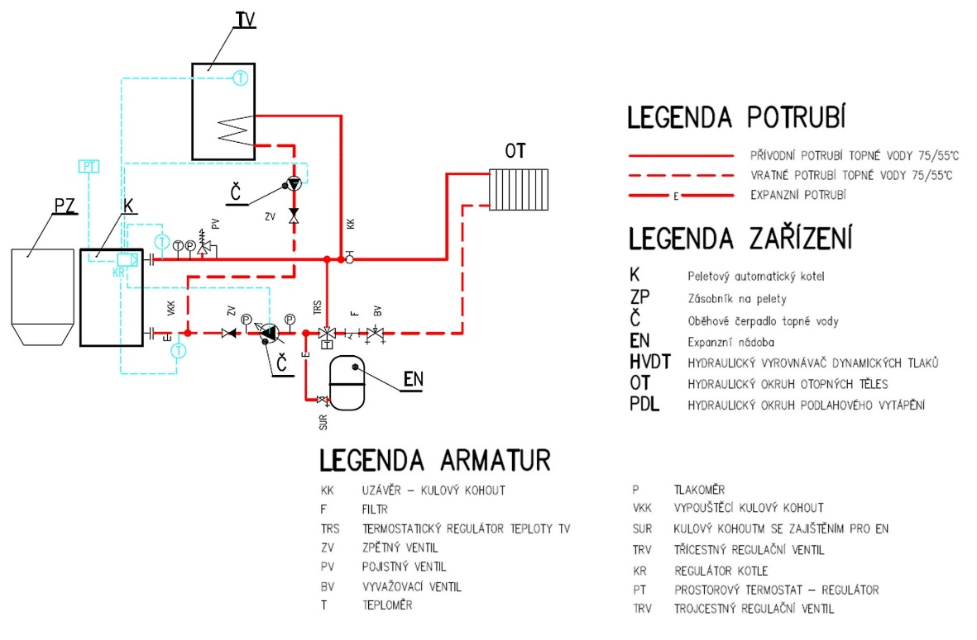
P PRESSURE GAUGE
VKK DRAIN BALL VALVE
SUR BALL VALVE WITH LOCK FOR EN
TRV THREE-WAY CONTROL VALVE
KR BOILER REGULATOR
PT SPACE THERMOSTAT - REGULATOR
TRV THREE-WAY CONTROL VALVE
KK CAP - BALL VALVE
F FILTER
TRS THERMOSTATIC TEMPERATURE TV REGULATOR
ZV CHECK VALVE
PV SAFETY VALVE
BV BALANCE VALVE
T THERMOMETER
FITTING LEGEND
PIPES LEGEND
K Automatic pellet boiler
ZP Pellet container
Č Heating water circulation pump
EN Expansion vessel
HVDT HYDRAULIC DYNAMIC PRESSURE REGULATOR
OT HYDRAULIC CIRCUIT FOR HEATING ELEMENTS
PDL HYDRAULIC CIRCUIT FOR FLOOR HEATING

DEVICE LEGEND
75/55°C HEATING WATER SUPPLY PIPE
75/55°C HEATING WATER RETURN PIPE
EXPANSION PIPE
Basic connection with one central heating circuit (controlled by CH pump) and one domestic hot water circuit (controlled by DHW pump):
- Protection of the boiler against low temperature corrosion by a thermostatic valve (50°C and above).
- Boiler regulation according to CH set temperature (60°C and above) and DHW set temperature (according to customer requirement).
- All control elements and accessories are connected to the control unit located at the front of the boiler.

- Connect the CH pump to the control unit at the CH pump output.
- Connect the DHW pump to the control unit at the DHW pump output.
- Connect the DHW sensor to the DHW sensor output of the control unit.
- Set the CH temperature in the Main Settings, Set CH Temperature.
- Set the DHW temperature in the Main Settings, Set DHW Temperature.

- Activate DHW Priority in Basic Settings, Operating Mode.
- The boiler will heat the DHW tank as the priority according to the set temperature (the DHW pump will be switched on first until the DHW tank is heated to the set temperature).
- Note that the DHW pump will only be switched on if the current measured CH temperature is higher than the current measured DHW temperature. This is to ensure that no colder water than the actual DHW boiler temperature enters the DHW boiler.
- When the set DHW temperature is reached, the DHW pump is switched off and the CH pump is activated at the same time to ensure water circulation in the heating system.
- The CH and DHW pumps will be switched on if the CH temperature exceeds 40 °C. Set in the Service menu, Pump Switch-on Temperature.
- The DHW pump will be switched on again after heating the DHW when the DHW temperature drops by the value set in DHW Hysteresis in the Service menu. The moment the DHW pump switches on, the CH pump switches off.
- Connect the room thermostat to the control unit, to the outputs of Room controller 1 or 2 (room thermostat), or to the RS output - depending on the type of thermostat selected. RT10 room thermostat is connected to the RS output. Standard thermostat operating on an open/closed circuit basis is connected to one of the Room Controller 1 or 2 outputs.
- Activate the room thermostat in the Installation menu, Room Thermostat - Standard Thermostat 1 or 2, or OPOP Controller (RT10 type) depending on the type of thermostat you are using.
- Set the boiler response type to instruction from the thermostat. The thermostat can turn the boilers off/on immediately, or it can lower the set CH temperature if the thermostat detects the room temperature has warmed to the set value:
P PRESSURE GAUGE
VKK DRAIN BALL VALVE
SUR BALL VALVE WITH LOCK FOR EN
TRV THREE-WAY CONTROL VALVE
KR BOILER REGULATOR
PT SPACE THERMOSTAT - REGULATOR
TRV THREE-WAY CONTROL VALVE
KK CAP - BALL VALVE
F FILTER
TRS THERMOSTATIC TEMPERATURE TV REGULATOR
ZV CHECK VALVE
PV SAFETY VALVE
BV BALANCE VALVE
T THERMOMETER
FITTING LEGEND
PIPES LEGEND
K Automatic pellet boiler
ZP Pellet container
Č Heating water circulation pump
EN Expansion vessel
HVDT HYDRAULIC DYNAMIC PRESSURE REGULATOR
OT HYDRAULIC CIRCUIT FOR HEATING ELEMENTS
PDL HYDRAULIC CIRCUIT FOR FLOOR HEATING

DEVICE LEGEND
75/55°C HEATING WATER SUPPLY PIPE
75/55°C HEATING WATER RETURN PIPE
EXPANSION PIPE

  - Immediate switching off/on of the boiler by the thermostat:
    - Activate the Ignition function in the Installation menu, Room Thermostat.
    - If you want to switch off the CH pump together with the boiler, activate the CH Pump - Room Thermostat function in the Installation menu, Room Thermostat. Beware of the possibility of overheating the boiler if the pump is switched off together with the boiler!

  - Lowering the CH set temperature using the thermostat:
    - Deactivate the Ignition function in the Installation menu, Room Thermostat.
    - Set the lowering level of the set CH temperature in case the thermostat does not give a heating instruction in the Temperature Lowering by Thermostat function in the Installation menu, Room Thermostat.
    - The value by which the set CH temperature has just been lowered (in case the room thermostat is not currently giving a heating instruction) will be displayed on the Main Panel, under Set CH Temperature.
    - This regulation method is particularly advantageous for heating systems with large amount of water, where lowering the set CH temperature will ensure that the system is then heated to the required level more quickly without the system cooling down. Otherwise, it would take a long time for the cooled water in the system to heat up again.

- The boiler will heat the DHW even if there is no requirement for central heating from the room thermostat.

Two CH circuit + DHW

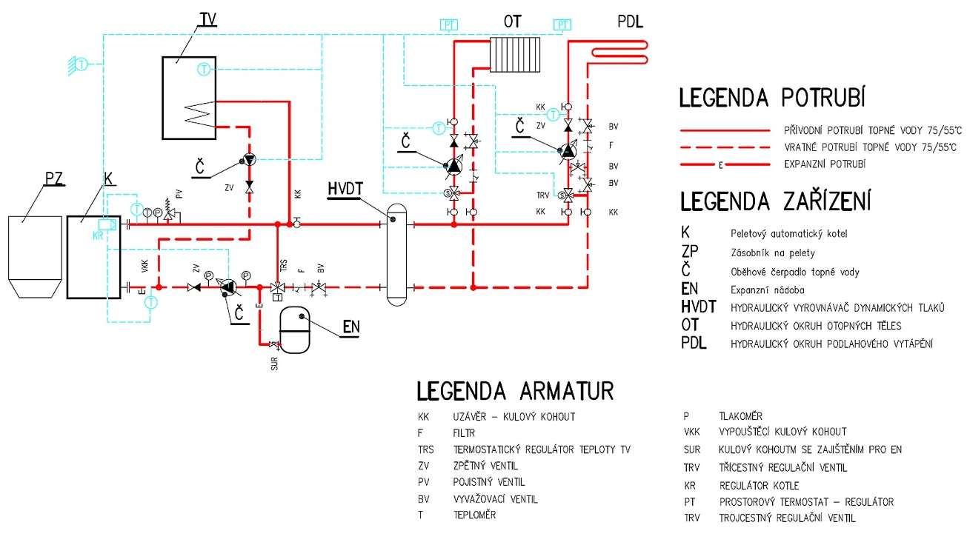
P PRESSURE GAUGE
VKK DRAIN BALL VALVE
SUR BALL VALVE WITH LOCK FOR EN
TRV THREE-WAY CONTROL VALVE
KR BOILER REGULATOR
PT SPACE THERMOSTAT - REGULATOR
TRV THREE-WAY CONTROL VALVE
KK CAP - BALL VALVE
F FILTER
TRS THERMOSTATIC TEMPERATURE TV REGULATOR
ZV CHECK VALVE
PV SAFETY VALVE
BV BALANCE VALVE
T THERMOMETER
FITTING LEGEND
PIPES LEGEND
K Automatic pellet boiler
ZP Pellet container
Č Heating water circulation pump
EN Expansion vessel
HVDT HYDRAULIC DYNAMIC PRESSURE REGULATOR
OT HYDRAULIC CIRCUIT FOR HEATING ELEMENTS
PDL HYDRAULIC CIRCUIT FOR FLOOR HEATING

DEVICE LEGEND
75/55°C HEATING WATER SUPPLY PIPE
75/55°C HEATING WATER RETURN PIPE
EXPANSION PIPE
Connection with two central and floor heating circuits (controlled by mixing valve 1, 2 and valve pump 1, 2) and a domestic hot water circuit (controlled by DHW pump):
- Protection of the boiler against low temperature corrosion by a thermostatic valve (50°C and above).
- Boiler regulation according to CH set temperature (60°C and above) and DHW set temperature and floor heating (according to customer requirement).
- All control elements and accessories are connected to the control unit located at the front of the boiler.

Connecting pumps:
  - Connect the CH pump to the control unit at the CH pump output.
  - Connect the DHW pump to the control unit at the DHW pump output.
  - Connect the Valve1 pump (OT) to the control unit at the output of the Valve1 pump (OT pump, radiators).
  - Connect the Valve2 pump (PDL) to the control unit at the output of the Valve2 pump (PDL pump, floor heating).

Connecting temperature sensors:
  - Connect the DHW sensor to the DHW sensor output of the control unit.
  - Connect the Valve1 sensor (OT) to the control unit at the Valve1 sensor ("Valve1 sens.") output.
  - Connect the Valve2 sensor (PDL) to the control unit at the Valve2 sensor ("Valve2 sens.") output.
  - Connect the Return Water sensor to the return (inlet) water pipe to the boiler and control unit at the Return sensor ("Return sens.") output.
  - Connect the Outdoor Temperature sensor to the control unit to the Weather sensor ("Weather sens.", outdoor sensor) output.
  - Check the correct wiring of the CH temperature sensor, which is in the sink on the boiler outlet water funnel.

Connecting mixing valves:
  - Connect Valve1 (OT) to the control unit at the Valve1 output.
  - Connect Valve2 (PDL) to the control unit at the Valve2 output.

Connect room thermostats to OT and PDL circuits:
  - It is necessary to connect 2 thermostats to control each circuit. These thermostats will work in conjunction with the mixing valves and will control the temperature at these valves as required by the thermostat.
  - Connect the room thermostats to the control unit, to the outputs of Room controller 1 or 2 (room thermostat), or to the RS output - depending on the type of thermostat selected. RT10 room thermostat is connected to the RS output. Standard thermostat operating on an open/closed circuit basis is connected to one of the Room Controller 1 or 2 outputs.

Basic parameter settings:
  - Set the CH temperature in the Main Settings, Set CH Temperature.
  - Set the DHW temperature in the Main Settings, Set DHW Temperature.

DHW heating activation:
  - Activate DHW Priority in Basic Settings, Operating Mode. The DHW pump will be activated independently of the heating of the OT and PDL circuits, according to the set DHW temperature. The DHW hysteresis is set in the service menu to 10 °C and can be changed at any time.
  - On the Main Panel, top left, the DHW priority message is now displayed.
  - Note that the DHW pump will only be switched on if the current measured CH temperature is higher than the current measured DHW temperature. This is to ensure that no colder water than the actual DHW boiler temperature enters the DHW boiler.
  - When the set DHW temperature is reached, the DHW pump is switched off and the CH pump is activated at the same time to ensure water circulation in the heating system.
  - The CH and DHW pumps will be switched on if the CH temperature exceeds 40 °C. Set in the Service menu, Pump Switch-on Temperature.
  - The DHW pump will be switched on again after heating the DHW when the DHW temperature drops by the value set in DHW Hysteresis in the Service menu. The moment the DHW pump switches on, the CH pump switches off.
Then follows the activation of the mixing valves and room thermostats for each of the heated circuits. Continue as described on the next page.
Activation and setting mixing valve 1 (OT):
  - Activate Valve1 (OT) in the Installation menu, Built-in Valve 1.
  - Set the desired temperature on the valve in the Installation menu, Built-in Valve 1, Valve Temperature.
  - The valve will now maintain this temperature. If the temperature is reached, the valve will close. The opening is factory-set to the minimum of 5%. This means the valve will always be 5% open to ensure water flow in the system. This setting can be changed.

Activation and setting mixing valve 2 (PDL):
  - Activate Valve2 (PDL) in the Installation menu, Built-in Valve 2.
  - Set the valve type to floor valve in Installation menu, Built-in Valve 2, Valve Type, Floor. The maximum adjustable temperature on the valve is now lowered to max. 55°C to avoid destroying the floor heating circuit.
  - Set the desired temperature on the valve in the Installation menu, Built-in Valve 2, Valve Temperature.
  - The valve will now maintain this temperature. If the temperature is reached, the valve will close. The opening is factory-set to the minimum of 5%. This means the valve will always be 5% open to ensure water flow in the system. This setting can be changed.

Activation and setting of room thermostats to control mixing valves:
- Connect the room thermostat to the control unit, to the outputs of Room controller 1 or 2 (room thermostat), or to the RS output - depending on the type of thermostat selected. RT10 room thermostat is connected to the RS output. Standard thermostat operating on an open/closed circuit basis is connected to one of the Room Controller 1 or 2 outputs.
- Activate the room thermostat in the Installation menu, Room Thermostat - Standard Thermostat 1 or 2, or OPOP Controller (RT10 type) depending on the type of thermostat you are using.

- Set the boiler response type to instruction from the thermostat. The thermostat can turn the boilers off/on immediately, or it can lower the set CH temperature if the thermostat detects the room temperature has warmed to the set value:

  - Immediate switching off/on of the boiler by the thermostat:
    - Activate the Ignition function in the Installation menu, Room Thermostat.
    - If you want to switch off the CH pump together with the boiler, activate the CH Pump - Room Thermostat function in the Installation menu, Room Thermostat. Beware of the possibility of overheating the boiler if the pump is switched off together with the boiler!

  - Lowering the CH set temperature using the thermostat:
    - Deactivate the Ignition function in the Installation menu, Room Thermostat.
    - Set the lowering level of the set CH temperature in case the thermostat does not give a heating instruction in the Temperature Lowering by Thermostat function in the Installation menu, Room Thermostat.
    - The value by which the set CH temperature has just been lowered (in case the room thermostat is not currently giving a heating instruction) will be displayed on the Main Panel, under Set CH Temperature.
    - This regulation method is particularly advantageous for heating systems with large amount of water, where lowering the set CH temperature will ensure that the system is then heated to the required level more quickly without the system cooling down. Otherwise, it would take a long time for the cooled water in the system to heat up again.

- The boiler will heat the DHW even if there is no requirement for central heating from the room thermostat.

One CH Circuit with 4-Way Valve + DHW
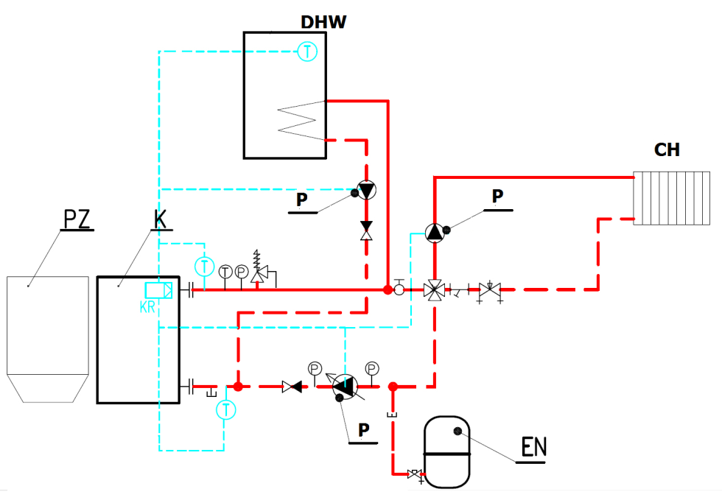

Connection with one central heating circuit (controlled by mixing valve 1 and valve 1 pump) and a domestic hot water circuit (controlled by DHW pump):
- Boiler regulation according to CH set temperature (60°C and above) and DHW set temperature and floor heating (according to customer requirement).
- All control elements and accessories are connected to the external socket, located in the front of the boiler.

Connecting pumps:
  - Connect the CH pump to the control unit at the CH pump output.
  - Connect the DHW pump to the control unit at the DHW pump output.
  - Connect the Valve1 pump (OT) to the control unit at the output of the Valve1 pump (OT pump, radiators).

Connecting temperature sensors:
  - Connect the DHW sensor to the DHW sensor output of the control unit.
  - Connect the Valve1 sensor (OT) to the control unit at the Valve1 sensor ("Valve1 sens.") output.
  - Connect the Return Water sensor to the return (inlet) water pipe to the boiler and control unit at the Return sensor ("Return sens.") output.
  - Connect the Outdoor Temperature sensor to the control unit to the Weather sensor ("Weather sens.", outdoor sensor) output.
  - Check the correct wiring of the CH temperature sensor, which is in the sink on the boiler outlet water funnel.

Connecting mixing valves:
  - Connect Valve1 (OT) to the control unit at the Valve1 output.

Basic parameter settings:
  - Set the CH temperature in the Main Settings, Set CH Temperature.
  - Set the DHW temperature in the Main Settings, Set DHW Temperature.

DHW heating activation:
  - Activate DHW Priority in Basic Settings, Operating Mode. The DHW pump will be activated independently of the heating of the OT and PDL circuits, according to the set DHW temperature. The DHW hysteresis is set in the service menu to 10 °C and can be changed at any time.
  - On the Main Panel, top left, the DHW priority message is now displayed.
  - Note that the DHW pump will only be switched on if the current measured CH temperature is higher than the current measured DHW temperature. This is to ensure that no colder water than the actual DHW boiler temperature enters the DHW boiler.
  - When the set DHW temperature is reached, the DHW pump is switched off and the CH pump is activated at the same time to ensure water circulation in the heating system.
  - The CH and DHW pumps will be switched on if the CH temperature exceeds 40 °C. Set in the Service menu, Pump Switch-on Temperature.
  - The DHW pump will be switched on again after heating the DHW when the DHW temperature drops by the value set in DHW Hysteresis in the Service menu. The moment the DHW pump switches on, the CH pump switches off.
Next, the mixing valve is activated. Continue as described below.
Activation and setting mixing valve 1 (OT):
  - Activate Valve1 (OT) in the Installation menu, Built-in Valve 1.
  - Set the desired temperature on the valve in the Installation menu, Built-in Valve 1, Valve Temperature.
  - The valve will now maintain this temperature. If the temperature is reached, the valve will close. The opening is factory-set to the minimum of 5%. This means the valve will always be 5% open to ensure water flow in the system. This setting can be changed.
  - Set the minimum return water temperature in the Installation menu, Built-in Valve 1, Return Water Protection. The minimum return water temperature is recommended by the boiler manufacturer at 55°C.

One CH Circuit with 4-Way Valve and Buffer Tank + DHW

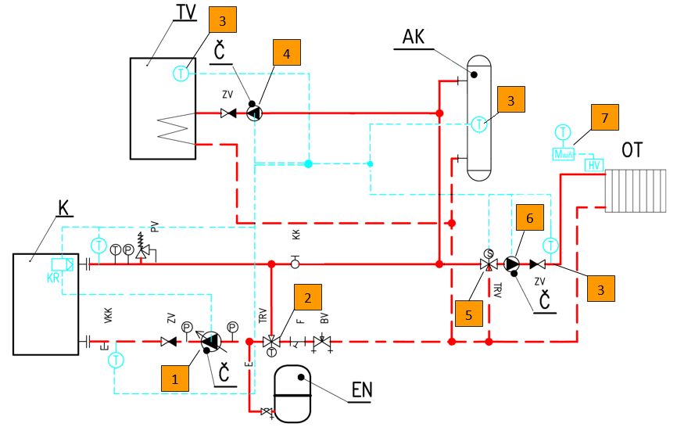

No. | Part | Type / Component / Description | Terminal | Ordering number
1. | CH pump | Primary circuit pump | CH pump | -
2. | Thermostatic valve | 3-way thermostatic valve | - | -
3. | KTY temperature sensors | KTY sensor of mixing valve 1 | Valve 1 sens. | 345718000020
3. | KTY temperature sensors | KTY hot water sensor | DHW sens. | 345718000020
3. | KTY temperature sensors | Buffer tank KTY sensor | Buffer sens. | 345718000020
4. | HW pump | Hot water pump | DHW pump | -
5. | Mixing valve 1 | 3- or 4-way mixing valve | Valve 1 | -
6. | Valve 1 pump | Pump | Valve pump | -
7. | Wireless control of radiator heads | Module wifi8 (for 1 building) | - | 358120400020
7. | Wireless control of radiator heads | Zone sensor wifi8 (for 1 zone/room), (1 module = max. 8 zones/rooms) | - | 358120400040
7. | Wireless control of radiator heads | Valve head wifi8 (for 1 radiator), (1 zone = max. 6 radiator heads) | - | 358120400030

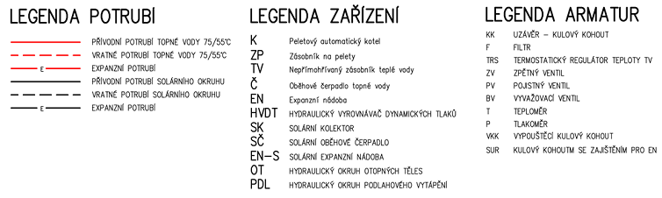
KK CAP - BALL VALVE
F FILTER
TRS THERMOSTATIC TEMPERATURE TV REGULATOR
ZV CHECK VALVE
PV SAFETY VALVE
BV BALANCE VALVE
T THERMOMETER
P PRESSURE GAUGE
VKK DRAIN BALL VALVE
SUR BALL VALVE WITH LOCK FOR EN

DEVICE LEGEND
FITTING LEGEND
PIPES LEGEND
75/55°C HEATING WATER SUPPLY PIPE
75/55°C HEATING WATER RETURN PIPE
EXPANSION PIPE
SOLAR CIRCUIT SUPPLY PIPE
SOLAR CIRCUIT RETURN PIPE
EXPANSION PIPE
K Automatic pellet boiler
ZP Pellet container
TV Indirectly heated hot water tank
Č Heating water circulation pump
EN Expansion vessel
HVDT HYDRAULIC DYNAMIC PRESSURE REGULATOR
SK SOLAR COLLECTOR
SČ SOLAR CIRCULATION PUMP
EN-S SOLAR EXPANSION VESSEL
OT HYDRAULIC CIRCUIT FOR HEATING ELEMENTS
PDL HYDRAULIC CIRCUIT FOR FLOOR HEATING

- Boiler protection against low-temperature corrosion by a thermostatic valve (65 °C).
- Boiler regulation according to set CH temperature (60 °C and above) and set DHW temperature and mixing valve (according to customer requirement).
- All control elements and accessories are connected to the control unit located on the boiler.

Connecting pumps:
  - Connect the CH pump to the control unit at the CH pump output.
  - Connect the DHW pump to the control unit at the DHW pump output.
  - Connect Valve1 sensor (OT) to the control unit at the Valve1 sensor output.

Connecting temperature sensors:
  - Connect the DHW sensor to the DHW sensor output of the control unit.
  - Connect the Valve1 sensor (OT) to the control unit at the Valve1 sensor (Valve sens. 1) output
  - Connect the Return Water sensor to the return (inlet) water pipe to the boiler and control unit at the Return sensor ("Return sens.") output.
  - Check the correct wiring of the CH temperature sensor, which is in the sink on the boiler outlet water funnel.

Connecting mixing valves:
  - Connect Valve1 (OT) to the control unit at the Valve1 output.

Connect room thermostats to OT and PDL circuits:
  - Connect the room thermostats to the control unit, to the Room Controller Standard (room thermostat) outputs, or to the RS output - depending on the type of thermostat selected. RT10 room thermostat is connected to the RS output. Standard thermostat operating on an open/closed circuit basis is connected to the Room Controller output.

Basic parameter settings:
  - Set the CH temperature in the Main Settings, Set CH Temperature.
  - Set the DHW temperature in the Main Settings, Set DHW Temperature.

DHW heating activation:
  - Activate DHW Priority in Basic Settings, Pump Operating Mode. The DHW pump will be activated independently of the heating of the OT and PDL circuits, according to the set DHW temperature.
  - On the Main Panel, top left, the DHW priority message is now displayed.
  - Note that the DHW pump will only be switched on if the current measured CH temperature is higher than the current measured DHW temperature. This is to ensure that no colder water than the actual DHW boiler temperature enters the DHW boiler.
  - When the set DHW temperature is reached, the DHW pump is switched off and the CH pump is activated at the same time to ensure water circulation in the heating system.
  - The CH and DHW pumps will be switched on if the CH temperature exceeds 40 °C. Set in the Service menu, Pump Switch-on Temperature.
  - The DHW pump will be switched on again after heating the DHW when the DHW temperature drops by the value set in DHW Hysteresis in the Service menu. The moment the DHW pump switches on, the CH pump switches off.
Then follows the activation of the mixing valves and room thermostats for each of the heated circuits. Continue as described on the next page.
Activation and setting mixing valve 1 (OT):
  - Activate Valve1 (OT) in the Installation menu, Built-in Valve.
  - Set the desired temperature on the valve in the Installation menu, Built-in Valve, Valve Temperature.
  - The valve will now maintain this temperature. If the temperature is reached, the valve will close. The opening is factory-set to the minimum of 5%. This means the valve will always be 5% open to ensure water flow in the system. This setting can be changed.

Activation and setting of room thermostats to control mixing valves:
- Connect the room thermostat to the control unit, to the Room Controller (room thermostat) outputs, or to the RS output - depending on the type of thermostat selected. RT10 room thermostat is connected to the RS output. Standard thermostat operating on an open/closed circuit basis is connected to one of the Room Controller outputs.
- Activate the room thermostat in the Installation menu, Room Thermostat - Standard Thermostat, or OPOP Controller (RT10 type) depending on the type of thermostat you are using.

  - Lowering the CH set temperature using the thermostat:
    - Set the lowering level of the set CH temperature in case the thermostat does not give a heating instruction in the Temperature Lowering by Thermostat function in the Installation menu, Room Thermostat.

- The boiler will heat the DHW even if there is no requirement for central heating from the room thermostat.

Storage tank size determination
The use of a storage tank is not required for Biopel MINI boilers. If you wish to use one in your heating system, use the formula below to calculate the correct size of the buffer tank for your boiler size.
Calculation of the smallest storage tank volume:
Vsp = 15 Tb x Qn (1-0.3 x (QH/Qmin)
- Vsp ….. buffer tank volume in L
- Tb ...…. burning time in hours
- Qn …… nominal thermal power in kW
- QH …… building thermal load in kW
- Qmin … minimum thermal power in kW

The storage tank dimensions must be determined according to the boiler power. The pellet boiler does not require a storage tank for its operation. There is no excess heat to be stored in the storage tank. On the contrary, the boiler modulates its power so that it never exceeds the set limit. If the boiler heats the heating system to the desired level, it switches off and on again when the temperature drops.
A buffer tank is recommended if the heating system contains more than one heating branch and generally for more complex heating systems with several heating circuits. We recommend that you consult a professional plumbing company or representatives of OPOP s.r.o. before purchasing a buffer tank.

REGULAR MAINTENANCE
Boiler maintenance is an integral part of solid fuel boiler operation. Recommended intervals for manual cleaning of the boiler, burner and flue. Please note that the intervals given are only basic recommendations and may differ from the actual requirement for regular cleaning. The frequency of regular cleaning generally depends on the quality of the combustion process, pellet type and quality, amount of dust and moisture in pellets, chimney draft, etc. Therefore, always check the clogging rate of the boiler at short intervals during the first months of operation so that you can determine how often the boiler, burner and flue gas outlet need to be cleaned according to actual conditions.
 | weekly | monthly | quarterly | annually
ashtray cleaning
burner grate cleaning
boiler exchanger cleaning
combustion check
photosensor cleaning
door tightness check
complete burner cleaning
feeder cleaning
hopper cleaning
Flue gas outlet and chimney

- Cleaning the ashtray is an essential step during regular boiler maintenance. Make sure that the ashtray is correctly positioned when placing it back into the boiler. There are two ashtrays in the boiler, so clean both regularly.
- The burner grate is removable and requires regular cleaning. During the first few weeks of operation, observe how often ash builds up on the grate and scrape it off regularly with cleaning tools. Only carry out this operation when the boiler is deactivated (extinct).
- Clean the front of the boiler in the burner area as needed at the same time as cleaning the burner grate.
- Cleaning the flue gas turbulators and heat exchanger is an essential task. Ash on the heat exchanger grates reduces efficiency and in turn increases the flue gas temperature, i.e., more heat escapes down the chimney if the heat exchanger is contaminated with ash.
The flue gas turbulators are removable, it is recommended to check the clearance between the turbulator plates regularly and remove and clean them if necessary. The boiler heat exchanger can be accessed by removing the cleaning door at the top of the boiler.
- Once or twice a season, check the flue gas outlet for clearance and clean it using the sweep hole that should be located on the flue.
- Once a season, check the asbestos sealing cords on all doors for tightness. If they are hard and have lost their sealing ability, we recommend replacing them.
Ask your installer to carefully explain how to clean the boiler and burner so that the boiler is operated in accordance with the instructions provided. Regular cleaning of the boiler, the burner and flue ensures maximum boiler efficiency and low fuel consumption during boiler operation.

BIOPEL ONLINE
Every Biopel MINI boiler can be connected free of charge to the OPOP online server, which runs an application for remote management of the boiler and heating system via the internet using your web browser. Connecting the boiler to this online system is very simple, see points below.
- Activate and connect the wi-fi network in the internet module settings in the installation menu
- In the v12 MINI control unit settings, display the Registration Code, in the Registration function in the Installation menu, Ethernet Module. Write this registration code down, you'll need it later.
- This code has a limited validity term, so after displaying the code, we recommend that you proceed immediately to register the boiler, see the next points of the procedure.
- Start the internet browser on your computer and enter the following address: opop.emodul.eu
- Click on New User and register the user to the OPOP online server.
- After successful registration, log in to the system using the username and password you chose earlier during the new user registration.
- Once connected, you must register your boiler by clicking on New Module in the Settings tab (top right).
- During the registration of the new module (boiler), enter all the information requested, including the registration code you wrote down earlier.
- Once the module registration is saved, our online server connects to your boiler and all data from the boiler is uploaded to the server within seconds.
Now your boiler is fully connected to the OPOP online server and you can take full advantage of all the functions that remote boiler management offers via the internet. OPOP s.r.o. technicians are ready to deal with any questions you may have.

FIRMWARE UPDATES
Each v12 MINI unit can be updated using a USB key. OPOP s.r.o. regularly releases new versions of the unit software for free download. New versions usually contain new features and options that increase the boiler's automation and provide more control options for the heating system. Consult the possibility of using new software updates with your installer or directly with an OPOP s.r.o. representative. The installation procedure is very simple, see points below.
- Upload a file with the extension ".bin" to the USB key.
- Switch off the boiler using the main switch on the top of the boiler.
- Using a micro USB adapter, insert the USB key into the connector on the side of the display.
- Switch on the boiler using the main switch.
- Wait until the installation is complete (the unit displays the standard basic panel) and remove the USB key.
- The v12 MINI control unit and the v12 MINI display are now updated.

The USB key in use must be formatted in the FAT32 file system for proper file upload. To check the file system your USB key is formatted in, right-click the USB key icon in your computer's operating system and enter Properties.
Caution: when uploading new software, the control unit settings will be reset to the original factory default values. Therefore, it is necessary to perform all settings again, including the so-called First Boiler Start-Up.

OPERATING AND ALARM MESSAGES
Below is a list of common questions we encounter. These relate to the boiler's installation and operation. Read these questions carefully, they may help you in dealing with specific situations you may encounter.
- Alarm: Feeder sensor damaged
It is safety sensor on the burner. Check the connection of the sensor in the burner circuit board and in the control unit in the "Feeder sens." output.
- Alarm: CH sensor failure
CH sensor connected in output "CH sens." It is damaged or not connected.
- Alarm: DHW sensor failure
DHW sensor connected to the "DHW sens." output. It is damaged or not connected while one of the functions that needs it to work properly is activated.
- Alarm: CH temperature too high
The CH temperature measured by the CH sensor has exceeded 93 °C, i.e., the value set in the Max. Boiler Temperature function in the Service menu.
- Alarm: DHW temperature too high
The DHW temperature measured by the DHW sensor has exceeded the maximum value set in the Set DHW Temperature function in the Main Settings.
- Alarm: Termik sensor opened
Termik sensor is not connected or is defective. Check the contact in the control unit.
- Alarm: Reverse flow sensor damaged
The return water sensor has been activated in the Built-in Mixing Valve 1 or 2 settings, but is defective or has not been connected to the Return sensor ("Return sens.") output in the control unit.
- Alarm: Temperature sensor C1-C4 damaged
The temperature sensor has been activated but has not been connected to the appropriate output in the unit.
- Alarm: Mixing valve sensor failure
Built-in mixing valve 1 or 2 has been activated, but the valve 1 or 2 sensor has not been connected to the control unit to the "Valve 1, 2 sensor" output.
- Alarm: 3 ignitions in 30 min.
Boiler ignites too often. Check correct flame detection by photosensor after Ignition. If the photosensor does not see the light, the boiler goes into normal operation.
- Message: No communication with room thermostat
The RT10 room thermostat has not been connected but is activated. Check the thermostat settings.
- Message: No communication with lambda sensor
Lambda sensor was not connected or connected incorrectly but is activated. Check the lambda settings in the Installation menu, Lambda and check the lambda sensor wiring.
- Message: Temperature reached
The boiler has been switched off by reaching the CH temperature.
- Message: DHW heated
DHW temperature has been reached. The DHW pump has been switched off.
- Alarm: Outdoor sensor failure
The outdoor temperature sensor has been activated in the settings for built-in mixing valve 1 or 2, but is not connected to the boiler's external socket to the "Weather sens." output.
- Alarm: Mosfet sensor damaged
The Mosfet component is responsible for fan speed control and has probably overheated. Check the supply voltage, which should not be higher than 240V. If everything is fine, the fan got stuck or is scraping. Check the fan operation and the functionality of the start-up fan, which is located on the burner.
- Alarm: Mosfet temperature too high or Incorrect airflow
The temperature at the component measuring the fan speed and current draw is too high. Check the fan operation and the fan start-up capacitor to see if they are OK.
- Feeder temperature too high
The temperature in the burner has exceeded 80 °C. Check correct grate placement, the internal feeder operation using the manual operation in the Installation menu. Check the flue gas outlet passage.
- Alarm: Unsuccessful ignition
The igniter is defective or the ignition process is incorrectly set. Make sure that after the flame is formed, it is detected by the photosensor.
- Alarm: Temperature not rising
If the CH temperature does not exceed 30°C in 30min after the ignition, an alarm message appears. Set in the service menu, in the Min. Temperature Alarm & Min. Temperature Time functions.

TROUBLESHOOTING OF SPECIFIC SITUATIONS
Below is a list of common questions we encounter. These relate to the boiler's installation and operation. Read these questions carefully, they may help you in dealing with specific situations you may encounter.
- Incorrect flame at max. power:
  - Flame extension: Service menu, Feeder settings, Work
    - Max feed work - set longer feeder operating time
    - Min feed pause - set a shorter feeding pause time
  - Flame Shortening: Service menu, Feeder settings, Work
    - Max feed work - set shorter feeder operating time
    - Min feed pause - set a longer feeding pause time
  - Reduce air quantity: Service menu, Feeder settings, Work
    - Max. fan power - set a lower number
  - Increase air quantity: Service menu, Feeder settings, Work
    - Max fan power - set a higher number
By making these changes you can adjust the flame size and therefore the combustion quality. After the ignition phase, wait 10 minutes for the burner to reach maximum power and then make the changes.
- Incorrect flame at min. power:
  - Reduce the boiler power to the minimum:
Wait until the CH temperature is close to the set value, or set the same values in the Service menu, Feeder Settings, Work, for min. and max. power. Example:
    - Service Menu: Feeder settings, Work, for min. and max. power:
      - Max. feeding work = 2s (value for max. power)
      - Min. feeding work = 2s (value for min. power)
      - Max. feeding pause = 10s (value for min. power)
      - Min. feeding pause = 10s (value for max. power)
Now the same values are set for running the feeder at min. and max. power. Wait 10mins for the flame to stabilise and make any corrections, see below.
  - Flame extension: Service menu, Feeder settings, Work
    - Min. feed work - set higher feeder operating number
    - Max. feeding pause - set a shorter feeding pause time
  - Flame Shortening: Service menu, Feeder settings, Work
    - Min. feed work - set lower feeder operating number
    - Max. feeding pause - set a longer feeding pause time
  - Reduce air quantity: Service menu, Feeder settings, Work
    - Min. fan speed operation - set a lower number
  - Increase air quantity: Service menu, Feeder settings, Work
    - Min. fan speed operation - set a higher number
It is important that the flame is stable during minimum power and there is no risk of extinction during boiler operation.

- Unburnt pellets in ashtray:
  - Reduce fan speed: Service menu, Feeder settings, Work
    - Max. fan power - set a lower number
  - Reduce feeder operating time: Service menu, Feeder settings, Work
    - Max. feeding work - set a lower number
    - Min. feeding pause - set a higher number

- Long or failed ignition:
  - High chimney draft - Chimney draft is a major factor that can affect ignition cycle time. This time is normally 4 to 6 minutes. Chimney draft higher than 15Pa negatively affects the resulting ignition time. The solution is to install a draft stabiliser. Also, keep in mind that the higher the boiler power, the more likely it is to affect the ignition time.
We recommend installing a draft stabiliser with each boiler. In addition, the draft stabiliser must be set as indicated in the boiler parameter table - chimney draft.
  - Quantity of pellets on the grate: Service menu, Feeder settings, Ignition
    - Dose time - set a higher or lower number. The pellets should cover the opening of the igniter which is above the grate, but in general, the fewer pellets on the grate during ignition, the faster the ignition cycle.
  - Poor fan speed: Service menu, Feeder settings, Ignition
    - Fan speed 1/2 - set the fan speed lower or higher. A trained installer knows the recommended values.

- Photosensor does not see flame:
  - Sensitivity: Service menu, Feeder settings, Ignition
    - Brightness - set a lower number for higher sensitivity and vice versa. The minimum value should be around 30; if it is lower you risk that the photosensor sees ambient light without the boiler firing.
  - Bad contact in the burner socket.
    - If the display shows the message Feder Sensor Damaged, it means that the socket on the burner is badly connected or damaged. Check the inside of both sockets on the burner.
  - Cannot see the light during ignition.
    - The flame is too small or the pellets are blocking the flame detection in the burner. You need to extend the operating time of the internal feeder so that there are none left in the burner and all are delivered to the burner grate.

- Failed SW update:
  - USB must be formatted in FAT32 file system
  - or the USB file is corrupted.
We recommend to re-format the USB and upload the file for the update. Or replace the USB key with another one.

- No SIGMA regulation:
  - The CH sensor or flue gas sensor is not connected.
  - Flue gas temperature is higher than 170°C.
  - SIGMA regulation is affected by the rate of temperature change over time, so each system is likely to respond differently.

- Lambda sensor reduces boiler power:
  - Change the modulation range in the Installation menu, Lambda. The factory setting is -15 to +15. It is necessary to reduce this range.
  - Leaks in the flue outlet connections and in the lambda sensor sink. False air is being drawn in, Lambda is trying to regulate it.

- Lambda sensor degrades combustion quality:
  - If the flame is consistently large and dark after the Lambda sensor is activated (i.e., not enough combustion air) then it means that the Lambda sensor is measuring a large amount of excess air and trying to reduce it to the set limit by adding fuel or reducing fan speed.
  - This could be due to a leak in some part of the flue gas outlet, boiler or lambda sensor hole. These leaks allow additional air into the boiler, which the lambda sensor tries to eliminate by the above-mentioned means. The only place that air enters the boiler should be the burner fan.
  - Also, reduce the modulation range that the lambda sensor can do, under the Min. Change and Max. Change items in the Installation menu, Lambda.

- The data changed on the internet will be uploaded to the boiler after a long time:
  - Normally, with a good internet connection, it takes 1 minute for internet data to be uploaded to the boiler unit
  - If the data takes e.g. 10 minutes or more to upload, this means that the internet connection is bad or one of the additional devices is activated and not connected to the external socket: RT10 room thermostat, Lambda sensor, 431N module. Connect these additional devices or deactivate them in the settings of the additional device.

- When the cause of the alarm is removed, it will reappear
  - The unit has fixed the detection of possible alarms to 15s. If you remove the cause of an alarm after the last detection, the alarm may still reappear after the cause is deactivated. After reconfirmation, the alarm will no longer appear if the cause of the alarm has been removed.
- Failed synchronisation
- The unit synchronises data with the control unit at start-up.
- If the synchronisation fails, this is due to inconsistent SW in the display and the control unit respectively. Upload the latest version of the SW to both devices.

- Clogged burner grate:
  - Clogged grate with unburned pellets, too much ash on the grate.
  - External feeder dosing time too long. Reduce the Max. feeder coefficient in the Coefficients function in the Installation menu. If necessary, re-adjust the value in the Max Feeder Coefficient after a while.
  - Low fan speed. Increase the Fan Max. Coefficient in the Coefficients function in the Installation menu.
  - Wrong type of pellets that are not 100% wood; the specific type of wood does not matter.
  - High humidity in pellets, pellets only burn on the surface and do not burn completely.
  - Wrong grate position in the burner, clogged burner grate holes.
  - Lower than required chimney draft.
  - Large amount of dust in the pellets.

- High temperature of the internal feeder in the burner:
  - Displayed in the lower left corner of the main panel of the v12 MINI unit.
  - The standard value is up to 50°C.
  - Possible causes are:
    - Clogged grate due to poor combustion or wrong fuel type.
    - Wrong grate position in the burner, clogged burner grate holes.
    - Lower than required chimney draft.
    - Clogged boiler or flue gas path
  - There is a risk of backfiring to the rear of the burner, remedial action is required.

ELECTRICAL SAFETY

- The boiler is designed for connection to 230 V / 50 Hz mains.
- Electrical connections may only be carried out by a person with the appropriate electrical qualifications.
- The device must be connected via protective conductor (PE).
- The power supply circuit must be equipped with a current protector (RCD) max. 30 mA.
- The boiler must be disconnected from the mains before any intervention (maintenance, cleaning, servicing).
- It is prohibited to operate the device with a damaged power cable or incomplete cover.
- All covers of electrical parts must be closed during operation.
- It is forbidden to interfere with the wiring and safety features of the equipment.
- The device must not be exposed to water or excessive moisture; protection rating: IP20.
- In the event of a malfunction or unusual behaviour (odour, smoke, malfunctions), immediately disconnect the device from the mains and contact service.

FACTORY SETTINGS

Ignition parameters | 10 kW | 15 kW | 20 kW | 30 kW | 40 kW
Blowing time | 30s | 30s | 30s | 30s | 30s
Blowing speed | 100% | 100% | 100% | 100% | 100%
Feed (hopper) time | 13 s | 13 s | 14 s | 14 s | 15 s
Ignition delay | 20s | 20s | 20s | 20s | 20s
Feeding time | 3 s | 3 s | 3 s | 3 s | 3 s
Feeding pause | 120s | 120s | 120s | 120s | 120s
Fan speed | 1% | 1% | 1% | 8% | 8%
Fan speed 2 | 3% | 3% | 3% | 13% | 13%
Heater protection | 12min | 12min | 12min | 12min | 12min
Ignition brightness | 38 | 38 | 38 | 38 | 38
Fan delay | 30s | 30s | 30s | 30s | 30s

Operating parameters: | 10 kW | 15 kW | 20 kW | 30 kW | 40 kW
Min. feeder operation | 1 | 1 | 1 | 1 | 1
Max. feeder operation | 1 | 1 | 2 | 2 | 3
Min. feeder pause | 11 | 9 | 9 | 7 | 10
Max. feeder pause | 24 | 24 | 19 | 19 | 17
Min. fan speed - operation | 5 | 5 | 5 | 17 | 18
Max. fan speed - operation | 9 | 10 | 13 | 36 | 37
Cleaning period | 0 h 0 min | 0 h 0 min | 0 h 0 min | 0 h 0 min | 0 h 0 min
Operation check | 30s | 30s | 30s | 30s | 30s

Extinction parameters: | 10 kW | 15 kW | 20 kW | 30 kW | 40 kW
Fan speed | 70% | 70% | 70% | 70% | 70%
Feeding time | 5s | 5s | 5s | 5s | 5s
Feeding pause | 20s | 20s | 20s | 20s | 20s
Extinction time | 10min | 10min | 10min | 10min | 10min
Delay time | 5 min | 5 min | 5 min | 5 min | 5 min

Service menu: | 10 kW | 15 kW | 20 kW | 30 kW | 40 kW
Max. flue gas temperature | 220°C | 220°C | 220°C | 220°C | 220°C
Feeder Alarm temperature | 80 °C | 80 °C | 80 °C | 80 °C | 80 °C
Priority Temperature | 75°C | 75°C | 75°C | 75°C | 75°C
CH pump emergency activation | 85°C | 85°C | 85°C | 85°C | 85°C
Boiler alarm temperature | 93°C | 93°C | 93°C | 93°C | 93°C
Internal feeder coefficient | 100% | 100% | 100% | 100% | 100%
Min. boiler temperature | 40°C | 40°C | 40°C | 40°C | 40°C
Pump switch-on temperature | 40°C | 40°C | 40°C | 40°C | 40°C
Growth impulses | 0 | 0 | 0 | 0 | 0
Supervision temperature | 5°C | 5°C | 5°C | 5°C | 5°C
Boiler Hysteresis | 15°C | 15°C | 15°C | 15°C | 15°C
DHW Hysteresis | 10°C | 10°C | 10°C | 10°C | 10°C

Main settings, Burner cleaning: | 10 kW | 15 kW | 20 kW | 30 kW | 40 kW
On | Yes | Yes | Yes | Yes | Yes
Cleaning period | 15 min | 15 min | 15 min | 10min | 10min
Fan operating time | 10 s | 10 s | 10 s | 10 s | 10 s
Blowing intensity | 60% | 60% | 60% | 80% | 100%

Installation menu, Lambda: | 10 kW | 15 kW | 20 kW | 30 kW | 40 kW
First time for update | 10min | 10min | 10min | 10min | 10min
Update period | 300 s | 300 s | 300 s | 300 s | 300 s
Oxygen surge | 2% | 2% | 2% | 2% | 2%
Fan surge | 2% | 2% | 2% | 2% | 2%
Sum | Yes | Yes | Yes | Yes | Yes
Min. change | 15% | 15% | 15% | 10% | 10%
Max. change | 15% | 15% | 15% | 10% | 10%
Lambda 100% | 11% | 10% | 9% | 11% | 11%
Lambda 1% | 12% | 12% | 13% | 14% | 15%

Installation menu, Compressor 1:  (Burner) | 10 kW | 15 kW | 20 kW | 30 kW | 40 kW
Cleaning period | 1min | 1min | 1min | 2 min | 2 min
Opening time | 2s | 2s | 2s | 2s | 2s
Cycle time | 17 s | 17 s | 17 s | 25s | 25s
Pause time | 20 h | 20 h | 20 h | 20 h | 20 h

Installation menu, Vacuum feeder: | 10 kW | 15 kW | 20 kW | 30 kW | 40 kW
Operating time | 30min | 30min | 30min | 30min | 30min
Switch-on hour | 9:00 | 9:00 | 9:00 | 9:00 | 9:00
Switch-on hour 2 | 15:00 | 15:00 | 15:00 | 15:00 | 15:00
Opening time | 80 s | 80 s | 80 s | 80 s | 80 s
Pause time | 20s | 20s | 20s | 20s | 20s

Installation menu, Ash Remover: | 10 kW | 15 kW | 20 kW | 30 kW | 40 kW
Operating time | 5 min | 5 min | 5 min | 10min | 10min
Pause time | 10 h | 10 h | 10 h | 10 h | 10 h
Installation menu, Compressor 1 and 2 (exchanger): | 10 kW | 15 kW | 20 kW | 30 kW | 40 kW
Cleaning period | 1min | 1min | 1min | 2 min | 2 min
Opening time | 3 s | 3 s | 3 s | 3 s | 3 s
Cycle time | 25s | 25s | 25s | 25s | 25s
Pause time | 8 h | 8 h | 8 h | 6 h | 5 h

These values can only be changed by a certified installer who is authorised to install and start up OPOP s.r.o. boilers.
Information given in the tables serves for better orientation in the Service Menu items and simplifies the clarity of the set values during the power selection in the First Boiler Start-up.
Changing these parameters has a significant effect on the boiler operation. If you need to reset the settings to the default values (see table), you can perform the first boiler start-up again or use the Factory Settings function in the Main, Installation and Service menus to reset to factory settings.

ENERGY EFFICIENCY

I. | II. | III. | IV. | V. | VI.
name or trademark of the supplier; | supplier's model identification mark; | energy efficiency class | nominal thermal power in kW | energy efficiency index | seasonal heating energy efficiency in %
OPOP s r.o. | Biopel 10 | A+ | 11 | 119 | 81
OPOP s r.o. | Biopel 15 | A+ | 15 | 119 | 81
OPOP s r.o. | Biopel 21 | A+ | 21 | 120 | 82
OPOP s r.o. | Biopel 30 | A+ | 30 | 120 | 82
OPOP s r.o. | Biopel 40 | A+ | 40 | 121 | 82

IDENTIFICATION MARKS
model identification mark: BIOPEL MINI 11
Condensing boiler: |  | no | Solid fuel cogeneration boiler: |  | no | Combined boiler: |  | no
Feeding mode: automatic |  | Manual: the boiler should be operated with a hot water tank of at least x(*) litres / Automatic: we recommend that the boiler be operated with a hot water tank of at least x(**) litres]
Fuel |  |  |  |  | Preferred fuel (only one): |  | Other suitable  fuel(s):
Wood logs, moisture content ≤ 25 %. |  |  |  |  | no |  | no
Wood chips, moisture content 15-35 % |  |  |  |  | no |  | no
Wood chips, moisture content > 35 % |  |  |  |  | no |  | no
Pressed wood in the form of pellets or briquettes |  |  |  |  | yes |  | no
Sawdust, moisture content ≤ 50 % |  |  |  |  | no |  | no
Other woody biomass |  |  |  |  | no |  | no
Non-wood biomass |  |  |  |  | no |  | no
Black coal |  |  |  |  | no |  | no
Brown coal (including briquettes) |  |  |  |  | no |  | no
Coke |  |  |  |  | no |  | no
Anthracite |  |  |  |  | no |  | no
Briquettes from a mixture of fossil fuels |  |  |  |  | no |  | no
Other fossil fuel |  |  |  |  | no |  | no
Briquettes from a mixture of biomass (30-70 %) and fossil fuels |  |  |  |  | no |  | no
Other mixture of biomass and fossil fuels |  |  |  |  | no |  | no
Properties when operating with preferred fuel:
Seasonal indoor heating energy efficiency ηs [%]: |  |  |  |  | 81
Energy Efficiency Index EEI: |  |  |  |  | 119
Energy efficiency class: |  |  |  |  | A+
Name | Designation | Value | Unit |  | Name | Designation | Value | Unit
Rated thermal output |  |  |  |  | Rated efficiency
At nominal thermal power | Pn(***) | 11 | kW |  | At nominal thermal power | ηn | 86.6 | %
At [30 %] of rated thermal power, if applicable | Pp | 3.3 | kW |  | At [30 %] of rated thermal power, if applicable | ηp | 84.7 | %
Solid fuel cogeneration boilers: Electrical efficiency |  |  |  |  | Auxiliary electricity consumption
At nominal thermal power | ηel,n |  | % |  | At nominal thermal power | elmax | 0.035 | kW
 |  |  |  |  | At [30 %] of rated thermal power, if applicable | elmin | 0.015 | kW
 |  |  |  |  | Of the built-in secondary emission abatement device, if applicable |  | not applicable | kW
 |  |  |  |  | In standby mode | PSB | 0.005 | kW
Contact details |  | OPOP s.r.o., Zašovská 750, Valašské Meziříčí, 757 01, Czech Republic
(*) Tank volume = 45 × Pr × (1 – 2,7/Pr) or 300 litres, whichever is the higher, where Pr is expressed in kW
(**) Tank volume = 20 × Pr, where Pr is expressed in kW
(***) For the preferred fuel, Pn is equal to Pr

model identification mark: BIOPEL MINI 15
Condensing boiler: |  | no | Solid fuel cogeneration boiler: |  | no | Combined boiler: |  | no
Feeding mode: automatic |  | Manual: the boiler should be operated with a hot water tank of at least x(*) litres / Automatic: we recommend that the boiler be operated with a hot water tank of at least x(**) litres]
Fuel |  |  |  |  | Preferred fuel (only one): |  | Other suitable  fuel(s):
Wood logs, moisture content ≤ 25 %. |  |  |  |  | no |  | no
Wood chips, moisture content 15-35 % |  |  |  |  | no |  | no
Wood chips, moisture content > 35 % |  |  |  |  | no |  | no
Pressed wood in the form of pellets or briquettes |  |  |  |  | yes |  | no
Sawdust, moisture content ≤ 50 % |  |  |  |  | no |  | no
Other woody biomass |  |  |  |  | no |  | no
Non-wood biomass |  |  |  |  | no |  | no
Black coal |  |  |  |  | no |  | no
Brown coal (including briquettes) |  |  |  |  | no |  | no
Coke |  |  |  |  | no |  | no
Anthracite |  |  |  |  | no |  | no
Briquettes from a mixture of fossil fuels |  |  |  |  | no |  | no
Other fossil fuel |  |  |  |  | no |  | no
Briquettes from a mixture of biomass (30-70 %) and fossil fuels |  |  |  |  | no |  | no
Other mixture of biomass and fossil fuels |  |  |  |  | no |  | no
Properties when operating with preferred fuel:
Seasonal indoor heating energy efficiency ηs [%]: |  |  |  |  | 81
Energy Efficiency Index EEI: |  |  |  |  | 119
Energy efficiency class: |  |  |  |  | A+
Name | Designation | Value | Unit |  | Name | Designation | Value | Unit
Rated thermal output |  |  |  |  | Rated efficiency
At nominal thermal power | Pn(***) | 15 | kW |  | At nominal thermal power | ηn | 86.3 | %
At [30 %] of rated thermal power, if applicable | Pp | 4.4 | kW |  | At [30 %] of rated thermal power, if applicable | ηp | 84.9 | %
Solid fuel cogeneration boilers: Electrical efficiency |  |  |  |  | Auxiliary electricity consumption
At nominal thermal power | ηel,n |  | % |  | At nominal thermal power | elmax | 0.040 | kW
 |  |  |  |  | At [30 %] of rated thermal power, if applicable | elmin | 0.026 | kW
 |  |  |  |  | Of the built-in secondary emission abatement device, if applicable |  | not applicable | kW
 |  |  |  |  | In standby mode | PSB | 0.005 | kW
Contact details |  | OPOP s.r.o., Zašovská 750, Valašské Meziříčí, 757 01, Czech Republic
(*) Tank volume = 45 × Pr × (1 – 2,7/Pr) or 300 litres, whichever is the higher, where Pr is expressed in kW
(**) Tank volume = 20 × Pr, where Pr is expressed in kW
(***) For the preferred fuel, Pn is equal to Pr
model identification mark: BIOPEL MINI 21
Condensing boiler: |  | no | Solid fuel cogeneration boiler: |  | no | Combined boiler: |  | no
Feeding mode: automatic |  | Manual: the boiler should be operated with a hot water tank of at least x(*) litres / Automatic: we recommend that the boiler be operated with a hot water tank of at least x(**) litres]
Fuel |  |  |  |  | Preferred fuel (only one): |  | Other suitable  fuel(s):
Wood logs, moisture content ≤ 25 %. |  |  |  |  | no |  | no
Wood chips, moisture content 15-35 % |  |  |  |  | no |  | no
Wood chips, moisture content > 35 % |  |  |  |  | no |  | no
Pressed wood in the form of pellets or briquettes |  |  |  |  | yes |  | no
Sawdust, moisture content ≤ 50 % |  |  |  |  | no |  | no
Other woody biomass |  |  |  |  | no |  | no
Non-wood biomass |  |  |  |  | no |  | no
Black coal |  |  |  |  | no |  | no
Brown coal (including briquettes) |  |  |  |  | no |  | no
Coke |  |  |  |  | no |  | no
Anthracite |  |  |  |  | no |  | no
Briquettes from a mixture of fossil fuels |  |  |  |  | no |  | no
Other fossil fuel |  |  |  |  | no |  | no
Briquettes from a mixture of biomass (30-70 %) and fossil fuels |  |  |  |  | no |  | no
Other mixture of biomass and fossil fuels |  |  |  |  | no |  | no
Properties when operating with preferred fuel:
Seasonal indoor heating energy efficiency ηs [%]: |  |  |  |  | 82
Energy Efficiency Index EEI: |  |  |  |  | 120
Energy efficiency class: |  |  |  |  | A+
Name | Designation | Value | Unit |  | Name | Designation | Value | Unit
Rated thermal output |  |  |  |  | Rated efficiency
At nominal thermal power | Pn(***) | 21.0 | kW |  | At nominal thermal power | ηn | 85.9 | %
At [30 %] of rated thermal power, if applicable | Pp | 6.1 | kW |  | At [30 %] of rated thermal power, if applicable | ηp | 85.3 | %
Solid fuel cogeneration boilers: Electrical efficiency |  |  |  |  | Auxiliary electricity consumption
At nominal thermal power | ηel,n |  | % |  | At nominal thermal power | elmax | 0.048 | kW
 |  |  |  |  | At [30 %] of rated thermal power, if applicable | elmin | 0.030 | kW
 |  |  |  |  | Of the built-in secondary emission abatement device, if applicable |  | not applicable | kW
 |  |  |  |  | In standby mode | PSB | 0.005 | kW
Contact details |  | OPOP s.r.o., Zašovská 750, Valašské Meziříčí, 757 01, Czech Republic
(*) Tank volume = 45 × Pr × (1 – 2,7/Pr) or 300 litres, whichever is the higher, where Pr is expressed in kW
(**) Tank volume = 20 × Pr, where Pr is expressed in kW
(***) For the preferred fuel, Pn is equal to Pr

model identification mark: BIOPEL MINI 30
Condensing boiler: |  | no | Solid fuel cogeneration boiler: |  | no | Combined boiler: |  | no
Feeding mode: automatic |  | Manual: the boiler should be operated with a hot water tank of at least x(*) litres / Automatic: we recommend that the boiler be operated with a hot water tank of at least x(**) litres]
Fuel |  |  |  |  | Preferred fuel (only one): |  | Other suitable  fuel(s):
Wood logs, moisture content ≤ 25 %. |  |  |  |  | no |  | no
Wood chips, moisture content 15-35 % |  |  |  |  | no |  | no
Wood chips, moisture content > 35 % |  |  |  |  | no |  | no
Pressed wood in the form of pellets or briquettes |  |  |  |  | yes |  | no
Sawdust, moisture content ≤ 50 % |  |  |  |  | no |  | no
Other woody biomass |  |  |  |  | no |  | no
Non-wood biomass |  |  |  |  | no |  | no
Black coal |  |  |  |  | no |  | no
Brown coal (including briquettes) |  |  |  |  | no |  | no
Coke |  |  |  |  | no |  | no
Anthracite |  |  |  |  | no |  | no
Briquettes from a mixture of fossil fuels |  |  |  |  | no |  | no
Other fossil fuel |  |  |  |  | no |  | no
Briquettes from a mixture of biomass (30-70 %) and fossil fuels |  |  |  |  | no |  | no
Other mixture of biomass and fossil fuels |  |  |  |  | no |  | no
Properties when operating with preferred fuel:
Seasonal indoor heating energy efficiency ηs [%]: |  |  |  |  | 82
Energy Efficiency Index EEI: |  |  |  |  | 120
Energy efficiency class: |  |  |  |  | A+
Name | Designation | Value | Unit |  | Name | Designation | Value | Unit
Rated thermal output |  |  |  |  | Rated efficiency
At nominal thermal power | Pn(***) | 30 | kW |  | At nominal thermal power | ηn | 85.7 | %
At [30 %] of rated thermal power, if applicable | Pp | 7.6 | kW |  | At [30 %] of rated thermal power, if applicable | ηp | 85.5 | %
Solid fuel cogeneration boilers: Electrical efficiency |  |  |  |  | Auxiliary electricity consumption
At nominal thermal power | ηel,n |  | % |  | At nominal thermal power | elmax | 0.055 | kW
 |  |  |  |  | At [30 %] of rated thermal power, if applicable | elmin | 0.032 | kW
 |  |  |  |  | Of the built-in secondary emission abatement device, if applicable |  | not applicable | kW
 |  |  |  |  | In standby mode | PSB | 0.005 | kW
Contact details |  | OPOP s.r.o., Zašovská 750, Valašské Meziříčí, 757 01, Czech Republic
(*) Tank volume = 45 × Pr × (1 – 2,7/Pr) or 300 litres, whichever is the higher, where Pr is expressed in kW
(**) Tank volume = 20 × Pr, where Pr is expressed in kW
(***) For the preferred fuel, Pn is equal to Pr

model identification mark: BIOPEL MINI 40
Condensing boiler: |  | no | Solid fuel cogeneration boiler: |  | no | Combined boiler: |  | no
Feeding mode: automatic |  | Manual: the boiler should be operated with a hot water tank of at least x(*) litres / Automatic: we recommend that the boiler be operated with a hot water tank of at least x(**) litres]
Fuel |  |  |  |  | Preferred fuel (only one): |  | Other suitable  fuel(s):
Wood logs, moisture content ≤ 25 %. |  |  |  |  | no |  | no
Wood chips, moisture content 15-35 % |  |  |  |  | no |  | no
Wood chips, moisture content > 35 % |  |  |  |  | no |  | no
Pressed wood in the form of pellets or briquettes |  |  |  |  | yes |  | no
Sawdust, moisture content ≤ 50 % |  |  |  |  | no |  | no
Other woody biomass |  |  |  |  | no |  | no
Non-wood biomass |  |  |  |  | no |  | no
Black coal |  |  |  |  | no |  | no
Brown coal (including briquettes) |  |  |  |  | no |  | no
Coke |  |  |  |  | no |  | no
Anthracite |  |  |  |  | no |  | no
Briquettes from a mixture of fossil fuels |  |  |  |  | no |  | no
Other fossil fuel |  |  |  |  | no |  | no
Briquettes from a mixture of biomass (30-70 %) and fossil fuels |  |  |  |  | no |  | no
Other mixture of biomass and fossil fuels |  |  |  |  | no |  | no
Properties when operating with preferred fuel:
Seasonal indoor heating energy efficiency ηs [%]: |  |  |  |  | 82
Energy Efficiency Index EEI: |  |  |  |  | 121
Energy efficiency class: |  |  |  |  | A+
Name | Designation | Value | Unit |  | Name | Designation | Value | Unit
Rated thermal output |  |  |  |  | Rated efficiency
At nominal thermal power | Pn(***) | 40 | kW |  | At nominal thermal power | ηn | 86.6 | %
At [30 %] of rated thermal power, if applicable | Pp | 9.8 | kW |  | At [30 %] of rated thermal power, if applicable | ηp | 85.8 | %
Solid fuel cogeneration boilers: Electrical efficiency |  |  |  |  | Auxiliary electricity consumption
At nominal thermal power | ηel,n |  | % |  | At nominal thermal power | elmax | 0.084 | kW
 |  |  |  |  | At [30 %] of rated thermal power, if applicable | elmin | 0.034 | kW
 |  |  |  |  | Of the built-in secondary emission abatement device, if applicable |  | not applicable | kW
 |  |  |  |  | In standby mode | PSB | 0.005 | kW
Contact details |  | OPOP s.r.o., Zašovská 750, Valašské Meziříčí, 757 01, Czech Republic
(*) Tank volume = 45 × Pr × (1 – 2,7/Pr) or 300 litres, whichever is the higher, where Pr is expressed in kW
(**) Tank volume = 20 × Pr, where Pr is expressed in kW
(***) For the preferred fuel, Pn is equal to Pr

WARRANTY CONDITIONS, GENERAL INSTRUCTIONS
The following points must be met not only to comply with the warranty conditions, but also to ensure that the installation is correct in terms of the applicable standards, safety and to ensure trouble-free operation of the boiler.
- Biopel MINI boilers may only be installed by a company with a valid installation and maintenance licence. The installation must be supported by a project in accordance with the applicable regulations.
- The heating system must be filled with water that meets requirements of ČSN 07 7401 and especially its hardness must not exceed the required parameters. The use of antifreeze is not recommended by the manufacturer.
- Connection of the boiler to the system must be made in accordance with the applicable regulations and standards.
- The flue pipe must be inspected by a chimney sweep company before the boiler is installed. An inspection report must be prepared, including the basic parameters of the flue, including the diameter of the chimney, its length and the chimney draft.
- The flue must be no longer than 1m and fitted with a sweep hole. The flue may only be longer if the chimney draft has been measured and recorded no further than 30cm from the boiler and meets the minimum operating draft requirements, see chapter Main Parameters and Dimensions.
- The Biopel boiler must be installed in a separate boiler room specially adapted for heating. The boiler room must have sufficient space for boiler installation and maintenance. Sufficient fresh air circulation for combustion must be ensured.
- The boiler must never be installed in open spaces or balconies, in areas occupied by people such as the kitchen, living room, bathroom, bedroom, in areas where explosive and flammable materials are present.
- It is recommended to install the boiler on a concrete base made of fire-resistant material.
- Around the boiler and the pellet hopper must be a minimum handling space, free of obstructions, namely: 60cm from the rear and sides, 100cm from the front of the boiler and hopper.
- Safe distance of 200 mm from combustible materials must be maintained during installation and operation of the boiler.
- It is forbidden to store fuel behind the boiler or to stack it next to the boiler at a distance of less than 800 mm.
- It is forbidden to store fuel between two boilers in the boiler room.
- A spacing of 1000 mm must be observed between the boiler and fuel, or place the fuel in a different room from where the boiler is installed.
- The warranty fuel is considered to be wood pellets only, with a diameter of 6mm or more, with the parameters specified in the instructions for use.
- The manufacturer is not liable for the quality of the fuel, in terms of combustion quality, ash quantity or frequency of boiler cleaning due to the fact that these are only influenced by external factors such as pellet quality, dust and moisture in pellets, chimney draft or correct combustion settings.
- It is forbidden to use flammable liquids (petrol, alcohol, etc.) to fire the boiler.
- It is forbidden to overheat the boiler in any way during operation.
- If there is a risk of flammable vapours or gases entering the boiler room or during work that creates a temporary risk of fire or explosion (gluing floor coverings, painting with flammable paints, etc.), the boiler must be shut down well in advance of work commencement.
- The boiler must be thoroughly cleaned after the end of the heating season, including the flue gas outlet. The boiler room must be kept clean and dry.
- It is forbidden to interfere with the boiler's construction and electrical installation.
- The manufacturer is not liable for damage caused by improper adjustment or improper operation of the product.
- Pursuant to Section 2167(2) of Czech Act No. 89/2012 Coll., the Civil Code, wear and tear caused by normal use of a product is not a defect of the product. Parts subject to normal wear and tear are: gaskets, sealing cords, fireclay/grenamate/ceramic fittings, PVC hoses, grates, spacer/base spacer plates, ignition cartridges, lambda sensors, auxiliary line pipes. Wear and tear of these parts thus is not a product defect. Still, these parts remain functional for a long time providing that the boiler and its components are operated in accordance with the instructions for use.
- The manufacturer is not liable for rust on the boiler and its components, as this is always and only due to external influences such as moisture in the room, fuel or due to unprofessional installation without protecting the boiler against low temperature corrosion.
- The boiler must be protected against low return water temperature by a valve that prevents cold water from entering the boiler. The minimum acceptable return water temperature is set by the manufacturer at 55°C.
- The manufacturer is not responsible for condensation of cold air in the flue gas passage, as this must be prevented by correct installation of the flue gas passage and correct adjustment of the boiler combustion process.
- The manufacturer is not liable for smoke leakage from the boiler into the room if this is caused by low chimney draft, incorrect boiler installation or incorrect adjustment of the combustion process.
- The manufacturer is not liable for damage to parts caused by handling, transport, incorrect adjustment or misuse, or other external causes not directly related to the function of the individual boiler components.
- The boiler installation, boiler additional devices and correct boiler set-up and start-up are always the responsibility of the installation company who sold the boiler to the end customer.
- If it has been agreed that a third party (e.g., The so-called commissioning company) will hold the warranty conditions, then this must be stated and agreed by 3 parties, namely the boiler dealer, the boiler commissioning company and the end customer. All of the above-mentioned parties must agree to this and their signatures must be provided in the warranty addendum.
- The manufacturer is not responsible for the incorrect selection of boiler power to the heating losses of the building (e.g., placing a boiler with too little or too much power in relation to the demand).

APPLICABLE STANDARDS AND REGULATIONS
These standards must be met during boiler installation and operation. Information below is designated for installers and plumbing companies carrying out boiler installation and start-up.
Heating system:
The heating system must be filled with water that meets requirements of ČSN 07 7401 and especially its hardness must not exceed the required parameters: Hardness = 1mmol/l, Ca2+ = 0.3mmol/l, concentration of total Fe+Mn = 0.3mg/l.

ČSN 06 0310 Heating systems in buildings - Design and installation
ČSN 06 0830 Heating systems in buildings - Safety devices
ČSN 07 7401 Water and steam for thermal energy equipment with working steam pressure up to 8 MPa.
ČSN EN 303-5+A1 Boilers for central heating – Part 5: Heating boilers for solid fuel, with manual or automatic fuel supply, nominal heat output up to 500 kW – Terminology, requirements, testing and marking.

Flue gas system:
ČSN 73 4201 Designing chimneys and flues.

Fire regulations:
ČSN 06 1008 Fire protection of heating appliances.
ČSN EN 13 501-1+A1 Fire classification of construction products and building elements - Part 1: Classification using test data from reaction to fire.

Electricity network:
ČSN 33 0165 Electrical regulations. Marking the conductors with colours or digits. Implementing regulations.
ČSN 33 1500 Electrical regulations. Revision of electrical devices.
ČSN 33 2000-3 Electrical regulations. Electrical equipment. Part 3: Setting the basic characteristics.
ČSN 33 2000-4-41 Low-Voltage Electrical Installations – Part 4-41: Protective Measures for Ensuring Safety chap. 41: Protection against electric shock.
ČSN 33 2000-5-51 Electrical regulations. Construction of electrical devices.
ČSN 33 2130 Electrical regulations. Internal wiring.
ČSN 33 2180 Electrical regulations. Connection of electrical devices and appliances.
ČSN 34 0350 Electrical regulations. Regulations for mobile connections and wiring management.
ČSN 33 60 079-10 Electrical regulations. Regulations for electrical equipment in areas with potentially explosive flammable gases and vapours.
ČSN EN 60 079-14 ed.2 Electrical apparatus for explosive gas atmospheres - Part 14: Electrical installations in hazardous areas (other than mines).
ČSN EN 60 252-1 Capacitors for AC motors - Part 1: General - Performance, testing and rating - Safety requirements - Guide for installation and operation.
ČSN EN 60 335-1 ed.2 Electric appliances for household and similar purposes - Safety - Part 1: General requirements.
ČSN EN 60 335-2-10 Electric appliances for household and similar purposes - Safety - Part 2-102: Particular requirements for appliances burning gas, oil and solid fuel having electrical connections.
ČSN EN 60 445 ed. 3 Basic and safety principles for man–machine interface, marking and identification.
ČSN EN 60 446 Basic and safety principles of machinery operation - Marking the conductors with colours or digits.

ČSN EN 61000 – 6 – 3 EMC – Part 6 – 3: Generic standards – Emissions - residential, commercial and light industry.
ČSN EN 61000 -3 – 2 EMC - Part 3 – 2: Limits – Limits for harmonic current emissions (equipment input current up to 16 A inclusive).
ČSN EN 61000 – 3 –3 EMC – Part 3 - Limits - section3: Limits for harmonic current emissions (equipment input current ≤ 16 A per phase)

System for DHW:
ČSN 06 0320 Heating systems in buildings - Hot water preparation - Designing and planning.
ČSN 06 0830 Heating systems in buildings - Safety devices.
ČSN 73 6660 Water supply systems.

Placement options:
ČSN 06 1008 Combustion grades B, C1, C2 and C3.
ČSN EN 13 501-1 Building materials and products classified in the flammability degree
ČSN 33 2000-3 The basic environment for handling space around the boiler AA5 / AB5.

WARRANTY CARD
Biopel v12 MINI
Manufacturer: OPOP s r.o., Valašské Meziříčí, Czech Republic
Tel.: 00420 571 675 589, fax: 00420 571 611 225

Complaint procedure instructions:
The user is obliged to entrust commissioning, regular maintenance and fault rectification only to a professional service. This warranty card contains a quality and completeness certificate. The manufacturer confirms that the product is inspected and complies with technical specifications and ČSN EN 303-5+A1. We guarantee the boiler quality, function and performance for a period of 24 months from the date of sale to the relevant consumer, but no longer than 30 months from the date of being dispatched from the factory, in such a way that defects arising from proven faulty materials, faulty construction or faulty workmanship are rectified at our expense as soon as possible, provided that the product:
- is in normal technical condition according to the operating instructions and is operated in accordance with the operating instructions.
- has not been mechanically damaged by force (no unauthorised intervention has been carried out except as permitted in the operating instructions).
- the consumer presents this warranty card, duly completed, when making a claim
- the manufacturer's instructions for the use of the equipment have been followed
- if the purchaser fails to sell the product within the above-mentioned statutory warranty period, all liability for any defect in the product shall be borne by the purchaser
- it is connected to a chimney flue according to EN 73 4201:1989
- the costs associated with the handling of the complaint will be charged to the customer
- when reporting a defect, it is always necessary to present this warranty card, give the exact address and state the circumstances under which the defect occurred. The method and place of repair will be decided by our company.

Please note that if the consumer purchases a boiler from a third party, the warranty for the boiler is provided to the consumer by that third party as opposed to our company. If the third party is our contractual partner, we guarantee the quality, function and performance of the boiler for a period of 24 months from the date of sale to the consumer, but no longer than 30 months from the date of the boiler being dispatched from our factory. In the event that the period of 30 months from the date of being dispatched expires earlier than 24 months from the date of purchase of the boiler by the consumer, the consumer's right to the warranty shall continue for the full 24 months from the purchase, but any costs of fulfilling the warranty beyond the 30 months from the date of being dispatched shall be borne solely by the third party who sold the boiler to the consumer.

We guarantee the permanent tightness of the steel weldment for a standard period of two years from the date of being dispatched from the factory. We guarantee a standard 60-month warranty if the required temperature range of the heating water is ensured and the leakage was caused by poor quality material or welding work.
To accept the warranty of a flowing steel weldment, it must be clearly proven that the water in the boiler was not caused by condensation of cooled air, but by a leak in the weldment. The warranty cannot be accepted if the faults were caused by operation or when the boiler is connected to a heating system which does not meet the basic operating conditions of the boiler. If the warranty is accepted during the extended warranty period, we will deliver a replacement weldment by means of individual package transport or by personal pick-up of the user.
If the defective weldment is not returned to the manufacturing company within 30 days from the shipment or delivery date of the replacement weldment, the user will be charged for the full cost of the weldment including the shipping costs for the new weldment.
Weldments replaced within the extended warranty period of 60 months shall have a warranty for 24 months from the removal date. The boiler weldment is sprayed with black, water-diluted paint, which may result in the paint peeling. Peeling paint does not affect the boiler function. This paint will be scorched after the first flooding. The extra warranty is held by OPOP if the plumbing company has regularly completed the Extension Warranty Card through years 3 to 5 as described on the following pages of this manual. In the case of a flowing steel weldment, the customer will be asked to provide a properly completed Warranty Extension Card.
Pursuant to Section 2167(2) of Czech Act No. 89/2012 Coll., the Civil Code, wear and tear caused by normal use of a product is not a defect of the product. Parts subject to normal wear and tear are: gaskets, sealing cords, fireclay/grenamate/ceramic fittings, PVC hoses, grates, spacer/base spacer plates, ignition cartridges, lambda sensors, auxiliary line pipes. Wear and tear of these parts thus is not a product defect. Still, these parts remain functional for a long time providing that the boiler and its components are operated in accordance with the instructions for use.
Warranty card page 1 of 2

When reporting a defect, it is always necessary to present this warranty card, give the exact address and state the circumstances under which the defect occurred. It is also necessary to provide a table filled in by the installer, see below, with all relevant parameters affecting the correct operation of the boiler.
Service menu - Ignition Parameters - Feed time |  | Installation menu - Room Thermostat - Standard Thermostat - Activated? | Yes / No
Service menu - Ignition Parameters - Fan speed 1 |  | Installation menu - Room Thermostat - Thermostat RT10 (RS) - Activated? | Yes / No
Service menu - Ignition Parameters - Fan speed 2 |  | Installation menu - Communication with Room Thermostat RS - Activated? | Yes / No
Service menu - Operating Parameters - Min feeder operation |  | Installation menu - Buffer Tank - Activated? | Yes / No
Service menu - Operating Parameters - Max feeder operation |  | - Installation menu - Buffer Tank - Set temperature top
Service menu - Operating Parameters - Max feeder pause |  | - Installation menu - Buffer Tank - Set temperature bottom
Service menu - Operating Parameters - Min feeder pause |  | Installation menu - Valve Settings - Built-in Valve 1 or 2 - Activated? | Yes / No
Service menu - Operating Parameters - Min feeder speed in operation |  | Installation menu - Valve Settings - Built-in Valve 1 - Set valve temperature
Service menu - Operating Parameters - Max feeder speed in operation |  | Installation menu - Valve Settings - Built-in valve 2 - Set valve temperature
Service menu - Temperature Settings - Supervision temperature |  | Installation menu - Valve Settings - Built-in valve 1 or 2 - Reverse Protection - Activated? | Yes / No
Service menu - Temperature Settings - Pump Switch-on Temperature |  | - Installation menu - Valve Settings - Built-in valve 1 or 2 - Reverse Protection - Minimum Reverse Temperature

Date and signature - boiler sale: _______________

Date and signature - boiler installation: _______________

Date and signature - commissioning: _______________

Warranty card page 2 of 2

Warranty period extension for the steel weldment tightness

Customer name: ___________________________ Boiler name: ___________________________
Address: ___________________________ Serial number: ___________________________
City: ___________________________ Installation date: ___________________________

Answer Yes or No to all questions or provide a value for each parameter each year. Provide additional information if necessary. Indicate the date of inspection at the end.

Text colour indicates visual inspection Text colour indicates flood test inspection

Question: | First start | Year +1 | Year +2 | Year +3 | If NO, then please state the reason
Is the boiler used at a maximum operating pressure of up to 2 bar?
Is the safety valve used up to a maximum of 2 bar?
Is the return water temperature during boiler operation 55°C or more?
Is a 3-way or 4-way valve used as protection against low temperature corrosion?
Is the boiler installed and started up by a certified company? |  |  |  |  | Company name:
Is the boiler operated according to the conditions specified in the instructions for use?
Is the boiler and burner clean?
Is the boiler dry inside?
Is regular annual servicing carried out?
Are the temperature sensors installed in accordance with the installation manual?
Is only warranty fuel used?
Is the combustion and flame, correct?

Is the warranty extended? (yes/no)

Inspection date

Service Centre: ___________________ ___________________ ___________________
Year +1 Year +2 Year +3

Use this form together with the warranty card when making a claim during the extended warranty period.

OPOP s r.o.
Zašovská 750
757 01 Valašské Meziříčí
Bank account:
UNI CREDIT BANK, account number: 1008228004/2700
ID: 14091704, TAX ID: CZ14091704
Phone: Sales Department: 571 675 589, Secretariat: 571 611 250, Production: 571 675 405
Supply: 571 675 114, Financial Department: 571 675 472
Fax: 571 611 225

Issued on: 2026/03

