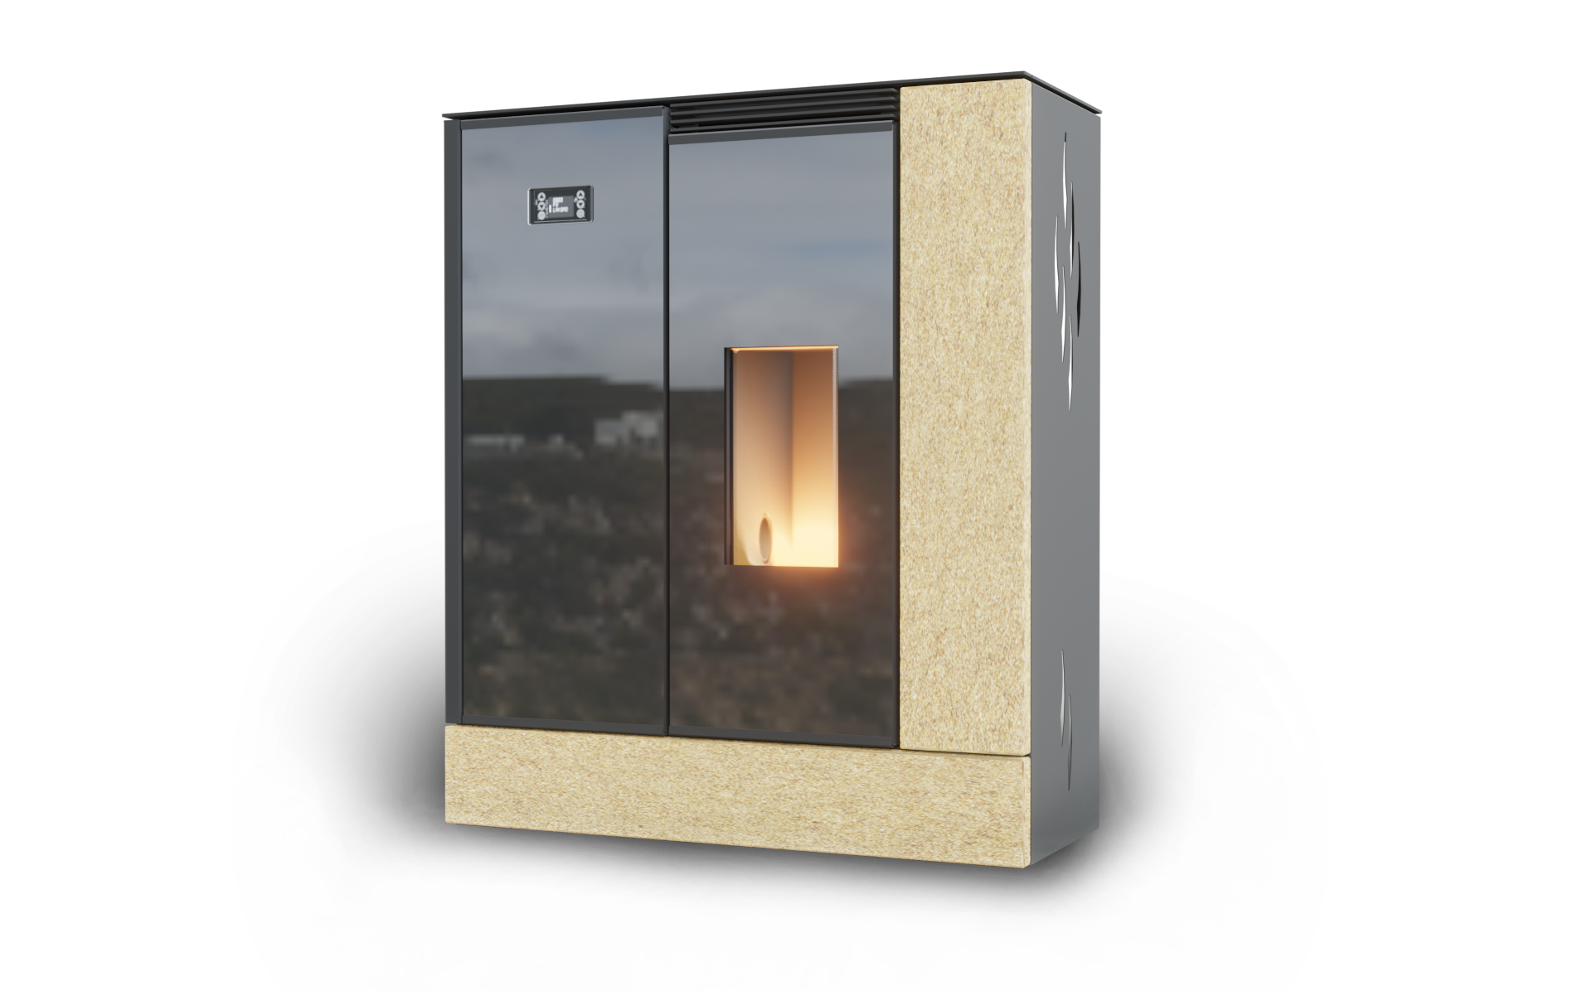

Instruction Manual
LP6 Pellet Stove

1. INTRODUCTION 3
2. TECHNICAL PARAMETERS 3
3. STOVE OPTIONS 4
4. TRANSPORT AND STORAGE 5
5. STOVE PLACEMENT 5
6. CHIMNEY CONNECTION 7
7. CENTRAL AIR CONNECTION 7
8. PUTTING INTO OPERATION 8
7.1 OPENING THE STOVE DOOR 8
7.2 SAFETY INSTRUCTIONS 8
7.3 FUEL 9
7.4 MAIN OPERATION PRINCIPLES 9
7.5 FIRST START-UP 9
9. CONTROL UNIT CONTROL 10
8.1 THE PELLET STOVE’S MAIN MODES 10
8.2 DISPLAY DESCRIPTION 10
8.3 STARTING THE STOVE 11
8.3.1 PELLET DOSING 11
8.3.2 IGNITING PELLETS 11
8.3.3 WORK MODE 11
8.3.4 ADJUSTING POWER SETTINGS 12
8.3.5 ROOM TEMPERATURE SETTINGS 12
8.3.6 ROOM TEMPERATURE HAS REACHED THE SET VALUE – POWER MODULATION 12
8.3.7 ROOM TEMPERATURE HAS REACHED THE SET VALUE – STAND-BY 12
8.3.8 SWITCHING THE STOVE OFF 12
8.4 USER MENU 12
8.4.1 NAVIGATION IN THE USER MENU 12
8.4.2 USER MENU STRUCTURE 12
8.5 BURNING ADJUSTMENT 13
8.6 FACTORY SETTINGS 14
8.7 ALARM MESSAGES 14
10. MAINTENANCE AND CLEANING 15
10.1 GENERAL RECOMMENDATIONS 15
10.2 CLEANING THE GLASS AND SURFACE OF THE STOVE 15
10.3 CLEANING THE COMBUSTION CHAMBER 16
10.4 CLEANING THE PELLET HOPPER 16
10.5 CLEANING FLUE GAS PATHS 16
11. CIRCUIT DIAGRAM 17
12. ROOM TEMPERATURE SENSOR 18
13. REPLACING THE IGNITION CARTRIDGE 18
14. DISPOSAL OF TRANSPORT PACKAGING AND THE PRODUCT AFTER ITS SERVICE LIFE 19
15. WARRANTY TERMS 19
16. WARRANTY CARD 20

INTRODUCTION
The automatic pellet stove is designed for permanent heating in residential and commercial premises. The fuel is transported by a screw feeder from the hopper to the burn pan and the fuel is automatically adjusted according to the desired room temperature. The stove's permanent operation is possible for around 30 hours with a full fuel hopper, depending on the desired room temperature and on the type of pellets and the stove's average performance when heating.

The stove is made from steel sheets. The fireplace is equipped with a heat-resistant, stainless-steel burn pan. The pellet stove doors are equipped with refractory ceramic glass and their design allows them to be opened horizontally to the left. A removable ashpan is also included.

The stove is controlled with an integrated control unit in the front cover. The user has the choice of stove power and can also set the desired room temperature. It is measured by a temperature sensor at the back of the stove.

The control unit regulates the starting phase, the heating phase and the extinguishing phase, therefore ensuring the stove's automatic operation. The display shows the current operating mode. Possible error messages are displayed in text form.

TECHNICAL PARAMETERS

Total height | mm | 1101
Width | mm | 931
Depth | mm | 396
Weight | kg | 209
Flue neck | mm | 80
Air inlet neck | mm | 50
Fuel hopper volume | kg | 35 kg
Minimum flue draught | Pa | 10-15
Calorific value of the living space (depending on the degree of building insulation) | m³ | 50 - 220
Efficiency | % | 87.3
Rated heat output | kW | 6.4
Heat output range | kW | 2.6–6.5
Power supply | V/Hz | 230/50
Average power consumption | W | ca 25
IP code | IP | 20
Fuse | A | 2.5
Fuel consumption at min ~ max heat output | kg/h | 0.7~1.6
Average flue gas temperature behind the neck | °C | 143
Flue gas mass flow rate | g/s | 6.5
CO content at 13% O₂ | % | 0.018
Noise level | dB | Not exceeding 50 dB
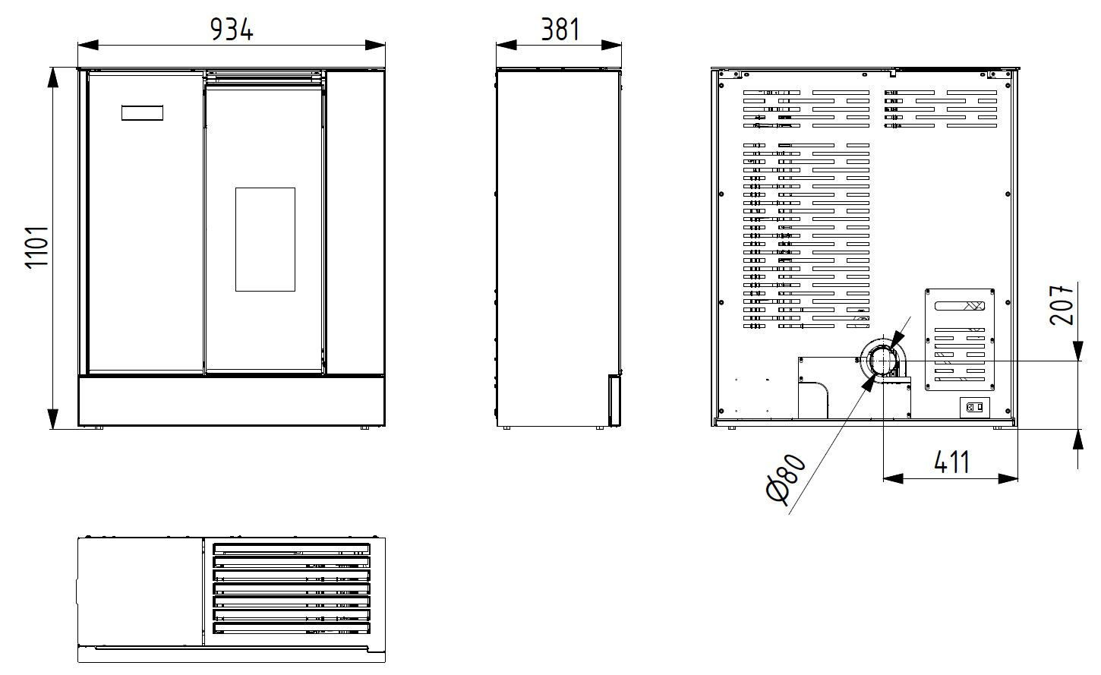
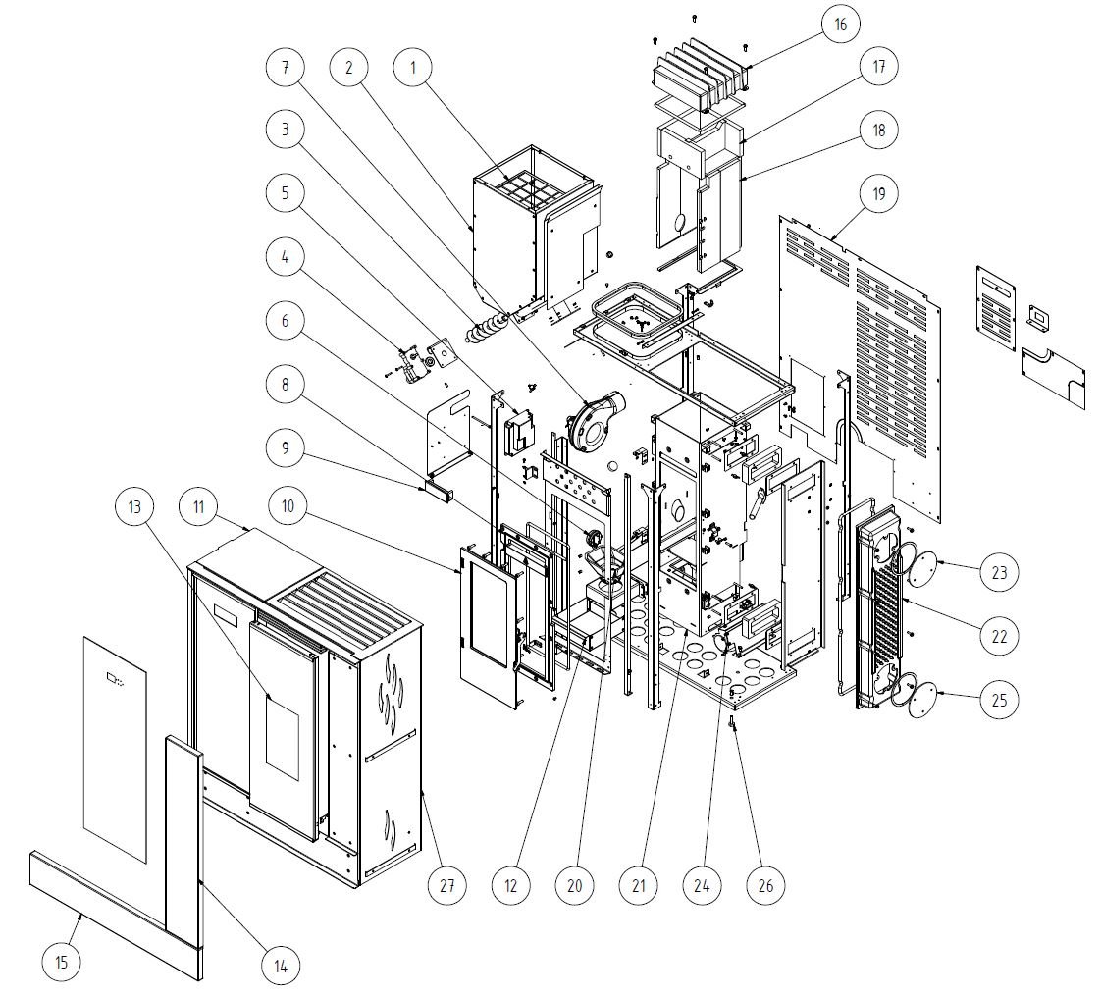

- Protective grille
- Hopper
- Screw feeder
- Feeder motor
- Control unit
- Vacuum sensor
- Flue gas fan
- Cast iron door frame
- Display
- Cast iron door
- Hopper cover
- Ashpan
- Door
- Side stone
- Bottom stone
- Steel heat exchanger
- Insulation
- Ceramic insulation
- Rear casing
- Burn pan
- Fire chamber
- Heat exchanger
- Cleaning lid
- Cross flow fan
- Cleaning lid
- Height adjustable feet
- Side casing

STOVE OPTIONS

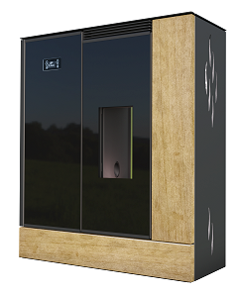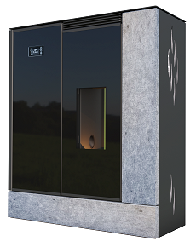
LP6 SA
(sandstone)
LP6 SE
(serpentine)

TRANSPORT AND STORAGE
Pellet stoves can only be transported in an upright position, in their original packaging and must properly secured against movement and falling. Transport must take place in a confined space to avoid damage due to weather conditions. It is necessary to maintain a vertical position when handling, the stove must not be tilted in any way to prevent damage. The stove must be held and carried by the metal parts at the bottom.

Upon receiving the product, please check the packaging's integrity and completeness, including its contents.

A pellet stove must be stored in a dry and tempered environment. Storage and handling must be done in an upright position. Handle with care. The stove is attached to the pallet with 2 screws. These must be removed before taking the stove off the pallet.

STOVE PLACEMENT
Each pellet stove must be unconditionally located and installed in a manner that complies with the conditions prescribed by local regulations or national and European standards, as amended, including their amendments, and in accordance with the instructions given in this Instruction Manual.

A pellet stove is intended for installation in a dry environment, which is characterised by the applicable standard as a non-aggressive environment free of any explosive and flammable gases.

Prior to installing a pellet stove, it is necessary to carry out an inspection of the flue body that will be used to connect the stove, including the design and assessment of the flue gas path, which must ensure safe flue gas removal from the connected pellet stove. Only one appliance can be connected to the flue gas path.

During installation, adequate access must be provided for cleaning the appliance, flue pipe and chimney.

We do not recommend that you have an air extraction device (e.g. a hood) in the interior where the pellet stove is placed, as it could cause backdraught and flue gases leaking into the room. If this device is in the interior, it is necessary to ensure the regulation of its draught and the intake of combustion air from an external room (cellar, utility room, etc.). Air conditioning can only be pressurised.

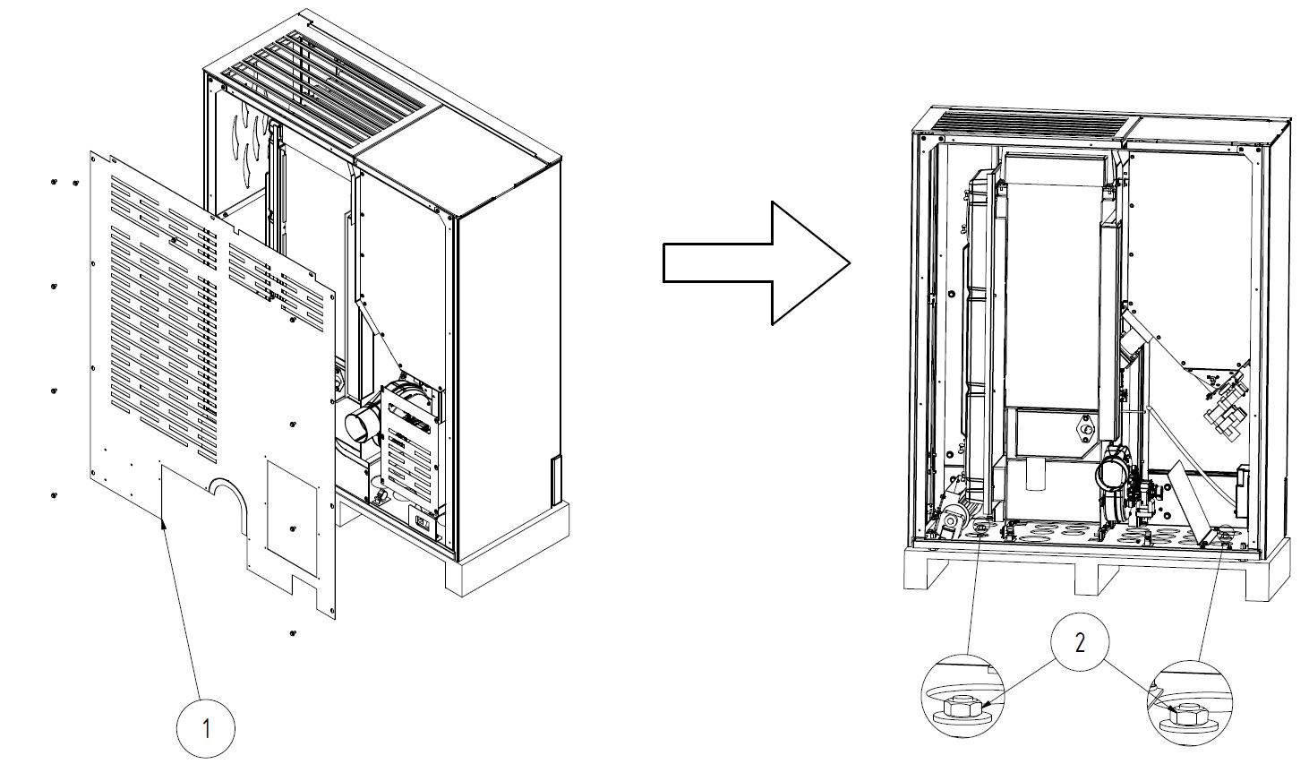
- Rear casing
- M10 nut

!
The pellet stove is attached to a pallet with 2 screws. These screws must be removed before taking the stove off the pallet. To remove these screws, first remove the 2 end caps on the stove's rear casing (marked with a red frame in the figure above). Then you can remove both screws and then take the stove from the pallet to its final location.

The appliance must be placed on a solid base with an appropriate load-bearing capacity, preferably on a concrete or other solid non-flammable board. If an existing assembly does not meet this necessary condition, appropriate measures must be taken to meet this requirement.
When installing on a floor made from combustible material, the appliance must be placed on an insulation pad made from non-combustible material, exceeding the floor plan of the appliance by 800 mm in the radiation direction and 400 mm from the remaining sides.

Items made from flammable materials must not be placed on the appliance and at distances smaller than the safety distance (see the following table). At an unknown degree of flammability, it is necessary to start from a distance for degree E (F).

Reaction to fire | Examples of construction materials and products classified as reaction to fire (selection from ČSN EN 13501-1+A1) | Minimum distance (mm)
 |  | Direction perpendicular to the radiant wall | Other directions
A1 – Non-combustible | granite, sandstone, concrete, brick, ceramic tiles, mortars, fire-resistant plasters, etc. | - | -
A2 – Limited combustibility | acumin, isumin, mineral bonded wood wool boards, plates and basalt felt, fiberglass plates, etc. | 800 | 400
B – Limited contribution to fire | beech, oak; Hobrex, Sirkolit, Werzalit boards; bonded paper, etc. | 800 | 400
C (D) – Minor (medium) contribution to fire | pine, larch, spruce, chipboard and cork boards, rubber flooring, etc. | 800 | 400
E (F) – High contribution to fire (easily flammable) | asphalt cardboard, fibreboard, cellulosic materials, polyurethane, polystyrene, polyethylene, PVC, etc. | 1600 | 800

For minimum distances from flammable or non-combustible materials, you can follow the following values:

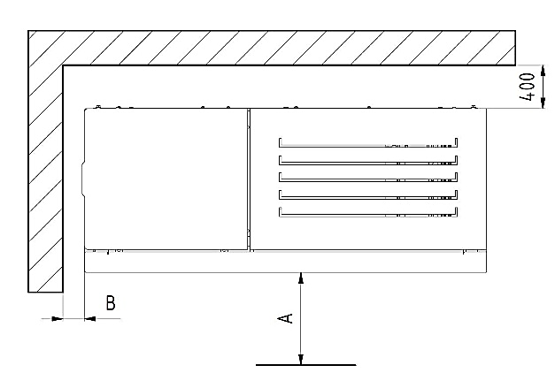
Flammable materials:
A > 800 mm
B > 200 mm

Non-combustible materials:
A > 400 mm
B > 100 mm

Safe distance of flue pipes from flammable building structures

The safe distance from the door frame lining and similarly placed building structures made of flammable materials and from pipe installations, including their insulation, is at least 20 cm. It is at least 40 cm from other parts of structures made from flammable materials in accordance with ČSN 06 1008/1997.

These are Class B, C and E combustibility construction materials in accordance with ČSN EN 13501-1/2010. This also applies to plastered walls and especially ceilings on a flammable base, e.g. laths, pallets, etc.! If these distances cannot be observed, the risk of fire must be prevented by means of construction measures, non-combustible tiles, heat-resistant insulation and screens.

The distances can be reduced up to a quarter if the flue pipe is sheathed with at least 2 cm thick non-combustible material (heat-resistant insulation).

The stove manufacturer bears no responsibility for a poorly built chimney or for insufficient distances between the chimney and combustible structures, etc. This is the total responsibility of the chimney contractor and the construction company that built the chimney. Similarly, the stove manufacturer bears no responsibility for an inappropriately designed flue pipe passage through a flammable wall or ceiling.

If flue pipes run through walls made from flammable construction materials or with flammable components, it is necessary to make a filler of non-flammable materials with very low thermal conductivity around the flue pipe (see ČSN 061008 Fire protection for heating appliances).

CHIMNEY CONNECTION
Before putting the pellet stove into operation, the flue gas path must be inspected and tested before the flue gas path is closed with the hot air chamber jacket. These activities can only be carried out by qualified personnel, e.g. a chimney sweep company. The inspection result must be entered in the flue gas path inspection report.

We recommend entrusting the stove's installation to properly trained, specialised construction companies or chimney sweep or stove-fitter companies.

Inspection of the flue gas paths must be carried out:
- Before the flue gas path is put into operation
- After every chimney modification
- Before replacing or reinstalling the appliance.

The inspection is carried out by professionally qualified personnel in the chimney sweep field who is a chimney inspection technician.

General instructions for chimney connection:

- The flue gas extraction is provided by a flue gas fan, which is part of the pellet stove.
- The stove must be connected to a separate chimney. It is not permissible to discharge the flue gases from other devices into this chimney.
- The chimney can be of classic design (brick), but also of stainless-steel or ceramic.
- Conventional pipes or flexible steel pipes for flue pipes can be used for chimney connection.
- All parts of the flue up to the entrance to the chimney must be gas-tight due to possible overpressure at the flue gas outlet.
- The flue pipe must not interfere with the chimney's free cross-section.
- The stove meets the requirements for chimney connection rated at a flue gas temperature of 350 °C.
- The minimum required chimney draught is 10 Pa. The draught is affected by both the chimney length and area as well as the quality of its sealing. The minimum recommended chimney length is 3.5 m from the place where the flue enters the chimney and the appropriate minimum cross-section is 150x150 mm.
- The coupling sleeve's outer diameter is 80x1.5 mm for flue parts.
- The flue must be made of sealed steel or stainless-steel pipes. Two pieces of 90° elbows can be used.
- If the flue pipe is located on the building's exterior, it must be provided with thermal insulation.
- Flue pipes with sharp bends and horizontal routing reduce chimney draught. The maximum horizontal piece of flue is 2 m, provided that the flue's vertical length is a minimum of 5 m.
- The flue pipe must be accessible for inspection and cleaning. It must be possible to sweep the entire length of the chimney and the chimney door must be easily accessible.
- Carefully check that the chimney is sealed and that there is no flue gas leaks around the chimney doors and the flue pipe connections.
- Flue gases are discharged through a flue pipe with a diameter of 80 mm connected to the stove's flue neck, which is located on the rear of the stove.

CENTRAL AIR CONNECTION
Central air connection must be implemented in airtight buildings, where oxygen content may be reduced in a room heated by a pellet stove.

- 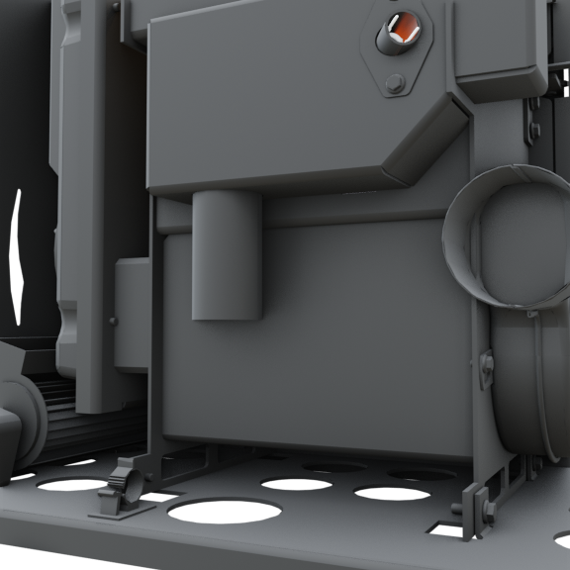Connect the hose to the air intake nozzle on the rear wall (Ø 50 mm).
- The air duct inlet must be located outdoors or in a well-ventilated room inside the building.
- When installing the pellet stove in a building with controlled ventilation of living areas, the air supply inlet must not be located in a room that is connected to the combined ventilation system.
- To ensure sufficient air supply, the duct must not be longer than 3 m and must not have too many bends. Minimum duct diameter is 50 mm.
- If the duct runs into the outdoor area, it must be bent downwards by 90° or it must end in a leeward direction.

PUTTING INTO OPERATION
See below for a complete list of instructions on how to start the stove for the first time. We recommend reading this chapter carefully before using the stove for the first time, including the following chapter on controlling the stove control unit.

  - OPENING THE STOVE DOOR
The stove has two doors. A cast iron door separates the combustion chamber from the surroundings and the glazed door is decorative and complements the overall design of the pellet stove. Make sure the sealed surfaces on the inner frame of the cast iron door are clean allowing closing to be as easy as possible. The cast iron door is opened and closed with a handle, the decorative door with a handle and a magnet (included). To open the decorative door, press it on the right edge. Make sure the glass on both doors is clean.
!
Both doors must always be closed when operating the stove, otherwise the stove will not work properly and there is a risk of damage or combustion products leaking into the room!

If necessary, always open the cast iron door slowly and carefully to prevent a sudden change in the pressure in the fire chamber and to avoid smoke escaping into the room.
!
If you see smoke without a flame in the fire chamber, NEVER open the door. When smoke is mixed with the air from the room, ignition of the resulting gases may occur, even an explosion of these gases in extreme cases.

If you see smoke in the combustion chamber, wait until the smoke is drawn into the chimney and the combustion chamber is clean, without smoke. The door can then be opened.

  - SAFETY INSTRUCTIONS
- Take extra care and follow the safety instructions when handling and unpacking!
- If there is a risk of combustible gases in the room with the installed pellet stove for a transitional period (when gluing linoleum, painting, etc.), the pellet stove must be decommissioned before this risk arises!
!
It is necessary to constantly ventilate and provide the room enough fresh air due to the warming of the stove's painted surface during first use!

- Sufficient supply of combustion air and safe exhaust of flue gases must be ensured during operation!
- Both doors must always be closed during operation!
- Pellet stove operation should only be carried out by a competent adult!
!
Ensure that children, people with mental disabilities and pets cannot enter fireplace area or get close to very hot parts (doors, glass, side casings, fire chamber cover, etc.) during operation – there is a risk of burns and possible danger to life!

- The stove fire must be checked regularly throughout its operation!
- When operating another thermal device simultaneously in the same space, it is necessary to ensure sufficient ventilation!
- NEVER touch the pellet stove's outer surfaces - risk of burns and possible danger to life, except for the control and regulating elements!
- NEVER extinguish a pellet stove fire with water!
!
Ashpan ash must be removed with caution and using protective equipment only outside the pellet stove operation!

- Store the ash in non-combustible containers with lids!
- The appliance must not be used to incinerate waste, NEVER use garbage and liquid fuels in any combination! Only use recommended fuels.
- In the event of a fire of deposits in the chimney, quickly extinguish the fire in the pellet stove with a powder fire extinguisher or sand, remove all flammable material from the stove and chimney body's vicinity. Close the doors, stove controls and smoke control damper (if installed) and call the fire brigade immediately! Have the pellet stove and flue gas paths, including the chimney, inspected by a specialist before putting it back into operation!
- No modifications to the product are allowed except for assembly and service work carried out by authorised personnel.
- NEVER put fuel on the grate pan by hand. If you throw pellets on the grate with your hands during operation, the flame goes out. Accumulated gases may then cause an explosion in the combustion chamber.

  - FUEL
Only using dry and high-quality fuel guarantees clean and good combustion. Fuel must be stored in a dry place. The stove is designed for burning high-quality wood pellets, burning e.g. wood chips, straw or maize is unacceptable. NEVER use pellets made from materials other than pressed wood (e.g. olives, maize, flax, etc.).

Pellets must comply with at least one of the following directives or standards:
- Directive No 14-2000 of the Czech Republic Ministry of the Environment
- DIN 517 31
- ÖNORM M 7135

Prescribed pellet grain size: 6 mm Water content in fuel: 12% max
Prescribed pellet length: 5–40mm Ash content: 1.5% max
!
Poor fuel quality can significantly affect the performance and emission parameters of the stove in a negative way.

Quality wood pellets usually have a smooth, glossy, light surface, a uniform length and low dust content. Poor quality pellets have longitudinal and transverse cracks, a dark surface, uneven length and high dust content. Pellet quality can be verified with a simple test. Put a few pellets in a glass of water. If the pellet quality is good, they sink to the bottom; if the quality is poor, they float on the surface.
However, the fuel quality can only be accurately determined using appropriate analytical instruments.
!
When adding wooden pellets into the hopper, make sure that the pellet bags are not in contact with the stove's hot surface.

  - MAIN OPERATION PRINCIPLES
- The stove and its operation is controlled automatically, using an electronic system. The stove cannot be overloaded if it is operated in accordance with the instructions for use. NEVER operate the stove using fuel other than that specified (see Chapter 7.3). Burning fuels other than those specified and failure to comply with the above conditions may result in damage to the stove's internal components or the entire stove and may void the warranty.
- Remove ash from the grate and ashpan prior to every use.
- Extra care must be taken when putting it into operation in seasonal use and in poor draught or weather conditions.
- It is necessary to check that there is no blockage of the flue gas paths after a longer period of interrupted operation.
- We recommend that a professional company performs maintenance, including cleaning, before each season.
- The stove is equipped with an automatic cleaning system for the burn pan during operation. This cleaning is set systemically at every 10 min of operation for 15 s. The flue gas fan is switched on at maximum speed and therefore the burn pan is blown through to clean the holes in the combustion air supply on the bottom surface of the grate pan. Do not be surprised if this activity occurs spontaneously during operation.

  - FIRST START-UP
it is necessary to constantly ventilate and provide the room with enough fresh air when warming the pellet stove's surface paint during the first use!
!
Prior to using the stove for the first time, we recommend that you carefully read the following chapter "Control Unit Control".

- Prior to first use, it is necessary to remove the stickers from the stove's glass parts and remove the accessories from the ashpan or the fire chamber area; this also applies to the possible transport safety lock.

- Check the burn pan is positioned correctly.

- Close the fire chamber door.

- Fill the hopper with standard wood pellets (Ø 6 mm).

- Close the pellet hopper cover.

- Connect the power cable.

- Turn the main switch to "1".

- If the house has mechanical ventilation and has low pressure inside, open a window near the stove for a few minutes before the fire starts.
- Fill the feeder with pellets using the Initial Load function. This function is only available when the stove is switched off. If the feeder is completely empty, you may need to press this function more than once to fill the feeder with pellets. Deactivate this function when the pellets start to fall on the grate.

You do not want extra pellets on the grate that do not belong there. If this happens, remove these pellets from the grate before igniting the stove. After activating the ignition, the stove adds its own correct dose of pellets for quick ignition.

- Start the stove's ignition. Hold down the T4 button for a few seconds to ignite the stove. After switching on, the display shows Start and then Waiting Fire.

More in Chapter 8.3, where you will learn about the stove's exact starting and its initial temperature settings.

CONTROL UNIT CONTROL

Using the display, you can control the stove unit by simply pressing a few touch keys. The display informs the user about the stove's operating condition. Below you will find a list of the unit's main functions in a comprehensible way, therefore allowing you to control the stove or correct its functions as required.

Bear in mind that pellet stoves are solid fuel stoves. Therefore, they require the correct pellet dosing settings and a sufficient supply of combustion air, which is ensured by the room's air supply and a sufficient flue gas fan speed.
!

The stove must not be operated by children and disabled people.

  - THE PELLET STOVE’S MAIN MODES
The following stove operating modes are listed chronologically as they follow after the stove is put into operation.

- Waiting Fire: When the stove is switched on, the grate is gradually cleaned, the ignition cartridge is preheated, the pellets are dispensed and ignited.
- Fire Present: Flame is detected; waiting for a stable flame that does not go out
- Work: The stove operates in work mode at a given output of 1 to 5 (5 highest output).
- Modulation: The power reduces when the specified temperature in the space is reached.
- Final Cleaning: After switching the stove off, the grate is cleaned and then switched off.

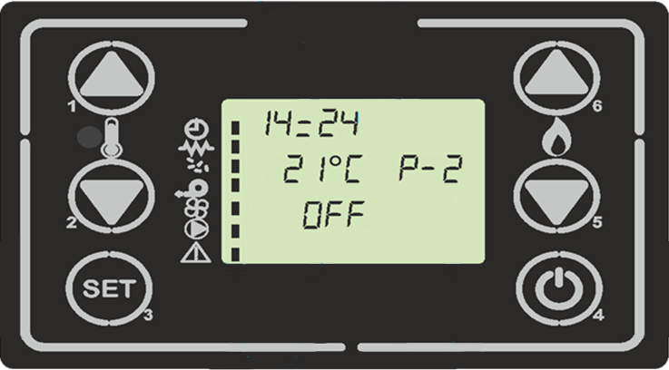 DISPLAY DESCRIPTION
The display shows information about the stove's operating status.

Button 1 – Room temperature increase
Button 2 – Room temperature decrease
Button 3 – Menu – parameter setting
Button 4 – Switching the stove on/off (hold down the button)
Button 5 – Reduce stove power
Button 6 – Increase stove power

The figure below shows the meaning of the status symbols on the left side of the display. Activation of one of the symbols on the display indicates the activation of the stove's corresponding electrical equipment.
Current time
Timer
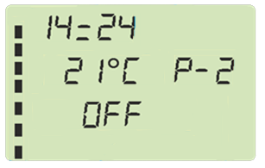
Ignition cartridge
Current room temperature
Entered maximum power factor (1-5)

Pellet feeder

Flue gas fan

Room fan
Current stove status
For the option with a hot-water exchanger

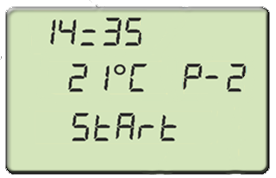 STARTING THE STOVE
Hold down the T4 button for a few seconds to ignite the stove. After switching on, the display shows Start and then Waiting Fire. The stove will now enter the ignition cartridge pre-heating, whereby the ignition cartridge and the flue gas fan for air extraction will be switched on simultaneously. Subsequently, the pellet feeder is switched on, which gradually dispenses the prescribed amount of pellets. If the igniting cycle lasts longer, the feeder gradually dispenses additional pellets to make sure that there are enough pellets on the grate pan to ignite.

The following are two possible functional states:

- Pellets are ignited: Fire Present message on the display.
- Failure to ignite: No Pellets message on the display.
!
Hold down the T4 button to reset any alarm displayed on the display.

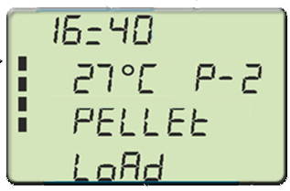PELLET DOSING
After the ignition cartridge pre-heating period has elapsed, the feeding screw loads the pellets onto the grate and the flue gas fan speed is constant. The heating cartridge is currently on. In the second phase, after the specified period has elapsed, the feed screw is switched off, with the heating cartridge still on as before and the fan running at a constant low speed. The feeder continuously dispenses more pellets so that there is a sufficient amount on the grate. The Waiting Fire message is displayed on the display at that moment.

    - IGNITING PELLETS
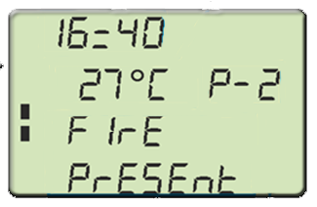The pellet stove unit monitors the current flue gas temperature at the outlet from the stove to the chimney. As soon as the pellets are ignited, the temperature at the chimney outlet begins to rise. After the flue gas temperature reaches and exceeds the limit value, the system enters the flame stabilisation mode and the display shows Fire Present.

At this stage, the temperature should remain stable for a defined period of time. A larger amount of pellets is added and the ignition cartridge is deactivated. If there is a decrease in the flue gas temperature at this stage, the pellet dosing will be stopped and an error state will be declared.

    - WORK MODE
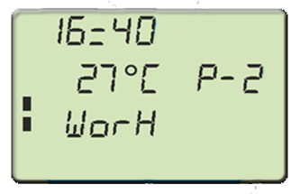After the flue gas temperature reaches the limit and does not drop during the specified period, the stove goes into standard operating mode. The display shows Work.

At that moment, the stove is working at the set power and the aim is to achieve the desired temperature in the room. The room fan is switched on and its speed depends on the current stove power.

The grate is cleaned at regular intervals at this stage. This is reflected in a short-term increase in the flue gas fan speed. Cleaning is indicated on the display with Burn Pan Cleaning. After cleaning, the stove will return to work mode.

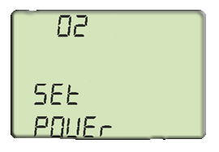ADJUSTING POWER SETTINGS
To adjust the maximum power setting, simply press the T5 or T6 button on the unit display. The display shows the Set Power. Press T5 (to decrease power) and T6 (to increase power) to change this number. After approximately 5 seconds, the heater saves the entered number in memory and the display returns to its normal state. Alternatively, you can press T3 and then T4 to exit.

ROOM TEMPERATURE SETTINGS
To adjust the room temperature setting, simply press the left T1 or T2 button on the home screen. The display shows the SET Temperature. Press T2 (to decrease) and T1 (to increase) to change this number. After approximately 5 seconds, the heater saves the entered number in memory and the display returns to home screen.

    - ROOM TEMPERATURE HAS REACHED THE SET VALUE – POWER MODULATION
When the ambient temperature reaches the set level, the stove power is automatically reduced to the minimum level. At this point, the message Work Modulation appears on the display. If the room temperature drops below the set temperature, the stove will return to work mode with the previously set power.
    - ROOM TEMPERATURE HAS REACHED THE SET VALUE – STAND-BY
If the stand-by function is enabled in the menu, it allows you to turn the stove off as soon as the ambient temperature is higher than the set one for the decisive time. When this period has exceeded, the display shows Cooling Wait. In this state, the feeding screw is switched off, pellets are not dispensed. The room fan switches off as soon as the temperature drops below its starting limit. If the room temperature decreases by a preset hysteresis, the stove will reignite.

Stand-by must be activated in the Stand-by Mode menu item.

SWITCHING THE STOVE OFF
To turn off the stove off, press and hold the T4 button. The display shows Final Cleaning. The feeder motor stops, both fans will change to the extinguishing speed.

USER MENU
Press the T3 button to access the menu. The menu is divided into different levels and items that allow access to the setting and programming of the stove operation.

NAVIGATION IN THE USER MENU
- Use the T3 button to enter the user menu from the home screen.
- Use the T5 and T6 buttons to move up and down in the menu items.
- Use the T3 button to enter individual items in the user menu.
- Use the T1 and T2 buttons to change the set value in a specific user menu item.
- Press the T3 button to save your selection. Press the T4 button to exit the settings of a specific item back to up one level.

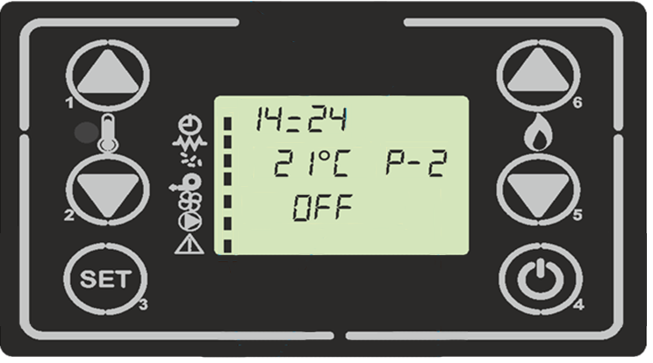
Switching the stove on and off.

Exit the menu and menu items

Enter the menu and menu items

Change the maximum stove power

Movement in menu items.
Room temperature change

Change the value in menu items

    - USER MENU STRUCTURE
The following table briefly describes the menu structure, especially with regard to the setting options available to the user.

Set clock | Sets the current time and date. The circuit board is equipped with a lithium battery to allow the internal clock to be autonomous for 3 to 5 years.
Set Chrono | The menu allows you to activate or deactivate all time-start functions.  The unit is equipped with 2 modes, namely a daily and a weekly programme. In the day mode, you can choose what time of day the stove will be activated. In the week mode, you choose which day the stove is to work and also to which time period during the day this weekly programme applies.
Set Language | Language selection.
Stand-by mode | Allows you to enable or disable stand-by mode. When the stand-by mode is activated, the stove switches off when the room temperature is reached.  If the stand-by mode is deactivated, the stoves enter the modulation mode (minimum stove power) after reaching the desired temperature.
Buzzer mode | Acoustic signal and its activation or deactivation. This is a signal for alarm messages.
Initial load | This function is only available when the stove is switched off. Allows the feeding screw to be filled the first time the stove is started when the pellet feeder is empty.  If the feeder is completely empty, you may need to press this function more than once to fill the full feeder with pellets. Deactivate this function when the pellets start to fall on the grate. You do not want extra pellets that do not belong on the grate to be on the grate. If this happens, remove these pellets from the grate before igniting the stove. After activating the igniting, the stove adds its own correct dose of pellets for quick igniting.
Stove state | Visualises the current status of different devices that are connected to it. Several pages are available for viewing.
Technical settings | This menu item is only accessible to the technician who installed the stove. Once the access password is entered, it allows you to set the stove's various operation parameters.  Do not enter this menu. You could fundamentally damage the proper operation of the stove.
Pellet type  (use for burning adjustment, Chapter 9) | Pressing P1 or P2 adjusts the pellet load up to the maximum value of +9 and down to the minimum value of -9.  Each step increases or decreases the load by approximately 3% of the total feeding screw time, with respect to the initial period. "0" is without feeding adjustments – factory settings.
Chimney type  (use for burning adjustment, Chapter 9) | Adjusting this item will change the exhaust fan speed up to the maximum value of +9 and down to the minimum value of -9. Each step will increase or decrease the flue gas fan settings by approximately 5% with respect to the initial speed. "0" is without speed adjustments - factory settings.

  - BURNING ADJUSTMENT
Burning adjustment can be performed using 2 functions in the control unit menu.

- Fan speed adjustment – Chimney type function, adjustment range from -9 to +9%

- Pellet load adjustment – Pellet type function, adjustment range from -9 to +9%

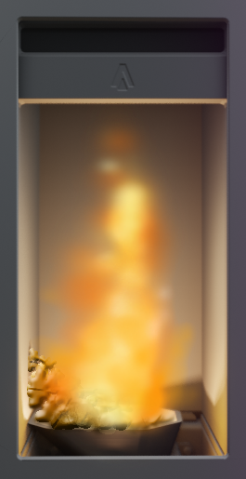Correct flame Low fan speed
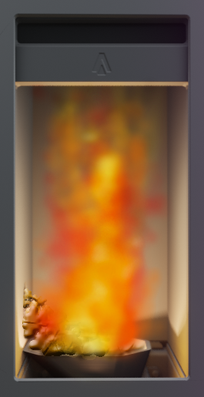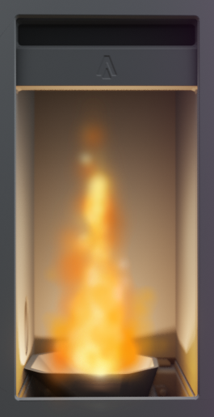
Pellets accumulated on the grate
Flame too big

High pellet load
  - FACTORY SETTINGS
The control unit has a service menu which can only be accessed by the manufacturer. All the main parameters affecting the stove's operation are stored in these settings. Do not interfere with these settings. Below is a list of all values if you need to put the stove into the factory, default state.

Parameter | Value |  | Parameter | Value |  | Parameter | Value
M-9-4-01 | 10' |  | M-9-4-18 | 2000 |  | M-9-2-01 | 0.5'
M-9-4-02 | 0.6' |  | M-9-4-19 | 2650 |  | M-9-2-02 | 10'
M-9-4-03 | 20' |  | M-9-4-23 | 140V |  | M-9-2-03 | 90''
M-9-4-04 | 4.0'' |  | M-9-4-24 | 185V |  | M-9-2-04 | 180''
M-9-4-05 | 4.0'' |  | M-9-4-28 | 60C |  | M-9-2-05 | 1900
M-9-4-06 | 1.5'' |  | M-9-4-29 | 2800 |  | M-9-2-06 | 2,0' C
M-9-4-07 | 3.0'' |  | M-9-4-30 | 0'' |  | M-9-2-07 | 0.2''
M-9-4-11 | 60'' |  | M-9-4-31 | ON |  | M-9-2-08 | 15''
M-9-4-12 | 10'' |  | M-9-4-32 | 0.2'' |  | M-9-2-09 | 200V
M-9-4-13 | 40C |  | M-9-4-33 | 30'' |  | M-9-2-10 | OFF
M-9-4-14 | 280C |  | M-9-4-34 | 10'' |  | M-9-2-11 | 0''
M-9-4-15 | 50C |  | M-9-4-35 | 2000 |  | M-9-2-12 | 2800
M-9-4-16 | 2000 |  | M-9-4-36 | 1000
M-9-4-17 | 2400 |  | M-9-4-37 | 2000

  - ALARM MESSAGES
If the control unit detects problems during operation, it will shut the stove down and sound an alarm accompanied by an acoustic signal (if activated in the Buzzer Mode).

Alarm origin | Alarm displayed | Alarm description
Power failure | AL 1 BLACK OUT | Power failure may occur during operating mode. When it restarts, the stove will go back to the Work Mode if the power failure time is shorter than specified in the BLACK OUT parameter (hidden menu); otherwise an alarm will sound.
Flue gas sensor failure | AL 2 FUME PROBE | If the flue gas sensor is faulty, an alarm will sound. Check the flue gas sensor that is connected to the exhaust fan at the back of the stove.
High flue gas temperature | AL 3 HOT FUME | An alarm will sound if the flue gas sensor reaches a temperature higher than the fixed value specified in the factory parameters.  If the flue gas temperature reaches above 280°C during operation, the stove power will be modulated downwards to reduce the flue gas temperate below this limit. If this is done within the specified time interval, the stove goes back to its original operating mode.
Fan fault | AL 4 FAN FAILURE | An alarm will sound if one of the fans is defective.
Igniting failure | AL 5 FAILED IGNITION | The alarm sounds when the stove does not ignite, i.e. if the flue gas temperature in the chimney does not rise by the specified lowest value during the set time.
Missing pellets | AL 6 NO PELLET | If the flue gas temperature drops below the critical parameter in the Work Mode, an alarm will sound.
Vacuum error | AL 8 FAILURE DEPRESS | An alarm sounds when the pressure switch reaches a pressure value lower than the trigger threshold. The pressure switch turns the feeder off and the display shows an error message after some time.

MAINTENANCE AND CLEANING
!
Maintaining and cleaning the stove is done only when the fire chamber is cold. The main switch must be in the "0" position and the network cable must be pulled out. The stove must not be operated by children and disabled people.

When cleaning is completed, the device's proper operating condition must be restored. The pellet burn pan must be properly fitted; the fire chamber door closed.

Ash must be placed in non-combustible containers with a lid. Protective equipment must be worn during work and personal safety must be taken into account.

Regular cleaning and regular maintenance must be carried out in connection with the formation of ash when burning pellets. This is the only way to achieve trouble-free operation. The maintenance and cleaning frequency depends decisively on the pellet quality (ash content). High-quality pellets have a low ash content, about 0.2-0.3%. With a higher ash content (0.5% or more), the maintenance and cleaning interval is shortened and the ash generation increases 2-3 times. The result is a lower heating capacity and therefore an overall reduction in the pellet stove's efficiency .

10.1 GENERAL RECOMMENDATIONS
Before each igniting, check that there is not a large amount of ash in the burn pan (above the level of the side holes). If so, clean the burn pan and the area under the pan from ash and return the burn pan back to its position.

Regularly check the ash level in the ashpan according to the heating intensity in the pellet stove. If the heating is intense (6 hours or more every day), it is recommended to clean the ashpan every other day. If the heating is less intense or only sporadic, just clean the ashpan weekly.

During the heating season, vacuum the ash and remnants of unburnt pellets located in the area around the burn pan and outside the ashpan monthly with the help of an ash vacuum cleaner. Scattered ash can prevent proper placement of the ashpan and proper closing of the door.

It is recommended to clean the side heat exchanger and the space below and above the fire chamber using a cleaning brush and an ash vacuum cleaner once per heating season (usually before the season).

10.2 CLEANING THE GLASS AND SURFACE OF THE STOVE
- NEVER use abrasive agents to clean glass or sheet metal parts as they may be damaged.
- It is necessary to first open the fire chamber door to clean the door glass. When cleaned regularly, it is usually enough to simply wipe the glass with dry paper. Soot buildup on glass doors can best be removed with cleaning fluid or some branded soot removers that are available in larger shops. Glass cleaning must only be carried out when the stove is cold.
- The stove surface can be cleaned with a damp cloth or, if necessary, with a weak soap solution.
- Minor damage to the stove surface can be repaired with paint for repair coatings.

10.3 CLEANING THE COMBUSTION CHAMBER
The cold combustion chamber must be cleaned as soon as you find ash residues. Excessive ash causes pellets to accumulate in the burn pan and prevents the necessary combustion air from entering the pellets. This could result in improper pellet burning, heating ignition cartridge clogging or the pellet stove's overall poor functioning. This could damage the stove and is not covered by the warranty.
- During operation, depending on the fuel quality, deposits may form in the combustion chamber (on the walls), which must be removed several times per heating season with an ordinary broom or ash vacuum cleaner.
- Make sure that no live coals remain in the ashpan when removing ash from the stove.
!
It is necessary to check the door seals regularly. The stove's performance and functioning is significantly affected by leaks.

- Concrete linings, burn pan or door seals must be changed regularly as needed.

  - CLEANING THE PELLET HOPPER
- Clean after emptying the hopper completely.
- Remove the protective grille.
- Clean the hopper and the fuel screw conveyor inlet with a vacuum cleaner.
- Reinstall the protective grille. It is necessary to ensure that no hard or metal parts remain in the pellet hopper to prevent subsequent damage to the screw conveyor.
  - CLEANING FLUE GAS PATHS
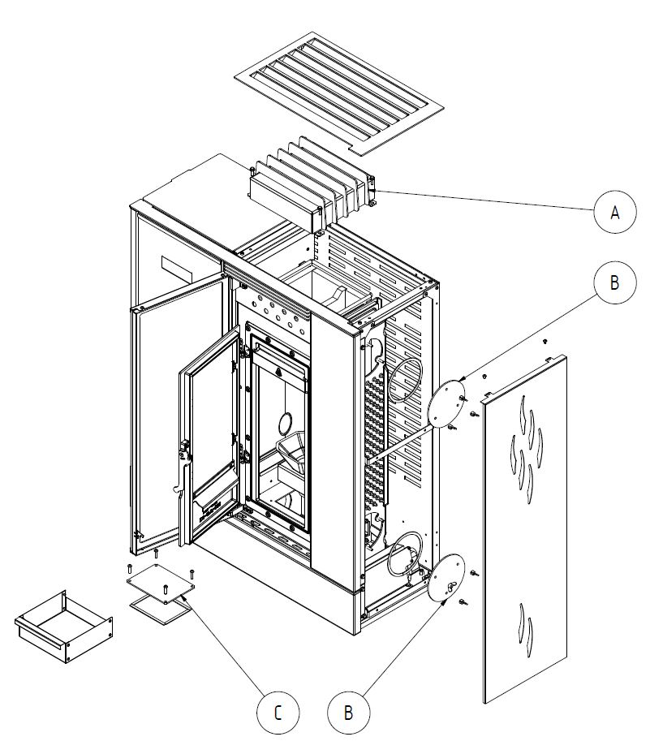
A Upper flue gas exchanger
B Side flue gas exchanger
C Space under the ashpan

Soot from the flue pipes and chimney should be removed annually by a qualified chimney sweep.

Soot can be removed from the stove by wiping or brushing the sides of the fire chamber or by using a soot vacuum cleaner.

- Upper flue gas exchanger:
1. Remove the top cover.
2. Loosen the exchanger cleaning lid screws using the wrench 10 and remove the cleaning lid.
3. Clean the exchanger walls with a brush and ash vacuum cleaner.
4. Replace the exchanger cleaning lid and secure with the 4 screws.
5. Replace the top cover.

- Side flue gas exchanger
1. Remove the 2 screws of the side cover using 3mm Allen wrench.
2. Loosen the 3 wing nuts of the upper cleaning lid and remove the lid.
3. Use a long brush to clean the exchanger with vertical strokes.
4. Loosen the 3 wing nuts on the lower cleaning lid and remove the lid.
5. Dust and soot should be vacuumed with an ash vacuum cleaner.
6. Replace the exchanger cleaning lids and secure with the 6 screws.
7. Reassemble the side cover and secure with the 2 screws.

- Space under the ashpan
1. Open the glass door.
2. Open the cast iron door.
3. Remove the ashpan.
4. Loosen the 4 screws on the cleaning lid using the wrench 8 and remove the cover.
5. Dust and soot should be vacuumed with an ash vacuum cleaner.
6. Replace the cover and secure with the 4 screws.

Cleaning the exhaust fan casing (not needed or only exceptionally). Follow these steps:
- Disconnect the appliance from the mains!!!
- Loosen the 4 screws.
- Remove the exhaust fan.
- Clean the exhaust fan blades, flue and flue pipes using a brush and ash vacuum cleaner.
- Reassemble the individual parts in reverse order. Take care of the fan motor's electrical connections and their proper placement.

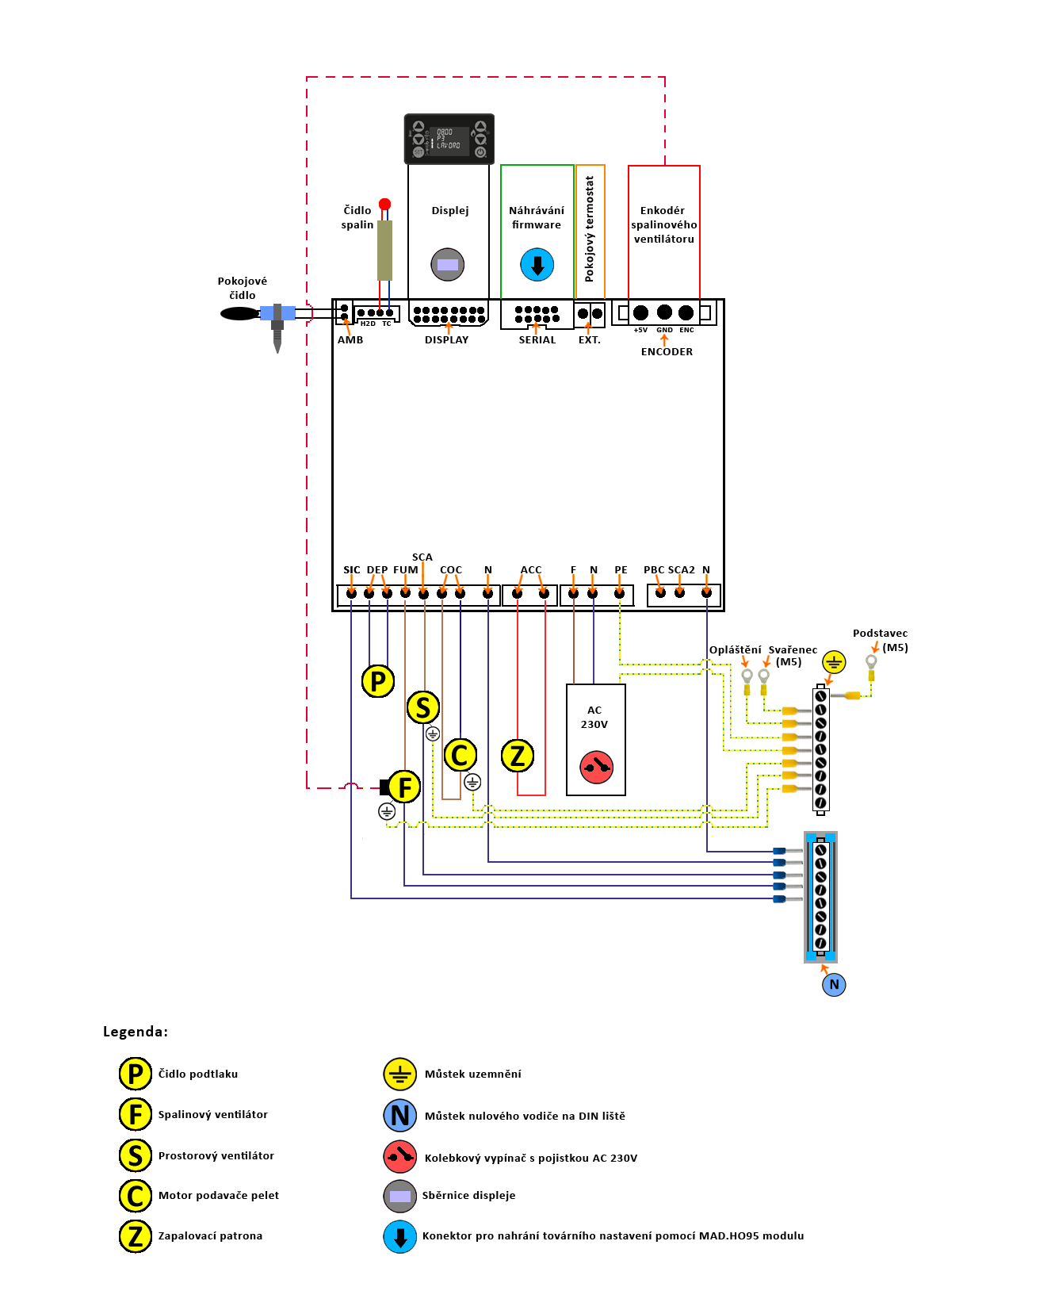
CIRCUIT DIAGRAM

ROOM TEMPERATURE SENSOR

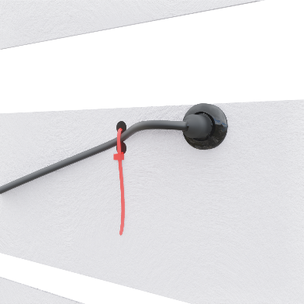
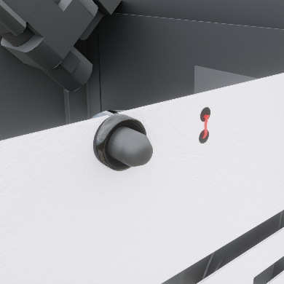
The room temperature sensor is at the rear of the stove. This sensor senses the temperature in the space. In order for the sensing temperature to correspond to real values, it is necessary to install the stove so that there is sufficient space for air flow at the rear of the stove. Otherwise, the value measured by the temperature sensor will not correspond to the actual room temperature.

Bear in mind that the value measured by the room sensor is only informative. The pellet stove uses it to adjust the power to maintain the temperature at the required level. The actual temperature in the room is affected by several factors and therefore the actual temperature may differ from the set one.
!

Sensor from the outside of the stove Sensor from the inside of the stove

REPLACING THE IGNITION CARTRIDGE

The ignition cartridge is at the rear of the stove; it is necessary to remove the stove's rear casing. The cartridge is inserted into the slot and connected electrically to the control unit via the WAGO clamps.
!
Ignition cartridge replacement should only always be carried out by a trained assembly/service company with a valid authorisation from the stove manufacturer.

When replacing the cartridge, proceed as follows:
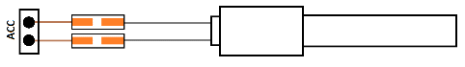
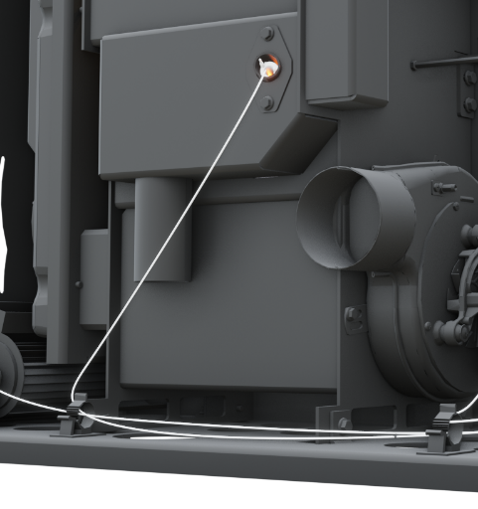
- Press and hold the T4 button until the combustion process is switched off. The Final Cleaning message appears on the control unit.
- Once the stove has finished cleaning and there is no flame inside the combustion chamber, turn the stove's power supply off via the main switch at the rear bottom corner of the stove.
- Disconnect the 230V power cable from the mains.
- Remove the stove's rear casing.
- Remove the ignition cartridge from the slot.
- Disconnect the ignition cartridge from the WAGO clamps.
- Attach a new ignition cartridge to the WAGO clamps (the ignition cartridge cables polarity does not matter).
- Make sure the cables hold the ignition cartridge on the WAGO clamps.
- Put the ignition cartridge into the ignition cartridge slot. Make sure that the wiring does not touch the hot parts of the weldment and the flue.
- Reinstall the stove's rear casing.
- Connect the power cable to the mains and switch the main switch on at the rear bottom corner of the stove.

DISPOSAL OF TRANSPORT PACKAGING AND THE PRODUCT AFTER ITS SERVICE LIFE

Cardboard box sorted municipal waste
Plastic packaging sorted municipal waste
Metal cable tie metal waste collection point
Ceramic glass glass collection point
Rope seal mixed municipal waste
The stove's steel body metal waste collection point
Stove casing metal waste collection point
Electronic components electrical waste collection point

WARRANTY TERMS

The following points must not only be met in order to meet the warranty terms, but also to ensure the correct installation in terms of applicable standards, safety and ensuring the stove's smooth operation.

1. The product may only be installed by a company with a valid authorisation to carry out such installation and maintenance. An installation project must be prepared according to the valid regulations.
3. The stove must be connected to the chimney in accordance with applicable regulations and standards.
4. The flue gas path must be checked by a chimney sweep company before installing the stove. An inspection report must be prepared covering the flue gas path's basic parameters, including the chimney diameter, length and draught.
5. The flue must not be longer than 1m and must be fitted with a sweep opening. The flue can be longer only if the chimney draught has been measured and recorded no further than 30 cm from the stove and that it meets the requirements for the minimum operating draught.
6. There must be sufficient circulation of fresh air for combustion.
7. NEVER install the stove where there are explosive and flammable materials.
9. There must be a minimum handling space around the stove from the obstacle; see "Stove placement".
10. When installing and operating the stove, it is necessary to keep a safe distance of 200 mm from flammable materials.
11. Fuel must not be stored behind the stove or stacked next to the stove at a distance of less than 800 mm.
12. Fuel must not be stored between two sources of heat in the room.
14. Pellets made only of wood, with a diameter of 6 mm and parameters specified in the Instruction Manual are the warranty fuel.
15. The manufacturer is not responsible for the quality of the fuel in terms of combustion quality, ash quantity or the frequency of stove cleaning as these factors are affected only by external influences such as pellet quality, dust and moisture in the pellets, chimney draught or the correct setting of the combustion process.
16. Using flammable liquids (petrol, alcohol, etc.) to ignite the stove is prohibited. Adding pellets into the combustion chamber and on the grate by hand is also prohibited.
17. It is prohibited to overheat the stove in any way during operation.
18. If there is a risk of flammable vapours or gases entering the room with the stove or during works in which there is a temporary risk of fire or explosion (gluing floor coverings, using flammable paints, etc.), the stove must be shut down in time before such work begins.
19. Opening the door to the combustion chamber during operation when there is a flame in the stove is prohibited.
20. Interfering with the stove's design and wiring is prohibited.
21. The manufacturer bears no responsibility for damage caused by the product's improper adjustment or improper operation.
22. Parts subject to wear are not covered by the standard warranty period. These parts include: rope seal, Grenamat board, ignition cartridge, burner grate, fireclay linings. However, these parts do their job long-term, the stove and its components are operated in accordance with the instructions for use.
23. The manufacturer bears no responsibility for rust formed on the stove and its components, as this is always and only given by external influences, such as the room humidity, fuel and the like.
25. The manufacturer is not responsible for cold air condensation in the flue gas path, as this must be prevented by proper installing the flue gas path correctly and the proper setting of the combustion process in the stove.
26. The manufacturer bears no responsibility for smoke leaking from the stove into the room if this is caused by low chimney draught, improper stove installation or improper setting of the combustion process. During the first start-up, the paint on the stove heat exchanger will become a little burnt due to the warming process, so the room must be well ventilated.
27. The manufacturer bears no responsibility for any damage to parts caused by handling, transport, incorrect adjustment or improper use or other external fault which is not directly related to the function of the stove's individual components.
28. The assembly company that sold the stove to the end user is always responsible for the stove's installation and its correct commissioning.
29. In the event that it has been agreed to hold the warranty conditions by a third-party (e.g. a commissioning company), it must be so stated and agreed by 3 parties, namely the stove seller, the stove commissioning company and the end user. All of these entities must agree to this and it must be indicated in the appendix to the warranty card, including the signatures of all of them.
30. The manufacturer bears no responsibility for incorrect selection of stove power for heating losses in the building (e.g. placement of stove with too little or too much power in relation to the need).

WARRANTY CARD

LP6 Pellet Stove
Manufacturer: OPOP spol. s r.o., Valašské Meziříčí

Date of dispatch from the plant:_________________________________________

The user is obliged to entrust commissioning, regular maintenance and repairs to a professional assembly company / service organisation. This warranty card shall contain a certificate of quality and completeness. The manufacturer confirms that the product has been inspected and that its design complies with the technical conditions and standards.
Report a product defect to your seller / company that installed it. When reporting a defect, it is always necessary to present this completed warranty card, give the exact address and indicate the circumstances under which the defect occurred.
In case of non-compliance with the above instructions, the warranties provided by the manufacturer will not be recognised.
The manufacturer provides the warranty for the pellet stove for 2 years from the date of sale, but no longer than 30 months from the date of dispatch from the production plant. The extended warranty applies to the weld tightness on the steel welded fire chamber for a period of 5 years from the date of sale. The warranty is limited to 6 months for mechanically stressed parts that are not firmly connected to the pellet stove (e.g. seals, fireclay linings, ignition cartridge).
The pellet stove is manufactured and dispatched according to valid drawings and in undamaged condition. It is packaged and handed over as a sub-unit. The warranty is provided to one buyer. The warranty applies only to the territory of the country where the product was purchased.
The warranty comes into force upon receipt of a fully completed warranty card. The warranty card must always state the exact date of sale! The warranty service on your pellet stove is performed by the seller, unless otherwise agreed. In the event of a complaint, please provide a copy of the warranty card and proof of chimney inspection.
The warranty does not cover:
    - defects caused by the pellet stove's improper installation;
    - defects caused by incorrect assembly and incorrect operation of the product defects caused by improper maintenance;
    - defects resulting from non-compliance with the instructions given in this manual;
    - defects caused during transport;
    - defects caused by improper storage;
    - defects caused by extinguishing the fire in the fire chamber in a way other than smooth burning out (e.g. with water);
    - defects caused by the use of inappropriate products when cleaning the glass or when the glass is damaged by mechanical impact; the inner glass normally withstands temperatures up to 750°C;
    - defects caused by a natural disaster or force majeure;
    - defects caused by the use of unsuitable fuel;
    - intentional damage to the entire pellet stove or parts thereof;
    - defects caused by improper selection of pellet stove (adequate heat output);
    - defects caused by an unsuitable chimney that does not have a valid inspection or sufficient draught;
    - spare parts not approved by the manufacturer;
    - any unauthorised modifications to the appliance.

The manufacturer reserves the right to make changes as part of the product innovation.

Installation and commissioning carried out by the company, on________________________________________________

Claim procedure:
- Submit personally, by post or by email a confirmed warranty card with proof of payment for the product to the assembly company / seller. Provide the defect description.

- In cooperation with OPOP s.r.o., the assembly company /boiler seller will assess the claim's legitimacy. If the claim is accepted, it will be resolved in one or more of the following ways:

- by sending the claimed part for replacement to the assembly company or directly to the user by agreement.
- in the event of the need for professional assembly / repair of the claimed part, this is carried out by the assembly company / seller; the user has the right to use the contractual service of OPOP s.r.o.
- the user is obliged to allow the manufacturer to make the repair according to point (b)
- if the user does not allow access to perform the repair, the manufacturer considers this complaint to be terminated
- if the defect cannot be repaired, the user has the right to replacement of the defective part
- in the event of unjustified complaint, i.e. failure to confirm the defect or leakage of the weldment by the service staff, the claimant will be charged the costs associated with the inspection and travel expenses to the user.
---------------------------------------------------------------------------------------------------------------------------------------------------------------------------------------------
Dear Customer,
We are very pleased with your decision to buy our product. This decision entitles you to a 20% discount on spare parts. In order to receive the above benefits, it is necessary complete the registration card and send it to our address: OPOP spol s r.o., Obchodní oddělení, Zašovská 750, 757 01 Valašské Meziříčí
Upon receipt of the completed form, we will immediately send you the Customer Card, which entitles you to receive discounts on spare parts from the manufacturer. When ordering spare parts, it is always necessary to provide the number of your Customer Card indicated on it.
Thank you for your trust.

Cut along the dotted line and send it to our address
---------------------------------------------------------------------------------------------------------------------------------------------------------------------------------------------

REGISTRATION CARD

Possibility to register also on our website, www.opop.cz.

Name………………………………………………. Product Serial No………………………………………………………….

Surname……………………………………………. Seller……………………………………………………………………………..

Street address ………………………………………. Product type ………………………………………………………………………..

City………………………………………………………….

Postcode ……………………………..

Telephone No. (optional) …………………………………….

Email …………………………………………………………………… Signature………………………………………………

CONTACT DETAILS

There is a complete list of contacts below, that will help you to obtain comprehensive information from ordering products and spare parts to technical advice on already installed products by OPOP spol. s.r.o.

Sales Department

Telephone:
(+420) 571 675 240
(+420) 571 675 108
(+420) 571 675 589

Email:
sales@opop.cz

Spare Parts

Telephone:
(+420) 571 675 578

Email:
nahradnidily@opop.cz

Technical Support

Telephone:
(+420) 571 675 252

Email:
servis@opop.cz

