H8-A, AP, P
Instruction Manual

Automatic boiler series H8-A, H8-AP, H8-P are boilers fulfilling the strict requirements for heating ecology with low combustion emissions. The boilers enable comprehensive regulation of the heating system and the connection of a wide range of additional devices. The manual provides a comprehensive list of all accessories which can be connected to the control unit. This manual contains full information required for the installation, start-up, and operation of all types of boiler series H8-A, H8-AP and H8-P, i.e. boilers of all outputs. Information defined in the manual are designated for the plumbers and the final customers. Individual chapters are defined chronologically, according to the assembly, start-up, and correct setting of the boiler, until regular use and maintenance of the boiler. Carefully study all information in the manual.
We believe you will be happy with our product for many years of operation. In order to receive further important information on boiler H8-A, outside this instruction manual, you can use the network of assembly and servicing companies stated on our internet pages, or contact directly one of the representatives of OPOP spol. s.r.o.

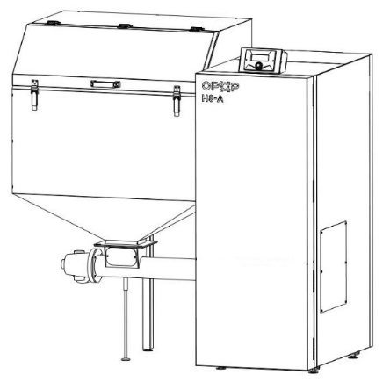
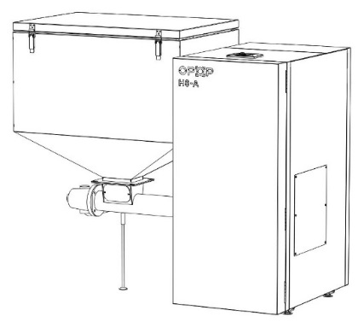
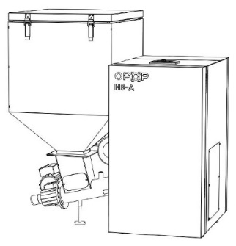
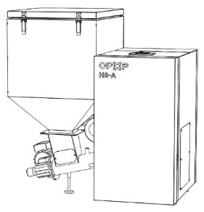




CONTENTS
1. INTRODUCTION 3
2. BASIC CHARACTERISTICS OF BOILER SERIES H8-A and H8-AP, H8-P 3
3. THE MAIN PARAMETERS AND DIMENSIONS 4
3.1. Boilers H8-A 4
3.2. Boilers H8-AP, H8-P 5
3.3. Burners H8-A 7
3.4. Burners H8-AP, H8-P 8
3.5. Fuel container 8
4. BASIC ELEMENTS OF THE INSTALLATION CONFIGURATION AND THE PACKAGING CONTENT 10
4.1. H8-A, H8-AP, H8-P 10
4.2. Burner 11
5. INSTALLATION PROCEDURE 12
5.1. Boiler series H8-A, H8-AP a H8-P 13
5.2. Burner 15
5.3. Fuel container 16
5.4. Connection of electrical components 17
5.5. Electrical diagram 18
6. BOILER CONTROL UNIT 19
6.1. Basic control 19
6.2 Basic operating modes 19
7. CONTROL UNIT FUNCTION DESCRIPTION 20
7.1 Main page 20
7.2 Display 20
7.3 Heating start/ stop 20
7.4 Entered ÚT temperature 20
7.5 Entered boiler temperature 20
7.6 Tank filled 20
7.7 Manual operation 20
7.8 Operating modes of the pumps 21
7.9 Weekly program 21
7.10 Fan correction 21
7.11 Boiler performance coefficient 21
7.12 Feeder in automatic mode 21
7.13 Boiler disinfection 22
7.14 Factory Settings 22
7.15 Information about programme 22
7.16 Installation menu 22
7.16.1 Room thermostat 22
7.16.2 Setting the room regulator 22
7.16.3 Module ethernet 23
7.16.4 GSM module 23
7.16.5 Built-in valve, Valve 1 and 2 23
7.16.6 Pump switching temperature 25
7.16.7 TUV hysteresis 26
7.16.8 Additional pump 1, 2 26
7.16.9 The fuel amount calibration 26
7.16.10 Setting the clock 26
7.16.11 Date setting 26
7.16.12 Supervision mode 26
7.16.13 Pump turning 26
7.16.14 Sensitivity of the rotary controller 26
7.16.15 PID selection 26
7.16.16 Language selection 27
7.16.17 Display brightness and contrast 27
7.17 Servicing menu 27
8 THE FIRST BOILER START-UP 28
9 BURNING CORRECTION 29
9.1 Flame quality 29
9.2 Fan correction 29
9.3 Boiler performance coefficient 12
10 HEATING SYSTEM CONTROL 30
10.1 One circuit ÚT + heating TUV 31
10.2 Two circuits ÚT + heating TUV 31
10.3 One circuit ÚT + solar heating + heating TUV 32
11 REGULAR MAINTENANCE 33
12 SAFETY ELEMENTS 34
12.1 Temperature Alarm 34
12.2 Safety thermostat 34
12.3 Automatic sensor inspection 34
12.4 Security against overheating in the boiler by means of Termik sensor 34
12.5 Security against overheating in the boiler 34
12.6 Fuel feeding security 34
12.7 Fuse 34
13 SPARE PARTS H815-A, H815-AP, H815-P 35
14 SPARE PARTS H824-A, H824-AP, H824-P 37
15 SPARE PARTS H835-A, H835-AP, H835-P 40
16 SPARE PARTS H845-A, H845-AP, H845-P 42
17 RETTING AND TARRING OF THE BOILER 44
18 RISK ANALYSIS 44
19 ENERGY EFFICIENCY 46
20 IDENTIFICATION CARDS 47
21 WARRANTY CONDITIONS, GENERAL INSTRUCTIONS 55
22 VALID STANDARDS AND REGULATIONS 56
23 WARRANTY CERTIFICATE 57

INTRODUCTION
The correct installation, start-up, and operation of boiler series H8-A, H8-AP, H8-P we recommend reading this instruction manual gradually from chapter 1 and proceed chronologically to prevent the omission of any step required for correct boiler function during commissioning. The chapters gradually describe the assembly, the first commissioning, the connection, and the activation of the connected devices, and the maintenance of the boiler. The manual gradually describes individual steps and adds practical information for every chapter which help the customer to understand the activity of the boiler and the regulation elements of the heating system.
The second half of the manual contains the examples of connected heating systems and the accessories including the description of the setting in the control unit. If one or more accessories are connected to the boiler, use this information for correct setting of the defined accessories so the operation complies with this manual.
In case of requirement for additional information considering the boiler activity or the boiler controlled components, do not hesitate the contact the certified installation company or directly a representative of OPOP spol. s.r.o.

BASIC CHARACTERISTICS OF BOILER SERIES H8-A and H8-AP, H8-P
Boilers H8 are automatic boilers which enable to control the combustion process and also many additional devices. The basic parts of the set include the boiler, burner, and hopper. The defined components are equipped separately and their final installation is completed in the boiler room. The installation and start-up of the boiler can only be performed by a trained and certified plumbing company with the authorisation to install and start automatic boilers OPOP spol. s.r.o.
The control unit enables:
- Control of 4 pumps
- Control of mixing valve mixing valve.
- The connection of the room thermostat
- Outside-temperature-based equithermal control.
- Boiler output temperature time control - programmable weekly operation mode.
- Online control and record of all boiler functions via internet interface OPOP
- The outlet for the boiler connection with the solar collector unit.
- The outlet for the boiler connection with the mixing valve control unit.

The control unit for H3 boiler series H8-A and H8-AP allows the connection of attachment devices that automate the boiler operation or add new control options:
- RT10 room thermostats displaying information about the entire heating system including the regulation of individual heating system circuits. It can be mutually connected with the boiler unit and additional module 431N.
- Module 431N, controlling the mixing valve and the mixing valve pump for the control of 1 heating circuit.
- GSM module by means of which you can accept report of boiler condition via a text. Used in case when your boiler cannot be connected to internet and controlled online.

The devices can be purchased to the boiler any time and installed additionally to the operated boiler. Consult the options for using individual devices with certified installation company or a representative of OPOP spol. s.r.o.

THE MAIN PARAMETERS AND DIMENSIONS
The main components of the basic configuration include the boiler, burner, feeder, and hopper for fuel. The below main parameters and dimensions for every components are defined below.

Boilers H8-A
Rated heating output (defined by the manufacturer) | [kW] | 15 | 24 | 35 | 45
Measured rated output | [kW] | 15 | 23,1 | 34,9 | 44,8
Minimum measured output | [kW] | 4,4 | 7,1 | 10,4 | 13,1
Efficiency | [%] | 92,8 | 93 | 93,6 | 94
Boiler class * |  | 4 | 4 | 4 | 5
Limits for ECODESIGN |  | yes | yes | yes | yes
Prescribed fuel |  | Brown coal nut 2 | Brown coal nut 2 | Brown coal nut 2 | Brown coal nut 2
Fuel consumption (measured rated output) | [kg/hour] | 2,999 | 4,703 | 6,963 | 8,953
Fuel consumption (measured min. output) | [kg/hour] | 0,793 | 1,464 | 2,06 | 2,595
Maximum operating heating water temperature | [°C] | 80 | 80 | 80 | 80
Minimum heating water temperature | [°C] | 70 | 70 | 70 | 70
Minimum return water temperature | [°C] | 65 | 65 | 65 | 65
Temperature of combustion products | [°C] | 89,5 | 106,1 | 105 | 89
Minimum temperature of waste gas | [°C] | 59,3 | 66,3 | 68 | 68,6
Minimum required chimney draught | [Pa] | 17 | 15 | 18 | 19
Maximum water service pressure | [MPa] | 2 | 2 | 2 | 2
Minimum water service pressure | [MPa] | 1,5 | 1,5 | 1,5 | 1,5
Maximum water test pressure | [MPa] | 4 | 4 | 4 | 4
Connecting voltage | [V/Hz] | 230V/50Hz | 230V/50Hz | 230V/50Hz | 230V/50Hz
Electricity consumption rated output/ min. output | [W] | 54 / 22 | 73 / 27 | 131/44 | 131/44
Boiler water capacity | [l] | 31 | 39 | 63 | 81
Electric protection |  | IP 20 | IP 20 | IP 20 | IP 20
Boiler body wall thickness (water/flame) | [mm] | 5 | 5 | 5 | 5
Boiler body wall thickness (water) | [mm] | 3 | 3 | 3 | 3
Hopper capacity | [l] | 203 | 245 | 360 | 573
* Emission values and classes are tested in the test institutes subject to standard ČSN EN 303-5.

Type of funnel: outlet / inlet type (inner thread) | Js | G 1 1/4" | G 1 1/4" | G 1 1/4" | G 1 1/4"
Connected for drainage and filling (inner threading) | Js | G 1/2" | G 1/2" | G 1/2" | G 1/2"
A - boiler height | [mm] | 969 | 969 | 1264 | 1553
A1 – control unit height | [mm] | --- | --- | --- | 112
B -boiler hopper height with feeder | [mm] | 1200 | 1215 | 1365 | 1610
B1 - height of hopper with the lid open – position 1/ position 2 | [mm] | 1519/1671 | 1671/1843 | 1748/1912 | 1872
C - boiler width | [mm] | 454 | 514 | 565 | 565
D - boiler width with hopper | [mm] | 1063 | 1119 | 1517 | 1517
E – boiler depth with setting system behind the hopper | [mm] | 846,5 | 931 | --- | ---
E1 - boiler depth | [mm] | 761,5 | 821,5 | 901,5 | 1002
F - outlet water funnel location from the ground | [mm] | 825 | 825 | 1120 | 1322
G -location of fume duct from the ground | [mm] | 687,5 | 687,5 | 983,5 | 1160
H - inlet water funnel location from the ground | [mm] | 134,5 | 134,5 | 134,5 | 134,5
K – hopper depth | [mm] | 636 | 718 | 670 | 764
Fume duct diameter | [mm] | 150 | 150 | 150 | 198

Boilers H8-AP, H8-P

Rated heating output (defined by the manufacturer) | [kW] | 17 | 21 | 33 | 40
Measured rated output | [kW] | 16,5 | 19,6 | 32,2 | 39,8
Minimum measured output | [kW] | 5,1 | 6,3 | 9,4 | 12
Efficiency | [%] | 87,7 | 91,7 | 91,3 | 91,7
Boiler class * |  | 4 | 5 | 4 | 4
Limits for ECODESIGN |  | yes | yes | yes | yes
Prescribed fuel |  | Pellets 6-8mm | Pellets 6-8mm | Pellets 6-8mm | Pellets 6-8mm
Fuel consumption (measured rated output) | [kg/hour] | 4,08 | 4,834 | 7,94 | 9,977
Fuel consumption (measured min. output) | [kg/hour] | 1,271 | 1,498 | 2,235 | 2,773
Maximum operating heating water temperature | [°C] | 80 | 80 | 80 | 80
Minimum heating water temperature | [°C] | 70 | 70 | 70 | 70
Minimum return water temperature | [°C] | 65 | 65 | 65 | 65
Temperature of combustion products | [°C] | 149 | 97,7 | 101 | 95
Minimum temperature of waste gas | [°C] | 85 | 68 | 70 | 71
Minimum required chimney draught | [Pa] | 16 | 19 | 20 | 20
Maximum water service pressure | [MPa] | 2 | 2 | 2 | 2
Minimum water service pressure | [MPa] | 1,5 | 1,5 | 1,5 | 1,5
Maximum water test pressure | [MPa] | 4 | 4 | 4 | 4
Connecting voltage | [V/Hz] | 230V/50Hz | 230V/50Hz | 230V/50Hz | 230V/50Hz
Electricity consumption rated output/ min. output | [W] | 91/32 | 95 / 31 | 152/49 | 152/49
Boiler water capacity | [l] | 31 | 39 | 63 | 81
Electric protection |  | IP 20 | IP 20 | IP 20 | IP 20
Boiler body wall thickness (water/flame) | [mm] | 5 | 5 | 5 | 5
Boiler body wall thickness (water) | [mm] | 3 | 3 | 3 | 3
Hopper capacity | [l] | 203 | 245 | 360 | 573
* Emission values and classes are tested in the test institutes subject to standard ČSN EN 303-5.


The combustion parameters for brown coal for boilers H8-AP are identical for boiler series H8-A. And the table defined in chapter 3.1. applies for bronw coal combustion for boiler H8-AP

H815-A, AP, P:

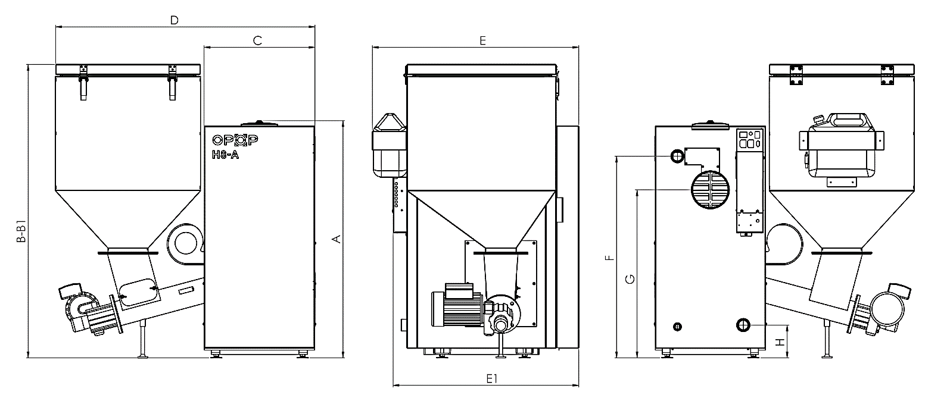

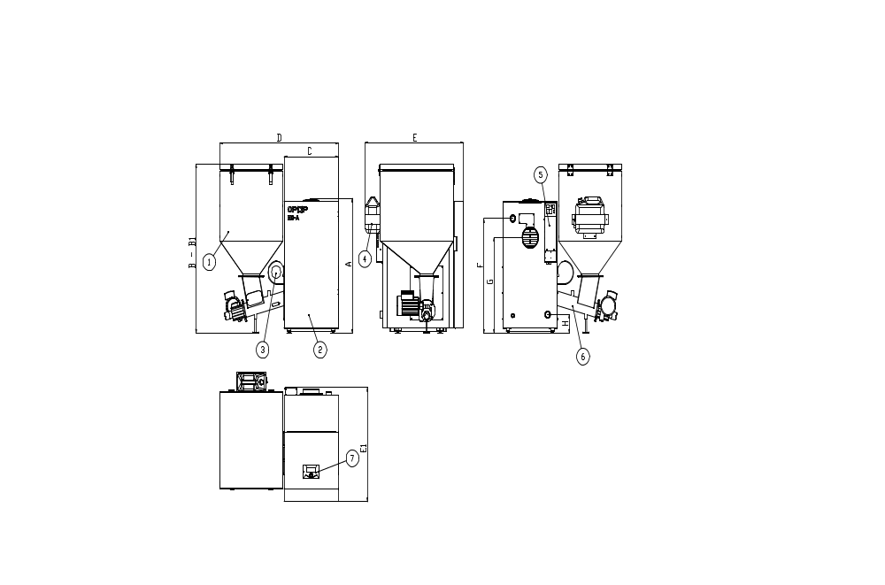H824-A, AP, P:

- Fuel hopper – in more sizes as per max. boiler output
- Boiler H824-A
- Fan – gixed above burner and under hopper
- Fire extinguishing system – container in the rear hopper part
- External base – connection of additional devices and the main switch
- Burner – connectable to the boiler from the left to the right
- Control unit – used for the boiler control

H835-A, AP, P:
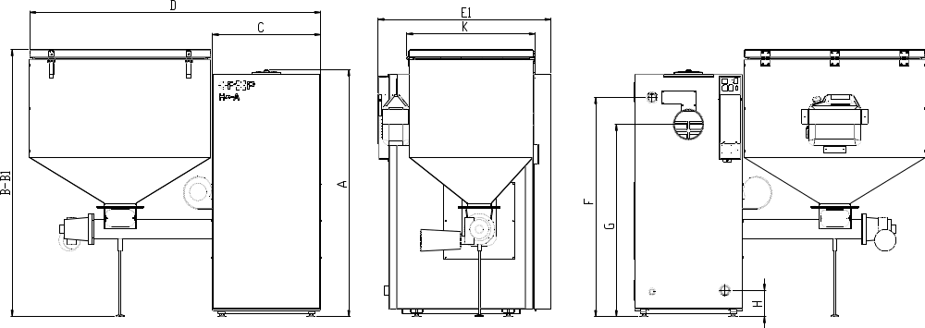

H845-A, AP, P:
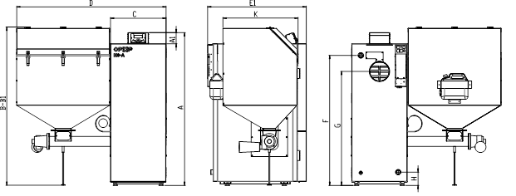

Burners H8-A
The retort burner identically to the boiler differs according to the maximum output. The differences are in the burner size, the selection of electrical components, shape and size of the grill, thickness of applied material.
H815-A, H824-A:
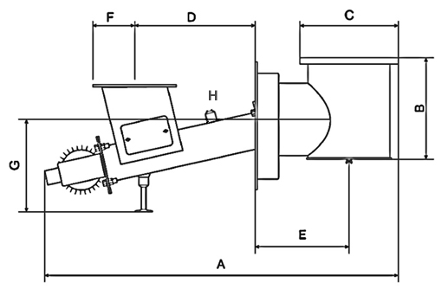
Technical parameters
Motor power | kW | 0,09
Electromotor - rpm | rpm | 1340
Motor power supply | V/Hz | 230/50
Screw diameter | mm | 85
Weight | kg | 55kg ±10%
Dosage | kg/hour | 15-26
Burner size |  | 15kW | 24kW | 35kW/50kW
A | mm | 900 | 950 | 1225
B | mm | 240 | 240 | 297
C | mm | 220 | 290 | 275
D | mm | 315 | 315 | 288
E | mm | 220 | 250 | 488
F | mm | 120 | 120 | 120
H835-A, H845-A:
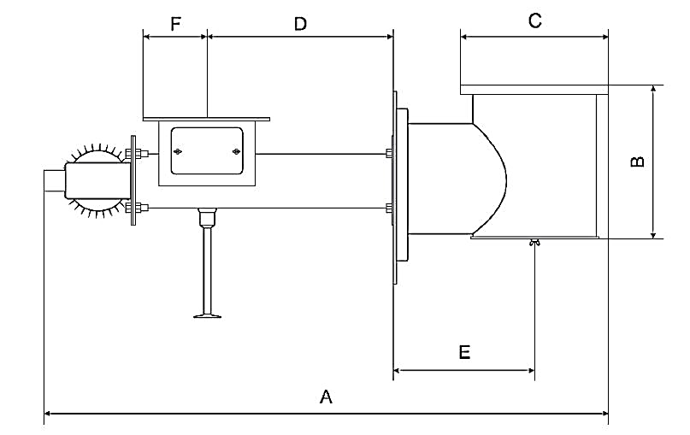
Burner feeder is tilted under angle 15° so the transported fuel in the retort was not in the retort bend (under the circle grill) crushed with the feeder.
The angle provides more gradual fuel transport into the retort without excessive crushing. The feeder under the angle also limits the risk of fuel burning back to the hopper.

The burner cam be installed from the left or right side of the boiler.

Burners H8-AP, H8-P
The burner dimension in variant H8-A and H8-AP are identical. Table with dimensions defined in chapter 3.3. applies for both variants. The difference between boilers H8-A and H8-AP, P is cast-iron sleeve which is placed on the cast-iron burner retort. It is used as extended retorts and prevents the falling out of non-burnt pellets.
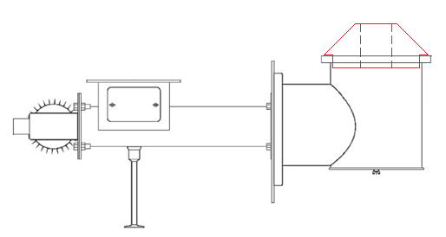

The packaging includes the stove putty used for sealing the contact surfaces between the circular retort and cast-iron sleeve to prevent the air leak. Make sure the connection is sealed.

Fuel container
The fuel container, also called the hopper, is divided in several sizes according to the boiler output. The below basic parameters and other parameters are defined for every type of the coal hopper.
H815-A, AP, P:
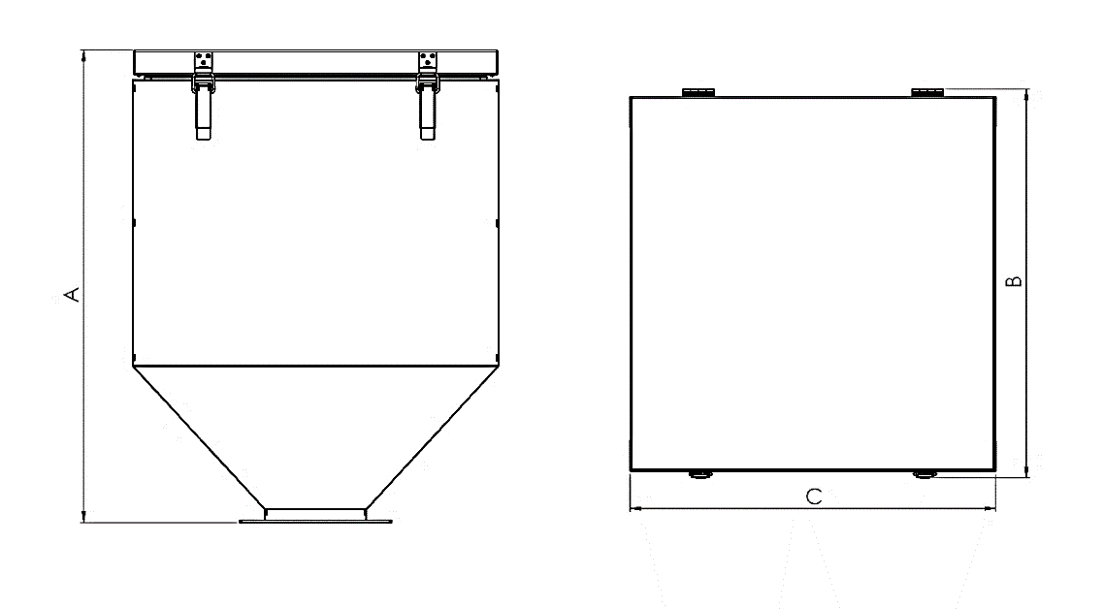

The hopper size
Fuel volume (Brown coal nut 2) | kg | approx. 146
Capacity | l | 203
Weight | kg | 31
A | mm | 772
A (with open lid including the burner – position 1/position 2) | mm | 1515/1672
B | mm | 635
C | mm | 943

H824-A, AP, P:
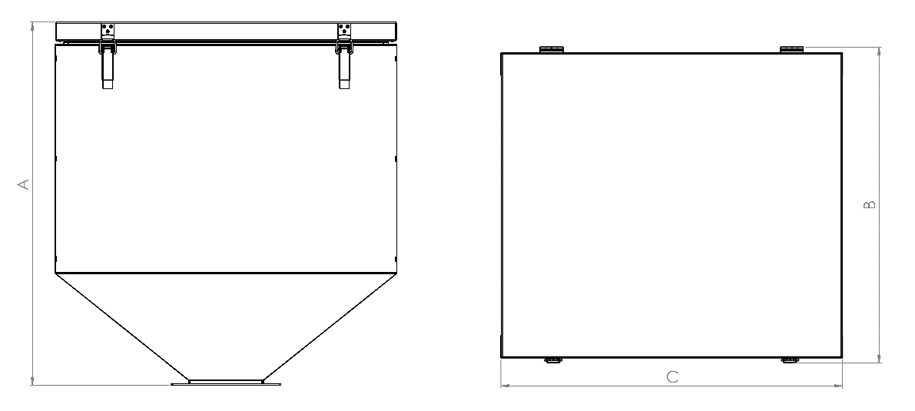

The hopper size
Fuel volume (Brown coal nut 2) | kg | approx. 177
Capacity | l | 245
Weight | kg | 34,4
A | mm | 807
A (with open lid from the floor – position 1/position 2) | mm | 1843/1671
B | mm | 694
C | mm | 593

H835-A, AP, P:
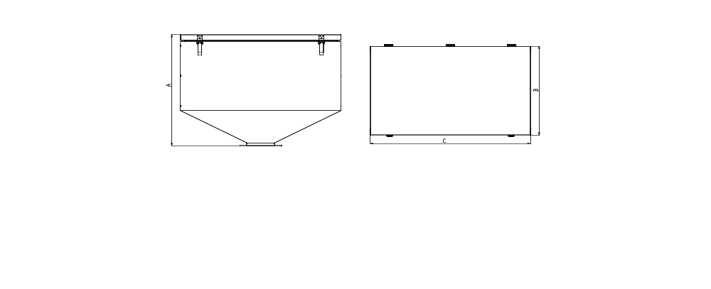

The hopper size
Fuel volume (Brown coal nut 2) | kg | approx. 260
Capacity | l | 360
Weight | kg | 45
A | mm | 807
A (with open lid from the floor – position 1/position 2) | mm | 1748/1912
B | mm | 646
C | mm | 593

H845-A, AP, P:
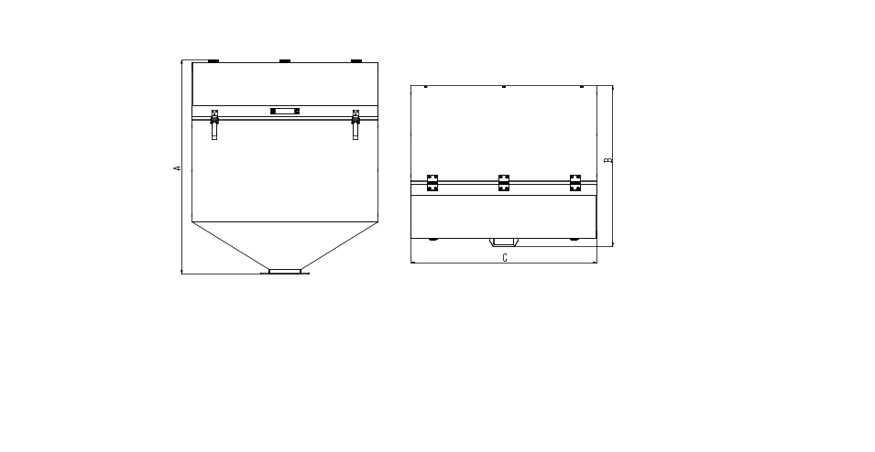
The hopper size
Fuel volume (Brown coal nut 2) | kg | approx. 414
Capacity | l | 573
Weight | kg | 54
A | mm | 1052
A (with open lid from the floor – position 1) | mm | 1872
B | mm | 794
C | mm | 943

The fuel container is designed in such way it can be installed from both sides of the boiler. During the installation always observe perfect sealing of the connection between the hopper and the feeder to prevent the suction of false air which could in extreme case activate the fire extinguishing system placed in the rear side of the hopper.
The canister with the setting system can be installed everywhere according to the boiler room layout. In case of installation on the hopper, remember that the connections between the canister container and holder must be sealed to prevent the air suction into the container.

BASIC ELEMENTS OF THE INSTALLATION CONFIGURATION AND THE PACKAGING CONTENT
H8 is produced in several sizes according to the maximum boiler performance. Every boiler size differs in external dimensions and also in the construction design of the boiler exchanger, doors, connections funnels, fume ducts. The boiler size also affects the fuel funnel dimensions, burner dimensions, etc. The below basic parameters of all main elements of the complete set of boiler series H8.

H8-A, H8-AP, H8-P
The boiler is fitted with three doors behind the front cover on hinges. The upper part of the boiler is fitted with the control unit marked H3 for better installation. The cables and temperature sensors from this unit lead to the boiler rear part with placed External base for the connection of additional devices including the temperature sensors. The external base also includes the main switch and 2A fuse for safety.
The upper, rear part of the boiler includes the cleaning doors fastened to the location by means of 2 butterfly nuts. After the door and the cleaning door flap removal you can view the heat exchanger comprising of 1 vertical well and 3 vertical pipewalls. The heat exchanger is also fitted with 4 waste gas whirlers. The burner can be installed in the boiler from the left or right according to the boiler room layout. It is attached to the boiler by means of 4 screws.
The burner cam be installed from the left or right on the steel boiler body.
The rear part of the boiler includes 2 funnels – on the top for the water outlet from the boiler, on the bottom for the water inlet from the boiler. The upper, rear part of the boiler includes wells for temperature sensors (ÚT sensor and Termik sensor). The boiler lower part includes the funnel for filling valve. The outlet for the fume duct connection is placed in the rear, central part of the boiler.
Temperature sensors (ÚT, Termik and waste gas sensors) are connected to the wells in the upper rear part of the boiler behind the rear cover and boiler insulating material.
The lower part of the boiler includes the adjustable legs on the threads for the boiler height adjustment and levelling the uneven base in the boiler room. The boiler includes the ashtrays (2pcs) and the waste gas whirlers above in the boiler exchanger part to reduce the waste gas temperature and increase the boiler efficiency. The well above the burner is fitted with fireclay bricks lined on the periphery of the area inside the front part of the boiler.

Package Content:
The boiler contains the additional package with the accessories and connection material for the assembly and installation completion. The amount and type of additional parts differ according to the boiler and burner size. 3 cleaning tools (brush, brush handle, scraper) – for cleaning the internal parts of the boiler.

- Fireclay bricks
- Filling valve
- Ashtray – in the lower part of the boiler, two piece.
- 4 burner flange screws.
- Cleaning tools
- Connecting material for burner preparation in the boiler (SCREW M12X30 933 ZN – 4pcs)
- Fan connection material (SCREW M6X12 DIN933Zn – 4pcs)
- Putty (60ml)
- SCREW M10X20 DIN 933 – 4pcs (for the hopper attachment)
- NUT M12 DIN 934.8 ZN – 4pcs (for the hopper attachment)
- WASHER *13 DIN 125A ZN – 4pcs (for the hopper attachment)
- Cast iron sleeve for pellet burning (only for boiler series H8-AP)

Burner
Retort burner differs according to the performance, type of applied electrical components of the burner. Maximum burner performance also defines its external dimensions. The burner is fitted with the components below:

- Flange for the hopper connection
- The sweeping opening for dust cleaning from internal part of the screw feeder
- Burner connection flange
- The sweeping opening for cleaning the retort internal part
- Opening for the fuel transfer from the hopper to the screw feeder
- The leg for keeping the feeder in the correct position
- Feeder motor
- Round retort grill
- Screw feeder end
- The cotter pin preventing the motor destruction during the screw jamming
- Well for fire extinguishing system

The retort burner comprises of 3 main components: Retorts with round grill, screw feeder, and opening for the fuel hopper connection. Screw feeder is connected to the motor which turns it and transports fuel to the retort grill. The motor connection and screw feeder include the cotter pin with the function of the screw turning interruption of it is stuck. It provides the prevention of the motor damage during the situation. In such case, the cotter pin requires replacement.
The burner includes the fan which moves air from the burner internal part to the openings in the grill. The fan and the motor of the feeder are connected with the external base by means of cables.
The centre of the screw feeder includes the funnel used in the connection with the canister as the fire extinguishing system if the flame reaches the internal part of the screw feeder. The funnel includes the current fuse which melts under high temperature and water from the canister extinguishes the occurred flame in the screw feeder. It prevents the flame spreading into the hopper. The canister with water can be placed to any position according to the boiler room layout commonly on the rear side of the hopper.
The burner also includes the safety sensor inserted in the well in the centre of the burner. The sensor detects the increased temperature inside the screw feeder and the feeder and fan are deactivated in case of overheating to prevent the flame from spreading.
The burner flange must be sealed in the connection with the boiler flange using stove or high-temperature silicon putty to prevent the smoke and heat leak from the connection to the room. Otherwise the burning products would leak into the room causing the risk of the boiler components damage and fire risk. The connection between the burner flange and the hopper flange must be perfectly sealed.
The burner is the heart of the boiler and requires regular maintenance for the components, particularly the grill. The burner grill is replaceable for more comfortable cleaning. Pay attention to correct grill location back to the burner in order to prevent its movement or falling out. More information on the burner cleaning and handling is in chapter Regular Maintenance.

Package Content:
- Retort burner
- Burner grill
- Screw feeder motor cotter pin
- Fan, incl. the connecting material
- Leg

Hopper
The fuel hopper is fixed to the burner opening by means of 4 screws and nuts. The hopper size differs according to the boiler output. The upper part includes the lid which enables to fill the hopper with the fuel. Use the orange brace in the right part of the hopper for the lid fixing in open position.

The canister is installed in the hopper rear side for the extinguishing system. It can be installed in any position according to the boiler room layout. It is connected with the hose with funnel in the burner. The funnel includes the current fuse used as a barrier to prevent water entry to the burner during common operation. In case of the motor overheating the fuse melts and fire is extinguished with water from the canister. If this happens, the burner requires cleaning and the current fuse replacement with the new one.
It is very important that the hopper is closed during the operation to ensure the sealing of the hopper lid.
Otherwise there is a risk that the flame in the burner starts spreading in the opposite direction causing the burner overheating and the fire extinguishing system activation. During the boiler commissioning, it is necessary to check the sealing of the hopper in all locations.

Package Content:
- Hopper
- Canister
- Canister holder with the connection material
- The hose connecting the canister and the funnel of the current fuse including further accessories.

INSTALLATION PROCEDURE
During the installation process it is necessary to ensure problem free boiler connection to the heating system and also the hopper and burner installation supplied separately, and their assembly is performed in the installation location.
The whole installation process can be divided to these points:
- Installation of the boiler, hopper, burner (chapters 5.1 to 5.3)
- Installation of additional electrical devices (chapter 5.4)
- the first boiler commissioning (chapter 8)
- Burning correction (chapters 9.1 to 9.3)
- setting further functions and correction of the additional devices operation (chapter 7)
The basic installation and the first step of the installation process is the boiler connection to the heating system followed by the boiler and hopper connection. The chapters below are divided into three sections. Continue gradually according to individual chapters for successful installation of the whole set.

Boiler series H8-A, H8-AP a H8-P
The below defined points are used as the installation manual of the boiler unit to the heating system. Individual points are defined chronologically. Read gradually individual points to prevent the omission of any of the basic installation points.
- Unpack the boiler from the packaging and the paper package. Remove the cover transparent foil and place the boiler body on the final position in the boiler room. During the boiler handling observe to following:
  - If you handle the boiler in the packaging pay attention to possible boiler casing damage. The packaging is made of wood and it is fixed with staple nails. They can damage the boiler housing during handling or other parts.
  - The boiler must be placed on a flat floor or a base so one bottom is in horizontal position. The boiler tilting is not possible.
  - Pay attention to observing the minimum free space around the boiler, considering safety and access to the boiler due to maintenance.
  - Check the boiler room for sufficient space for opening the ashtray doors and the boiler upper lid.
Always handle the boiler in order to prevent its damage. We recommend removing the accessories from the boiler before handling it.
- Remove all accessories from the boiler. The accessories should be in the ashtray and in the boiler front chamber.
- install the filling valve on the funnel in the boiler rear lower part.
- Connect the funnel G1 1/4" of the outlet water from the boiler to the heating system.
- Connect the funnel G1 1/4" of the inlet water to the boiler to the heating system.
- Connect the fume duct to the outlet for the fume duct in the rear part of the boiler. The connection must be sealed, if required use the stove putty for sealing the connection. During the fume duct connection observe the following:
  - The fume duct must not reduce the draught in the chimney to the level it represents the draught reduction below the minimum defined limit 12Pa, according to the boiler size, see chapter Main parameters and dimensions.
  - The diameter of the fume duct and the chimney must not be smaller than the boiler outlet according to the boiler size, see the chapter Main parameters and dimensions.
  - The connection between the boiler outlet and the fume duct must not intervene in the opening of the waste gas temperature sensor. Pay attention to prevent the waste gas temperature sensor damage during the fume duct fitting to the outlet from the boiler.
  - After connecting the fume duct to the boiler outlet measure the chimney draught as close as possible to the boiler outlet. If the value does not fulfil the minimum requirements for the chimney draught consider the installation of additional device, so called. Extraction ventilator. In the opposite case, the smoke may leak during operation from the boiler to the room.

Sufficient chimney draught is essential for a correct function of the boiler. In case of fume and hot air leak during the boiler operation, the chimney draught is not sufficient.

- Connect the water supply hose to the filling valve and fill the boiler and the heating system with water. Maximum water operating pressure suitable for the system use is 2 bar. Attention : the operating pressure is during the boiler operation. in cold state the water pressure in the heating system is lower.
- After filling, close the filling valve and dismantle the supply hose from the valve.
- Check the connections of all funnels for sealing. Repair potential leaks prior to commissioning the boiler.
- Check the correct location of the temperature sensor ÚT and safety sensor Termik placed in the well on the boiler upper side. the sensors must be fixed in the well otherwise their falling and potential boiler heating is possible. The sensors can be reached after removing the boiler upper lid. It can be removed by pressing the cover on the side in the front part in the backwards direction. You can use a screwdriver for better pressing on the upper cover side. The cover shall be shifter backwards by 1sm and then simply removed. The sensors are placed under the sealing material. After the sensor inspection insert the upper cover back to the original position.
- Install the fireclay bricks to the boiler front part (see the installation scheme below).
- Check the internal parts of the boiler, particularly: correct location of the waste gas whirlers in the boiler exchanger, correct function of the ashtray position, and make sure there are no accessories or connection material in the boiler. Remove all parts which do not belong in the boiler.
- During the boiler handling the door attachment may be removed from the axes and reduce their sealing. Check all boiler doors, the fixing, cleaning, and ashtray doors. Check the fitting of the asbestos sealing cords, the correct closing of the doors and their sealing.
- Choose a side to assemble the burner. Cover the burner opening on the opposite side of the boiler with a seal which is commonly assembled on the right opening for the burner. If required assemble it on the opposite side of the burner.
H815-A, AP, P:
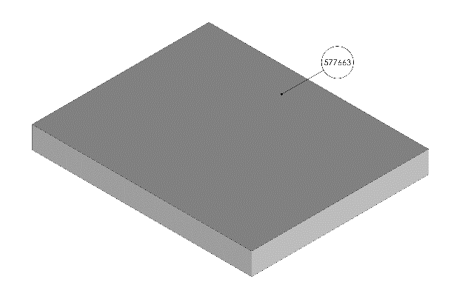

577663 | Block I (30x240x298)

H824-A, AP, P:
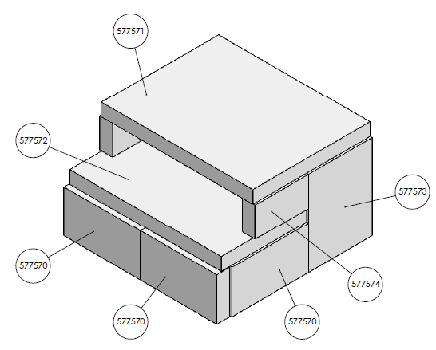

577571 | Block I (30x275x355)
577570 | Block II (30x100x179)
577572 | Block III (30x200x355)
577573 | Block IV (30x149x200)
577574 | Block V (30x70x125)

H835-A, AP, P:
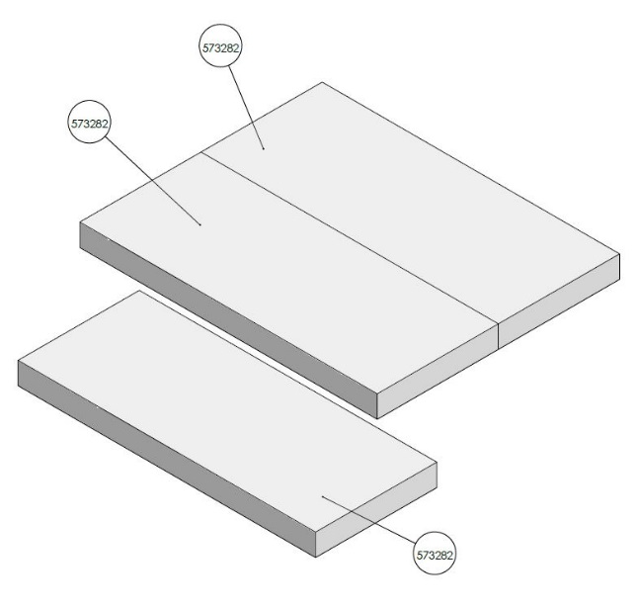
577583 | Block I (30x165x405)

H845-A, AP, P:
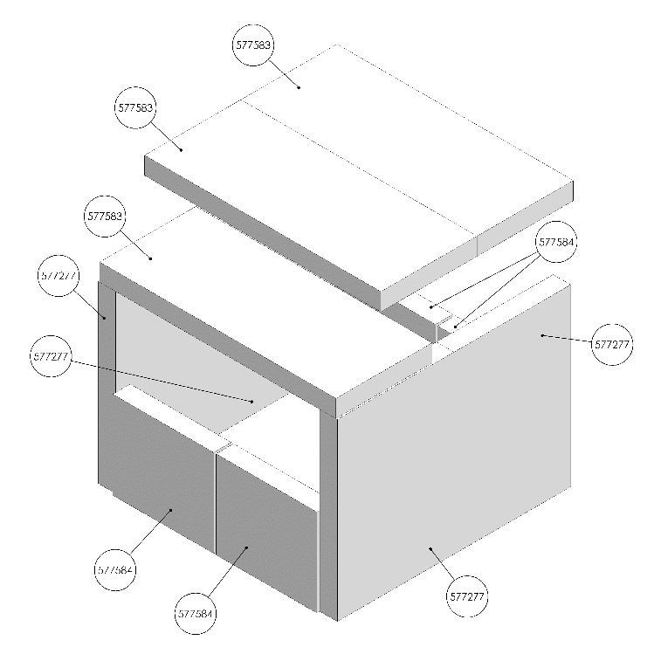

577277 | Fireclay block III (30x200x300)
577583 | Block I (30x165x405)
577584 | Fireclay block II (30x150x173)

Burner
The retort burner with cast iron round grill is installed in the boiler assembly location. The burner is packed outside the boiler for better handling of individual part of the whole set.
- Remove the package from the burner and remove all accessories from the burner packaging.
- The cast iron head is screwed from the manufacturer with the screw part of the feeder with safety screws. These two parts are connected with the stove putty in order to prevent the air leak through the connection out from the burner.
- Apply the stove or high-temperature silicon putty on the flange periphery.
- Place the burner into the opening in the boiler side tightly to the burner side to attach the burner to the boiler by means of 4 screws packed to the boiler as accessories.
- During the burner connection to the boiler, you can set the burner legs in such way the leg is in contact with the ground and supports the burner for better handling. After fastening the screws the legs can be reset to the correct length to keep the burner in stable position.
- Then connect the fan with 4 screws holding the fan in place.
We recommend to apply putty to the cast iron burner head (grill) in such way the air from the fan flows to the retort in a correct direction.

- In the boiler variant H8-AP fir the retort with cast iron sleeve according to the figure in chapter 8.4, and seal the connection with putty.

Fuel container
The fuel container, also called hopper, is assembled to the burner flange during the boiler set installation. It is very important that the connection between the burner and the hopper was sealed to the maximum to prevent the return draught, suction of false air into the hopper which could cause the fuel burning to the hopper. Carefully read the below assembly process of the hopper.
- Remove the hopper from the package and move it to the burner.
- We recommend applying the stove or silicon high-temperature putty on the burner opening on the whole opening periphery to keep the connection between the burner and the hopper sealed.
- Place the hopper on the burner opening in such the hinges of the hopper lid are in the rear part of the boiler and 2 silver closing clips in the front part of the boiler. It ensures proper installation of the hopper with the lid and the hopper lid can be open from the front side of the boiler.
- Secure the hopper using 4 screws and nuts and fasten the connections for maximum sealing.
- Test problem-free opening of the hopper lid. Use the orange stops in the right part of the hopper for the lid fixing in open position.
- Check the contact and sealing of the hopper lid in open position. The lid must be sealed.
- Install the canister of fire extinguishing system to the rear side of the hopper or to any position according to the boiler room layout. Use the sheet metal canister holder and the attached screws.
- Install the wax plug into the funnel placed under the burner flange where the fuel hopper is assembled. Seal the connection and fasten.
- Connect the wax plug and the canister by means of attached hose and the secure the connection with metal rings. Fasten them to ensure fixed connection of both ends and prevent the hose falling out.
- Pour water in the canister and leave the canister lid open. Pour water in the canister once in ½ year due to its gradual evaporation.
- The canister with the setting system can be installed everywhere according to the boiler room layout. In case of installation on the hopper, remember that the connections between the canister container and holder must be sealed to prevent the air suction into the container.
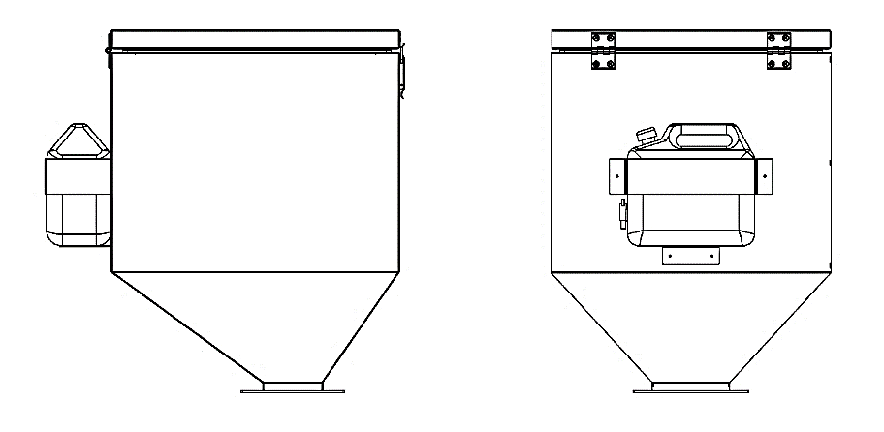

The connect electrical components and additional devices. Read the below chapter for more information to connect the electrical components of the burner.
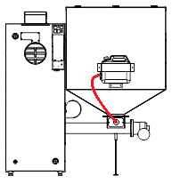
Canister
Hose
Funnel with wax plug

The fire extinguishing system canister can be installed anywhere. The hose of the filling system is installed in such way that water during its activation flows in the funnel in the burner. It is the only efficient fire extinguishing of the burning fuel.

Connection of electrical components
The rear part of the boiler includes External base with all electrical outlets for connecting the basic and additional electrical devices. Proceed by connecting electrical parts in the external base.
- Connect 1. power supply cable to the fan connector. The fan is now connected with External base and control unit H3.
- Connect 2. power supply cable to the fan connector. The fan is now connected with External base and control unit H3.
- Connect the burner sensor in the well in the burner centre. this sensor switches off the boiler in case of flame burning into the burner.
- Connect 230V power supply cable to the socket to supply electricity to the boiler. The socket is placed on external base in the rear part of the boiler.
- Connect 230V cable from external hopper to the socket in the upper part of external feeder. The boiler is connected using the power supply by means of fork in the standardized socket 230 V/50 Hz/10 A.
- If you connect additional devices to the external base, proceed to chapter Electrical scheme.

After connecting all electrical components into the external base, you can start the boiler by means of the main switch placed in the external base.
Never connect electrical components if the device is life. Always connect the power supply cable before the installation of electrical components.
Wiring scheme and electrical outlets are displayed below. Use the scheme for connecting further additional devices of your choice. After connecting all electrical components close the external base, you can start the boiler for the first time by means of the main switch (red button in the upper part of external base).
The installation is now practically completed. The following process is the first boiler start and correction of the combustion process defined in the chapters First boiler start-up and Burning correction. Before commencing the steps we recommend studying the method of the basic boiler control and the description of the menu items in chapters First boiler start-up and Burning correction.
Prior to the first start-up study the chapters Electrical scheme, Control unit, and Function description of control unit.
The chapters shall help you to understand the boiler control method and the boiler unit H3. The chapters mentioned shall be used for the installation of accessories to be activated in the control unit menu. Be aware that the operation of additional devices is preset in the factory setting and it is therefore sufficient to activate it and it should operate under the standard conditions free of problems. The operation setting of additional devices can be changed any time on the boiler control unit.
The control unit parameters marked H3:

Supply voltage | V | 230V/50Hz +/-10%
Input | W | 11
Operating temperature | °C | 5÷50
Current load on outputs for pump ÚT,  TUV; floor, circulation, and valves | A | 0,5
Output load for the fan | A | 0,6
Output load for the fuel feeder | A | 2
Temperature range | °C | 0÷90
Temperature measuring accuracy | °C | 1
Temperature setting scope | °C | 45÷80
Temperature sensor scope | °C | -25÷90
Fuse | A | 6,3

Electrical diagram
Prior to completing any activities related to the power supply (connection of the conductors, device installation, etc.) it is necessary to make sure the regulator is not connected in the network! The assembly must be executed by a person with relevant authorization.
Prior to starting the controller it is necessary to measure the efficiency of resetting the electrical motors and the boiler and insulation measuring of electrical conductors.
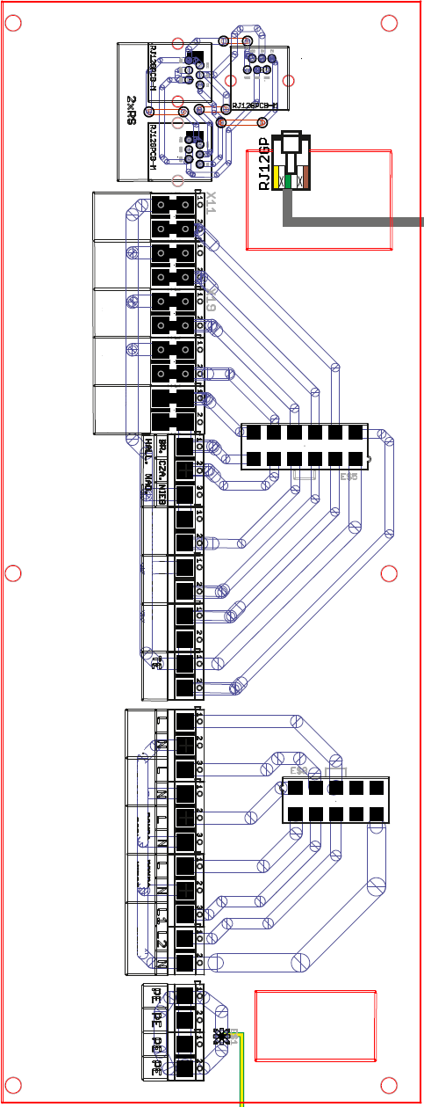

Floor heating sensor
External temperature sensor

Return water sensor
Valve sensor

Room thermostat (voltage-free)

Feeder sensor

TUV sensor
ÚT sensor
Termik, safety sensor 95°C

Fuel feeder
Fan
Pump 3
Pump 4

Mixing valve

Earth conductor

BOILER CONTROL UNIT
The boiler control unit with marking H3 is fitted with 3 buttons, navigation, menu button and exit. Use the buttons to perform the setting and the unit control. The connectors leading to the external base in the rear boiler part from the rear side, and also the outlets for 2 temperature sensors (sensor ÚT and Termik) for measuring the boiler temperature.

Basic control
The basic control is simple and intuitive. The basic description of the boiler control unit of the main panel including the content and control is defined below.
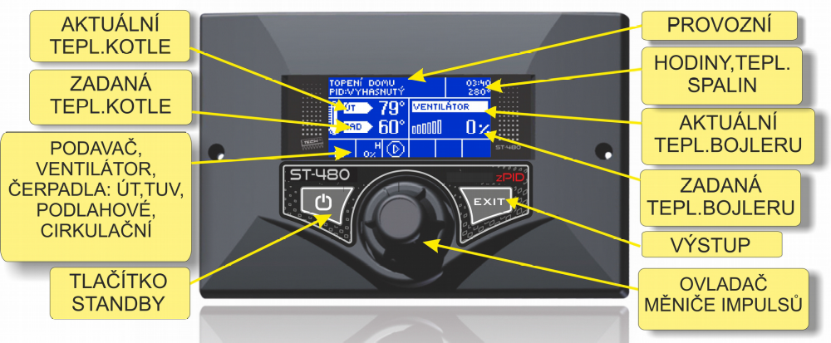
The main panel of the control unit H3

The control unit H3 is designated for boilers ÚT equipped with screw feeder. It controls water circulation pump, pump for warm utility water
(TUV), floor heating pump, circulation pump, burner fan, and fuel feeder. The control unit has inbuilt control module for the valve. The device can cooperate with two mixing valves (by means of additional modules 431N), classic room regulator (two-position) or with RT10 room thermostat, module GSM, and module Internet for remote administration of the heating system.
The advantage of the regulator is its simpler operation. The user completes all changes of the parameters by means of the impulse converter controller – navigation buttons. Another advantage is the clear graphic display with actual operating state of the boiler.

6.2 Basic operating modes
H8 during the operation passes through several operating modes displayed on the main panel. The below explanations define the operating modes and the associated reports.
Heating start: This cycle lasts until the waste gas temperature reaches the defined value and upon the condition it does not drop below the value for 30 seconds (the manufacturer set the heating times).
Attention : The defined time intervals and other values are set from production. They can be changed any time.
PID works: After terminating the heating, the regulator transfers to the operating cycle and the display includes information: „PID:PRACE”. It is a basic function of the regulator when the fan and the fuel supply are controlled automatically according to the algorithm PID and the temperature oscillates around the temperature entered by the user. If the temperature grows unexpectedly by more than 5°C above entered temperature, the supervision mode is activated.

CONTROL UNIT FUNCTION DESCRIPTION
This chapter provides the complete service of all functions in the control unit H3 menu. This list is used for the basic acquaintance with individual functions. All functions include the recommended setting and description of the individual items control and information on mutual combination of individual functions.

Main page
During common fan operation, the graphic display includes the main page. According to the actual operating mode the respective display panels are on. Pressing the impulse converter controller the user moves to the first menu level. The display will show the first three options of the menu. The display of further options is completed by the converter controller turning. The option of the defined function requires pressing the converter controller. Proceed similarly during the change of the parameters. The change must be confirmed. It is performed by pressing the converter controller during title CONFIRM. If the user requires to perform a change in the defined function press the converter controller during title RESET.
To leave the menu select the option EXIT or use button EXIT. The emergency stop mode (standby) is located in the regulator case and enables to switch off all operating devices if required within short time. It is a sufficient security; emergency disconnection of power supply of all operating devices (feeder, fan, pumps).
Attention : Emergency mode does not disconnect the regulator power supply.

Display
This function enables the user to select one of three main displays of the regulator operation. These are:
- panel ÚT (it displays the actual operating mode the boiler)
- Built-in valve (it displays the valve operation parameters)
- valve 1, 2 (it displays the first valve operation parameters)

ATTENTION: To keep the panels with the valve parameters active, the valves must be correctly installed and configured by the professional employee in advance.

Heating start/ stop
This function enables simply start/stop the boiler. The user after the initial fireplace ignition of the boiler starts the heating automatic cycle. The selection of optimum parameters and the function PID enable the boiler transfer to the operating mode. The boiler moves to PID operation in the situation to increase the waste gas temperature during heating start.

Entered ÚT temperature
This option enables to define the entered boiler temperature. The boiler temperature can be changed by the user within scope from 45°C to 80°C. The entered ÚT temperature can be changed directly on the regulator main page display by turning the impulse converter controller. Entered ÚT temperature can be regulated by means of function Reduced room temperature and Weekly mode. The entered temperature is the summarising of all values but solely within the scope 45°C- 80°C.

Entered boiler temperature
This option enables to define the entered temperature of utility water. The user can change the temperature within scope from 40°C to 60°C.

Tank filled
This enters the information to the unit that the hopper was filled. When the fuel is consumed from the hopper, the unit starts reporting low fuel amount on the display. It is necessary to correctly calibrate the function in the Installation setting, Calibration of fuel amount.

Manual operation
The user comfort is provided by the module for Manual operation on the regulator. This function enables switching on and off every operating device (feeder, fun, pump ÚT, pump TUV, circulation pump, floor pump and valves) independently on others. Pressing the impulse converter activates the drives of selected devices. The device shall operate until the next pressing of the impulse converter. Additionally the option Fan performance is available and the user can set any fan revolutions speed in manual mode.

Operating modes of the pumps
This function activates one of four operating modes of the boiler as required by the user.
- The house heating – The option of this function ensures the regulator heating of the house. Pump ÚT starts operating to reach the temperature in the pump switching on (factory setting). During temperature drop (minus 2OC - hysteresis ÚT) the pump stops operating.
- Boiler priority – In this mode the boiler pump is switched on (TUV) and operates until reaching the entered temperature TUV. Upon reaching the temperature, the pump switches off and activates the circulating ÚT. The ÚT pump operation is active for the whole period until the moment the boiler temperature drops below the entered temperature by the value of hysteresis TUV. The ÚT pump switches off and TUV pump starts. In this mode the fan and feeder operation are limited by the boiler operation 65°C to prevent the boiler overheating.
Attention : The boiler must have assembled the return valve on the pump circulation ÚT and TUV. The valve on the pump TUV prevents the hot water suction from the boiler.

- The pumps collaterally – In this operating mode the pumps start to operate collaterally upon reaching the limit of switching on the pumps (from production 40°C). Pump ÚT operates permanently and pump TUV switches off upon reaching the entered boiler temperature.
- Summer mode – In this mode the pump ÚT remains off and pump TUV switches on at the limit temperature for switching the pump on (factory setting to 40O C). In this mode the pump TUV operates for the whole period the temperature is above the limit of switching on the pumps (from production 40°C). In summer mode, only the assigned boiler temperature is defined for heating water in the boiler (the boiler entered temperature is collaterally assigned temperature). After switching on the summer mode the display shows the real ÚT temperature and two temperatures TUV (real and entered).

Weekly program
This function enables to program the temperature changes during the day. Entered deviations are within range +/-10°C.
- The first step:
At first the user must set the actual hour and date (Menu of the installer>Hours).
- The second step:
The user sets temperature to individual days in the week ( Set mode 1):
Monday - Sunday
In this mode it is necessary to set the specific hours and required deviations from the entered temperatures (the grades defined for the temperature drop or increase) for every day in the week. To simplify the operation, the setting can be copied.
Monday – Friday; Saturday - Sunday
In this mode, similarly to the former, it is necessary to define the specific hours and required deviations from the entered temperature for the working days (Monday-Friday) and the weekend (Saturday, Sunday).
- The third step (mode):
The user activates one of two formerly selected modes (Mode 1, Mode 2) or completely switches off the weekly regulation function. During the activation of one of the modes, the main page of the regulator display shows the entered ÚT temperature and also the actual value of the defined deviation (informs concurrently on the weekly regulation activation). The data deleting function enables a simple removal of former option of the weekly program which enables entering new settings.

Fan correction
This option enables to change the fan revolution percentage during PID work so the customer can simply adjust the combustion process. Use this function in combination with the boiler performance coefficient function in case the combustion is not optimum.

Boiler performance coefficient
This option enables to change the feeder operation time so the customer can simply adjust the combustion process. Use this function in combination with the fan correction function in case the combustion is not optimum.

Feeder in automatic mode
It activates and deactivates the feeder in PID work. Standard setting is Activated.

Boiler disinfection
It is available solely if TUV heating was activated in the Pump operating mode. Boiler temperature is periodically increased to destroy potential bacteria in the hot water container.

Factory Settings
The regulator is factory set to enable operation. It is necessary to adjust the setting to the specific operation conditions and requirements.. It is possible to return to the factory setting values any time. The option of the factory setting deletes the boiler set values by the user (entered in the menu) for the benefit of the boiler manufacturer values. From this moment the user can set own parameters again.
Attention : The return to the factory setting does not remove the completed changes in the service mode.

Information about programme
This function enables the user to check the program version available in the regulator.

Installation menu
The function in the plumber menu must be set by an employee appropriately trained with valid certification or servicing employee of OPOP spol. s.r.o.

Room thermostat
The regulator H3 enables connecting the room regulator. This function enables the regulator configuration by marking the option On. The user can also find out the program version available in the room regulator.
In case of connecting the room regulator RT10 the user can check and change the temperatures ÚT and TUV or the mixing valve in case of connecting module 431N; all alarms of the boiler regulator are also displayed. During the cooperation with the mixing valve, the user upon checking the main screen with the valve parameters can
find out the outdoor temperature.
Upon switching the option Thermostat OPOP/TECH letter „P” is displayed on the main page of regulator in the upper part. Flashing letter „P” means the room is not heated. Upon reaching the entered temperature in the room letter „P” shall be on permanently.

If you use a classic voltage-free thermostat on/off, connect it to the required outlet on the external base in the boiler rear part and activate it by means of item Thermostat standard.
Attention : Never connect any external voltage to the room regulator outlet.

Setting the room regulator
This function enables to program the room regulator activity in case it was activated in item Room thermostat.
ÚT pump regulation: It switches off the ÚT pump in case there is no requirement for heating from the room thermostat. It is necessary to set the time for the pump start in this menu to prevent the boiler overheating! Set the regular pump start in this sub-menu or use the preset values.

Boiler regulation – this function activates the ÚT temperature drop by the defined limit that upon the stop heating instruction from the room thermostat the boiler reduced the set temperature ÚT and adjusted the performance drop.
Example: Upon reaching temperature in the flat (the room regulator signals heating completed) the entered temperature of the boiler drops by the set value. The temperature drop does not continue below the entered minimum temperature ÚT:

Entered temperature of the boiler: 55ºC
Room temperature reduction: 15ºC
Minimum temperature of the boiler: 45ºC (factory setting)
Upon reaching the flat temperature (the room regulator signals), the entered boiler temperature drops to value 45ºC, only by 10ºC, even if the room temperature drop is 15ºC. At the same time the display shows the title next to the boiler temperature: „!-10°”.

Module ethernet
The use of the operating mode is possible solely upon purchasing and connecting additional control module ST-500 , which is not a part of the standard equipment of regulator H3.
The internet module is the device enabling remote control of the boiler operation via internet or local network. The user checks the state of all devices of the boiler installation on home computer screen. The activity of every device is displayed as animation. Additionally to the temperature of every sensor, the user can change the entered temperatures of the pumps and the mixing valves. Upon switching on the internet module and selecting DHCP, the regulator automatically collects the parameters below from local network: IP address, network mask, gate address, address DNS. In case of any problems with the network parameter collection it is possible to set the parameters manually. The method to receive data from local network is defined in the internet module manual.
The function Restart the module password can be used of the user replaced the factory password with a different password on the login page. If the new password was lost, the return is possible to the factory password after resetting the module password.

GSM module
The use of the operating mode is possible solely upon purchasing and connecting additional control module 431N, which is not a part of the standard equipment of the boiler control unit.
Module GSM is additional device cooperating with the boiler regulator which enables remote control of the boiler operation by means of mobile telephone. The user is notified by means of SMS message on potential alarm of the boiler regulator and informed by SMS at every moment on the actual temperature of all sensors. Upon entering the authorisation code, the remote control of entered data is possible.
Module GSM can also operate independently on the boiler regulator. It is fitted with two inlet for temperature sensors. One is contact for the use in any configuration (it registers the closing/ opening of the contacts), the second is a controlled inlet (e.g. for the connection of sufficient contactor in any electrical circuit). As soon as any temperature sensor registers the reaching of the set maximum or minimum temperature, the module automatically sends SMS with the information. It similarly applies to the contactor closing or opening. It is possible for e.g. simple protection of the property. If the regulator H3 is equipped additionally with module GSM, it is necessary to activate the option Switched on (MENU>Plumber menu>Module GSM>Switched on).

Built-in valve, Valve 1 and 2
The valve control 1 and 2 is possible solely upon purchasing and connecting additional control module regulator 431N , which is not commonly supplied with the regulator. The control of two valves requires the connection of two modules 431N. This function enables the setting for work of the mixing valve. The valve is controlled by means of connected control module. To ensure the valve correct operation and the compliance with the user requirements, it is necessary in case of valves 1 and 2 to perform the registration. It can be completed by entering the module number (the number defined on the module cover) and consequent setting of several parameters.

Menu of the valves differs according to the valve type (built-in by means of 431N). Therefore select the items in the manual according to the menu in the unit.
- Registration: (the option is available solely for valve 1 and 2)
In this function the plumber records the module series number for the control of the servomotor of three way valve (431N, it is five digit number defined on the module cover). Without entering the number, the function will not be active.
  - The valve state:
The function enables eliminating the valve from the activity for a specific period without having to perform the valve registration upon further switching on.

  - Entered temperature of the valve:
This option enables to set the entered valve temperature. The user can change the valve temperature within scope from 10°C to 50°C. The entered valve temperature can be changed directly on the regulator main page display by turning the impulse converter controller.
  - Temperature control:
This parameter defines the measuring (inspection) frequency of water temperature behind the valve in ÚT or TUV installation. If the sensor means the temperature change (deviation from the entered), the electro valve opens or closes by required distance (lift), to reach the entered temperature.

  - Opening time:
This function sets the time of complete valve opening, i.e. the period required for the valve opening from 0% to 100%. The time must be set in compliance with the applied valve servomotor (defined on the production label).

  - Minimum opening:
This function defines the minimum value for the valve opening. The valve will not close below the value.

  - Valve type:
Use this option to select the valve type: ÚT or floor.

  - Regulation according to the weather:
This function requires the assembly of the outdoor sensor. The sensor must be placed to avoid the exposure to direct sunlight and other adverse atmospheric effects. After the installation and the connection of the outdoor sensor, it is necessary to select the Regulation function according to the weather in the regulator menu. To ensure correct operation of the valve the entered temperature is defined (behind the valve) for our possible outdoor temperatures:
    - TEPL. PRO -20
    - TEPL. PRO -10
    - TEPL. PRO 0
    - TEPL. PRO 10

The heating curve – the curve displays the entered temperature of the regulator depending on the outdoor temperature. The curve of our regulator is based on four points of entered temperatures which comply with the respective outdoor temperatures. The entered values must be defined for outdoor temperatures -20°C,-10°C, 0°C and 10°C. The more points are applied for the curve the more accurate it is.
It enables thorough and gradual shaping. Our case with the application of four points seems to be a suitable compromise between the required accuracy and simple display of the curve process. In our regulator:
XA = -20ºC, XC = 0ºC, XB = -10ºC, XD = 10ºC
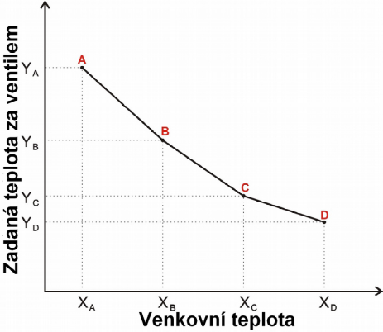
YA, YB, YC, YD – entered valve temperatures for the adequate outdoor temperatures: XA, XB, XC, XD. After switching on the regulation according to weather, the parameter for the valve entered temperature is not available.

  - Reverse protection:
This function enables setting the boiler protection from excessively cold water returning from the main circuit (reverse) which can cause low temperature corrosion of the boiler. The reverse protection functions in such way the temperature of return water is too low and closes the valve until the short boiler circuit reaches the adequate temperature.
The function also protects the boiler from hazardous high reverse temperature by preventing the water from boiling. Upon switching on the function, the user set the minimum and maximum reverse temperature.

  - Additional sensors:
If two mixing valves are operated, the user is to select the sensors upon the function activation to receive data on temperature values for the valve operation (for the sensors of outdoor temperature ad reverse). Temperatures can be read from the set valve sensors (own) or valve sensors 2 (from module 2).

  - Control with the room regulator:
This function enables to program the effects of the room regulator for the specific valve.
Room regulator – this option is used to define the room regulator type to cooperate with the valve. The options below are available:
    - Switched off – room regulator does not affect the valve setting
    - Regulator standard – two position regulator. In case of additional valves (valve 1 and 2) it includes the regulator directly connected to the valve control module (431N). In case of the main valve, the room regulator is connected directly to the boiler regulator H3.
    - Regulator OPOP – regulator with communication RS
    - Proportionate regulation – the option is available during the application of regulators OPOP RT10 with RS communication. It functions upon activating the change of entered valve value and the temperature difference in the room.
Room temperature reduction – after the room regulator signals the reaching of entered temperature in the room, the entered valve temperature drops by the assigned value (the option is not possible in the proportionate regulation function).
Change of entered valve temperature – this setting defines the drop or increase value of the valve temperature at the unit change of the room temperature (see: Temperature difference in the room). The function is active solely with the regulator OPOP and it closely relates to the parameter Temperature difference in the room.
Temperature difference in the room – this setting defines the unit change of the actual room temperature (with accuracy up to 0,1oC), when the defined change of the entered valve temperature occurs (the function is active solely with the use of room regulator OPOP).

  - Correction of outdoor sensor:
This function enables the calibration of the outdoor sensor.

  - Factory setting:
This parameters enables the return to the factoring setting of the defined valve. The return to the factory setting does not change the entered valve type (ÚT or floor).

  - Removal of the valve:
This function enables complete valve deleting from the regulator memory. The valve removal is used e.g. during the valve disassembly or module replacement (it requires new registration of the exchanged module).

  - Information about program:
This function enables the user to check the program version available in the control module.

Pump switching temperature
This function is used for setting the temperature for switching pumps ÚT and TUV (it is temperature measured on the boiler). If the temperature in the boiler is lower, the pumps do not operate. If temperature is higher, the pumps are switched on but operate according to the selected operating mode (see: Operating modes of the pumps).

TUV hysteresis
This option enables the hysteresis setting of the entered temperature on the boiler. It is a maximum difference between the entered temperature (or selected temperature on the boiler when the pump is off) and temperature, when it starts operating again.
Example: Entered temperature has value 55°C and hysteresis is 5°C. Upon reaching the entered temperature 55°C, pump TUV, the ÚT pump switches on and off. When temperature drops to 50°C, the TUV pump switches on again.

Additional pump 1, 2
Enter the type and operating parameters of the pump as required. The unit can control the pumps according to the three main types, as the circulation pump according to the exactly defined parameters, ÚT pump, and TUV pump.

The fuel amount calibration
It enables to calibrate the amount of fuel in the hopper. At first fill the hopper with fuel and press Full hopper. This starts the calibration. Now wait for the fuel to be burnt in the boiler. When the hopper is empty (fuel is completely burnt), press Empty hopper. At this moment you have deactivated the calibration. The unit now knows the duration of fuel burning in the hopper.
From now, every time you fill the hopper with fuel, go to the unit menu and press item Hopper empty. From now on, the unit starts counting the fuel consumption from the beginning and upon emptying, the empty hopper indication shall be on the unit display and our online system if the boiler is connected to the internet.

Setting the clock
Use this function to set actual hour and day.

Date setting
Use this function to set actual date (day and month).

Supervision mode
When the output drops to minimum, the unit transfers to the sustaining mode when the feeder and the fan operate differently to the PID work. In this mode you can set the time of the operation and break of the feeder and the fan revolutions in this mode.

Pump turning
If the boiler has not been operated for a long time, you can set the pump activation with the timer to prevent their blocking.

Sensitivity of the rotary controller
This setting enables to define the sensitivity of the impulse converter control (round button) at levels from 1 to 6 (where 1 means the highest sensitivity).

PID selection
After switching off PID the regulator shall operate as a common two-position regulator and the main menu shows additional information below:
Fuel feeding period – Use this option to define the work period of the fuel feeder. It must be defined considering the applied fuel and the boiler type.
Break in the feeder work – Use this function to define the break period in the fuel feeder work which must comply with the applied fuel. Incorrect time and break setting in the fuel feeding can result in incorrect boiler function, i.e. the fuel will not be well burnt or the boiler does not reach the required temperatures. The selection of adequate times enables correct boiler operation.
Temperature alarm – Use this function to define time for alarm switching on in case water temperature during this time interval increases to the defined temperature. Upon pressing the impulse converter controller, the alarm switches off and the regulator returns to the original setting.
Fan performance – Use this function to set the fan revolutions. The regulation fluctuates between from 1 to 100 %. Minimum fan performance is 1%, maximum 100%.
Inhibition mode – Use this function to set the time of fuel supply in the inhibition mode (boiler temperature is higher than entered temperature). It prevents the boiler burning out when the actual temperature is higher than entered temperature.
Attention : Incorrect setting of this parameter may cause adverse temperature increase in the boiler!
Break in the inhibition mode – This option sets the break period during the feeder work during the inhibition mode. The break in the inhibition mode must not be too short.
Attention : Incorrect setting of this parameter may cause adverse temperature increase in the boiler!
Fan in the inhibition mode – This function is used to set the operation period and the break period of the fan in the inhibition mode.
Boiler hysteresis – In this mode define the hysteresis of the entered temperature. It is a difference between the temperature in inhibition and temperature for the return in the common operation.
Example: Entered temperature has value 60°C and hysteresis is 3°C. The inhibition mode is entered after reaching temperature 60°C, and return to the operating cycle upon reducing temperature to 57°C). If we deactivate algorithm PID concurrently from the main menu and the plumber menu, the functions disappear (defined solely for work from PID):
- Heating start,
- Burning out,
- boiler performance,
- Air correction,
- type of fuel,
- Supervision mode.

Language selection
This function enables the user to select language version for the regulator control.

Display brightness and contrast
This function enables setting the display features of the display. Use it if information on the display is not clearly visible.

Servicing menu
The entry to the servicing menu of regulator H3 requires four digit code. This code shall be provided by OPOP spol. s.r.o. if you are a certified plumber with appropriate certification to install and start automatic boilers OPOP.

THE FIRST BOILER START-UP
After successful installation of all components and additional devices to the boiler, the The first start-up when the certified plumber sets the basic data for correct burning process and activates additional devices connected to the external base. Proceed as per the points below.
- Prior to the fuel ignition check the fan correct operation, screw feeder and the pumps connected to the external base of the boiler. The electrical components for the test purposes can be started in 3.6 Manual operation. If all components function correctly, proceed to the next point.
- The hopper filling with fuel – fill the hopper with coal/ pellets which must comply with the criteria below:
Fuel | Type of fuel | Grain size [mm] | Calorific power [kJ/kg-1]
Lignite | Nut 2 | 8-25 | 16,5-19,5
  - Content of water in fuel: max. 20%
  - Content of volatile flammable substance: 28 - 40%
  - Ash deformation temperature by melting: ˃ 1150˚C
  - Low binding power
  - Low swelling capacity

Fuel | Type of fuel | Grain size [mm] | Calorific power [kJ/kg-1]
Wooden pellets | ENplus A1 | 6-8 | 16,5-19,5
  - Content of water in fuel: max. 8%
  - Low binding power
  - Low swelling capacity

- upon filling the hopper with fuel close tightly the hopper upper lid to ensure sealing and prevent suction of false air in the hopper.
- Now transport the fuel from the hopper to the upper edge of the round burner grill. Again use function 3.6 Manual operation when you start and switch off the screw feeder after the fuel reaches the burner grill edge. Watch the continual state through the boiler doors.
- The fuel is shifted to the grill and now you are prepared for ignition. Prepare several chips and paper, place it in the retort, i.e. in the round grill opening.
- Before starting the heating, we recommend checking the below items in the Service menu:
  - Fuel type – Coal – check the factory setting of the feeder operation and fan revolutions for minimum and maximum performance. In this menu you can adjust the combustion process directly if the correction is not sufficient in the function Boiler performance coefficient and fan coefficient.
  - Boiler performance – select the performance as per the boiler type. Correct maximum performance of the boiler on the label on the rear side of the boiler.
- Start the fan in manual operation and set the revolutions to 5%.
- Ignite the paper and wait for the fire to move to wood. When the flame is permanent and burning out is not impending (it mostly lasts for several minutes to settle the flame) you can leave the manual operation and activate the heating up function. This is the phase of the fan revolutions and the operation of the screw feeder controlled with H3 boiler unit. Set the operation values and the fan revolutions in the heating up function so the fuel burns well and cannot burn out. During this phase the waste gas temperature is monitored. When waste gas temperature increases due to fire in the boiler and remains increased constantly from the original value for at least 30s, the unit transfers to PID operation.
- In PID operation, the combustion process is automatically controlled according to the ÚT entered temperature of boiler outlet water. Set the required outlet temperature from the boiler in item ÚT entered temperature. Recommended limit is from 65 – 80°C
- During the boiler door opening and closing use gloves to prevent burning.
Detailed description of individual functions is in chapter Control unit function description
The first boiler start is completed. Most options can be repeatedly changed after completing the First start-up in the Main or Installation menu.

BURNING CORRECTION
In PID work wait for several minutes until the main panel displays the maximum performance in kW. It is displayed on the control unit display H3. Currently the boiler operates at full output. Open the central door and check the combustion process quality, the fire parameters. In case it is not ideal, perform the correction using the method below. We recommend checking the combustion quality continually, in case of the chimney draught change or type and quality of fuel, readjust the combustion.

Flame quality
The flame inspection from the burner can define if the combustion process is optimum or if correction is required. The examples of good or bad combustion process are defined below.
Ideal flame at 100% output:
- Maximum length depends on the type of burner (it can be affected by the chimney draught and the fuel type).

  - Boiler 15-25kW = cca 20 – 30cm from the end of the grill
  - Boiler 30-40kW = cca 30 – 40cm from the end of the grill
  - Boiler 45-50kW = cca 40 – 50cm from the end of the grill
- Yellow-orange colour, non-burnt fuel does not fall from the grill, the ashtray contains fine ash.
Incorrect flame at 100% output:
- Maximum flame duration is lower or higher than above defined.

- Light yellow colour (too much combustion air) or dark orange or red (insufficient combustion air).
- The ashtray includes non-burnt fuel, dark fuel leaves chimney.
Use the functions below for the combustion process correction. The whole combustion can be affected by the change of the fan revolutions and time of screw feeder operation, always for the maximum and minimum boiler performance. Inside this scope (min/max) the change of the fan operation and the feeders is controlled with automatic performance modulation according to entered actual temperature ÚT.

Fan correction
The fan correction function in unit menu H3. Use this function to control the fan activity. The function principle of the regulation is based on the changes of characteristics of the fan up to down. If the fan performance within the whole regulation scope is low/ high, it is necessary to increase/ reduce the coefficient to enable the fan operation using adequate performance.

The correction downwards (minus values):
- The flame is too aggressive and spits
- The fan drops non-burnt fuel
- The flame is too low and aggressive
The correction upwards (plus values):
- The flame is slow and dark
- The grill is contaminated with black ash
- The flame is too large and smoke is black

Boiler performance coefficient
The feeder operation correction function in unit menu H3. In case the combustion process correction by means of the fan is insufficient, you can commence the time correction of the screw feeder, i.e. the fuel amount adjustment. Be aware that the correction directly affects the boiler performance.

Higher break or lower period of feeding when:
- The grill is excessively contaminated with black ash
- The flame is too large and smoke is black
- Waste gas temperature is higher than recommended
Lower break or higher period of feeding when:
- The boiler is not able to adequately heat ÚT temperature
- The flame is too low and aggressive
- Waste gas temperature is lower than recommended

After every correction leave the flame to settle for several minutes and check the change which occurred after your correction intervention on the flame. In case you are not satisfied, perform the correction again.
The recommended combustion parameters are factory set in the service mode.

Therefore adjust the parameters solely in case the flame is not optimum which is caused by other than recommended chimney draught or quality of applied fuel.

HEATING SYSTEM CONTROL
The below defined are the most frequent examples of the heating system connection with boiler H8-A. The examples are solely representative. The specific type of the heating system connection requires consulting with your plumbing company.

One circuit ÚT + heating TUV

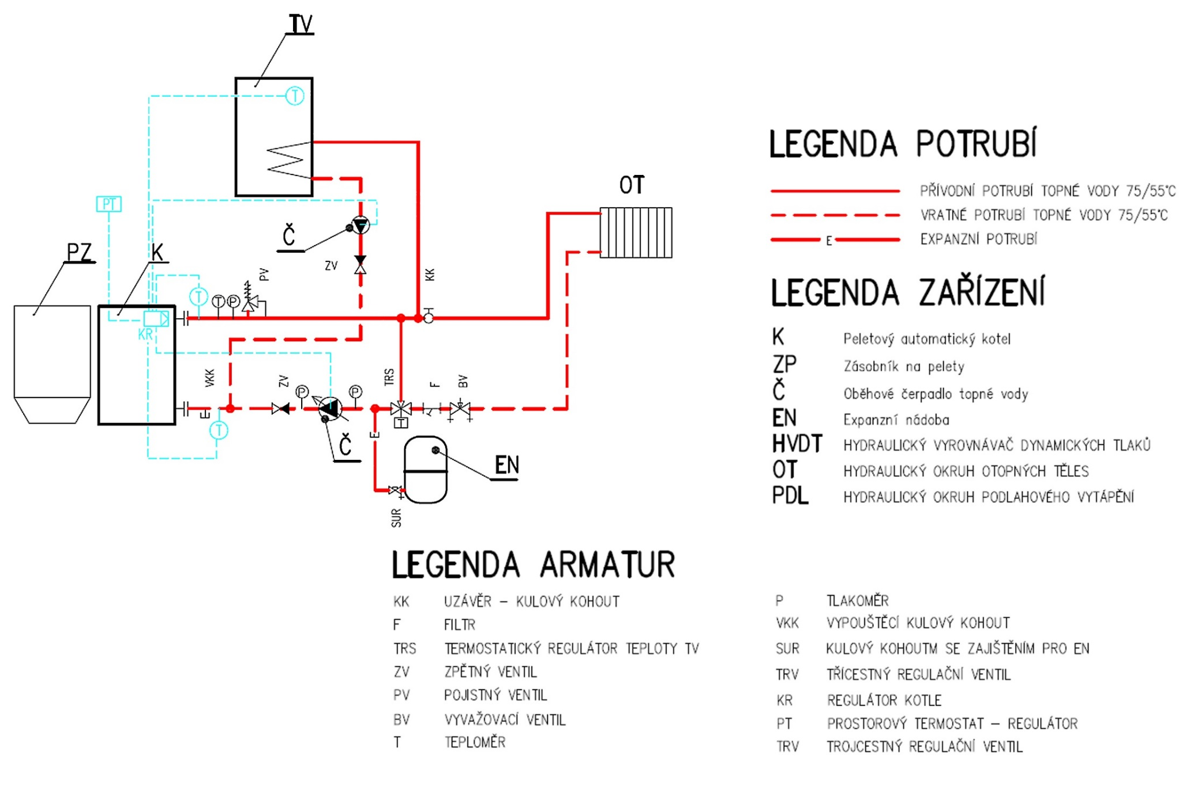

Two circuits ÚT + heating TUV

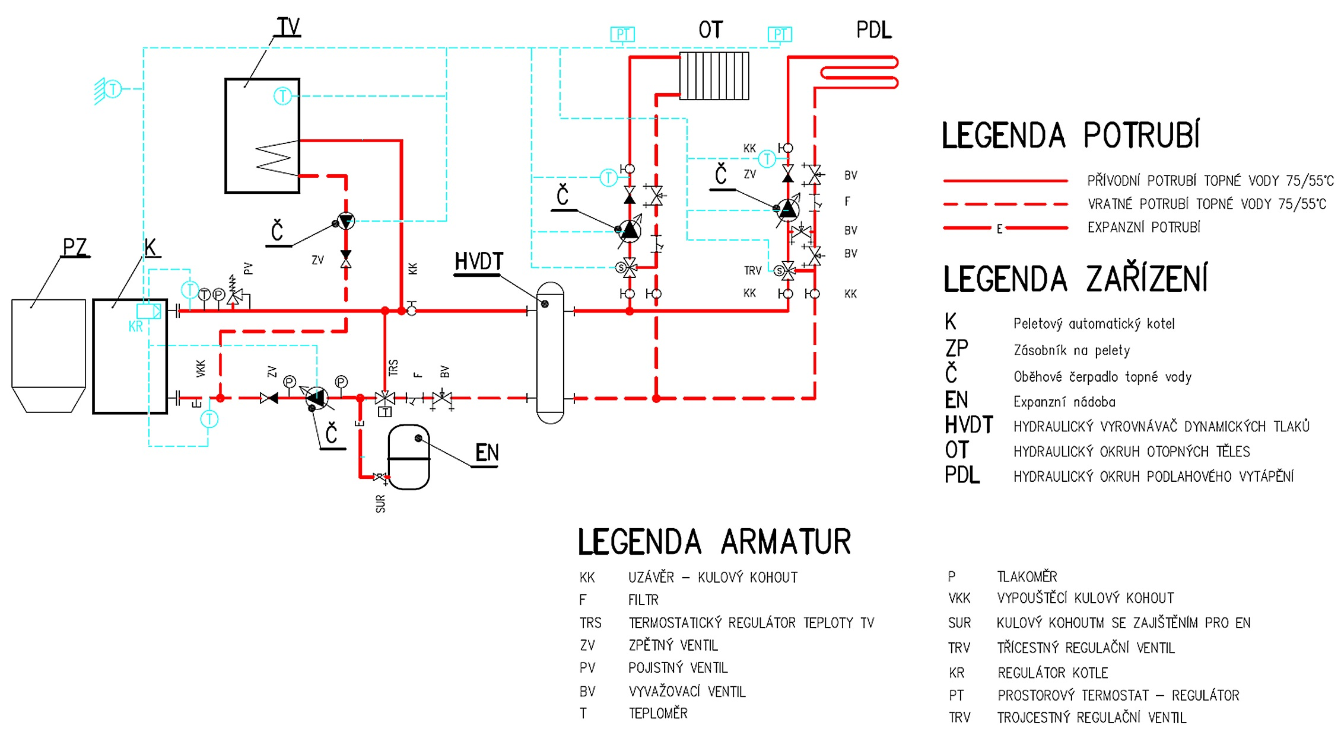

One circuit ÚT + solar heating + heating TUV
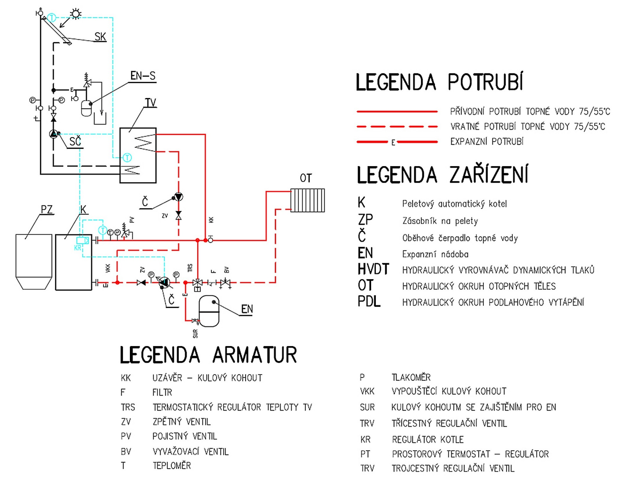

REGULAR MAINTENANCE
The boiler quality is an integral part of the boiler operation for solid fuels. The recommended intervals of manual boiler, burner, and fume duct cleaning. Be aware that the defined intervals are solely the basic recommendation which may differ from the real requirements for regular cleaning. The frequency of regular cleaning is defined by the combustion process quality, type and quality of fuel, the dust level and moisture in the fuel, chimney draught, etc. Always check the boiler contamination speed within short intervals during the first months of the operation to define yourself the time interval of the boiler, burner, and fume duct path cleaning.

 | Weekly | monthly | Quarterly | Annually
Ashtray cleaning
Burner grill cleaning
Boiler exchanger cleaning
Combustion inspection
Cleaning the burner sweeping openings
Door sealing inspection
Burner complete cleaning
Hopper cleaning
Fume duct and chimney

- The ashtray cleaning is a principle step during regular boiler inspection. Pay attention to correct location of the ashtray during returning back to the boiler.
- The burner grill is replaceable and requires regular cleaning During the first weeks of the operation, monitor the frequency of ash formation on the grill and scrape it regularly by means of cleaning tools. Perform this task solely with deactivated boiler state (light off).
- Cleaning the front parts of the boiler in the burner area as required at the same time as the burner grill cleaning.
- The cleaning of waste gas whirlers and exchanger is essential task. The ash on the exchanger partitions reduces the efficiency and increases the waste gas temperature, i.e. more heat leaves the chimney if the heat exchanger is contaminated with ash. Waste gas whirlers are removable, we recommend to regularly check the passage between individual plates of the whirlers and potentially remove and clean them.
- Once or twice per season, check the passage of the fume duct and clean it by means of sweeping opening which should be placed on the fume duct.
- The burner should be completed cleaned occasionally. Use the burner sweeping openings on the burner. The burner maintenance method is defined in the sub-chapter below.
- Once per season check the sealing of the asbestos sealing cords on all doors. In case they are hard and lost the sealing ability, we recommend performing the exchange.
It generally applies that the boiler parts contamination and the fume duct depends on the combustion process quality, type and fuel quality, the amount of dust in fuel, etc. Adjust the recommended cleaning intervals according to the real situation of the boiler operation.
The burner cleaning is essential factor defining the combustion quality.
- The burner grill is extractable for better access to the grill and under the grill. The grill must be clean so all openings in the grill were passing.
- The grills are attached to the burner by means of screws which must be fastened to prevent independent grill falling out after repeated grill location on the burner.
- The burner includes 2 flaps for dust and ash sweeping from the burner. One is placed under the grill (the retort bottom) and the second is under the hopper flange.
- Once per season, check the sealing of sealed connections of individual flanges (burner vs. boiler, burner vs. hopper).
Ask your assembly company for careful explanation of the boiler and burner cleaning method to operate the boiler in compliance with the defined instructions. Regular cleaning of the boiler, burner, and waste duct route provides maximum boiler efficiency and low fuel consumption during the boiler operation.

SAFETY ELEMENTS
In order to provide maximum safety and defect-free operation, the regulator is equipped with the whole series of safety elements. In case of alarm, a sound signal sounds and the display shows the respective information. To restart the regulator operation it is necessary to press the impulse converter controller. In case of alarm High temperature ÚT it is necessary to wait for the temperature drop below the alarm temperature.

Temperature Alarm
The security is activated only in the operation mode (if the boiler temperature is lower than entered temperature). If the boiler temperature in the user set time grows, the alarm sound signal is on, the feeder and fan switches off, and the display shows: „Temperature does not grow”.
Upon pressing the impulse converter controller, the alarm switches off and the regulator returns to the set operating mode.

Safety thermostat
It is sufficient bimetal mini sensor placed at the boiler temperature sensor (potentially on the supply piping as close to the boiler as possible). It switches off the fan and the feeder if the alarm temperature is exceeded around 85÷95°C. It prevents water boiling in the installation during the boiler overheating or in case of regulator defect. After the sensor fulfils the function and temperature drops to the safe value, the sensor is unblocked independently
In case of damage or the sensor overheating, the fan and the feeder remain switched off.
Attention : In case of damage the fan or feeder does not operate, in the manual and automatic operation.

Automatic sensor inspection
In case of ÚT, TUV or screw damage, the signal sounds and the display shows the defect, e.g. „Damaged sensor ÚT ”. The feeder and the fan remain switched off, the pump operates independently on boiler temperature.
In case of ÚT or screw damage, the alarm will be active until the replacement for new. In case of TUV sensor damage, press the impulse converter controller to switch off the alarm and the regulator returns to the operating mode with one pump (ÚT). The operation restart in all modes it is necessary to replace the sensor.

Security against overheating in the boiler by means of Termik sensor
Sensor Termik provides the protection from overheating in case the boiler temperature exceeds 93°C. Sensor termik opens the closed circuit and the unit immediately stops the fuel feeding and fan operation. Sensor Termik with measuring accuracy +-2°C.

Security against overheating in the boiler
The regulator is sufficiently equipped with the security program from hazardous temperature growth. In case of exceeding the alarm temperature (80°C) the fan switches off and the pumps start operating to distribute overheated water in the household. If temperature exceeds 85°C, the alarm is on and the display shows caution: ‘Excessively high temperature’.
After the temperature drop to the safe value and pressing the impulse converter controller, the alarm switches off and the regulator returns to the set operating mode.

Fuel feeding security
The screw feeder includes sufficient temperature sensor. In case of high temperature growth (above 85°C) the alarm switches on; the feeder starts operating constantly for 20 minutes and discharges fuel into the combustion area. This prevents the fuel ignition in the hopper.

Fuse
The network safety is provided with two tube melting fuses WT 6.3A. The use of another fuse with higher current value, can cause damage to the whole regulation.

SPARE PARTS H815-A, H815-AP, H815-P

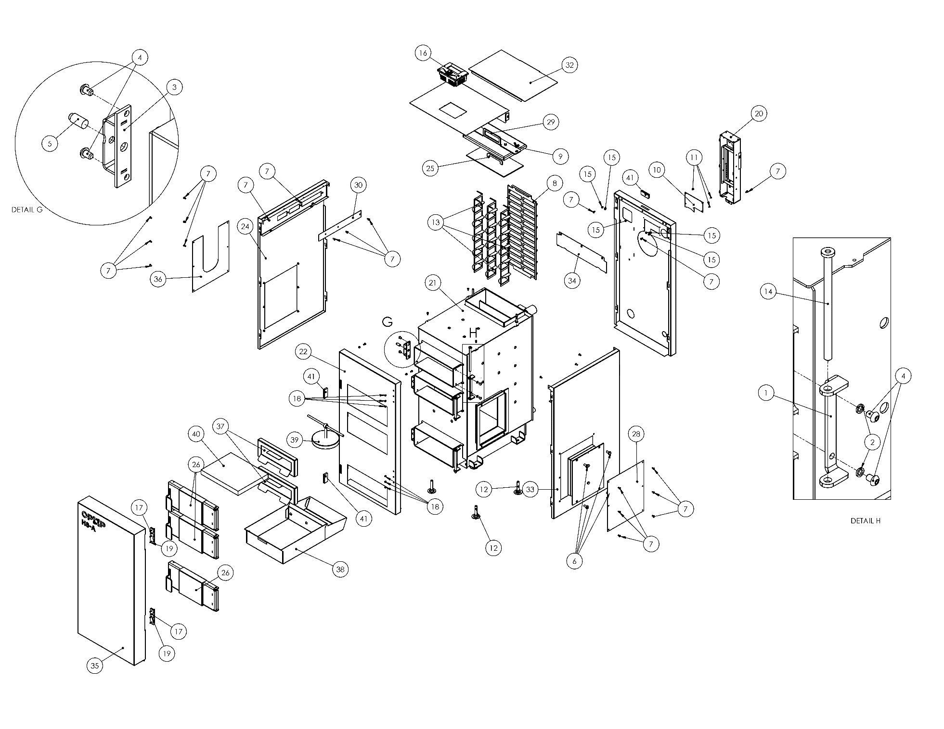

Item No. | Part no. | Name | Amount per 1pcs
1 |  | Item ČSN 02 1740.00 | 16
2 |  | Screw ISO 7380 M8x12-8.8 | 16
3 | 214400 | Handle pin 2 | 3
4 |  | Screw ISO 4017 M10x20 | 4
5 |  | Screw ISO 7045 M5x10 | 34
6 |  | Nut ČSN 02 1665.00 | 2
7 |  | Screw ISO 7049 ST3,5x9,5 | 5
8 |  | Leg assembly | 4
9 |  | Nut HEYMAN M5 113518 | 10
10 |  | OPOP H3 | 1
11 |  | hinge 50x100 | 4
12 |  | Nut HEYMAN M4 113517 | 12
13 |  | Screw ISO 7046-1 M4x16 | 24
14 | 7001426 | Electronics cabinet | 1
15 | 573269 | Weld set | 1
16 | 577584 | Fireclay block II | 4
17 | 577583 | Block I | 3
18 | 577277 | Fireclay block III | 4
19 | 3652874 | Front cover | 1
20 | 3652875 | Rear cover | 1
21 | 7001471 | Side left cover assembly | 1
22 | 7001467 | Set of cleaning door flap | 1
23 | 7001469 | Front door set | 2
24 | 3652856 | Attachment door hinge | 2
25 | 7001462 | Front door lid set | 2
26 | 7001466 | Cover set | 1
27 | 3631932 | Side cover set | 1
28 | 3652870 | waste gas whirlers | 1
29 | 7001468 | Cleaning door set | 1
30 | 3631933 | Rear cover plug | 1
31 | 3652857 | waste gas whirlers 2 | 8
32 | 7001463 | door pin set | 2
33 | 3631934 | Covering strip | 1
34 | 7001472 | Upper cover assembly | 1
35 | 3652881 | Rear upper cover | 1
36 | 7001473 | Side right cover assembly | 1
37 | 3631935 | Cover bar 2 | 1
38 | 7001474 | Front door set | 1
39 | 3631936 | Side cover set 2 | 1
40 | 7001475 | Chamber insulation assembly | 2
41 | 7001477 | Front ashtray door lid set | 1
42 | 3652893 | Ashtray door hinge | 1
43 | 7001478 | Ashtray door pin set | 1
44 | 7001479 | Front door set | 1
45 | 7001520 | Front ash pan assembly | 1
46 | 7001521 | Rear ash pan assembly | 1
47 | 7001556 | Electronics cabinet | 1
48 |  | Item ČSN 02 1745.09 5,3 | 2
49 |  | Magnet | 4

SPARE PARTS H824-A, H824-AP, H824-P
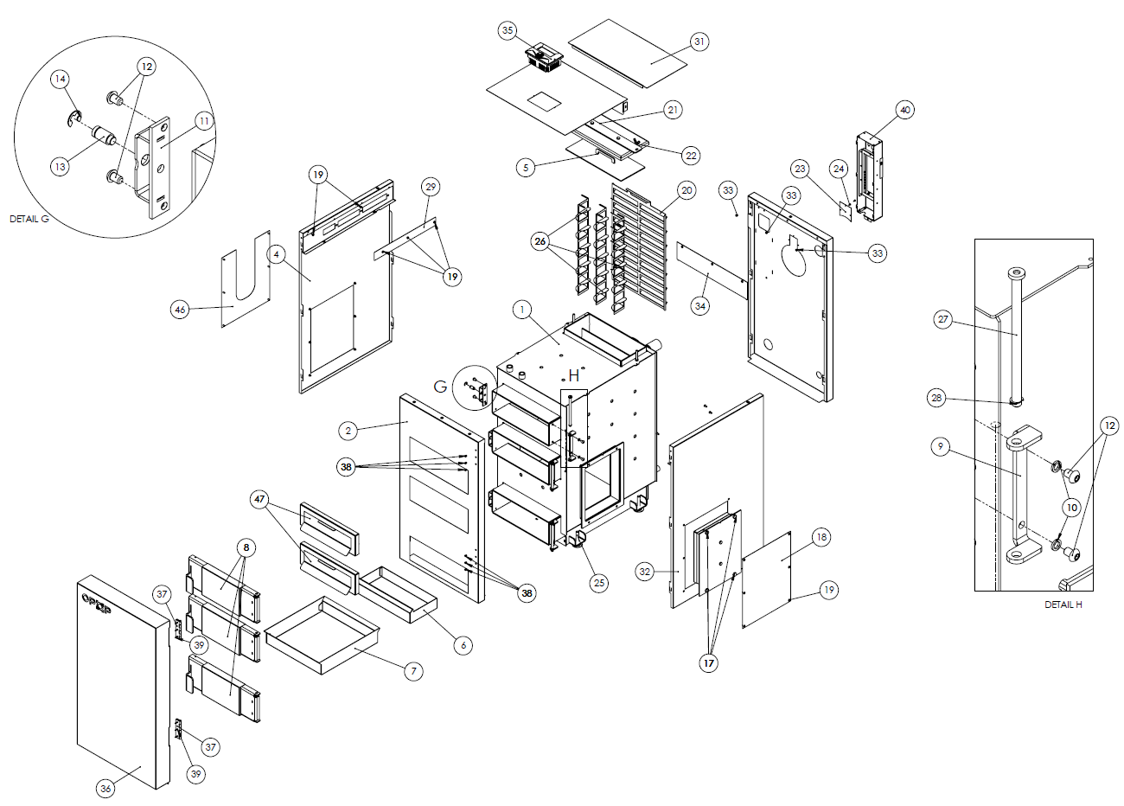

Item No. | Part no. | Name | Amount per 1pcs
1 | 573263 | Weld set | 1
2 | 3652799 | Front cover | 1
3 | 3652800 | Rear cover | 1
4 | 7001425 | Side left cover assembly | 1
5 | 7001416 | Set of cleaning door flap | 1
6 | 3652774 | Rear Ashtray | 1
7 | 3652775 | Front ashtray | 1
7A | 7001440 | Ashtray set | 1
8 | 7001418 | Front door set | 3
9 | 3652721 | Attachment door hinge | 3
10 |  | Item ČSN 02 1740.00 8 | 12
11 | 7001401 | Front door lid set | 3
12 |  | Screw ISO 7380 M8x12-8.8 | 12
13 | 214400 | Handle pin 2 | 3
14 |  | Ring ČSN 02 2929.09 9 | 3
15 | 3652712 | Fireclay anchor | 4
16 | 7001415 | Cover set | 1
17 |  | Screw ISO 4017 M10x20-5.6 | 4
18 | 3631869 | Side cover set | 1
19 |  | Screw ISO 7045 M5x10 | 26
20 | 3652777 | waste gas whirlers | 1
21 | 7001417 | Cleaning door set | 1
22 |  | Nut ČSN 02 1665.00 M8 | 2
23 | 3631870 | Rear cover plug | 1
24 |  | Screw ISO 7049 ST3,5x9,5 | 3
25 |  | Leg assembly | 4
26 | 3652733 | waste gas whirlers 2 | 3
27 | 7001412 | door pin set | 3
28 |  | Ring ČSN 02 2929.09 7 | 3
29 | 3631871 | Covering strip | 1
30 | 7001427 | Upper cover assembly | 1
31 | 3652810 | Rear upper cover | 1
32 | 7001428 | Side right cover assembly | 1
33 |  | Nut HEYMAN M5 -113518 | 4
34 | 3631872 | Cover bar 2 | 1
35 |  | Control unit OPOP-H3 independent (without temperature sensors and connectors and without electronics base) | 1
35A |  | Control unit OPOP-H3 with temperature sensors and connectors and with electronics base | 1
35B |  | Electronics base including temperature sensors and connectors | 1
35C |  | Emergency sensor Termik/85°C,1m | 1
35D |  | The revolution sensor cable of the fan to the hallotron | 1
35E |  | Therm. comb. sensor PT-1000/0,25m, black connection block | 1
35F |  | Therm. sensor. KTY(2kΩ)/2,5m, with terminal | 1
36 | 7001429 | Front door set | 1
37 |  | hinge 50x100 | 2
38 |  | Nut M4-113517 | 6
39 |  | Screw ISO 7046-1 M4x16-4.8 | 12
40 | 7001426 | Electronics cabinet | 1
41 | 577571 | Block I (30x275x355) | 1
42 | 577570 | Block II (30x100x355) | 4
43 | 577572 | Block III (30x200x355) | 1
44 | 577573 | Block IV (30x149x200) | 4
45 | 577574 | Block V (30x70x125) | 2
46 | 3631877 | Side cover set 2 | 1
47 | 7001436 | Attachment chamber insulation assembly | 2
48 |  | Setting system incl. accessories | 1
48A |  | canister 5L | 1
48B |  | hose 3/8 - 1m | 1
48C |  | hose clip | 2
48D |  | Wax cartridge | 2
48E | 3652831 | Sheet metal A (setting system holder) | 1
48F | 3652832 | Sheet metal B (setting system holder) | 1
48G |  | Connecting material for the setting system (self-cutting screw with hexagonal head 3,5x9,5 DIN 7504K steel, zinc | 4
48H |  | Hose holder | 1
49 |  | hopper (according to the boiler type) | 1
49A |  | Rubber insulation of the hopper upper lid | 1
49B |  | Front clamping clip of the hopper | 2
49C |  | Rear hopper hinge | 2
49D |  | Hopper connecting material
50 |  | putty TEKASIL acetate 60ml | 1
51 |  | Multipurpose burner (according to the boiler type) | 1
51A |  | Multipurpose burner furnace (according to the burner type) | 1
51B |  | Multipurpose burner sleeve (according to the burner type) | 1
51C |  | Screw line tube (according to the burner type) | 1
51D |  | Multipurpose burner screw (according to the burner type) | 1
51E |  | Motor (0,09kW) | 1
51F |  | transmission | 1
51G |  | Transmission with motor | 1
51H |  | Arresting leg (according to the burner type) | 1
51J |  | fan | 1
51K |  | Connecting material of the fan
51L |  | Connecting material for the burner connection to the boiler flange M10x20 ISO 4017 | 4
52 | 7001436 | Chamber insulation assembly | 2
52A | 577575 | Attachment chamber insulation | 1
52B | 3652825 | Attachment chamber insulation sheet metal | 1
53 |  | Filling/draining cock DN 1/2" | 1
54 |  | Cleaning tools (hook, brush with extension)
55 |  | Commercial technical documentation | 1
56 | 405400008240 | Alloy sleeve of burner H824-AP | 1
 | * applies to the whole production set – enter solely the boiler type

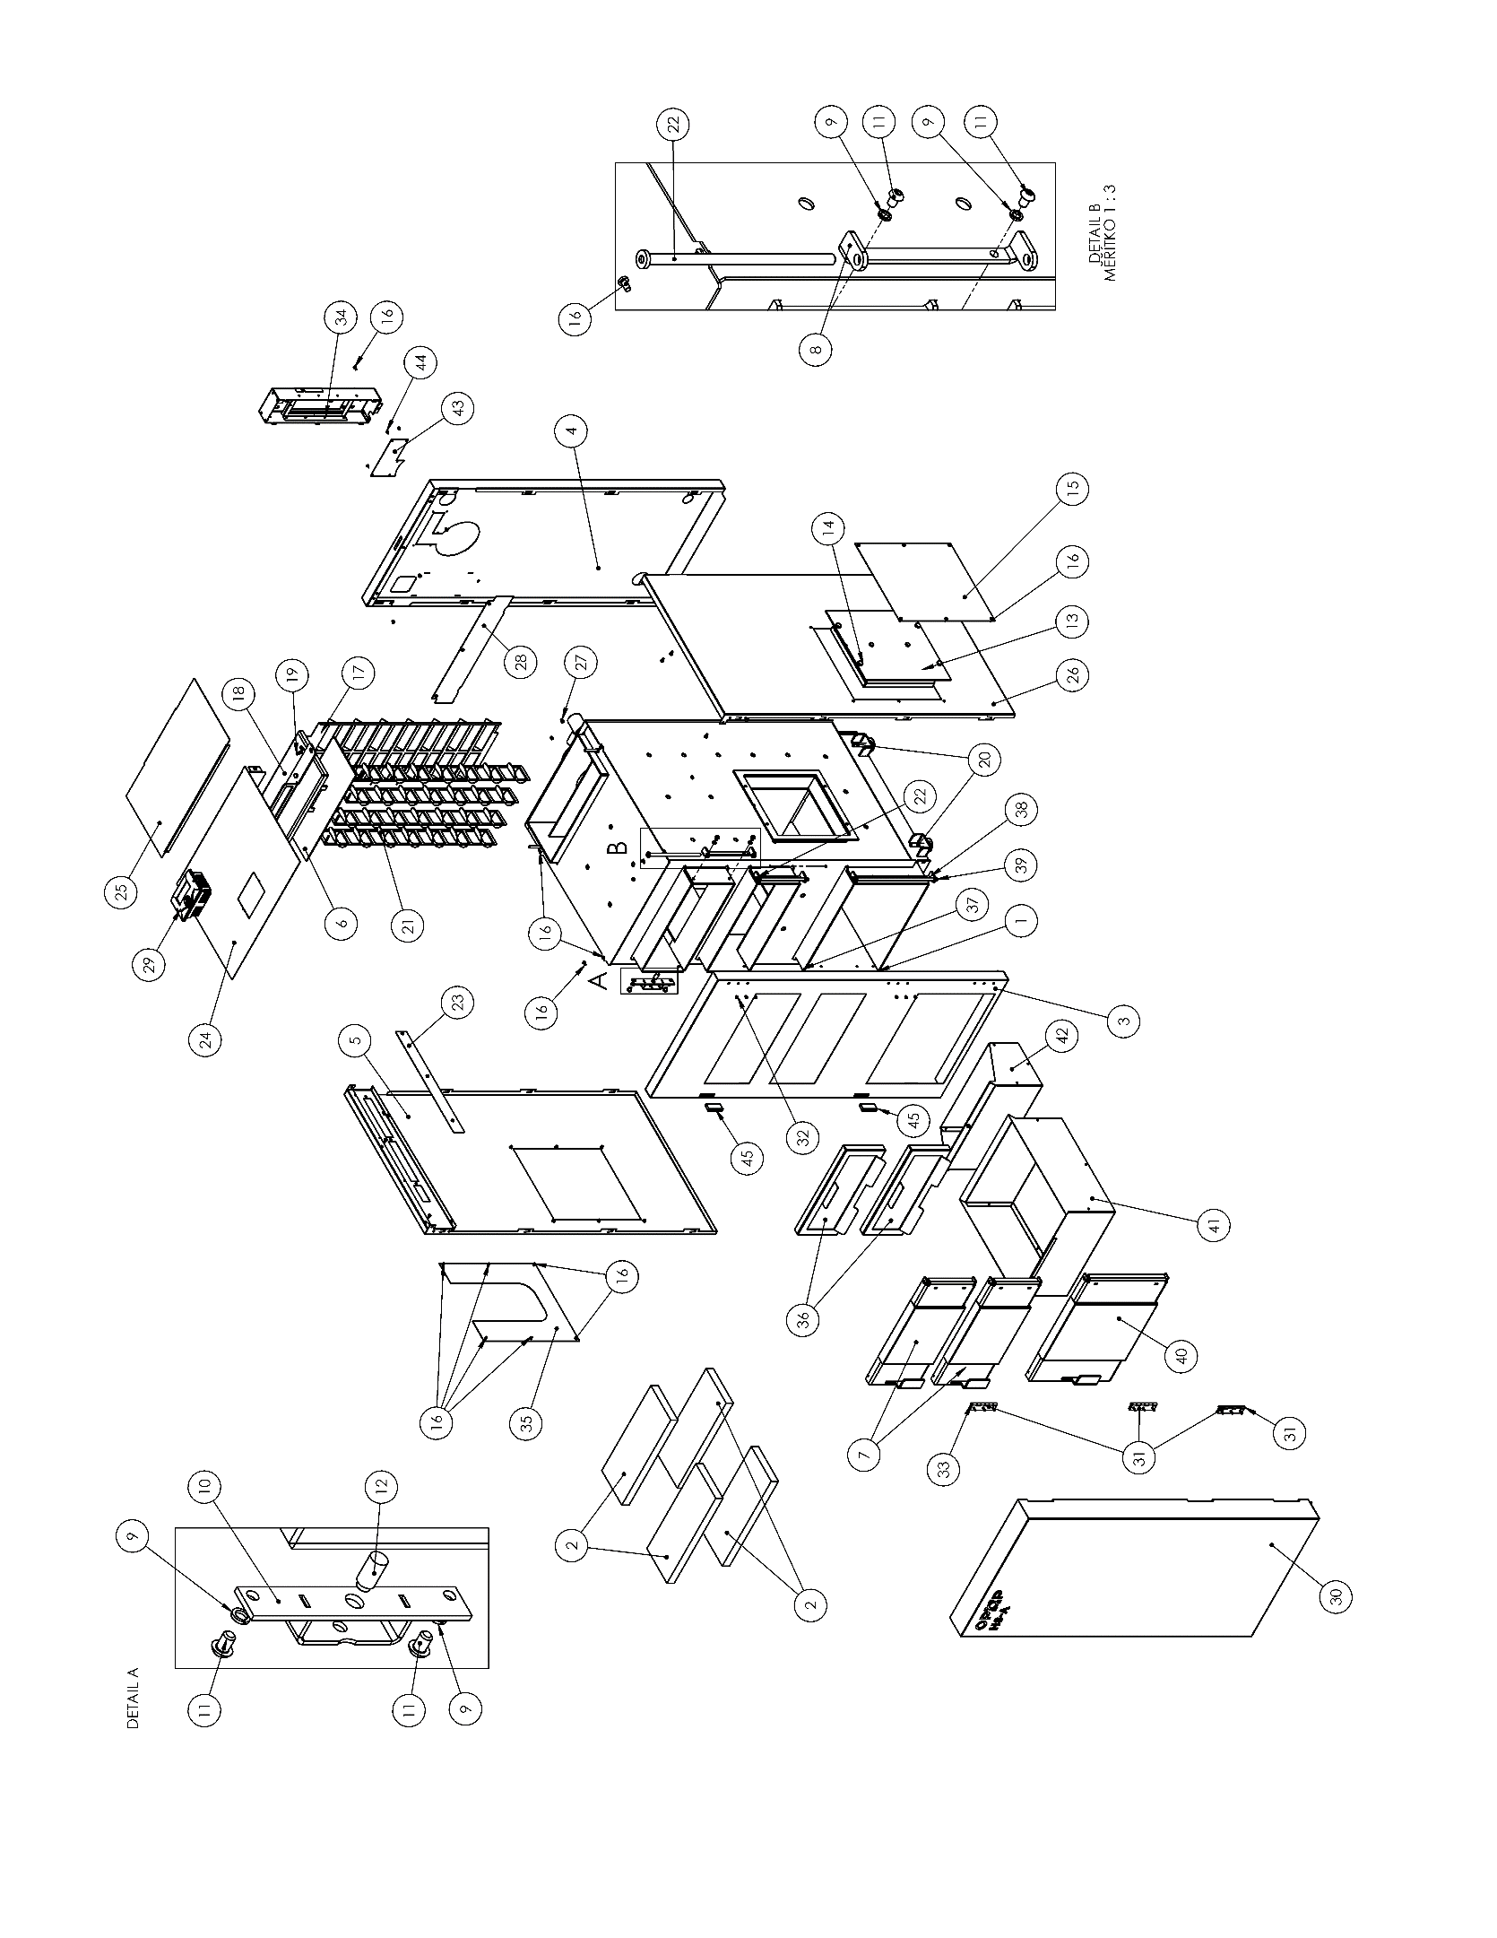
SPARE PARTS H835-A, H835-AP, H835-P

Item No. | Part no. | Name | Amount per 1pcs
1 | 573281 | Weld set | 1
2 | 577583 | Block I (30x165x405) | 3
3 | 3653532 | Front cover | 1
4 | 3652996 | Rear cover | 1
5 | 7001561 | Side left cover assembly | 1
6 | 7001559 | Set of cleaning door flap | 1
7 | 7001469 | Front door set | 2
8 | 3652856 | Attachment door hinge | 2
9 |  | Item ČSN 02 1740.00 8 | 16
10 | 7001462 | Front door lid set | 2
11 |  | Screw ISO 7380 M8x12-8.8 | 16
12 | 214400 | Handle pin 2 | 3
13 | 7001466 | Cover set | 1
14 |  | Screw ISO 4017 M10x20-5.6 | 4
15 | 3631932 | Side cover set | 1
16 |  | Screw ISO 7045 M5x10-H | 32
17 | 3652995 | waste gas whirlers | 1
18 | 7001560 | Cleaning door set | 1
19 |  | Nut ČSN 02 1665.00 M8 | 2
20 |  | Leg assembly | 4
21 | 3652991 | waste gas whirlers 2 | 4
22 | 7001463 | door pin set | 2
23 | 3632332 | Covering strip | 1
24 | 7001472 | Upper cover assembly | 1
25 | 3652999 | Rear upper cover | 1
26 | 7001562 | Side right cover assembly | 1
27 |  | Nut HEYMAN M5 -113518 | 8
28 | 3631935 | Cover bar 2 | 1
29 |  | OPOP H3 | 1
30 | 7001563 | Front door set | 1
31 |  | hinge 50x100 | 3
32 |  | Nut HEYMAN M4 -113517 | 9
33 |  | Screw ISO 7046-1 M4x16-4.8-H | 18
34 | 7001426 | Electronics cabinet | 1
35 | 3631936 | Side cover set 2 | 1
36 | 7001475 | Chamber insulation assembly | 2
37 | 7001477 | Front ashtray door lid set | 1
38 | 3652893 | Ashtray door hinge | 1
39 | 7001478 | Ashtray door pin set | 1
40 | 7001479 | Front door set | 1
41 | 7001520 | Front ash pan assembly | 1
42 | 7001564 | Rear ash pan assembly | 1
43 | 3632331 | Rear cover plug | 1
44 |  | Screw ISO 7049 ST3,5x9,5-C-H | 5
45 |  | Magnet | 2

SPARE PARTS H845-A, H845-AP, H845-P
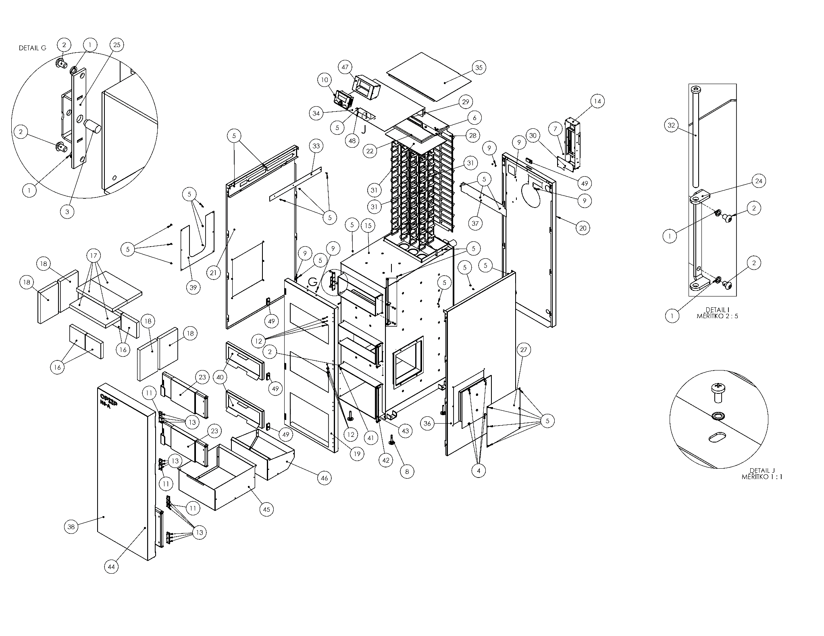

Item No. | Part no. | Name | Amount per 1pcs
1 |  | Item ČSN 02 1740.008 | 16
2 |  | Screw ISO 7380 M8x12-8.8 | 16
3 | 214400 | Handle pin 2 | 3
4 |  | Screw ISO 4017 M10x20-5.6 | 4
5 |  | Screw ISO 7045 M5x10-?-H | 34
6 |  | Nut ČSN 02 1665.00 M8 | 2
7 |  | Screw ISO 7049 ST3,5x9,5-C-H | 5
8 |  | Leg assembly | 4
9 |  | Nut HEYMAN M5 -113518 | 10
10 |  | OPOP H3 | 1
11 |  | hinge 50x100 | 4
12 |  | Nut HEYMAN M4 -113517 | 12
13 |  | Screw ISO 7046-1 M4x16-4.8-H | 24
14 | 7001426 | Electronics cabinet | 1
15 | 573269 | Weld set | 1
16 | 577584 | Fireclay block II | 4
17 | 577583 | Block I | 3
18 | 577277 | Fireclay block III | 4
19 | 3652874 | Front cover | 1
20 | 3652875 | Rear cover | 1
21 | 7001471 | Side left cover assembly | 1
22 | 7001467 | Set of cleaning door flap | 1
23 | 7001469 | Front door set | 2
24 | 3652856 | Attachment door hinge | 2
25 | 7001462 | Front door lid set | 2
26 | 7001466 | Cover set | 1
27 | 3631932 | Side cover set | 1
28 | 3652870 | waste gas whirlers | 1
29 | 7001468 | Cleaning door set | 1
30 | 3631933 | Rear cover plug | 1
31 | 3652857 | waste gas whirlers 2 | 8
32 | 7001463 | door pin set | 2
33 | 3631934 | Covering strip | 1
34 | 7001472 | Upper cover assembly | 1
35 | 3652881 | Rear upper cover | 1
36 | 7001473 | Side right cover assembly | 1
37 | 3631935 | Cover bar 2 | 1
38 | 7001474 | Front door set | 1
39 | 3631936 | Side cover set 2 | 1
40 | 7001475 | Chamber insulation assembly | 2
41 | 7001477 | Front ashtray door lid set | 1
42 | 3652893 | Ashtray door hinge | 1
43 | 7001478 | Ashtray door pin set | 1
44 | 7001479 | Front door set | 1
45 | 7001520 | Front ash pan assembly | 1
46 | 7001521 | Rear ash pan assembly | 1
47 | 7001556 | Electronics cabinet | 1
48 |  | Item ČSN 02 1745.09 5,3 | 2
49 |  | Magnet | 4

RETTING AND TARRING OF THE BOILER
Definitely during the first and also other heating, excessive boiler retting may occur; the ashtray part can include dark liquid. It is caused by low water temperature in the boiler (under dew point 65°C) and low waste gas temperature. The retting stops after frequent combustion product settling on the walls and after heating above temperature 65°C. It is not the product leaking. Every boiler is carefully tested with overpressure and the leak option is practically eliminated.
The tarring occurs in boilers:
- Low chimney draught. If it is permanently low, it can be removed by adjustment. If temporarily low, it is caused by weather conditions
- Wet fuel
- With permanently dampen operation under low temperatures below the dew point, i.e. 65°C
- In case of the boiler incorrect dimensioning, considering the area heat loss
- In case of unprofessional operation.
During wet or moist fuel combustion, the rated output may not be achieved, the boiler is clogged, retted, and tarred. It results in significant economic losses which are reflected by increased fuel consumption and by reduced boiler service life.
Warning:
If the dew point of waste gas is about 65 °C, the condensate occurs only in case of waste gas cooling with the limit layer on the boiler walls and temperature lower than 65 °C. If the retting occurs in the attachment well it means the fuel is too wet. In such case the condensate may flow into the ashtray area and with water temperature above 65 °C.

RISK ANALYSIS
Residual risks and their prevention. Risks associated with the operation of the boiler under the assumed application and logically anticipated incorrect application were minimized by means of available technical measures. Despite the applied constructional and technical measures, certain residual risks involved during the boiler operation remain, as indicated in the risk analysis, which are given by the technological process during various phases of the service life of the machine. These risks specifically result from boiler operators inattention and by failing to adhere to safety principles during operation. In order to reduce the risks and increase efficiency of the safety protection we highlight possible occurrence of residual risks which cannot be removed by any technical solution.

Risks associated with the boiler supply and its accessories
Risk source | Effects of risk | Danger elimination
Transport vehicle – freight vehicle, passenger vehicle of the technicians | Restrict the movement of employee (neighbours, family members) and machines in the locations where the device is unloaded from passenger freight car | Define the unloading area and notify of the fact the employees (neighbours, family members)
Handling trolley, forklift, freight vehicle arm and other vehicles to be unloaded | The risk of injury or damage from the device parts to be replaced | Thoroughly consider the unloading strategy of unloading and transport of individual device parts to the location where the device shall be temporarily stored or assembled.
The device storage, in folded state or unfolded | Collision of persons, machines, vehicle, etc. with placed machine parts. Water condensation in electrical installation and subsequent injury of technician, potentially the occurrence of damage to the device | The storage area must be appropriately marked and secured The area must be dry so the moisture does not penetrate the device electrical installation
Risks during the boiler fitting to the specific location and the completion
Risk source | Effects of risk | Danger elimination
Handling trolley, forklift, or other devices for fixing the device | The risk of injury or damage from the device parts to be replaced | Pay increased attention if you or your employees are assisting to the technicians
Independent completion | Injuries caused by the drill, angle grinder and common tools to be used by the technician. E.g. hammer, screwdriver, file, etc. The fall of some part of the device. | If your employees or you assist our technicians, get proper safety tools, e.g. safety goggles, work gloves, etc. For the whole period pay attention and anticipate
Risks associated with the common boiler operation and its accessories
Hazard source | Effects of risk | Danger elimination
Boiler unit | Burning by contact with the door (attachment, cleaning, ashtray) if open, hand or face burning upon opening | Open the door in safety goggles, the door is in direct contact with the waste gas and can reach temperature up to 400C. Upon the door opening stay in such way potential hot waste gas leak does not reach you. The hazard of steam lasts before automatic under-pressure balancing in the combustion chamber
Ashtray | Hand injury, burning from ashtray contact. Remove ash from the ashtray | handle the ashtray solely in protection gloves designated for the purposes. Pour out ash to the designated location. Ash may be still hot, therefore store in the designated location.
Risks associated with the boiler maintenance and its accessories
Hazard source | Effects of risk | Danger elimination
Combustion chamber | Burning, inhaling, eye contamination with dust | If the boiler is not shut down for a long period, its parts can be hot, use safety gloves. During the combustion chamber cleaning use protection goggles and respirator The recommended shutdown period is 4 hours.
Thermal risks
The boiler must not be exposed to higher operating overpressure than defined
It is prohibited to overheat the boiler
The boiler must be protected from low temperature corrosion with suitable connection with automatic reverse temperature protection
The boiler enables burning solely the defined fuels
It is prohibited to store flammable substances near the boiler
Risk resulting from fuel handling
During the fuel handling, the emission of solid particles occurs. The operators should use suitable protection devices according to the dust level.
The fuel requires to observe the respective fireproof regulations and must be available as fire extinguishing devices
Ergonomic risks
The boiler must be in horizontal position
During the boiler operation appropriately close all doors, lids, and covers

ENERGY EFFICIENCY

I. | II. | III. | IV. | V | VI
Name or trademark of the supplier; | Identification brand of the supplier’s model; | Energy efficiency class | rated heat output in kW | Energy efficiency index | Seasonal energy efficiency of heating in %
OPOP s.r.o. | H815-A | C | 15 | 79 | 79
OPOP s.r.o. | H824-A | C | 24 | 81 | 81
OPOP s.r.o. | H835-A | C | 35 | 81 | 81
OPOP s.r.o. | H845-A | B | 45 | 83 | 83
OPOP s.r.o. | H815-AP | A+ | 17 | 109 | 75
OPOP s.r.o. | H824-AP | A+ | 21 | 115 | 79
OPOP s.r.o. | H835-AP | A+ | 32 | 115 | 79
OPOP s.r.o. | H845-AP | A+ | 42 | 115 | 79
OPOP s.r.o. | H815-P | A+ | 17 | 109 | 75
OPOP s.r.o. | H824-P | A+ | 21 | 115 | 79
OPOP s.r.o. | H835-P | A+ | 32 | 115 | 79
OPOP s.r.o. | H845-P | A+ | 42 | 115 | 79

IDENTIFICATION CARDS

Identification brand of the model; H815-A
Condensation boiler: |  | no | Cogeneration boiler for solid fuels: |  | no | Combined boiler: |  | yes
Feeding module: Automatic |  | Manual: The boiler should be operated with hot water container with volume at least x(*) litres/ Automatic: We recommend the boiler should be operated with hot water container with volume at least x(**) litres]
Fuel |  |  |  |  | Preferred fuel (solely one): |  | Other suitable fuel/fuels:
Wooden logs, moisture content ≤ 25 % |  |  |  |  | no |  | no
Wood chips, moisture content 15–35 % |  |  |  |  | no |  | no
Wood chips, moisture content > 35 % |  |  |  |  | no |  | no
Pressed wood in the form of pellets or briquette |  |  |  |  | no |  | no
Sawdust, moisture content ≤ 50 % |  |  |  |  | no |  | no
Other wood biomass |  |  |  |  | no |  | no
Non-wood biomass |  |  |  |  | no |  | no
Black coal |  |  |  |  | no |  | no
Brown coal (including briquettes) |  |  |  |  | yes |  | no
Coke |  |  |  |  | no |  | no
Anthracite |  |  |  |  | no |  | no
Briquettes with fossil fuel mixture |  |  |  |  | no |  | no
Other fossil fuel |  |  |  |  | no |  | no
Briquettes with biomass (30–70 %) and fossil fuel mixture |  |  |  |  | no |  | no
Other mixture of biomass and fossil fuels |  |  |  |  | no |  | no
Properties during the operation for preferred fuel:
Seasonal energy efficiency of heating internal areas ηs [%]: |  |  |  |  | 79
Energy efficiency index EEI: |  |  |  |  | 79
Energy efficiency class |  |  |  |  | C
Name | Identification | Value | Unit |  | Name | Identification | Value | Unit
Useful thermal output |  |  |  |  | Useful efficiency
At rated thermal output | Pn(***) | 15,0 | kW |  | At rated thermal output | ηn | 86,0 | %
At [30 %] rated thermal output, if applicable | Pp | 4,4 | kW |  | At [30 %] rated thermal output, if applicable | ηp | 83,1 | %
Cogeneration boiler for solid fuels: Electrical efficiency |  |  |  |  | Auxiliary electricity consumption
At rated thermal output | ηel,n |  | % |  | At rated thermal output | elmax | 0,054 | kW
 |  |  |  |  | At [30 %] rated thermal output, if applicable | elmin | 0,022 | kW
 |  |  |  |  | Built-in secondary device for the emission reduction, if applicable |  | Not applicable | kW
 |  |  |  |  | In emergency mode | PSB | 0,002 | kW
Contact data |  | OPOP s.r.o. , Zašovská 750, Valašské Meziříčí, 757 01
(*) Tank volume = 45 × Pr × (1 – 2,7/Pr) or 300 litres depending on the higher value where Pr is expressed in kW
(**) Tank volume = 20 × Pr where Pr is expressed in kW
(***) For preferred fuel Pn equals Pr

Identification brand of the model; H824-A
Condensation boiler: |  | no | Cogeneration boiler for solid fuels: |  | no | Combined boiler: |  | yes
Feeding module: Automatic |  | Manual: The boiler should be operated with hot water container with volume at least x(*) litres/ Automatic: We recommend the boiler should be operated with hot water container with volume at least x(**) litres]
Fuel |  |  |  |  | Preferred fuel (solely one): |  | Other suitable fuel/fuels:
Wooden logs, moisture content ≤ 25 % |  |  |  |  | no |  | no
Wood chips, moisture content 15–35 % |  |  |  |  | no |  | no
Wood chips, moisture content > 35 % |  |  |  |  | no |  | no
Pressed wood in the form of pellets or briquette |  |  |  |  | no |  | no
Sawdust, moisture content ≤ 50 % |  |  |  |  | no |  | no
Other wood biomass |  |  |  |  | no |  | no
Non-wood biomass |  |  |  |  | no |  | no
Black coal |  |  |  |  | no |  | no
Brown coal (including briquettes) |  |  |  |  | yes |  | no
Coke |  |  |  |  | no |  | no
Anthracite |  |  |  |  | no |  | no
Briquettes with fossil fuel mixture |  |  |  |  | no |  | no
Other fossil fuel |  |  |  |  | no |  | no
Briquettes with biomass (30–70 %) and fossil fuel mixture |  |  |  |  | no |  | no
Other mixture of biomass and fossil fuels |  |  |  |  | no |  | no
Properties during the operation for preferred fuel:
Seasonal energy efficiency of heating internal areas ηs [%]: |  |  |  |  | 81
Energy efficiency index EEI: |  |  |  |  | 81
Energy efficiency class |  |  |  |  | C
Name | Identification | Value | Unit |  | Name | Identification | Value | Unit
Useful thermal output |  |  |  |  | Useful efficiency
At rated thermal output | Pn(***) | 23,1 | kW |  | At rated thermal output | ηn | 85,5 | %
At [30 %] rated thermal output, if applicable | Pp | 7,1 | kW |  | At [30 %] rated thermal output, if applicable | ηp | 84,6 | %
Cogeneration boiler for solid fuels: Electrical efficiency |  |  |  |  | Auxiliary electricity consumption
At rated thermal output | ηel,n |  | % |  | At rated thermal output | elmax | 0,073 | kW
 |  |  |  |  | At [30 %] rated thermal output, if applicable | elmin | 0,027 | kW
 |  |  |  |  | Built-in secondary device for the emission reduction, if applicable |  | Not applicable | kW
 |  |  |  |  | In emergency mode | PSB | 0,002 | kW
Contact data |  | OPOP s.r.o. , Zašovská 750, Valašské Meziříčí, 757 01
(*) Tank volume = 45 × Pr × (1 – 2,7/Pr) or 300 litres depending on the higher value where Pr is expressed in kW
(**) Tank volume = 20 × Pr where Pr is expressed in kW
(***) For preferred fuel Pn equals Pr

Identification brand of the model; H835-A

Condensation boiler: |  | no | Cogeneration boiler for solid fuels: |  | no | Combined boiler: |  | yes
Feeding module: Automatic |  | Manual: The boiler should be operated with hot water container with volume at least x(*) litres/ Automatic: We recommend the boiler should be operated with hot water container with volume at least x(**) litres]
Fuel |  |  |  |  | Preferred fuel (solely one): |  | Other suitable fuel/fuels:
Wooden logs, moisture content ≤ 25 % |  |  |  |  | no |  | no
Wood chips, moisture content 15–35 % |  |  |  |  | no |  | no
Wood chips, moisture content > 35 % |  |  |  |  | no |  | no
Pressed wood in the form of pellets or briquette |  |  |  |  | no |  | no
Sawdust, moisture content ≤ 50 % |  |  |  |  | no |  | no
Other wood biomass |  |  |  |  | no |  | no
Non-wood biomass |  |  |  |  | no |  | no
Black coal |  |  |  |  | no |  | no
Brown coal (including briquettes) |  |  |  |  | yes |  | no
Coke |  |  |  |  | no |  | no
Anthracite |  |  |  |  | no |  | no
Briquettes with fossil fuel mixture |  |  |  |  | no |  | no
Other fossil fuel |  |  |  |  | no |  | no
Briquettes with biomass (30–70 %) and fossil fuel mixture |  |  |  |  | no |  | no
Other mixture of biomass and fossil fuels |  |  |  |  | no |  | no
Properties during the operation for preferred fuel:
Seasonal energy efficiency of heating internal areas ηs [%]: |  |  |  |  | 81
Energy efficiency index EEI: |  |  |  |  | 81
Energy efficiency class |  |  |  |  | C
Name | Identification | Value | Unit |  | Name | Identification | Value | Unit
Useful thermal output |  |  |  |  | Useful efficiency
At rated thermal output | Pn(***) | 34,9 | kW |  | At rated thermal output | ηn | 85,5 | %
At [30 %] rated thermal output, if applicable | Pp | 10,4 | kW |  | At [30 %] rated thermal output, if applicable | ηp | 84,6 | %
Cogeneration boiler for solid fuels: Electrical efficiency |  |  |  |  | Auxiliary electricity consumption
At rated thermal output | ηel,n |  | % |  | At rated thermal output | elmax | 0,131 | kW
 |  |  |  |  | At [30 %] rated thermal output, if applicable | elmin | 0,044 | kW
 |  |  |  |  | Built-in secondary device for the emission reduction, if applicable |  | Not applicable | kW
 |  |  |  |  | In emergency mode | PSB | 0,002 | kW
Contact data |  | OPOP s.r.o. , Zašovská 750, Valašské Meziříčí, 757 01
(*) Tank volume = 45 × Pr × (1 – 2,7/Pr) or 300 litres depending on the higher value where Pr is expressed in kW
(**) Tank volume = 20 × Pr where Pr is expressed in kW
(***) For preferred fuel Pn equals Pr

Identification brand of the model; H845-A
Condensation boiler: |  | no | Cogeneration boiler for solid fuels: |  | no | Combined boiler: |  | yes
Feeding module: Automatic |  | Manual: The boiler should be operated with hot water container with volume at least x(*) litres/ Automatic: We recommend the boiler should be operated with hot water container with volume at least x(**) litres]
Fuel |  |  |  |  | Preferred fuel (solely one): |  | Other suitable fuel/fuels:
Wooden logs, moisture content ≤ 25 % |  |  |  |  | no |  | no
Wood chips, moisture content 15–35 % |  |  |  |  | no |  | no
Wood chips, moisture content > 35 % |  |  |  |  | no |  | no
Pressed wood in the form of pellets or briquette |  |  |  |  | no |  | no
Sawdust, moisture content ≤ 50 % |  |  |  |  | no |  | no
Other wood biomass |  |  |  |  | no |  | no
Non-wood biomass |  |  |  |  | no |  | no
Black coal |  |  |  |  | no |  | no
Brown coal (including briquettes) |  |  |  |  | yes |  | no
Coke |  |  |  |  | no |  | no
Anthracite |  |  |  |  | no |  | no
Briquettes with fossil fuel mixture |  |  |  |  | no |  | no
Other fossil fuel |  |  |  |  | no |  | no
Briquettes with biomass (30–70 %) and fossil fuel mixture |  |  |  |  | no |  | no
Other mixture of biomass and fossil fuels |  |  |  |  | no |  | no
Properties during the operation for preferred fuel:
Seasonal energy efficiency of heating internal areas ηs [%]: |  |  |  |  | 83
Energy efficiency index EEI: |  |  |  |  | 83
Energy efficiency class |  |  |  |  | B
Name | Identification | Value | Unit |  | Name | Identification | Value | Unit
Useful thermal output |  |  |  |  | Useful efficiency
At rated thermal output | Pn(***) | 44,8 | kW |  | At rated thermal output | ηn | 86,1 | %
At [30 %] rated thermal output, if applicable | Pp | 13,1 | kW |  | At [30 %] rated thermal output, if applicable | ηp | 87,0 | %
Cogeneration boiler for solid fuels: Electrical efficiency |  |  |  |  | Auxiliary electricity consumption
At rated thermal output | ηel,n |  | % |  | At rated thermal output | elmax | 0,131 | kW
 |  |  |  |  | At [30 %] rated thermal output, if applicable | elmin | 0,044 | kW
 |  |  |  |  | Built-in secondary device for the emission reduction, if applicable |  | Not applicable | kW
 |  |  |  |  | In emergency mode | PSB | 0,002 | kW
Contact data |  | OPOP s.r.o. , Zašovská 750, Valašské Meziříčí, 757 01
(*) Tank volume = 45 × Pr × (1 – 2,7/Pr) or 300 litres depending on the higher value where Pr is expressed in kW
(**) Tank volume = 20 × Pr where Pr is expressed in kW
(***) For preferred fuel Pn equals Pr

Identification brand of the model; H815-AP, P
Condensation boiler: |  | no | Cogeneration boiler for solid fuels: |  | no | Combined boiler: |  | yes
Feeding module: Automatic |  | Manual: The boiler should be operated with hot water container with volume at least x(*) litres/ Automatic: We recommend the boiler should be operated with hot water container with volume at least x(**) litres]
Fuel |  |  |  |  | Preferred fuel (solely one): |  | Other suitable fuel/fuels:
Wooden logs, moisture content ≤ 25 % |  |  |  |  | no |  | no
Wood chips, moisture content 15–35 % |  |  |  |  | no |  | no
Wood chips, moisture content > 35 % |  |  |  |  | no |  | no
Pressed wood in the form of pellets or briquette |  |  |  |  | yes |  | no
Sawdust, moisture content ≤ 50 % |  |  |  |  | no |  | no
Other wood biomass |  |  |  |  | no |  | no
Non-wood biomass |  |  |  |  | no |  | no
Black coal |  |  |  |  | no |  | no
Brown coal (including briquettes) |  |  |  |  | no |  | yes
Coke |  |  |  |  | no |  | no
Anthracite |  |  |  |  | no |  | no
Briquettes with fossil fuel mixture |  |  |  |  | no |  | no
Other fossil fuel |  |  |  |  | no |  | no
Briquettes with biomass (30–70 %) and fossil fuel mixture |  |  |  |  | no |  | no
Other mixture of biomass and fossil fuels |  |  |  |  | no |  | no
Properties during the operation for preferred fuel:
Seasonal energy efficiency of heating internal areas ηs [%]:
Energy efficiency index EEI:
Energy efficiency class
Name | Identification | Value | Unit |  | Name | Identification | Value | Unit
Useful thermal output |  |  |  |  | Useful efficiency
At rated thermal output | Pn(***) | 16,5 | kW |  | At rated thermal output | ηn | 80,3 | %
At [30 %] rated thermal output, if applicable | Pp | 5,1 | kW |  | At [30 %] rated thermal output, if applicable | ηp | 79,5 | %
Cogeneration boiler for solid fuels: Electrical efficiency |  |  |  |  | Auxiliary electricity consumption
At rated thermal output | ηel,n |  | % |  | At rated thermal output | elmax | 0,091 | kW
 |  |  |  |  | At [30 %] rated thermal output, if applicable | elmin | 0,032 | kW
 |  |  |  |  | Built-in secondary device for the emission reduction, if applicable |  | Not applicable | kW
 |  |  |  |  | In emergency mode | PSB | 0,002 | kW
Contact data |  | OPOP s.r.o. , Zašovská 750, Valašské Meziříčí, 757 01
(*) Tank volume = 45 × Pr × (1 – 2,7/Pr) or 300 litres depending on the higher value where Pr is expressed in kW
(**) Tank volume = 20 × Pr where Pr is expressed in kW
(***) For preferred fuel Pn equals Pr

Identification brand of the model; H824-AP, P
Condensation boiler: |  | no | Cogeneration boiler for solid fuels: |  | no | Combined boiler: |  | yes
Feeding module: Automatic |  | Manual: The boiler should be operated with hot water container with volume at least x(*) litres/ Automatic: We recommend the boiler should be operated with hot water container with volume at least x(**) litres]
Fuel |  |  |  |  | Preferred fuel (solely one): |  | Other suitable fuel/fuels:
Wooden logs, moisture content ≤ 25 % |  |  |  |  | no |  | no
Wood chips, moisture content 15–35 % |  |  |  |  | no |  | no
Wood chips, moisture content > 35 % |  |  |  |  | no |  | no
Pressed wood in the form of pellets or briquette |  |  |  |  | yes |  | no
Sawdust, moisture content ≤ 50 % |  |  |  |  | no |  | no
Other wood biomass |  |  |  |  | no |  | no
Non-wood biomass |  |  |  |  | no |  | no
Black coal |  |  |  |  | no |  | no
Brown coal (including briquettes) |  |  |  |  | no |  | yes
Coke |  |  |  |  | no |  | no
Anthracite |  |  |  |  | no |  | no
Briquettes with fossil fuel mixture |  |  |  |  | no |  | no
Other fossil fuel |  |  |  |  | no |  | no
Briquettes with biomass (30–70 %) and fossil fuel mixture |  |  |  |  | no |  | no
Other mixture of biomass and fossil fuels |  |  |  |  | no |  | no
Properties during the operation for preferred fuel:
Seasonal energy efficiency of heating internal areas ηs [%]: |  |  |  |  | 79
Energy efficiency index EEI: |  |  |  |  | 115
Energy efficiency class |  |  |  |  | A+
Name | Identification | Value | Unit |  | Name | Identification | Value | Unit
Useful thermal output |  |  |  |  | Useful efficiency
At rated thermal output | Pn(***) | 19,6 | kW |  | At rated thermal output | ηn | 80,7 | %
At [30 %] rated thermal output, if applicable | Pp | 6,3 | kW |  | At [30 %] rated thermal output, if applicable | ηp | 83,5 | %
Cogeneration boiler for solid fuels: Electrical efficiency |  |  |  |  | Auxiliary electricity consumption
At rated thermal output | ηel,n |  | % |  | At rated thermal output | elmax | 0,095 | kW
 |  |  |  |  | At [30 %] rated thermal output, if applicable | elmin | 0,031 | kW
 |  |  |  |  | Built-in secondary device for the emission reduction, if applicable |  | Not applicable | kW
 |  |  |  |  | In emergency mode | PSB | 0,002 | kW
Contact data |  | OPOP s.r.o. , Zašovská 750, Valašské Meziříčí, 757 01
(*) Tank volume = 45 × Pr × (1 – 2,7/Pr) or 300 litres depending on the higher value where Pr is expressed in kW
(**) Tank volume = 20 × Pr where Pr is expressed in kW
(***) For preferred fuel Pn equals Pr

Identification brand of the model; H835-AP, P
Condensation boiler: |  | no | Cogeneration boiler for solid fuels: |  | no | Combined boiler: |  | yes
Feeding module: Automatic |  | Manual: The boiler should be operated with hot water container with volume at least x(*) litres/ Automatic: We recommend the boiler should be operated with hot water container with volume at least x(**) litres]
Fuel |  |  |  |  | Preferred fuel (solely one): |  | Other suitable fuel/fuels:
Wooden logs, moisture content ≤ 25 % |  |  |  |  | no |  | no
Wood chips, moisture content 15–35 % |  |  |  |  | no |  | no
Wood chips, moisture content > 35 % |  |  |  |  | no |  | no
Pressed wood in the form of pellets or briquette |  |  |  |  | yes |  | no
Sawdust, moisture content ≤ 50 % |  |  |  |  | no |  | no
Other wood biomass |  |  |  |  | no |  | no
Non-wood biomass |  |  |  |  | no |  | no
Black coal |  |  |  |  | no |  | no
Brown coal (including briquettes) |  |  |  |  | no |  | yes
Coke |  |  |  |  | no |  | no
Anthracite |  |  |  |  | no |  | no
Briquettes with fossil fuel mixture |  |  |  |  | no |  | no
Other fossil fuel |  |  |  |  | no |  | no
Briquettes with biomass (30–70 %) and fossil fuel mixture |  |  |  |  | no |  | no
Other mixture of biomass and fossil fuels |  |  |  |  | no |  | no
Properties during the operation for preferred fuel:
Seasonal energy efficiency of heating internal areas ηs [%]: |  |  |  |  | 79
Energy efficiency index EEI: |  |  |  |  | 115
Energy efficiency class |  |  |  |  | A+
Name | Identification | Value | Unit |  | Name | Identification | Value | Unit
Useful thermal output |  |  |  |  | Useful efficiency
At rated thermal output | Pn(***) | 32,2 | kW |  | At rated thermal output | ηn | 77,5 | %
At [30 %] rated thermal output, if applicable | Pp | 9,4 | kW |  | At [30 %] rated thermal output, if applicable | ηp | 84,1 | %
Cogeneration boiler for solid fuels: Electrical efficiency |  |  |  |  | Auxiliary electricity consumption
At rated thermal output | ηel,n |  | % |  | At rated thermal output | elmax | 0,152 | kW
 |  |  |  |  | At [30 %] rated thermal output, if applicable | elmin | 0,049 | kW
 |  |  |  |  | Built-in secondary device for the emission reduction, if applicable |  | Not applicable | kW
 |  |  |  |  | In emergency mode | PSB | 0,002 | kW
Contact data |  | OPOP s.r.o. , Zašovská 750, Valašské Meziříčí, 757 01
(*) Tank volume = 45 × Pr × (1 – 2,7/Pr) or 300 litres depending on the higher value where Pr is expressed in kW
(**) Tank volume = 20 × Pr where Pr is expressed in kW
(***) For preferred fuel Pn equals Pr

Identification brand of the model; H845-AP, P
Condensation boiler: |  | no | Cogeneration boiler for solid fuels: |  | no | Combined boiler: |  | yes
Feeding module: Automatic |  | Manual: The boiler should be operated with hot water container with volume at least x(*) litres/ Automatic: We recommend the boiler should be operated with hot water container with volume at least x(**) litres]
Fuel |  |  |  |  | Preferred fuel (solely one): |  | Other suitable fuel/fuels:
Wooden logs, moisture content ≤ 25 % |  |  |  |  | no |  | no
Wood chips, moisture content 15–35 % |  |  |  |  | no |  | no
Wood chips, moisture content > 35 % |  |  |  |  | no |  | no
Pressed wood in the form of pellets or briquette |  |  |  |  | yes |  | no
Sawdust, moisture content ≤ 50 % |  |  |  |  | no |  | no
Other wood biomass |  |  |  |  | no |  | no
Non-wood biomass |  |  |  |  | no |  | no
Black coal |  |  |  |  | no |  | no
Brown coal (including briquettes) |  |  |  |  | no |  | yes
Coke |  |  |  |  | no |  | no
Anthracite |  |  |  |  | no |  | no
Briquettes with fossil fuel mixture |  |  |  |  | no |  | no
Other fossil fuel |  |  |  |  | no |  | no
Briquettes with biomass (30–70 %) and fossil fuel mixture |  |  |  |  | no |  | no
Other mixture of biomass and fossil fuels |  |  |  |  | no |  | no
Properties during the operation for preferred fuel:
Seasonal energy efficiency of heating internal areas ηs [%]: |  |  |  |  | 79
Energy efficiency index EEI: |  |  |  |  | 115
Energy efficiency class |  |  |  |  | A+
Name | Identification | Value | Unit |  | Name | Identification | Value | Unit
Useful thermal output |  |  |  |  | Useful efficiency
At rated thermal output | Pn(***) | 39,8 | kW |  | At rated thermal output | ηn | 77,5 | %
At [30 %] rated thermal output, if applicable | Pp | 12 | kW |  | At [30 %] rated thermal output, if applicable | ηp | 84,1 | %
Cogeneration boiler for solid fuels: Electrical efficiency |  |  |  |  | Auxiliary electricity consumption
At rated thermal output | ηel,n |  | % |  | At rated thermal output | elmax | 0,152 | kW
 |  |  |  |  | At [30 %] rated thermal output, if applicable | elmin | 0,049 | kW
 |  |  |  |  | Built-in secondary device for the emission reduction, if applicable |  | Not applicable | kW
 |  |  |  |  | In emergency mode | PSB | 0,002 | kW
Contact data |  | OPOP s.r.o. , Zašovská 750, Valašské Meziříčí, 757 01
(*) Tank volume = 45 × Pr × (1 – 2,7/Pr) or 300 litres depending on the higher value where Pr is expressed in kW
(**) Tank volume = 20 × Pr where Pr is expressed in kW
(***) For preferred fuel Pn equals Pr

WARRANTY CONDITIONS, GENERAL INSTRUCTIONS
The below defined points must be observed in order to fulfil the warranty conditions and also for appropriate installation considering the valid standards, safety, and problem-free operation.
- boiler series H8-A and H8-AP a H8-P can only be installed by a company with valid authorisation for the installation and maintenance. the installation requires a project processing as per valid regulations.
- The heating system must be filled with water compliant with ČSN 07 7401 and particularly the hardness must not exceed the required parameters. The use of anti-freeze mixtures is not recommended by the manufacturer.
- The boiler connection must be completed as per valid regulations and standards.
- the fume duct should be longer than 1m and fitted with the sweeping opening. The fume duct can be longer solely if the chimney draught was measured and registered for longer than 30cm from the boiler and complies with the requirements for minimum operating draught, see chapter Main parameters and dimensions.
- Boiler series H8-A and H8-AP must be installed in an independent boiler room, specially adjusted for heating. the boiler must include sufficient space for the boiler installation and maintenance. It is necessary to provide sufficient fresh air circulation for burning.
- Never install the boiler in open areas or balconies, in the residential areas such as kitchen, living room, bathroom, bedroom, and areas with flammable and explosive substances.
- We recommend installing the boiler on concrete base from fireproof material.
- Provide sufficient minimum handling space around the boilers and fuel hopper from the partition, as follows: 60cm from the back and from the sides, 100cm from the front part of the boiler and hopper.
- When installing and operating the boiler keep safe distance of 200 mm from flammable materials.
- It is prohibited to store fuel behind the boiler or next to the boiler at the distance below 800 mm.
- it is prohibited to store fuel between two boiler in the boiler room.
- We recommend observing the distance between the boiler and fuel min. 1000 mm or placing fuel in another room than the boiler.
- The warranty fuel is brown coal and wooden pellets (for boiler series H8-AP) with defined parameters on the instruction manual.
- The manufacturer is not responsible for the fuel quality, as regards the combustion quality, amount of ash or frequency of boiler cleaning because the matters affect solely the external effects such as fuel quality, dust, and moisture lebel, chimney draught or incorrect setting of the combustion process.
- The manufacturer is not responsible for damages occurred by unprofessional setting or unprofessional product operation.
- The parts subject to wear are not included in the standard warranty. The parts include: grenamat board, fireclay brick, refractory brick. The parts fulfil their function for a long period if the boiler and its parts are operated in compliance with the instruction manual.
- The manufacturer is not responsible for corrosion on the boiler or its parts because it results always and solely from external effects such as moisture in the room, fuel or unprofessional installation without the boiler protection from low-temperature corrosion.
- the boiler must be protected against low temperature of return water by means of valve which prevents cold water entry back to the boiler. Minimum installation temperature of return water is defined by the manufacturer to 55°C.
- The manufacturer is not responsible for the cold air condensation in the waste gas path because it must be prevented by correct installation and correct setting of the boiler combustion process.
- The manufacturer is not responsible for smoke leak from the boiler into the room if it is caused by low chimney draught, incorrect boiler installation or incorrect setting of the combustion process.
- The manufacturer is not responsible for the parts damage caused by handling, transport, incorrect setting or incorrect use or another external cause which is not directly related to the function of individual boiler components.
- The boiler installation, additional devices of the boiler, and correct setting and start-up are the responsibility of the assembly company which implemented the sale of the boiler to the end customer.
- If the observing of warranty conditions was agreed by the third party (e.g. so called starting company), it must be specified and agreed by 3 parties, by the boiler manufacturer, boiler starter, and end customer. All mentioned subjects must agree and it must be defined with the signatures in the warranty sheet amendment.

VALID STANDARDS AND REGULATIONS
Valid standards that must be observed during the boiler installation and operation. The information is defined for the plumbing companies performing the installation and start-up.
Heating system:
the heating system must be filled with water compliant with ČSN 07 7401 and particularly the hardness must not exceed the required parameters. Hardness = 1mmol/l, Ca2+ = 0,3mmol/l, Concentration of total Fe+Mn = 0,3mg/l.

ČSN 06 0310 Thermal systems in buildings – Designing and Installation
ČSN 06 0830 Thermal systems in buildings – Protecting devices
ČSN 07 7401 Water and steam for heat energy device with steam pressure up to 8 MPa.
ČSN EN 303-5 Solid fuel boilers for central heating – Part 5: Heating boilers for solid fuels, hand and automatically stocked, nominal heat output of up to 300 kW - Terminology, requirements, testing and marking

Waste gas path:
ČSN 73 4201 Chimneys and connecting flue pipes.
Fire regulations:
ČSN 06 1008 Fire safety of thermal devices.
ČSN EN 13,501-1+A1 Fire classification of the construction elements and the building constructions – Part 1: Classification according to the results from fire reaction.

Electrical power networks:
ČSN 33 0165 Electro-technical regulations. Identification of conductors by colours or numerals. Procedure provisions.
ČSN 33 1500 Electro-technical regulations. Revision of electrical devices.
ČSN 33 2000-3 Electro-technical regulations. Electrical equipment. Part 3: Specification of basic parameters.
ČSN 33 2000-4-41 Electric devices: Part 4: Protection for safety 41: Protection against electric shock.
ČSN 33 2000-5-51 Electro-technical regulations. Electrical installation of buildings.
ČSN 33 2130 Electro-technical regulations. Internal electrical distributions.
ČSN 33 2180 Electro-technical regulations. Connecting of electric devices and appliances.
ČSN 34 0350 Electro-technical regulations. Rules for flexible cords and cables ČSN EN 60 079-10 Electro-technical regulations. Electrical apparatus for explosive gas atmospheres.
ČSN EN 60,079-14 ed.2 Electrical devices for explosive gas atmosphere – Part 14: Electrical devices in hazardous areas (other than mining)
ČSN EN 60,252-1 AC motor capacitors – Part 1: General – Performance, testing and rating – Safety requirements – Guidance for installation and operation ČSN EN 60335-1 ed.2 Household and similar electrical appliances – Safety –
Part 1: General requirements.
ČSN EN 60 335-2-10 Household and similar electrical appliances – Safety –
Part 2-102:: Particular requirements for appliances for gaseous, oil, and solid fuels with electrical connections
ČSN EN 60 445 ed. 3 Basic and safety principles for interface human - Machine, marking and identification.
ČSN EN 60,446 Basic and safety principles for the machinery operation - identification of conductors with colours and numbers.

ČSN EN 61000 – 6 – 3 EMC – Part 6 – 3: Generic standards - Emission standard for residential, commercial and light-industrial environments
ČSN EN 61000 -3 – 2 EMC - Part 3 – 2: Limits – limits for emissions of harmonic current (devices with inlet phase current up to 16 A inclusive)
ČSN EN 61000 – 3 –3 EMC – Part 3 - Limits - section 3: Limits for voltage fluctuation and flashing in distribution networks of low voltage for appliances with rated current < 16A.

Systém for heating TV:
ČSN 06 0320 Thermal systems in buildings - Hot water preparation – Design and Project Engineering.
ČSN 06 0830 Thermal systems in buildings – Protecting devices.
ČSN 73 6660 Internal water conduits.

Option of location:
ČSN 06 1008 Flammability levels B, C1, C2 a C3.
ČSN EN 13 501-1 Building materials and products categorised by their flammability class
ČSN 33 2000-3 Basic environment for the handling area around the boiler AA5/AB5.

WARRANTY CERTIFICATE

H8-A, H8-AP, H8-P

Manufacturer: OPOP spol. s r.o., Valašské Meziříčí, Czech Republic
Tel.: 00420 571 675 589, fax.: 00420 571 611 225

Instructions for complaint procedure:
The user is obliged to assign the commissioning, regular inspection , and defect removal to professional service. This letter of warranty includes the certification of quality and completeness. The producer confirms that the product was inspected and the design complies with technical standards specified in ČSN EN 303-5. We provide 24 months guarantee for the boiler quality, function, and design from the day it is sold to the respective user, at the latest for 30 months from the day it was dispatched from the production plant warehouse. The failures resulting from defective material, construction, or design will be repaired within the shortest possible period at our costs with the condition, that the product:
- It is in normal technical condition as per the instruction manual and it is operated as per the manual.
- It is not mechanically damaged (unauthorized intervention was not performed with the exception of authorized interventions in the instruction manual)
- The user will submit completed letter of warranty during the claim procedure
- Manufacturers instructions for operating the device were observed
- If the customer does not sell the product within the above defined legal period, the responsibility for potential defect bears the customer
- The costs related to the complaint filing bears the customer
- During a failure reporting, it is necessary to submit this letter of warranty with accurate address and specify reasons resulting in the failure. The method and location for performing the repair work will be specified in our company.

For the steel weld – we provide common warranty for the permanent sealing for two years from the day of dispatch from the production plant. Above standard warranty 60 months in case the heating system does not include the expansion vessel, the required water volume issued, and the leak occurred due to low materials of potential welding work.
Non-standard warranty is provided by OPOP in case of regular completing of the sheet for the Warranty period extension on the 3rd to 5th year by a plumbing company as per this manual. In case of leaking steel weld, the customer shall be requested to record appropriately completed sheet for the Warranty period extension.
The approving the warranty for the leaking steel frame requires clear prove that water in the boiler did not cause condensation of cooled air but leak in the weld. The warranty cannot be approved in case of defects caused by the operators or the connection into the heating system which does not comply with the boiler operating conditions. If the warranty is extended and approved, we shall provide spare weld by means of piece transport or personal reception by the user. If the defective welded piece is not returned to the production plant within 30 days from the date of sending or submitting the spare welded piece, the user will pay the full costs of the welded piece including the new weld.
The replaced welded piece under the extended warranty period, i.e. 60 months, includes the 24 months warranty from the reception date. The boiler welded piece is finished with black, water-based paint, which can result in paint peeling off. The peeling paint finish does not effect the boiler function. Upon the first ignition, the paint will scorch.

Date and stamp of the manufacturer: Date and stamp of the plumber:
(boiler manufacturing) (plumbing company stamp, which completed the boiler sale)

Warranty extension

Customer name: Boilers name: ____________________________
Address: ___________________________________ Serial number: ___________________________
City: ___________________________________ The date of installation: _________________________
Answer YES or NO for all questions or define the value for individual parameters for every year. Define additional information, if necessary. Define the date of inspection.
Text colour means visual inspection Text colour means the setting test
Question: | First commissioning | Year +1 | Year +2 | Year +3 | If NO, specify
Is the boiler used at maximum operating pressure 2 bar?
Is the safety valve used up to max 2 bar?
Is return water temperature during boiler operation 55°C and more?
Is 3 or 4-way valve used as protection against low temperature corrosion?
Is the boiler installed and started by a certified company? |  |  |  |  | Company name:
Is the boiler operated as per the conditions defined in the operating manual?
Are the boiler and burner clean?
Is the boiler dry inside?
Is annual service completed regularly?
Are the temperature sensors installed in compliance with the installation manual?
Is warranty fuel applied?
Are combustion and flame correct?
Extended warranty? (Yes / No)
Check date

Service shop: ___________ ___________________
Year +1 Year +2 Year +3
Use this form together with the warranty sheet during the warranty application during extended warranty period.

Dear customer,
We are very happy that you have decided to purchase our product. Such decision entitles you to acquire 20% discount for spare parts. In order to acquire the above advantages, please complete the registration card and send it to our address:
OPOP spol s r.o.
Sales department
Zašovská 750
757 01 Valašské Meziříčí

Upon receiving the completed form, we will immediately send the Customer card to you, which entitles you to a discount for spare parts from the manufacturer. During the spare parts ordering procedure, pleas always specify your customer card number.

Thank you for your trust.

Cut here and send to our address
……………………………………………………………………………………

REGISTRATION CARD
Register on our web pages www.opop.cz

Name………………………………………………………………………. product manufacture number…………………….

Surname……………………………………………………………………………. seller……………………………………………………………………………..

Street and house no. ………………………………………………. product type……………………………….

Town……………………………. Post code ………………………

Telephone number (not obligatory)………………………… E-mail ………………………………………………………………………………………………..

Signature ………………………………………………

OPOP, spol. s r. o.
Zašovská 750
757 01 Valašské Meziříčí
Bank account:
Komerční banka a.s., account no.:1608851/0100
Company Registration Number: 47674105, Tax ID: CZ 47674105
Telephone: Business Department: 571 675 589, secretariat: 571 611 250, production: 571 675 405
Supply: 571 675 114 Financial planning: 571 675 472

